User Guide for Setting up Tomcat with Eclipse

November 2014

Version 1.0.0

Document Revisions

|  |  |  |
| --- | --- | --- |
| Date | Version Number | Document Changes |
| 11/22/2014 | 1.0.0 | Initial Draft |
|  |  |  |
|  |  |  |
|  |  |  |
|  |  |  |
|  |  |  |
|  |  |  |
|  |  |  |
|  |  |  |

Table of Contents

1 Introduction 5

1.1 Scope and Purpose 5

1.2 Overview 5

2 Download and Set up Eclipse 6

2.1 Download Eclipse 6

2.2 Download Java 8

3 Download and Set up Tomcat 11

3.1 Download Tomcat 11

3.2 Configure Tomcat 12

4 Integrate Tomcat with Eclipse 13

4.1 Understand Perspectives 13

4.2 Configure Tomcat in Eclipse 17

5 Create and setup Web Application 18

5.1 Configure Web application 18

5.2 Adding Web Application to Tomcat 21

5.3 Runnning Web application 21

Introduction

## Scope and Purpose

This User guide explains how to setup Eclipse IDE , Tomcat Web Server and integrating Tomcat with Eclipse.

This User guide is for intended Java Developers who have prior experience of using Tomcat and any other IDE for Java development but who have never used Eclipse OR tomcat along with Eclipse.

However knowledge of any specific tomcat version or any specific IDE is not required.

Running Tomcat with eclipse allows to run and debug the application easily without having to switch between Eclipse IDE and Tomcat Shell Windows.

## Overview

Eclipse is a popular IDE for Java development though not necessarily restricted to Java Development alone. E.g. PHP, Javascript development can also be done as easily as Java.

Eclipse is based on plugin architecture where components called as plugins can be installed to provide features required for development.

e.g. tomcat integration plugin that comes in built with certain versions of eclipse allows us to start restart stop tomcat within eclipse.

Tomcat is a popular web server used to host Java based web applications. It can serve static as well as dynamic content.

Integration of tomcat with eclipse allows ease of development.

Download and Set up Eclipse

* + 1. Download Eclipse IDE from following location :

[*https://eclipse.org/downloads/*](https://eclipse.org/downloads/)

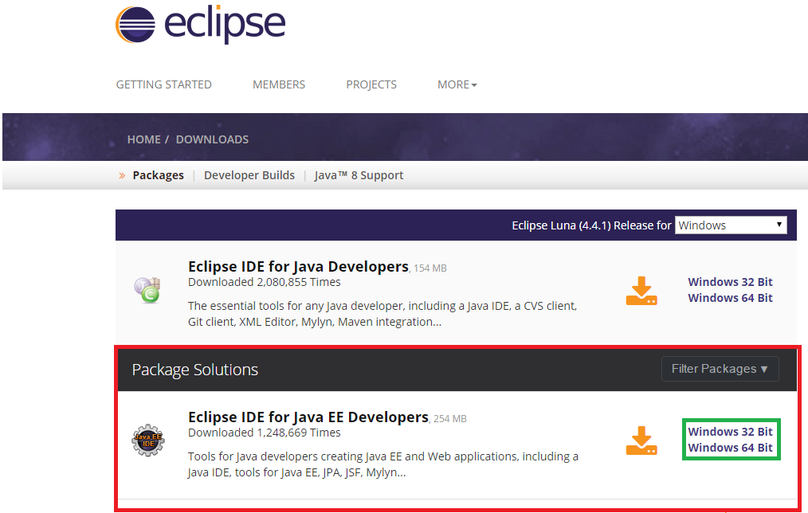

In above picture portion marked in red indicates the correct version and flavor of Eclipse IDE.

* + 1. As seen on the web-page there are various other versions of eclipse that are available which facilitate the development in other languages as well.

We have to choose Eclipse IDE for Java EE developers flavor and latest version so that we can run Java web applications in Eclipse. It comes prepackaged with plugin for integration of tomcat.

As indicated by portion marked in green Eclipse can be downloaded for both 32-bit windows and 64 bit windows.

To find out whether your machine is 32-bit or 64 bit follow below procedure:

1. Right click on My Computer Icon on the desktop and click Properties.
2. Look out for the System type option as shown below :

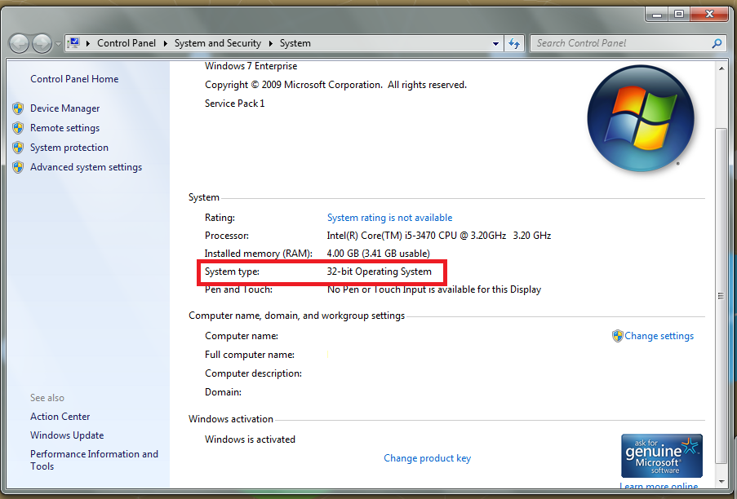

* + 1. Eclipse comes as an executable file. So there is no need to follow any separate installation steps. As shown in below picture click on the download arrow to download the .zip file. 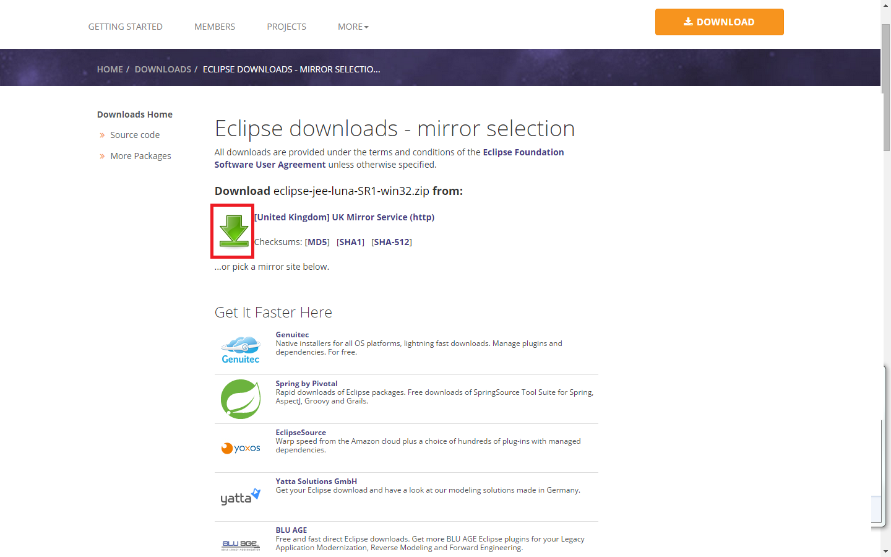
    2. After downloading the .zip file extract it using any .zip file extraction software such as WinZip or WinRAR or 7-Zip.
    3. In the extracted folder you will find a folder with name eclipse and inside that a file with name eclipse. The file type listed for this file is Application.

To start eclipse you can double click on above file. Please find below picture how the application file for eclipse looks like.

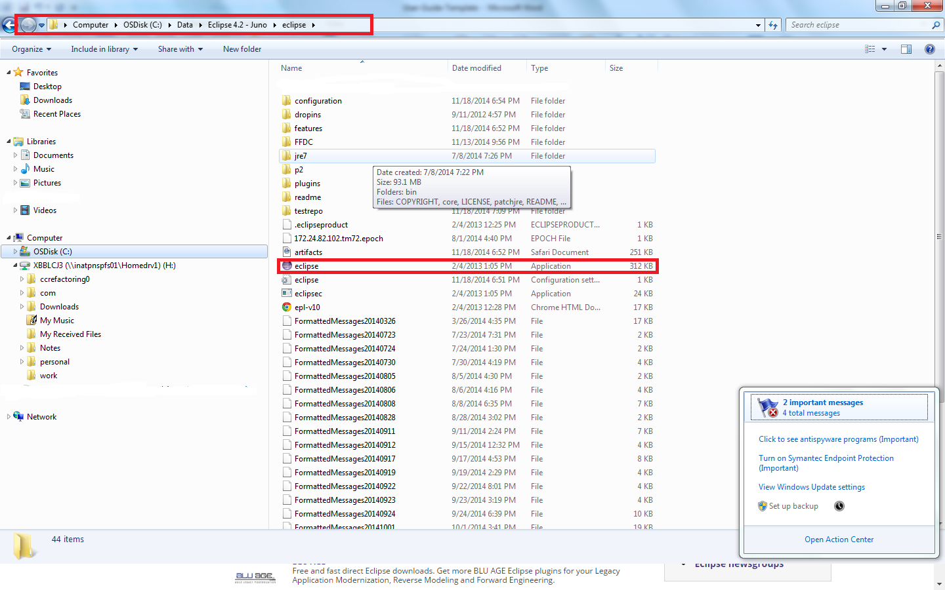

Before you can start working using Eclipse you need to setup JDK (Java development Kit ) as Eclipse uses Java to run. Please continue to read how to setup JDK.

2.2.1) Download JDK 7 from following location:

<http://www.oracle.com/technetwork/java/javase/downloads/jdk7-downloads->1880260.html

As shown in below picture download JDK version suitable for your operating

system.

Please make sure to download exact java version based on your operating system

32-bit/64-bit version. Please see portion marked in red in below picture.

Please select license agreement as marked in green as shown in below picture.

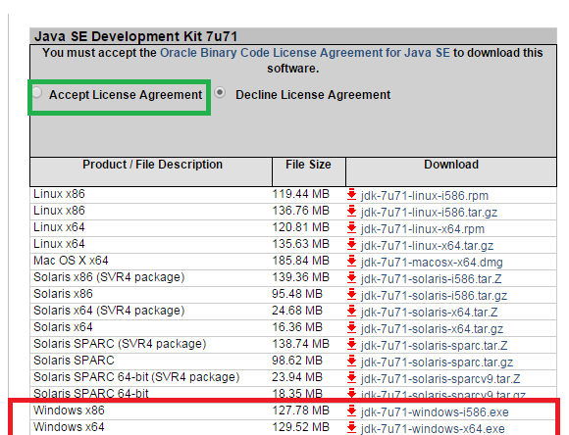

2.2.2) Set up JAVA-HOME system environment variable

This environment variable is needed to let eclipse installation know location of java

installation on computer.

For e. g. If java is installed at c:/ program files /java /jdk1.17.0_71 then set JAVA_HOME equal to c:/programfiles/ Java /jdk1.7.0_71

Please follow following steps

1) Right click on my computer icon on desktop and click on properties.

2) click on advance system settings as shown below.

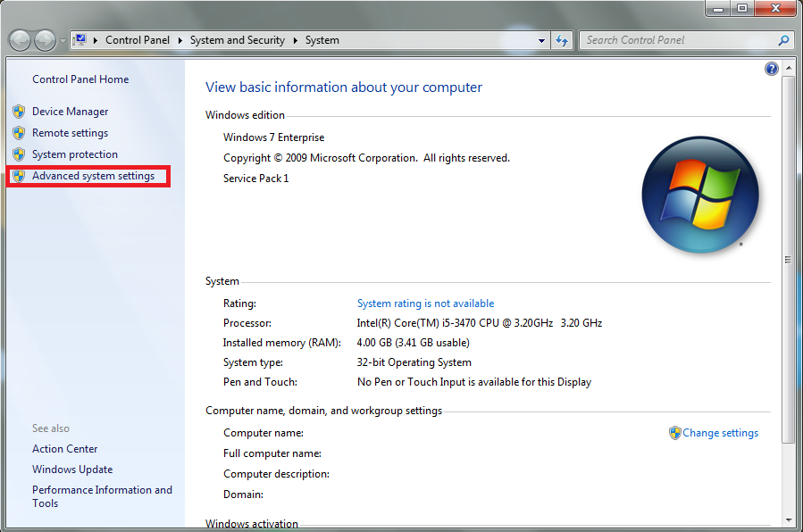

2.2.3) Click on environment variables as shown below in advanced tabs

Insert Screenshot

Click on new button to create a new environment variables.

In system variables section

Insert Screenshot

2.2.4) Set variable name to Java_ HOME and variable value to

c:/program files/ java/jdk1.7.0_71 and click on ok.

Insert Screenshot

Download and Set up Tomcat

3.1.1) Download and setup Tomcat

1) Download tomcat 7 from following location

<http://tomcat.apache.org/download-70.cgi>

Select appropriate version from your operating system and click on appropriate

link as mark in red in below picture.

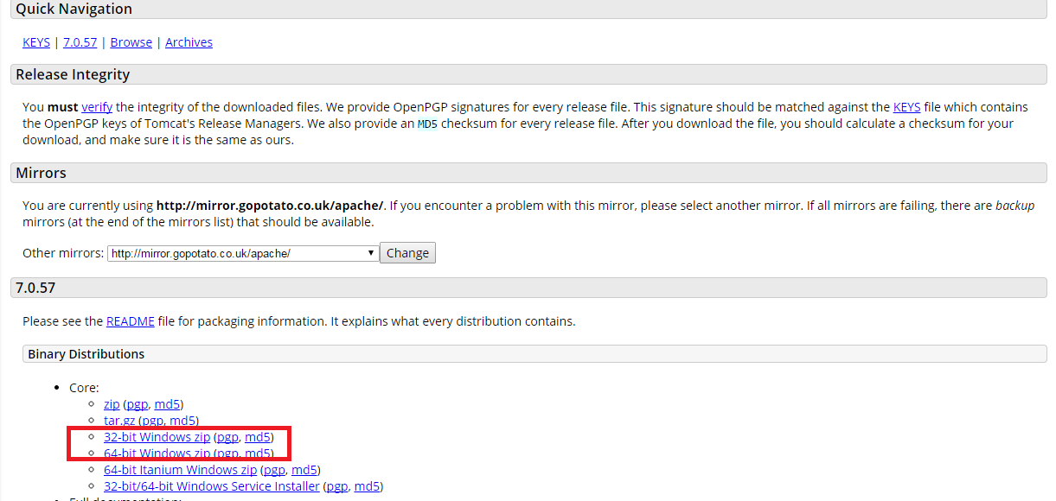

3.1.2) Extract downloaded.zip of archive on any directory .

It will be extracted to a directory with name corresponding tomcat version.

For e.g. if Tomcat version is 7.0.52. extraction will create

a directory with name apache-tomcat-7.0.52

Remember this directory name as it is needed to set CATALINA_HOME environment section.

3.2.1) Set up CATLINA_HOME environment variable.

Please follow following steps

1) Right click on my computer on desktop and click on properties.

2) Click on advanced system settings as shown below.



3) Click on environment variable as shown below in advanced tab.

4) Click on new button to create a new environment variable in system variable

section.

5) Set variable name to CATLINA_HOME and

variable value to {path to Tomcat directory}. For E.g. if tomcat is installed at

c:/apche-tomcat then set the value to c:/apache tomcat and click on ok.

Integrate Tomcat with Eclipse

4.1.1) Integrate tomcat with Eclipse

Eclipse provides different perspectives to carry out different types of tasks.

Each perspective provides an environment and utilities to perform the task.

For E.g. java perspective allows to create standalone java applications and

java ee perspective allows to create j2e applications.

Similarly debug perspective allows to debug an application.

To integrate a tomcat with eclipse we have to set up tomcat in j2ee perspective.

To switch to j2ee perspective click on window menu and select open perspective

as shown below. Sometimes J2EE will be the default perspective so we can skip this step.

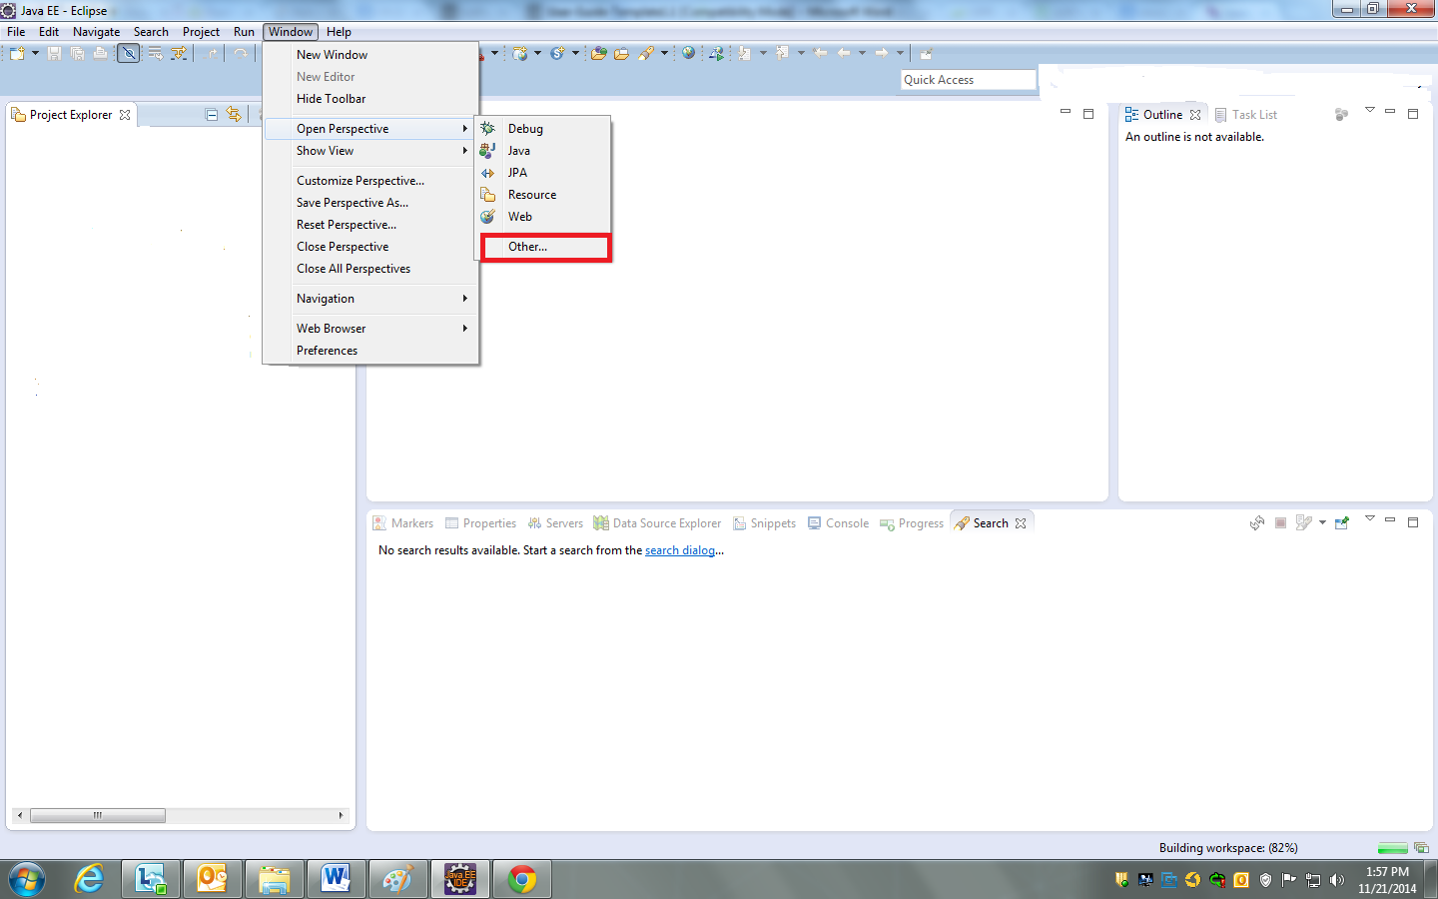

From the list appears select j2ee as shown perspective as shown below.

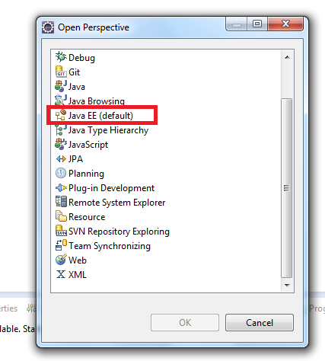

4.1.2) In this perspective open the servers view as shown below by selecting

Window🡪show view and select Servers.

If Servers view does not appear then select “Other” option and select Servers from “Server” option.

This view is added by default at the bottom of the window.

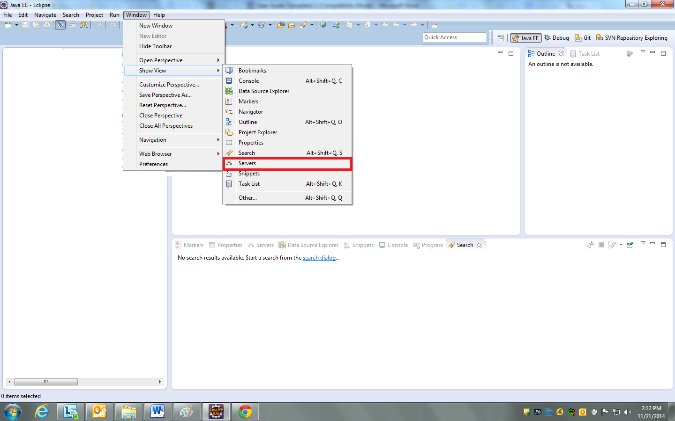

4.1.3) In servers view right click and say create new server.

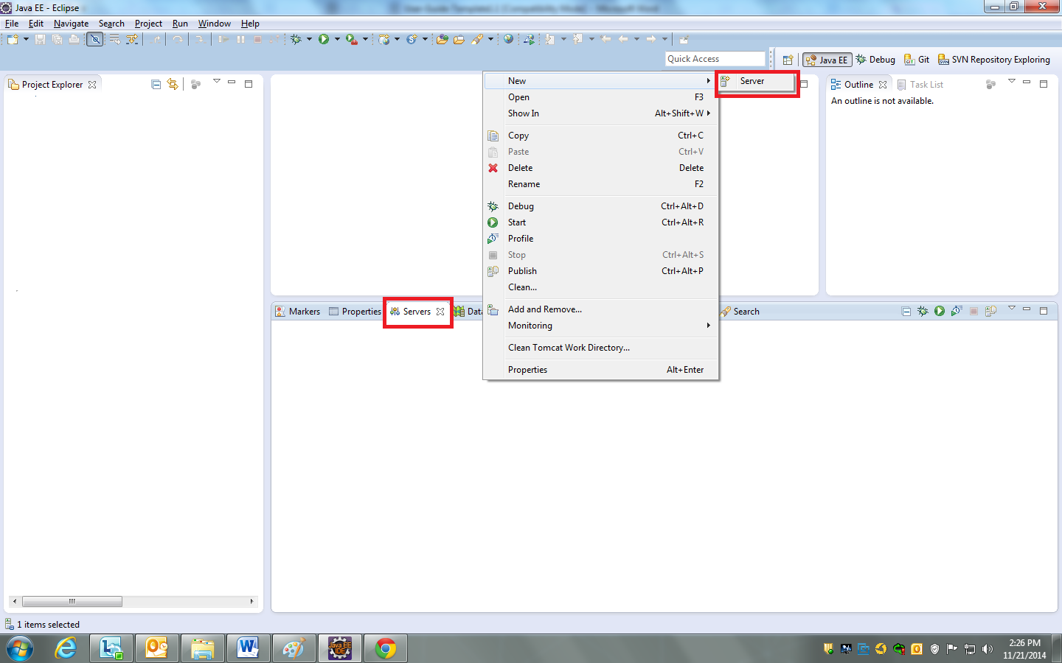

4.1.4) Select tomcat 7.0 from apache group as shown below.

Enter Server Name.

Enter host name.

Host name indicates where the tomcat is installed. For this user guide we assume it is hosted on local machine and hence specify localhost and click next.

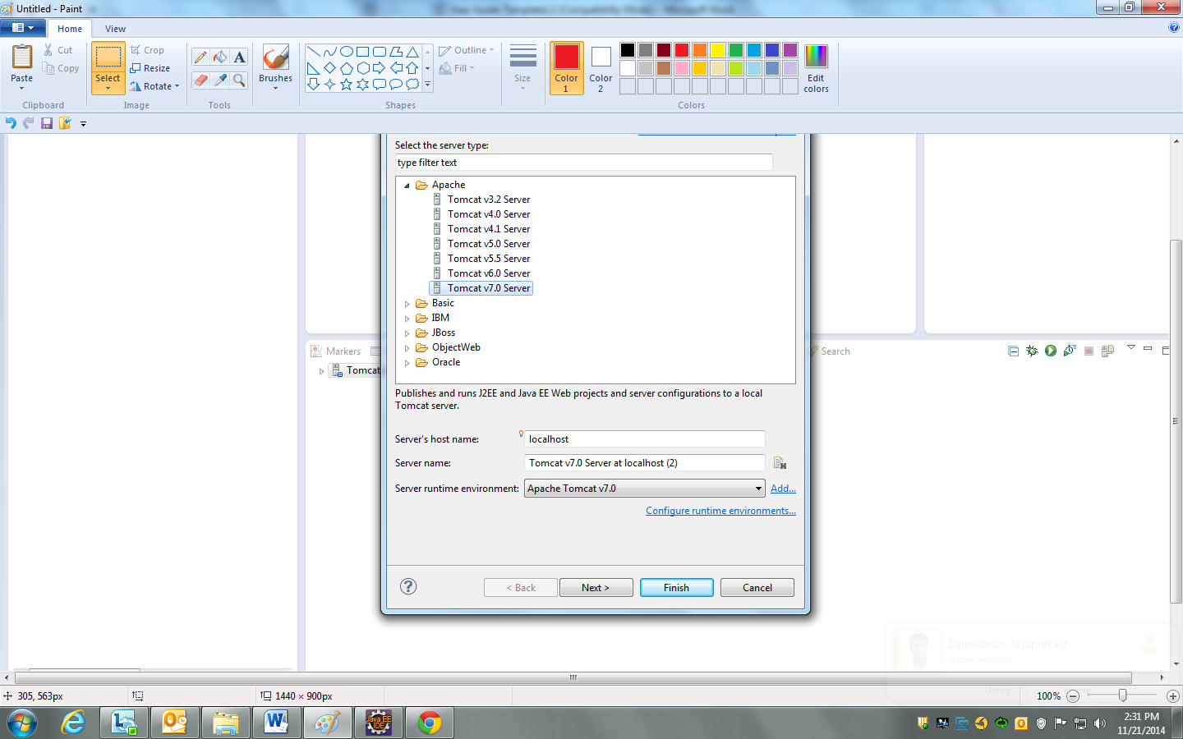

4.1.5) Below picture shows Add/Remove window of Server where you can add multiple web applications you want to deploy in this particular tomcat. All the projects that you have created as Dynamic Web Modules will be shown in the left pane.

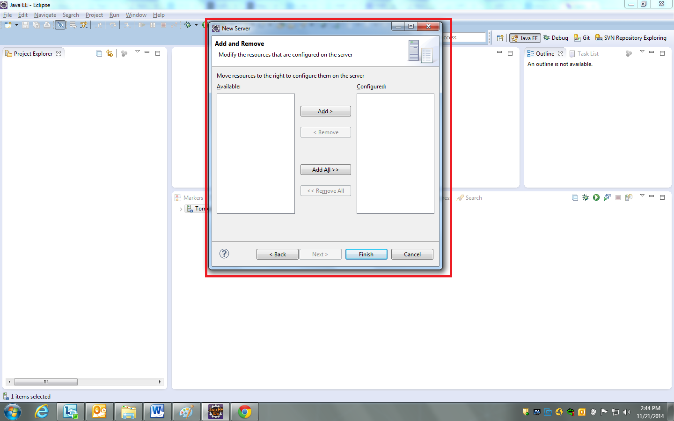

Click on finish. You will see Tomcat server added in Servers view as shown below.

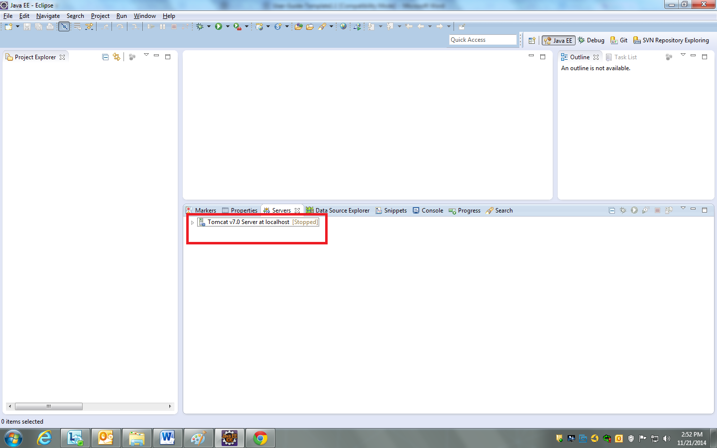

4.2) Double click on Server added shown in above picture.

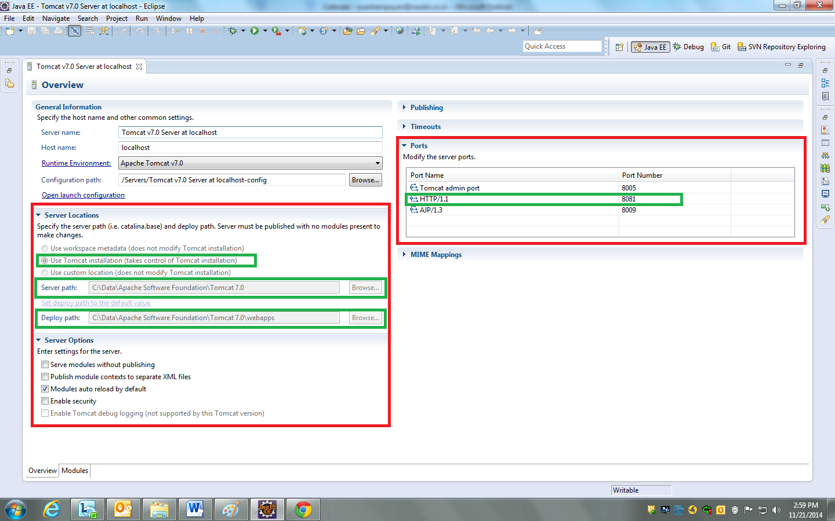

As shown in portion marked in green in above picture change the configurations for below Parameters :

1. In server Locations section select second option “Use tomcat installation”. This allows us deploy the web application in our own installed tomcat instead of eclipse’s internal embedded instance of tomcat. This makes easier for debugging purposes like to check if application has been deployed correctly or not.
2. In Server Path option enter path for tomcat installation directory as shown. In our case our tomcat is installed in directory C:\Data\Apache Software Foundation\Tomcat 7.0.

Please note above path must match with CATALINA_HOME environment variable.

1. In Deploy path select “webapps” subdirectory of tomcat installation directory that we set above. This is the default location where tomcat installs all the web applications. You can give any subdirectory in tomcat installation directory though it is not recommended.

In our case we have set this to C:\Data\Apache Software Foundation\Tomcat 7.0/webapps

1. In Ports section set the port at which your tomcat is running. By default it is 8080. If you want to run two tomcats at one time then you might have to assign different ports to each of them. The port configuration can changed from here.

Make the necessary changes and press Ctrl+S to save the changes and close the window

Set up Web application in Eclipse

5.1.1) From file Menu select New 🡪 Dynamic Web Project. Dynamic Web Project is a reject that can be built into .war archive which can be installed in any servlet container. This project by default creates a standard directory structure for you.

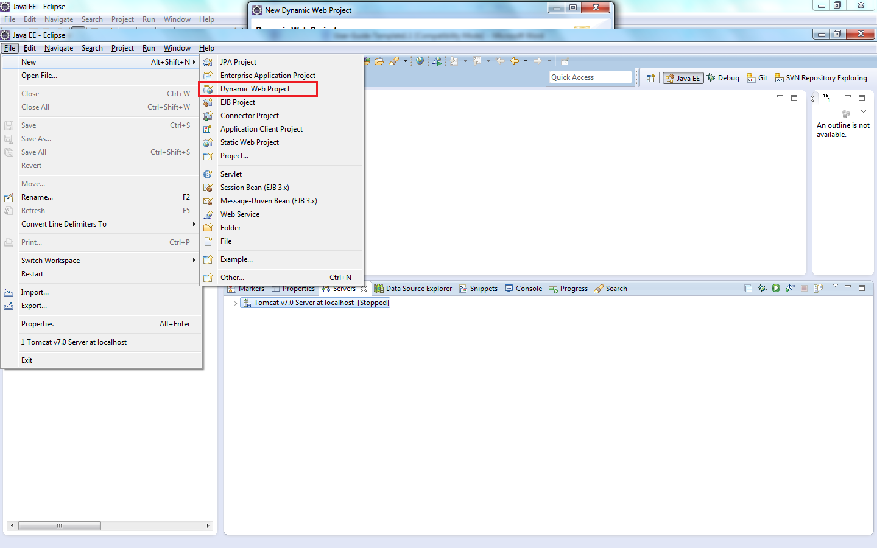

5.1.2) As shown in below picture provide Project name and click next. Other configuration options can be given default values as it is .

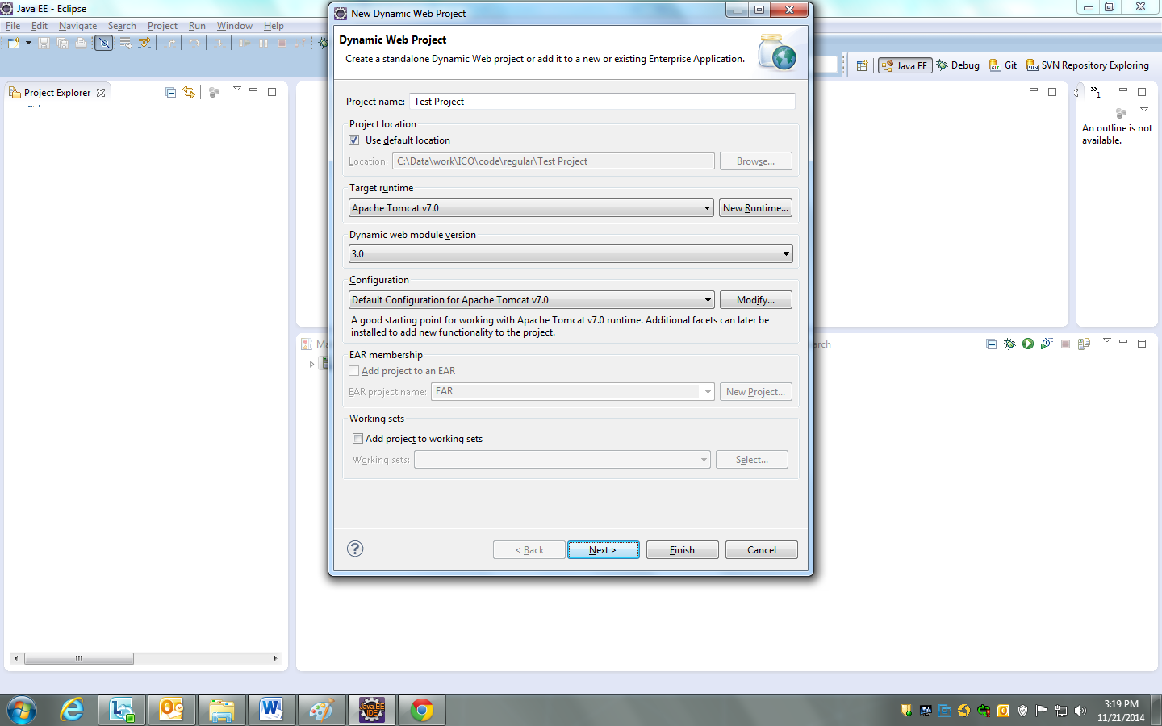

5.1.3) Select source folder as shown in below picture. Default configuration will create a folder with name “src” and add it to project’s source folder. All the folders listed here will be automatically added to classpath by Eclipse so that classes can be found at compile time.

Click Next to continue.

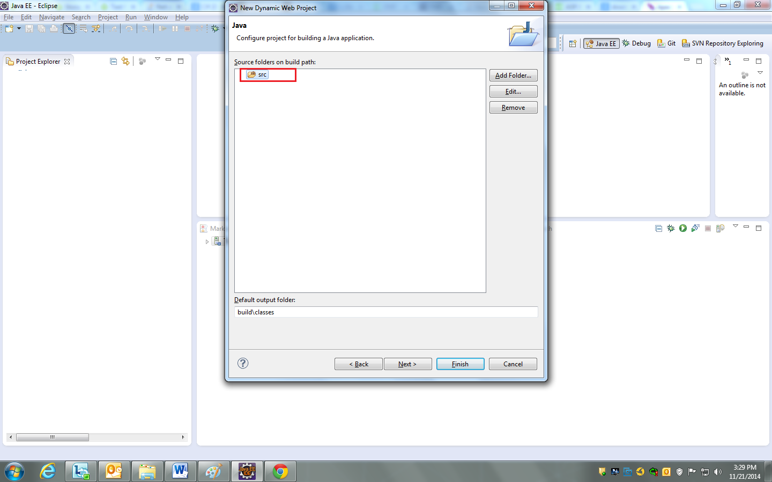

5.1.4) Select Context Root and Content directory name.

Context root is nothing but a application context name with which application will be deployed. Content directory is the directory under which we can our JSPs ,CSS,

and other resources that get deployed directly to {webapps/context root} directory.

Click Finish.

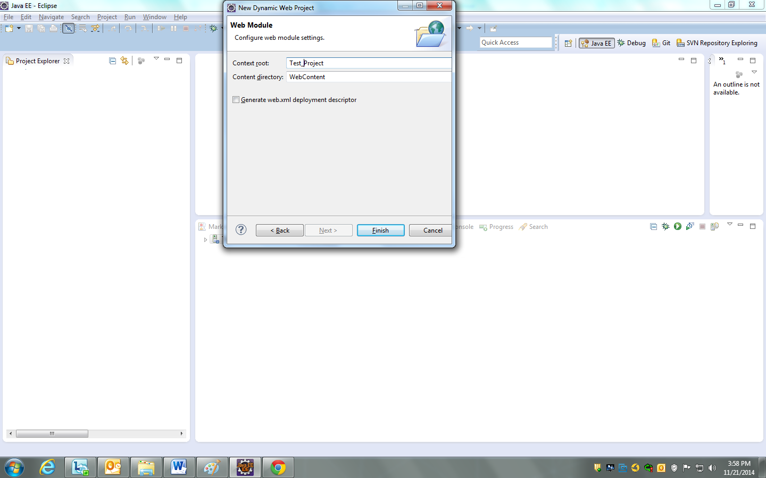

5.1.5) Below Picture shows how a dynamic project looks.

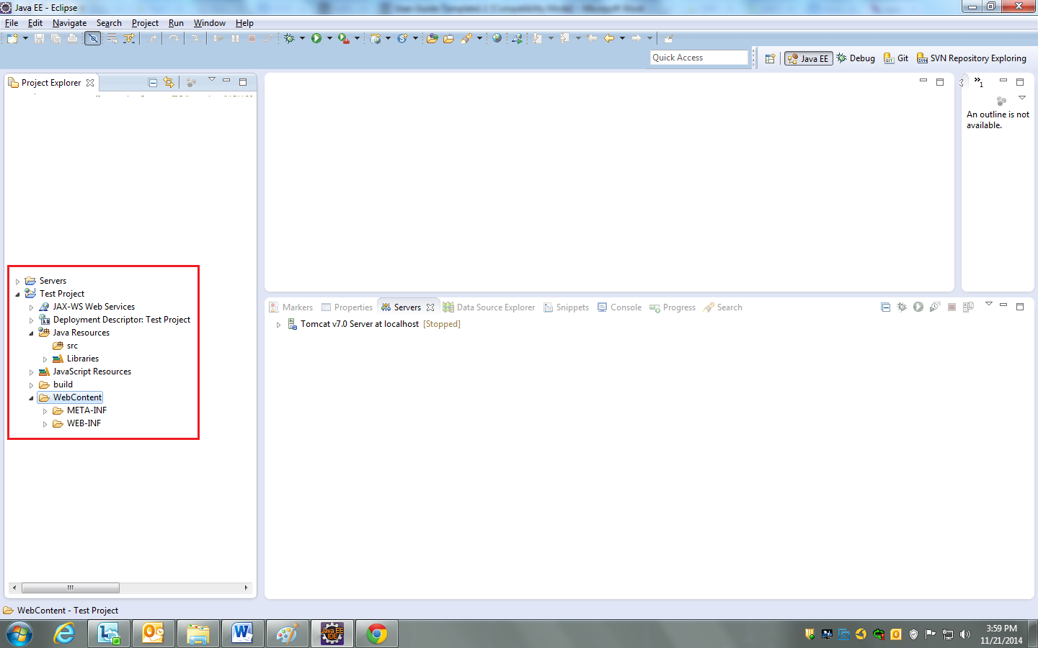

5.2.1) Now to add the recently created project right click on server name in Servers tab at the bottom of the window and click on Add and remove to open window as shown in below picture. Select the Project from left pane and click on Add. Click Finish.

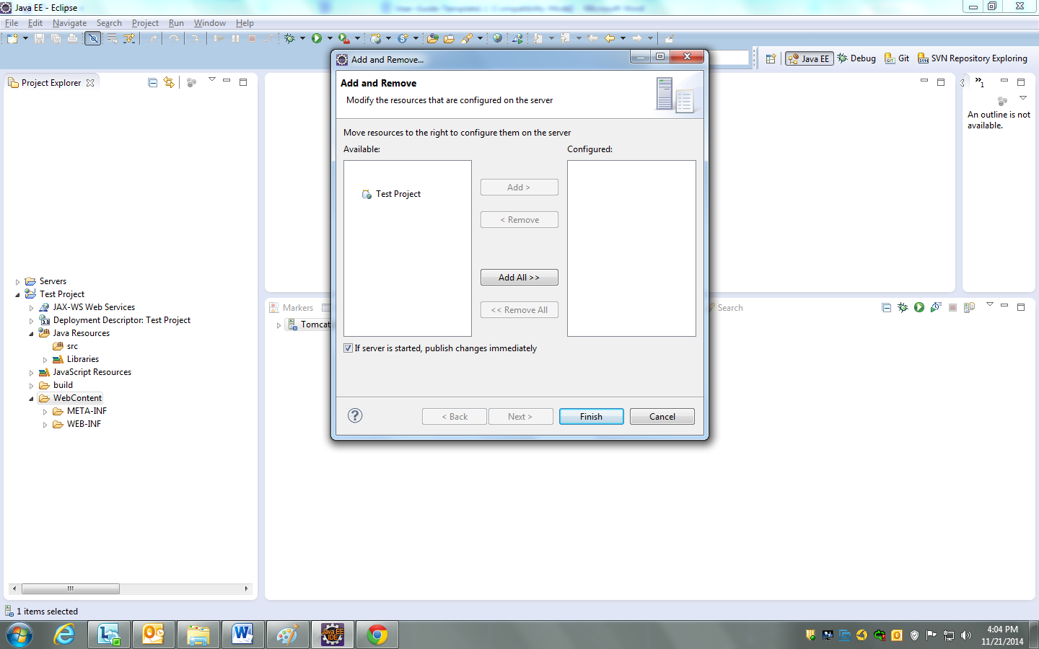

5.3.1) To start tomcat and run the web application right click on server name in Servers tab at the bottom of the window and click on Start. This will start the tomcat and application will be automatically published to web apps directory of the tomcat server.

When we make changes to any resources which are deployed in webapps directory we don’t need to restart the tomcat. Those changes are automatically deployed to tomcat. This is known as hot deploy.