Crop Rotation Documentation

José Fortuny

3/12/2021

# Synopsis

The Crop Rotation model attempts to allocate crops to fields such that the consumption needs of the user are satisfied while adhering to a set of constraints, described below.

## Elements of the model

There are some basic components of the model that are required for the model to exist. These are:

* A **Farm**, which is a collection of Fields
* **Fields** in the farm. A field is defined, in this model, as the unit of land that will be planted, as a whole, with a single crop. Thus it is the minimal, indivisible, planting unit. The fields can be used in the determination of the rotation or can be set aside. The fields have a *measure*, which is under user control and there is an amount of that *measure* in each field. In a vegetable crop setting, the measure will likely be *length* of row (feet or meters of beds or rows, depending on setup); in a farm crop setting, the measure will likely be *surface* of each field (acres or hectares in each field).

## Importing Farm Data

The model accepts its data from an Excel spreadsheet with tab names that identify the elements of the model and tab columns that identify the attributes of the element. Both tab names and column structure must adhere to the standard format that follows. Three tabs are required in the model:

* Farmland
* Demand
* Crops

The spreadsheet must have at least three tabs named with the labels listed; without them the data import will fail.

### Farmland

The **Farmland** tab identifies the **Fields** in the **Farm** by name, their *Measure* and how much land is *Available*, and whether or not they should be *Included* in the rotation (acceptable values are Y or N). The contents of the **Farmland** tab looks like this:

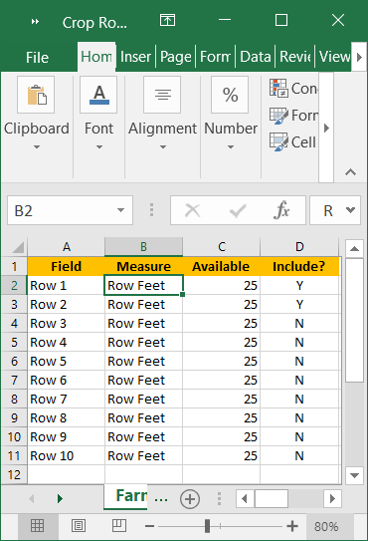

### Demand

The **Demand** tab identifies the Crop using a measure called **Is Same Crop As** (described under the Crop tab) and the amount of the crop required for a year or **Yearly Demand**. The unit of measure of the **Yearly Demand** is determined by the user and it requires consistency with the measure of yield in the Crop and by reference to the **Field** unit of measure; i.e., if the crop yields are expressed in pounds per foot of row then the demand should be expressed in pounds per year and the fields should be measured in row feet. The contents of the **Demand** Tab looks like follows:

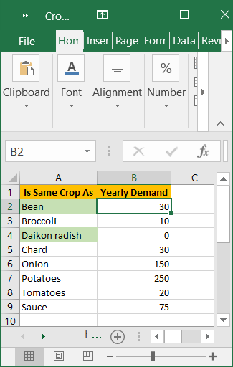

### Crops

The **Crops** tab identifies the crops the user considers planting and a large collection of attributes about those crops. It also indicates whether a crop is to be planted or not in column **Plant?**. The contents of the **Crops** tab that follows shows the columns of the spreadsheet in two images for clarity:

#