

Technical Safety Concept Lane Assistance

**Document Version: [Version]**

**Template Version 1.0, Released on 2017-06-21**



# Document history

|  |  |  |  |
| --- | --- | --- | --- |
| Date | Version | Editor | Description |
| 10/9/2018 | 1.0 | John O’Shea | Initial Draft |
| 11/27/2018 | 1.1 | John O’Shea | Corrected architecture allocation block for LKA Technical Safety Req 2,3 |
|  |  |  |  |
|  |  |  |  |
|  |  |  |  |

# 

# Table of Contents

Document history

Table of Contents

Purpose of the Technical Safety Concept

Inputs to the Technical Safety Concept

Functional Safety Requirements

Refined System Architecture from Functional Safety Concept

Functional overview of architecture elements

Technical Safety Concept

Technical Safety Requirements

Refinement of the System Architecture

Allocation of Technical Safety Requirements to Architecture Elements

Warning and Degradation Concept

# Purpose of the Technical Safety Concept

The technical safety concept involves:

* Turning functional safety requirements into technical safety requirements.
* Allocating technical safety requirements to the system architecture.

# Inputs to the Technical Safety Concept

## Functional Safety Requirements

|  |  |  |  |  |
| --- | --- | --- | --- | --- |
| **ID** | **Functional Safety Requirement** | **ASIL** | **Fault Tolerant Time Interval** | **Safe State** |
| Functional  Safety  Requirement  01-01 | The Lane Departure Warning (LDW) item shall ensure that the lane departure oscillating torque is below Max_Torque_Amplitude. | C | 50 ms | The torque amplitude is below Max_Torque_Amplitude |
| Functional  Safety  Requirement  01-02 | The Lane Departure Warning (LDW) item shall ensure that the lane departure oscillating torque is below Max_Torque_Frequency. | C | 50 ms | The torque frequency is below Max_Torque_Frequency. |
| Functional  Safety  Requirement  02-01 | The electronic power steering ECU shall ensure that the Lane Keeping Asssistance (LKA) torque is applied only for Max_Duration. | B | 500 ms | The torque applied by the power steering ECU after Max_Duration is 0Nm. |

## Refined System Architecture from Functional Safety Concept

### Functional overview of architecture elements

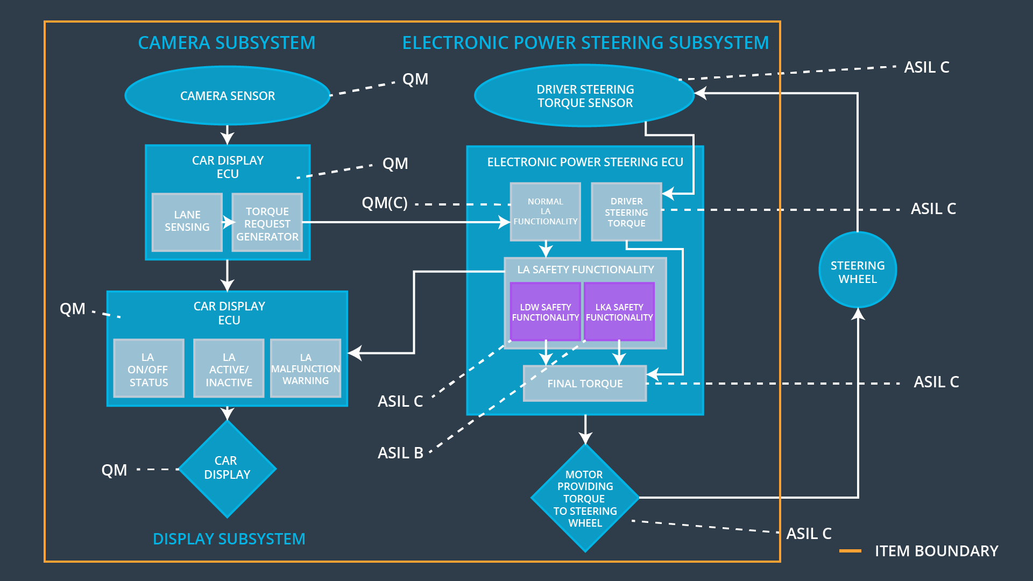

|  |  |
| --- | --- |
| **Element** | **Description** |
| Camera Sensor | Captures images of the road surface and sends them to the Camera Sensor ECU. |
| Camera Sensor ECU - Lane Sensing | Processes a valid image to look for lane lines |
| Camera Sensor ECU - Torque request generator | * Makes a determination of a lane line violation * Alerts Driver Steering Torque Sensor with “Lane Departure Alert” Torque request message |
| Car Display | Provides a visual indication to the driver if a “Lane Departure Alert ” was detected. |
| Car Display ECU - Lane Assistance On/Off Status | Processes status packets from Camera Sensor ECU. Detects “Lane Departure Alert” message packet and sets the Car Display warning “ON” indicator.  Detects “In Lane” message packet and sets the Car Display by turning off warning “OFF” indicator |
| Car Display ECU - Lane Assistant Active/Inactive | Processes Car Display input requests from the driver.  If “Activate” function is received from the driver the Car Display ECU will first check that the Lane Assistance item is functioning correctly, and will then proceed to send a “Lane Active” message packet to set Car Display indicator to “ACTIVE”  If “Deactivate” function is received from the driver the Car Display ECU send a “Lane Inactive” message packet to set Car Display indicator to “INACTIVE” |
| Car Display ECU - Lane Assistance malfunction warning | Processes data packets from Camera Sensor ECU.  If the camera ECU detects bad packets(CRC or other error code) from the camera sensor than an error message packet is sent to the Car Display ECU to set the Car Display warning “MALFUNCTION” indicator. |
| Driver Steering Torque Sensor | Measures the torque applied to the power steering unit. |
| Electronic Power Steering (EPS) ECU - Driver Steering Torque | * Processes status packets from Drivier Steering Torque Sensor ECU. * Detects “Lane Departure Alert” message packet and sends a command to the motor to apply an oscillating torque to the drive power steering unit. * Detects “In Lane” message packet and send a reset command to disable the oscillating torque if enabled. |
| EPS ECU - Normal Lane Assistance Functionality | Software module receiving the Camera Sensor ECU torque request |
| EPS ECU - Lane Departure Warning Safety Functionality | Software module ensuring the torque amplitude and torque frequency is below Max_Torque_Ampllitude and Max_Torque_Frequency respectively. |
| EPS ECU - Lane Keeping Assistant Safety Functionality | Software module ensuring the Lane Keeping Assistance (LKA) module is not activated for longer than Max_Duration in time. |
| EPS ECU - Final Torque | Process the the safe steering torque requests by the LKA and the LDA and send to EPS ECU |
| Motor | Process the requested torque request and apply it to the steering wheel motor. |

# Technical Safety Concept

## Technical Safety Requirements

**[**

**Lane Departure Warning (LDW) Requirements:**

Functional Safety Requirement 01-01 with its associated system elements

(derived in the functional safety concept)

|  |  |  |  |  |
| --- | --- | --- | --- | --- |
| **ID** | **Functional Safety Requirement** | **Electronic Power Steering ECU** | **Camera ECU** | **Car Display ECU** |
| Functional  Safety  Requirement  01-01 | The lane keeping item shall ensure that the lane departure oscillating torque amplitude is below Max_Torque_Amplitude | X |  |  |

Technical Safety Requirements related to Functional Safety Requirement 01-01 are:

|  |  |  |  |  |  |
| --- | --- | --- | --- | --- | --- |
| **ID** | **Technical Safety Requirement** | **ASIL** | **Fault Tolerant Time Interval** | **Architecture Allocation** | **Safe State** |
| Technical  Safety  Requirement  01 | The LDW component shall ensure that the LDW_Torque_Request for lane departure warning is below Max_Torque_Amplitude. | C | 50 ms | LDW Safety | The LDW torque amplitude is set to 0. |
| Technical  Safety  Requirement  02 | When the LDW feature is deactivated, the LDW software component shall block any requests to activate a warning light to the car display ECU | C | 50 ms | LDW Safety | The LDW torque amplitude is set to 0. |
| Technical  Safety  Requirement  03 | Once a failure is detected the LDW feature is deactivated and a torque request shall not be sent. | C | 50 ms | LDW Safety | The LDW torque amplitude is set to 0. |
| Technical  Safety  Requirement  04 | The validity and integrity of the data transmission for LDW_Torque_Request shall be checked | C | 50 ms | Data Transmission Integrity check | The LDW torque amplitude is set to 0. |
| Technical  Safety  Requirement  05 | A memory test shall be conducted during the start up of the EPS ECU to check for any faults in memory. | A | Ignition Cycle | Memory Test | The LDW torque amplitude is set to 0. |

Functional Safety Requirement 01-2 with its associated system elements

(derived in the functional safety concept)

|  |  |  |  |  |
| --- | --- | --- | --- | --- |
| **ID** | **Functional Safety Requirement** | **Electronic Power Steering ECU** | **Camera ECU** | **Car Display ECU** |
| Functional  Safety  Requirement  01-02 | The lane keeping item shall ensure that the lane departure oscillating torque frequency is below Max_Torque_Frequency | X |  |  |

Technical Safety Requirements related to Functional Safety Requirement 01-02 are:

|  |  |  |  |  |  |
| --- | --- | --- | --- | --- | --- |
| **ID** | **Technical Safety Requirement** | **ASIL** | **Fault Tolerant Time Interval** | **Architecture Allocation** | **Safe State** |
| Technical  Safety  Requirement  01 | The LDW component shall ensure that the LDW_Torque_Request frequency is below Max_Torque_Frequency. | C | 50 ms | LDW Safety | The LDW torque frequency is set to 0. |
| Technical  Safety  Requirement  02 | When the LDW feature is deactivated, the LDW software component shall block any requests to activate a warning light to the car display ECU | C | 50 ms | LDW Safety | The LDW torque frequency is set to 0. |
| Technical  Safety  Requirement  03 | Once a failure is detected the LDW feature is deactivated and a torque request shall not be sent. | C | 50 ms | LDW Safety | The LDW torque frequency is set to 0. |
| Technical  Safety  Requirement  04 | The validity and integrity of the data transmission for LDW_Torque_Request shall be checked | C | 50 ms | Data Transmission Integrity check | The LDW torque frequency is set to 0. |
| Technical  Safety  Requirement  05 | A memory test shall be conducted at start up of the EPS ECU to check for any faults in memory | A | Ignition Cycle | Memory Test | The LDW torque frequency is set to 0. |

**Lane Keeping Assistance (LKA) Requirements:**

Functional Safety Requirement 02-1 with its associated system elements

(derived in the functional safety concept)

|  |  |  |  |  |
| --- | --- | --- | --- | --- |
| **ID** | **Functional Safety Requirement** | **Electronic Power Steering ECU** | **Camera ECU** | **Car Display ECU** |
| Functional  Safety  Requirement  02-01 | The lane keeping item shall ensure that the lane keeping assistance torque is applied for only Max_Duration | X |  |  |

Technical Safety Requirements related to Functional Safety Requirement 02-01 are:

|  |  |  |  |  |  |
| --- | --- | --- | --- | --- | --- |
| **ID** | **Technical Safety Requirement** | **ASIL** | **Fault Tolerant Time Interval** | **Allocation to Architecture** | **Safe State** |
| Technical  Safety  Requirement  01 | The LKA component shall ensure that the LKA_Torque_Request sent does not exceed Max_Duration | B | 500ms | LKA Safety | The LKA Torque Request is set to 0. |
| Technical  Safety  Requirement  02 | When the LKA feature is deactivated, the LKA software component shall block any requests to activate a warning light to the car display ECU | B | 500 ms | LKA Safety | The LKA Torque Request is set to 0. |
| Technical  Safety  Requirement  03 | When a failure is detected by the LKA, it shall deactivate the LKA feature, and the LKA_Torque_Request shall be set to 0. | B | 500 ms | LKA Safety | The LKA function is turned off. |
| Technical  Safety  Requirement  04 | The validity and integrity of the data transmission for LDW_Torque_Request shall be checked | B | 500 ms | Data Transmission Integrity check | The LKA Torque Request is set to 0. |
| Technical  Safety  Requirement  05 | A memory test shall be conducted at start up of the EPS ECU to check for any faults in memory | A | Ignition Cycle | Memory Test | The LKA Torque Request is set to 0. |

## Refinement of the System Architecture

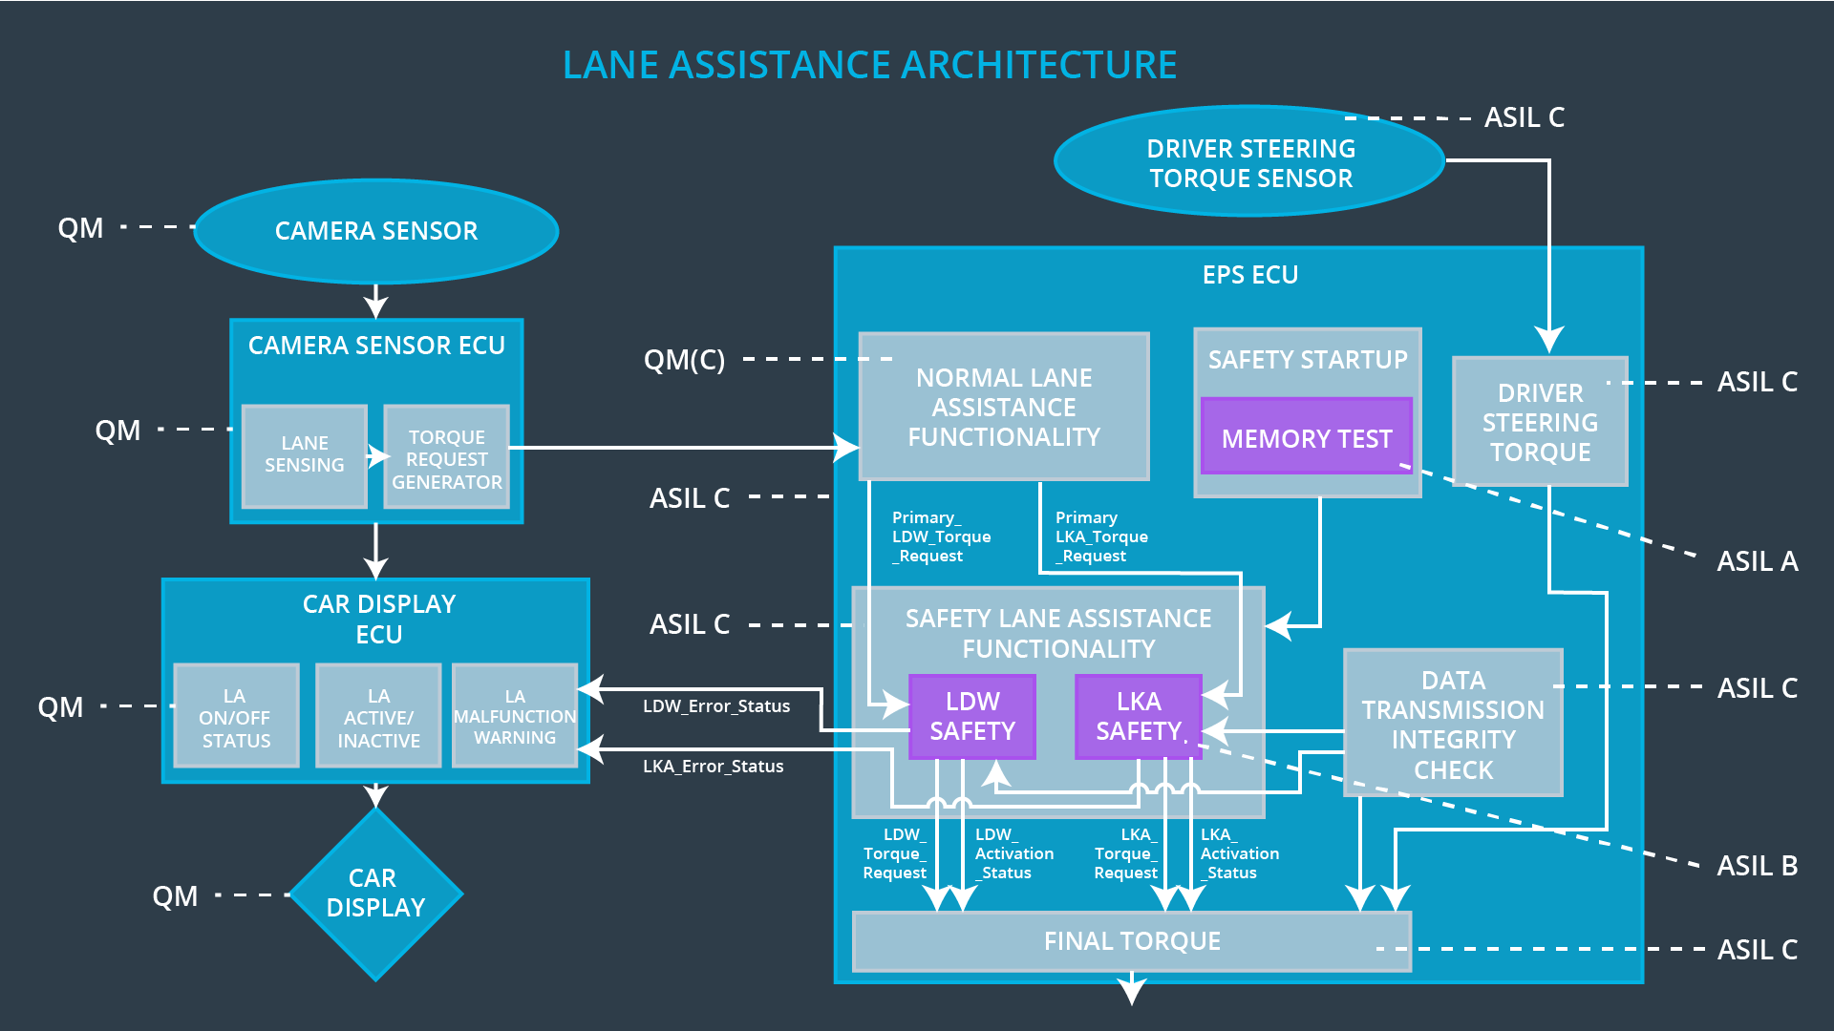

## Allocation of Technical Safety Requirements to Architecture Elements

All technical safety requirements are allocated to the Electronic Power Steering ECU

## Warning and Degradation Concept

|  |  |  |  |  |
| --- | --- | --- | --- | --- |
| **ID** | **Degradation Mode** | **Trigger for Degradation Mode** | **Safe State invoked?** | **Driver Warning** |
| WDC-01 | LDW is disabled | Malfunction_01,  Malfunction_02, | Yes | Car Display provides visual indication that LDW is disabled |
| WDC-02 | LKA is disabled | Malfunction_03 | Yes | Car Display provides visual indication that LKA is disabled |