

Software Safety Requirements and Architecture

Lane Assistance

**Document Version: [Version]**

**Template Version 1.0, Released on 2017-06-21**



# Document history

|  |  |  |  |
| --- | --- | --- | --- |
| Date | Version | Editor | Description |
| 10/15/2018 | 1.0 | John O’Shea | Initial Draft |
|  |  |  |  |
|  |  |  |  |
|  |  |  |  |
|  |  |  |  |

# 

# Table of Contents

Document history

Table of Contents

Purpose

Inputs to the Software Requirements and Architecture Document

Technical safety requirements

Refined Architecture Diagram from the Technical Safety Concept

Software Requirements

Refined Architecture Diagram

# Purpose

The purpose of the document is to document detailed software safety requirements using the technical safety requirments.

# Inputs to the Software Requirements and Architecture Document

## Technical safety requirements

Technical Safety Requirements related to Functional Safety Requirement 01-01 are:

|  |  |  |  |  |  |
| --- | --- | --- | --- | --- | --- |
| **ID** | **Technical Safety Requirement** | **ASIL** | **Fault Tolerant Time Interval** | **Architecture Allocation** | **Safe State** |
| Technical  Safety  Requirement  01 | The LDW component shall ensure that the LDW_Torque_Request for lane departure warning is below Max_Torque_Amplitude. | C | 50 ms | LDW Safety | The LDW torque amplitude is set to 0. |
| Technical  Safety  Requirement  02 | When the LDW feature is deactivated, the LDW software component shall block any requests to activate a warning light to the car display ECU | C | 50 ms | LDW Safety | The LDW torque amplitude is set to 0. |
| Technical  Safety  Requirement  03 | Once a failure is detected the LDW feature is deactivated and a torque request shall not be sent. | C | 50 ms | LDW Safety | The LDW torque amplitude is set to 0. |
| Technical  Safety  Requirement  04 | The validity and integrity of the data transmission for LDW_Torque_Request shall be checked | C | 50 ms | Data Transmission Integrity check | The LDW torque amplitude is set to 0. |
| Technical  Safety  Requirement  05 | A memory test shall be conducted during the start up of the EPS ECU to check for any faults in memory. | A | Ignition Cycle | Memory Test | The LDW torque amplitude is set to 0. |

## Refined Architecture Diagram from the Technical Safety Concept

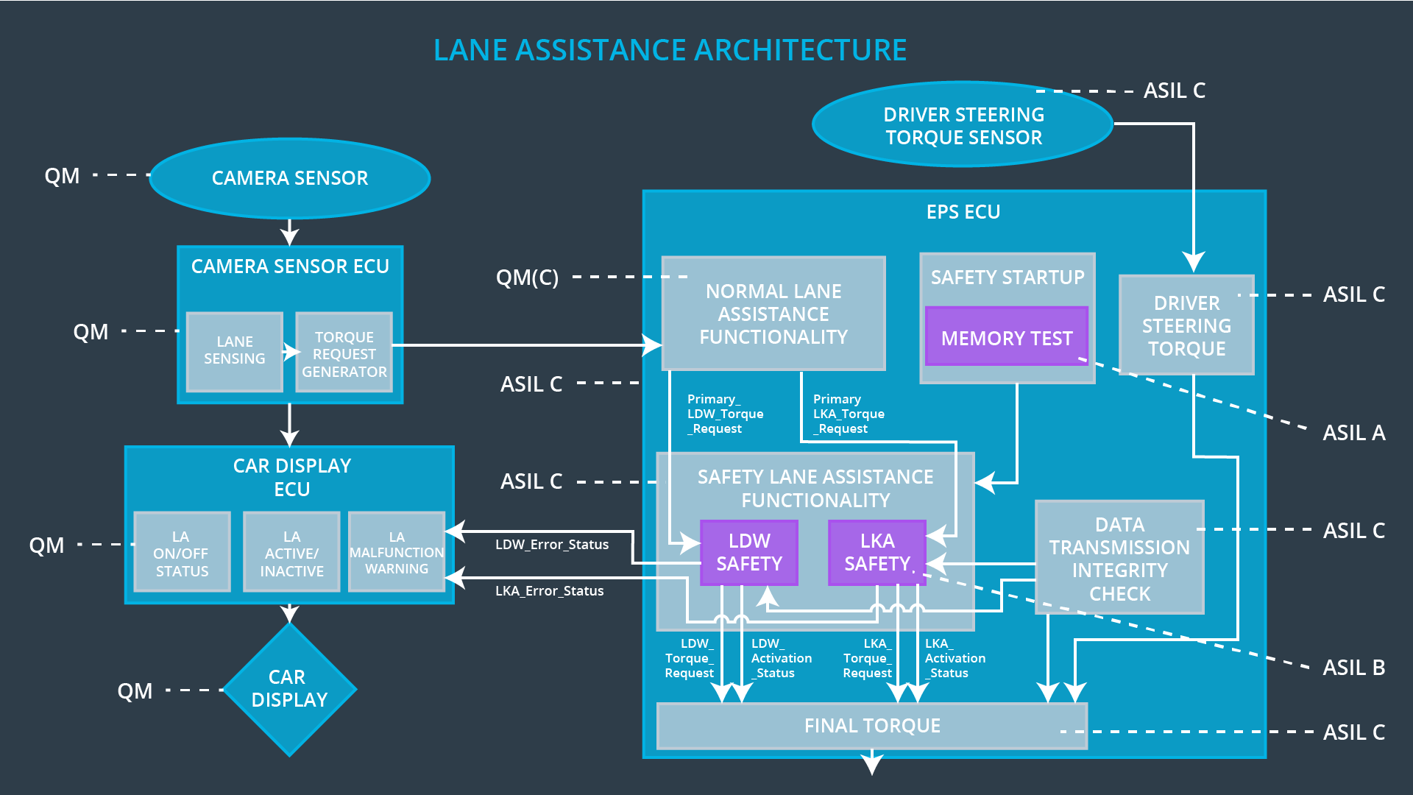

# Software Requirements

**Lane Departure Warning (LDW) Amplitude Malfunction Software Requirements:**

|  |  |  |  |  |  |
| --- | --- | --- | --- | --- | --- |
| **ID** | **Technical Safety Requirement** | **ASIL** | **Fault Tolerant Time Interval** | **Allocation to Architecture** | **Safe State** |
| Technical  Safety  Requirement  01 | The LDW component shall ensure that the LDW_Torque_Request for lane departure warning is below Max_Torque_Amplitude. | C | 50 ms | LDW Safety | The LDW torque amplitude is set to 0. |

|  |  |  |  |  |
| --- | --- | --- | --- | --- |
| ID | Software Safety Requirement | ASIL | Allocation Software Elements | Safe State |
| Software  Safety  Requirement  01-01 | The input signal ‘Primary_LDW_Torque_Request’ shall be read and pre-processed to determine the torque request coming from the ‘Basic/Main LANE Assistance Funtionality’ SW component. The signal ‘Processed_LDW_Torque_Request’ shall be generated at the end of processing. | C | LDW_SAFETY_INPUT_PROCESSING | N/A |
| Software Safety Requirement 01-02 | If ‘Processed_LDW_Torque_Request’ has a value greater than ‘Max_Torque_Amplitude_LDW’ , the torque signal ‘Limited_LDW_Torque_Request’ shall be set to zero, else  ‘Limited_LDW_Torque_Request’ shall take the value of the ‘Processed_LDW_Torque_Request’ | C | TORQUE_LIMITER | limited_LDW_Torque_Request = 0 |
| Software Safety Requirement 01-03 | The ‘Limited_LDW_Torque_Request’ shall be transformed into a signal ‘LDW_Torque_Request’ which is suitable to be transmitted outside the LDW safety component ‘LDW Safety’ to the final EPS Torque component. | C | LDW_SAFETY_OUTPUT_GENERATOR | LDW torque amplitude set to 0 |

|  |  |  |  |  |  |
| --- | --- | --- | --- | --- | --- |
| **ID** | **Technical Safety Requirement** | **ASIL** | **Fault Tolerant Time Interval** | **Allocation to Architecture** | **Safe State** |
| Technical  Safety  Requirement  02 | When the LDW feature is deactivated, the LDW software component shall block any requests to activate a warning light to the car display ECU | C | 50 ms | LDW Safety  Data Transmission Integrity check | The LDW torque amplitude is set to 0. |

|  |  |  |  |  |
| --- | --- | --- | --- | --- |
| **ID** | **Software Safety Requirement** | **ASIL** | **Allocation Software Elements** | **Safe State** |
| Software Safety Requirement 02-01 | When the LDW function is deactivated (activation_status=0), and further requests shall first check activation_status before sending requests | C | All SW Elements | The LDW torque amplitude is set to 0. |
| Software Safety Requirement 02-02 | When the LDW function is deactivated (activation_status=0), the activation_status shall be sent to the Car Display ECU to enable the Car Display warning light | C | Car Display ECU, Car Display | activation_status=0 |

|  |  |  |  |  |  |
| --- | --- | --- | --- | --- | --- |
| **ID** | **Technical Safety Requirement** | **ASIL** | **Fault Tolerant Time Interval** | **Allocation to Architecture** | **Safe State** |
| Technical  Safety  Requirement  03 | Once a failure is detected the LDW feature is deactivated and a torque request shall not be sent. | C | 50 ms | LDW Safety | The LDW torque amplitude is set to 0. |

|  |  |  |  |  |
| --- | --- | --- | --- | --- |
| **ID** | **Software Safety Requirement** | **ASIL** | **Allocation Software Elements** | **Safe State** |
| Software Safety Requirement03-01 | Each SW element detecting an error shall assert its error signal to indicate an error was detected. | C | All SW elements with error outputs | N/A |
| Software Safety Requirement03-02 | Each SW element shall check for errors asserted by other elements and if an error is detected it shall deactivate the LDW feature. (activation_status=0) | C | LDW_SAFETY_ACTIVATION | N/A |
| Software Safety Requirement03-03 | Each SW element shall check for errors asserted by other elements and if an error is not detected it shall assert keep LDW feature activated. (activation_status=1) | C | LDW_SAFETY_ACTIVATION | N/A |
| Software Safety Requirement03-04 | If an error is detected by any SW element the LDW_Torque_Request shall be set to 0 | C | All SW elements with error outputs | LDW_Torque_Request = 0 |
| Software Safety Requirement03-05 | If the LDW is deactivated, it shall stay deactivated until the vehicle is shut off and restarted | C | LDW_SAFETY_ACTIVATION | activation_status=0 |

|  |  |  |  |  |  |
| --- | --- | --- | --- | --- | --- |
| **ID** | **Technical Safety Requirement** | **ASIL** | **Fault Tolerant Time Interval** | **Allocation to Architecture** | **Safe State** |
| Technical  Safety  Requirement  04 | The validity and integrity of the data transmission for LDW_Torque_Request shall be checked | C | 50 ms | Data Transmission Integrity check | The LDW torque amplitude is set to 0. |

|  |  |  |  |  |
| --- | --- | --- | --- | --- |
| **ID** | **Software Safety Requirement** | **ASIL** | **Allocation Software Elements** | **Safe State** |
| Software Safety Requirement 04-01 | All data transmitted outside of “LDW Safety” shall be protected with End2End(E2E) protection.  The E2E shall be activated for header/payload portions of each data packet | C | E2E Calculation | LDW_Torque_Request is set to 0 |

|  |  |  |  |  |  |
| --- | --- | --- | --- | --- | --- |
| **ID** | **Technical Safety Requirement** | **ASIL** | **Fault Tolerant Time Interval** | **Allocation to Architecture** | **Safe State** |
| Technical  Safety  Requirement  05 | A memory test shall be conducted during the start up of the EPS ECU to check for any faults in memory. | A | Ignition Cycle | Memory Test | The LDW torque amplitude is set to 0. |

|  |  |  |  |  |
| --- | --- | --- | --- | --- |
| **ID** | **Software Safety Requirement** | **ASIL** | **Allocation Software Elements** | **Safe State** |
| Software Safety Requirement 05-01 | A BIST memory test shall be run to test data and address busses using various patterns to validate the integtrity of the memory system | A | MEMORY_TEST | activation_status=0 |
| Software Safety Requirement 05-02 | A CRC shall be computed for SW requests packets between ECUs | A | MEMORY_TEST | activation_status=0 |
| Software Safety Requirement 05-03 | Any error detected by the MEMORY_TEST shall be propogated to the LDW_Safety_ component | A | MEMORY_TEST | activation_status=0 |
| Software Safety Requirement 05-04 | Any error detected by the MEMORY_TEST shall cause the LDW_Safety_Activation component to set activation_status=0 | A | LDW_SAFETY_ACTIVATION | activation_status=0 |

# 

# Refined Architecture Diagram

