Homework 6
ECGR-4105
Joshua Foster, 801268118
GitHub: https://github.com/jfoste81/ECGR4105_Homework

Problem 1:
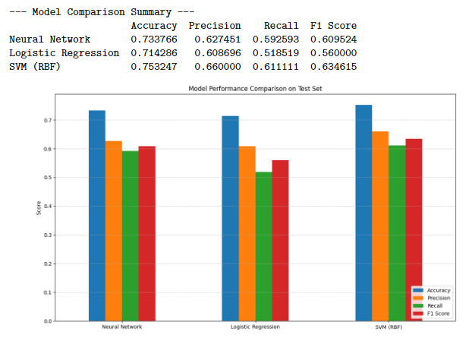
We can see from this graph, that is also in the notebook, that the SVM with RBF kernel performed the best on the diabetes dataset on average, with the neural network (a Multilayer Perceptron) being a relatively close second. The SVM beats the other models in all 4 categories of accuracy, precision, recall, and F1 score. The Logistic Regression has the worse performance by far, with a margin between it and the neural network of at least 2%.

Problem 2:
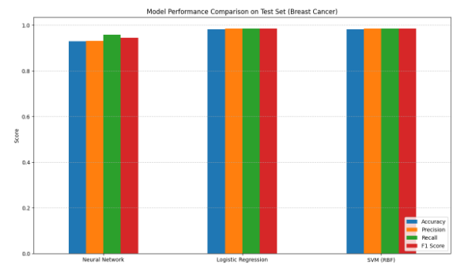
For the cancer dataset, we see that SVM still has the best performance. However, the Logistic Regression has a great resurgence, matching the top performance of the SVM across the board in all 4 categories. Finally, the neural network did technically perform the worst out of the three models, but it still produced low-mid 90% values in all of the categories, so it definitely still performed very well. The largest gap between the neural network and the other two models would be in accuracy, with a gap of ~6% and the smallest gap would be in the recall where there was a gap of only around 3%.

Problem 3:
- We see that the single-layer model did not perform well on this new image data. With a validation accuracy of 52.83%, we can see that the model really struggled to properly learn the trends and hit a wall. This is because of the step that flattens the data, which makes it incredibly hard for the model to derive any spatial information from this single dimension data.
- The results greatly improved with the added layers. The CNN finished with a validation accuracy of ~69% but peaked around 72%. From the calculations in the notebook, we can even see that the CNN takes less parameters (500,000 less!) but achieves a 20% increase in model performance. Additionally, we do see some overfitting as the model performance peaked early and then accuracy began to dip after the loss function had already converged.

