**Replication of “High Discounts and High Unemployment”**

**By: Joshua Foxworth**

**Original Paper By: Robert E Hall**

**Introduction**

The paper “High Discounts and High Unemployment” by Robert Hall (2017a) considers the model of unemployment presented by Diamond, Mortensen and Pissarides (DMP model). While the paper is a proponent of the model, it suggests that previous literature was in error. Previously, many authors suggested that the primary method by which the unemployment rate changed was via large swings in productivity changing the value of labor. However, Hall argues that this is not well supported empirically.

Productivity seems to change very little. By contrast, the discount rate seems to have larger swings and does seem to be predictive of unemployment. The discount rate in this paper refers to the rate at which investors discount future earnings to the present rate. So, when the discount rate is higher, future earnings are estimated as being smaller and vice versa.

The method by which it affects the unemployment rate is, first, the discount rate causes employers to value the future labor provided by employees less. This in turn makes them less willing to offer a wage that an employee would find acceptable and therefore the pair is less likely to reach an agreement. On the aggregate, this failure to reach labor agreements manifests as rising unemployment.

To test this, Hall constructed the DMP model and incorporated a “credible bargaining model” (CB), first presented in his 2008 paper (Hall and Milgrom, 2008), to capture how the discount rate affects the employee/employer hiring equilibrium. He then took data from Schiller (2017) on several key stock market indicators such as prices and dividends from the S&P 500 as well as measures relating to job vacancy, labor turnover and unemployment from the US Bureau of Labor and used these numbers to calculate the discount rate as well as to predict the unemployment values from 1948 – 2015 (Hall, 2017b). He found that these discount rate variables where predictive of the US unemployment rate over that period and, therefore, concluded that the discount rate is a predictive indicator.

**Motivation**

I chose this paper to replicate for several reasons. First, I wanted to improve my model building abilities and I felt that a good way to do this would be to build a deterministic model in R. With this approach, I cannot rely on pre-built tools for data analysis and therefore must learn to write my own tools in R.

In addition, the paper presents interesting models for the stock market and unemployment, which I felt would be interesting and instructive to duplicate. The DMP model is widely used to predict unemployment and so gaining familiarity in it can help me in any future work involving unemployment.

Also, the paper’s decision to use a mix of Excel templates and Matlab code (Hall, 2017b) presented an interesting challenge in duplication. To move the model into an R framework I had to dig through both excel spreadsheets and Matlab code. The excel code was especially valuable since it cannot be translated directly and required special effort.

Finally, replication is necessary for scientific work as it ensures that scientific results can be trusted and is advancing scientific knowledge. It is only through replication that we know results are valid. Therefore, the main theme of this paper is; can the original paper’s Excel and MatLab unemployment predictions be fully replicated in R?

**Methods**

To do the replication, I took data provided by the author and the American Economic Review in the paper’s supporting documents (Hall, 2017b) and began constructing the model. I started by placing each month into one of five state value buckets. These buckets are created by first finding the market tightness values (θ) as well as the stock market’s price to dividend ratio (P/D) for the years 1947-2015. The differences between these values, weighted by the inverses of their standard deviations, are computed for each year, and then each year is placed into one of the five buckets based on that value. From these buckets, it is possible to get a matrix of probabilities for moving from one state to the next (**π**), which can be seen in table 1.

|  |  |  |  |  |  |  |
| --- | --- | --- | --- | --- | --- | --- |
|  |  | To State | | | | |
|  |  | 1 | 2 | 3 | 4 | 5 |
| From State | 1 | 0.907 | 0.093 | 0 | 0 | 0 |
| 2 | 0.093 | 0.815 | 0.093 | 0 | 0 |
| 3 | 0 | 0.093 | 0.820 | 0.087 | 0 |
| 4 | 0 | 0 | 0.087 | 0.839 | 0.075 |
| 5 | 0 | 0 | 0 | 0.080 | 0.920 |

Table 1

Here, if January 1950 is in state 1, the probability of February being state 1 again is 0.907, 2 is 0.093, 3 is 0, and so forth. The main intuition to take away is that it is most likely that state values stay constant from month to month, with a small proportion of them moving one state up or down, and no chance of leaping two or more states away.

Using the transition matrix (πs,s’), I was also able to find the average productivity growth (gs,s’), the stock market return ratio (Rs,s’), and the average market tightness for each month’s state(θ). These factors are then taken as starting values for the fsolve function, which then iteratively solves for the author’s stock market model (Hall, 2017, equations 4 and 15) to solve for the state discount factors (ms,ms’) and the average discount factor (β):

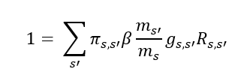

Once all the starting variables had been solved for, the unemployment rate can be computed. However, the author solves the credible bargaining model which alters the market tightness values. Hall then uses the credible bargaining theta values (table 2) to compute the unemployment values using the given parameters (table 3) and the following formula.

|  |  |
| --- | --- |
| State | Theta Value |
| 1 | 0.353 |
| 2 | 0.438 |
| 3 | 0.592 |
| 4 | 0.802 |
| 5 | 0.982 |

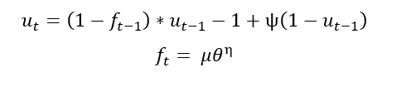

|  |  |
| --- | --- |
| Given Parameters | |
| $$ψ=0.034511$$ | Monthly job separation rate |
| $$μ=0.7705$$ | Matching efficiency parameter |
| $$η=0.5$$ | Elasticity of the matching function |
| $$u_{1}=3.4$$ | Starting value for unemployment |

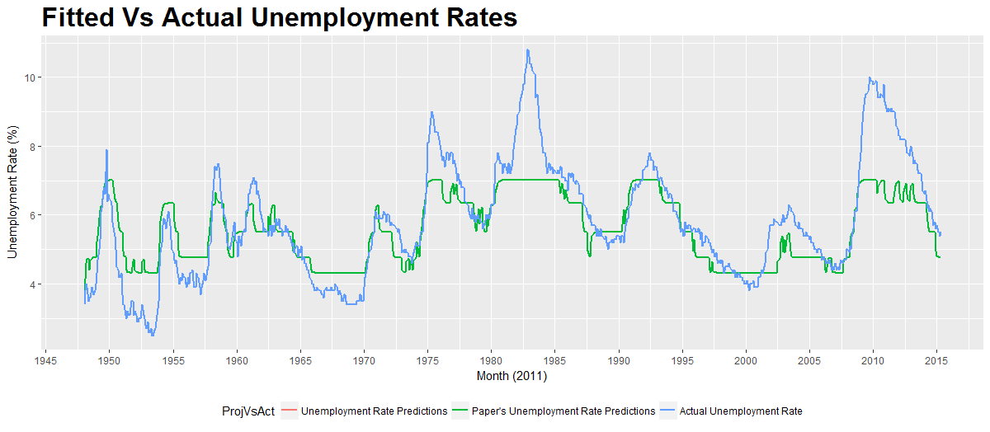

Figure 1

Table 2

Table 3

**Results**

Figure 1 is a replication of the graph in the original paper. Fitted on it are lines representing the actual unemployment rate (blue), the original unemployment predictions provided by the paper (green), as well as the replication results (orange). The replication results are almost entirely covered by the original results, indicating a successful replication.

|  |  |  |  |  |  |  |  |
| --- | --- | --- | --- | --- | --- | --- | --- |
|  | Min | 1st Quantile | Mean | Median | 3rd Quantile | Max | Variance |
| Replicated | 3.4 | 4.763 | 5.500 | 5.577 | 6.363 | 7.012 | 0.9548 |
| Original | 3.4 | 4.763 | 5.500  Table 4 | 5.577 | 6.363 | 7.013 | 0.9549 |

The summary statistics for the two data sets can be seen in table 4 above. In addition, the squared difference between the two data sets is 1.78x10-5 with a square root of 4.22x10-3.

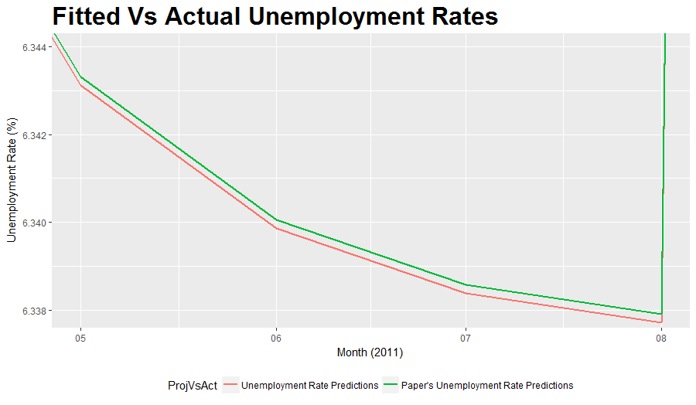

Figure 2

**Discrepancies**

Despite the paper being deterministic, some discrepancies exist. This can be seen in figure 2, a zoomed in graph of May-August 2011. The main source of these discrepancies is the ways the statistical software implements certain formulas. The clearest example of this is the way that the fsolve function is implemented. The systems of equations were not computed by hand, but rather with the help of fsolve from the R package pracma (Borchers, 2017). This function replicates Matlab’s fsolve by using the Gauss-Newton method for finding a minimum as well. This method was chosen because it is designed to mimic the function present in Matlab, used by the original author. As the goal of this paper is to provide a faithful replication, it seems reasonable to use a function as close to the original as possible to minimize error that might arise from using a different algorithm. Although the two functions are based on the same algorithm, they are implemented differently enough to add the small differences seen between the replication and the original paper.

**Differing Tightness Values**

As stated, the author finds two separate values for tightness. The first half of the paper uses values found through calculating it from stock market values. However, once certain variables are computed, theta is used as a variable itself in the credible bargaining model (CB), which is then solved for. The CB values are similar, but not identical, to the initial values, as can be seen in table 5. The unemployment rates predicted by each set of theta values can be seen in figure 3.

|  |  |  |
| --- | --- | --- |
| State | CB θ | Initial θ |
| 1 | 0.353 | 0.376 |
| 2 | 0.438 | 0.483 |
| 3 | 0.592 | 0.592 |
| 4 | 0.802 | 0.688 |
| 5 | 0.982 | 1.006 |

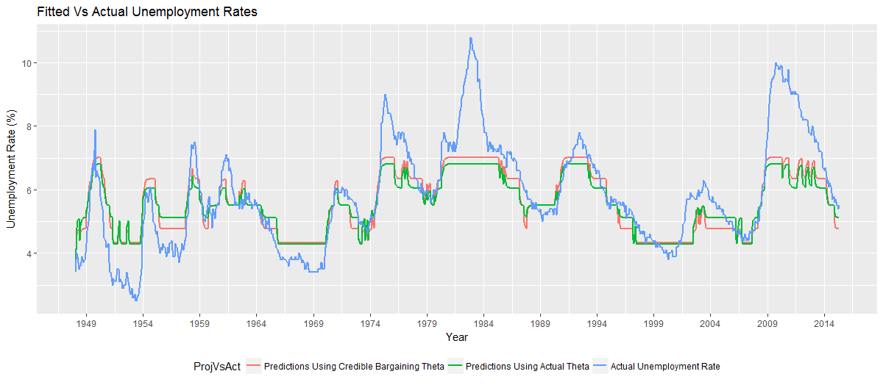

Figure 3

Table 5

The differences between each theta’s predictions and the actual unemployment rate are computed and the summary statistics shown in table 6 below.

|  |  |  |  |  |  |  |  |  |  |
| --- | --- | --- | --- | --- | --- | --- | --- | --- | --- |
|  | Min | 1st Quartile | Median | Mean | 3rd Quartile | Max | Variance | Sum of squares | Square Root |
| CB θ | -1.87 | -0.32 | 0.18 | 0.25 | 0.66 | 3.79 | 0.90 | 777.64 | 27.89 |
| Initial θ | -2.04 | -0.30 | 0.18 | 0.29 | 0.70 | 4.00 | 1.04 | 908.75 | 30.152 |

Table 6

**Conclusion**

Using the provided data (Hall, 2017b), the paper’s results are replicable. The small differences between the replication and the original is a result of the differences in the implementation of the two statistical software packages and does not have a significant effect on the predictions made by the model. The paper’s conclusion that the discount rate is the largest driver of unemployment seems to be credible.

Reference List

1. Borchers, Hans Werner. 2017. “pracma: Practical Numerical Math Functions”. R package version 2.0.4. URL: https://CRAN.R-project.org/package=pracma
2. Hall, Robert E. 2017. "High Discounts and High Unemployment." *American Economic Review*, 107(2): 305-30
3. Hall, Robert E.2017. “High Discounts and High Unemployment: Datasets.” *American Economic Review.* Accessed: 04/2017 URL: https://doi.org/10.1257/aer.20141297.
4. Hall, Robert E., and Paul R. Milgrom. 2008. “The Limited Influence of Unemployment on the Wage Bargain.” *American Economic Review* 98 (4): 1653–74.
5. R Core Team. 2017. “R: A language and environment for statistical computing”. R Foundation for Statistical Computing. Vienna, Austria. URL: https://www.R-project.org/.
6. Shiller, Robert J. 2017. “Stock Market Data Used in ‘Irrational Exuberance" *Princeton University Press*, 2000, 2005, 2015, updated. Accessed: 04/2017 URL: http://www.econ.yale.edu/~shiller/data/ie_data.xls
7. Wickham, H. 2009. “ggplot2: Elegant Graphics for Data Analysis.” Springer-Verlag. New York, United States.