Android 8.0 Bluetooth
framework learning

Table of Contents
1 Introduction 3
1.1 Purpose 3
1.2 Scope 3
2 Acronums & Abbreviations 3
3 References 3
4 Revision History 3

Introduction

Purpose
Android 8.0 BT framework learning notes.

Scope
N/A.

Bluetooth
Android provides a default Bluetooth stack that supports both Classic Bluetooth and Bluetooth Low Energy. Using Bluetooth, Android devices can create personal area networks to send and receive data with nearby Bluetooth devices.
In Android 4.3 and later, the Android Bluetooth stack provides the ability to implement Bluetooth Low Energy (BLE). To fully leverage the BLE APIs, follow the Android Bluetooth HCI Requirements. Android devices with a qualified chipset can implement either Classic Bluetooth or both Classic Bluetooth and BLE. BLE is not backwards compatible with older Bluetooth chipsets.
In Android 8.0, the native Bluetooth stack is fully qualified for Bluetooth 5. To use available Bluetooth 5 features, the device needs to have a Bluetooth 5 qualified chipset.
Note: The largest change in the native Bluetooth stack between Android 8.0 and previous versions is the use of Treble. Vendor implementations in Android 8.0 must use HIDL instead of libbt-vendor.

Android 8.0 architecture
A Bluetooth application communicates with the Bluetooth process through Binder. The Bluetooth process uses JNI to communicate with the Bluetooth stack and provides developers with access to various Bluetooth profiles. This diagram shows the general structure of the Bluetooth stack:
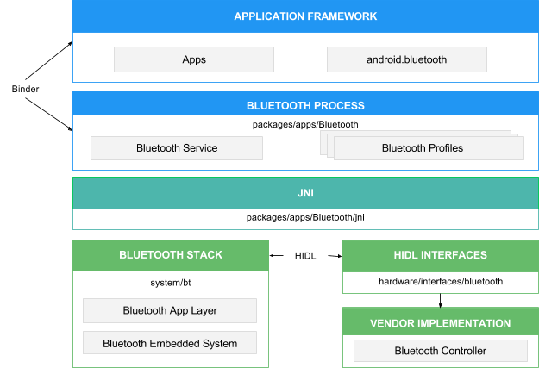Figure 1. Android 8.0 Bluetooth architecture
Application framework
/framework/base/core/java/android/bluetooth
At the application framework level is application code, which uses the android.bluetooth APIs to interact with the Bluetooth hardware. Internally, this code calls the Bluetooth process through the Binder IPC mechanism.
Bluetooth system service
The Bluetooth system service, located in packages/apps/Bluetooth, is packaged as an Android app and implements the Bluetooth services and profiles at the Android framework layer. This app calls into the native Bluetooth stack via JNI.
JNI
The JNI code associated with android.bluetooth is located in packages/apps/Bluetooth/jni. The JNI code calls into the Bluetooth stack when certain Bluetooth operations occur, such as when devices are discovered.
Bluetooth stack
The default Bluetooth stack is provided in AOSP and is located in system/bt. The stack implements the generic Bluetooth HAL and customizes it with extensions and configuration changes.
Vendor implementation
Vendor devices interact with the Bluetooth stack using the Hardware Interface Design Language (HIDL).

HIDL
HIDL defines the interface between the Bluetooth stack and the vendor implementation. To generate the Bluetooth HIDL files, pass the Bluetooth interface files into the HIDL generation tool. The interface files are located in hardware/interfaces/bluetooth.

Bluetooth stack development
The Android 8.0 Bluetooth stack is a fully qualified Bluetooth stack. The qualification listing is on the Bluetooth SIG website under QDID 97584.
The core Bluetooth stack resides in system/bt. Development happens in AOSP, and contributions are welcome.

Android 7.x and earlier architecture
A Bluetooth system service communicates with the Bluetooth stack through JNI and with applications through Binder IPC. The system service provides developers with access to various Bluetooth profiles. This diagram shows the general structure of the Bluetooth stack:
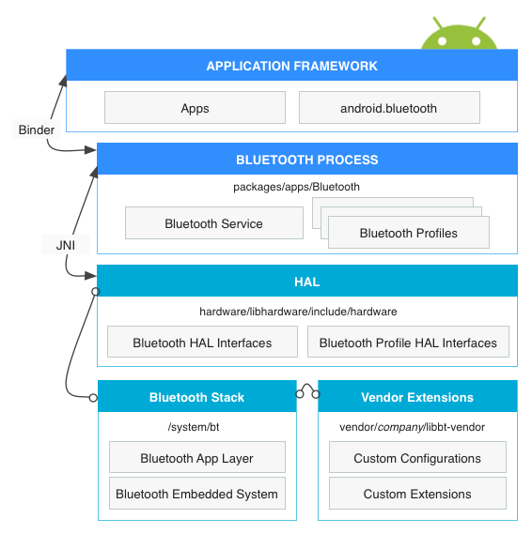Figure 2. Android 7.x and earlier Bluetooth architecture
Application framework
At the application framework level is application code, which utilizes the android.bluetoothAPIs to interact with the Bluetooth hardware. Internally, this code calls the Bluetooth process through the Binder IPC mechanism.
Bluetooth system service
The Bluetooth system service, located in packages/apps/Bluetooth, is packaged as an Android app and implements the Bluetooth service and profiles at the Android framework layer. This app calls into the HAL layer via JNI.
JNI
The JNI code associated with android.bluetooth is located inpackages/apps/Bluetooth/jni. The JNI code calls into the HAL layer and receives callbacks from the HAL when certain Bluetooth operations occur, such as when devices are discovered.
HAL
The hardware abstraction layer defines the standard interface that the android.bluetooth APIs and Bluetooth process call into and that you must implement to have your Bluetooth hardware function correctly. The header file for the Bluetooth HAL is hardware/libhardware/include/hardware/bluetooth.h. Additionally, review all of thehardware/libhardware/include/hardware/bt_*.h files.
Bluetooth stack
The default Bluetooth stack is provided for you and is located in system/bt. The stack implements the generic Bluetooth HAL and customizes it with extensions and configuration changes.
Vendor extensions
To add custom extensions and an HCI layer for tracing, you can create a libbt-vendor module and specify these components.

Implementing the HAL
The Bluetooth HAL is located in /hardware/libhardware/include/hardware/bluetooth.h. The bluetooth.h file contains the basic interface for the Bluetooth stack, and you must implement its functions.
Profile-specific files are located in the same directory. For details, see the HAL File Reference.

Bluedroid架构简介
https://segmentfault.com/a/1190000002982295
Bluedroid总框架图如下所示：
https://www.jianshu.com/p/a51b69669a07

BTIF —> BTA —-> BTM —–> BTU —–> HCI

Java
+--------------------------------+
+-----------------+ C++/C
| BTIF |
+-----------------+
| BTA |
+-----------------+
| Bluedroid Stack |
+-----------------+ user space
+---------------------------------+
kernel space
下面对各个部分进行简介。

Java Application/JNI
Bluetooth app运行于Java层，并通过JNI和协议栈的接口（stack’s Interface Layer，BTIF）进行如下交互：
- JNI层的作用是将Java调用转化为C函数的调用，同时为应用和协议栈提供了调用/回调的交互能力。

BTIF (Bluetooth Profile Interface)
Bluetooth Profile Interface在Bluetooth Application task (BTA)和JNI层之间充当了胶水层的角色，对上层（JNI）提供了所有profile功能性的接口。这一层上有一个Bluetooth Interface Instance，所有Profile的操作函数都注册在其中（GAP, AV, DM, PAN, HF,HH, HL, Storage, Sockets）。Client应用通过操作这个Instance来操作Profile。

BTA
这一层实现了各种Profile状态机。用户通过驱动状态机来操作Profile。
Profile状态机包含以下几个主要组成部分：
- BTA_profilexx_act.c => 包含对应Profile的“Action”函数，一般来说由Profile状态机调用。
- BTA_profilexx_api.c => 对应Profile的API的具体实现。通常它们是提供给用户使用，完成usecase的函数和回调
- BTA_profilexx_ci.c => 对应Profile的“call-in”函数的实现（供Profile以外的模块调用）
- BTA_profilexx_co.c => 对应Profile的“call-out”函数的实现（调用Profile以外的模块）
- BTA_profilexx_main.c => 对应Profile的状态机和处理协议栈上传消息的handler的具体实现。主要负责维护Profile状态的变化及其引起的“Action”
例如，调用“BTA_profilexx_act.c”中的API函数时，各部分的执行流程图如下所示：
seq2 +---------------------+ seq3 +-----------------------+
+----> BTA_Profilexx_API.c <----------> BTA's SYS Msg Posting |
| +----------^----------+ +-----------^-----------+
| | |
| |seq7 | seq4
| | |
+--------------+ seq1 +------------------+ | +----------v-----------+ seq5 +-----------v-------+
| User Command <---------> BTIF_Exposed_API +----+----> BTA_Profilexx_Main.c <---------> OS Message Posted |
+--------------+ seq9 +------------------+ seq8 +----------^-----------+ +-------------------+
|
|seq6
|
+----------v---------+
| BTA_Profilexx.Ci.c |
+--------------------+

Core Stack
核心协议栈（Core Stack）会被编译成一个linux动态库，其中包含的模块如下图所示。每一个模块都由api函数和函数回调接口组成。
+------------------------------------------+
| +--------------------+ |
| | LIBBT_BRCM_Stack | |
| +--------------------+ |
| +---------+ +-----+ +------+ +-----+ |
| | | |A2DP | |AVCTP | |AVDTP| |
| | | +-----+ +------+ +-----+ |
| | | +-----+ +------+ +-----+ |
| | | |BNEP | | PAN | |HID | |
| | BT | +-----+ +------+ +-----+ |
| | Manager | +-----+ +------+ +-----+ |
| | | |L2CAP| |RFCOMM| |SDP | |
| | | +-----+ +------+ +-----+ |
| | | +-----+ +------+ +-----+ |
| | | |MCAP | |SMP | |GATT | |
| +---------+ +-----+ +------+ +-----+ |
| +------------------------+ |
| | Host Control Interface | |
| +------------------------+ |
+------------------------------------------+

HCI and HAL Layers
HCI层由libbt-hci共享库组成，负责通讯层（transport layer，如UART H4或者SMD channel）和协议栈之间的交互。
HAL层libbt-vendor共享库组成，是各厂商的解决方案的特定实现。HAL层实现了各厂商对OPCODE的处理逻辑，这些OPCODE声明在HCI层的bt_vendor_lib.h中。

TASK管理
Bluedroid中，协议栈，蓝牙规范和蓝牙应用都运行在一个用户进程"com.android.bluetooth"之中。
蓝牙代码在以下四种task代表的上下文（context）中运行：
* BTIF_TASK
* BTU_TASK
* A2DP_MEDIA_TASK
* GKI_TIMER_TASK
task之间通过消息（message）来交换信息。
调用JNI层的API函数会通过消息转发机制，在BTIF_TASK中执行。
JNI，HAL回调在BTIF_TASK中执行。
有需要时，BTIF_TASK中的调用可切换到BTU_TASK中执行。
蓝牙规范（Profiles）和协议的实现代码在BTU_TASK中执行。
蓝牙传输驱动程序中有一条rx线程（bt_hc_worker_thread）负责从UART/SMD中读取数据。

HFP

HFP architecture
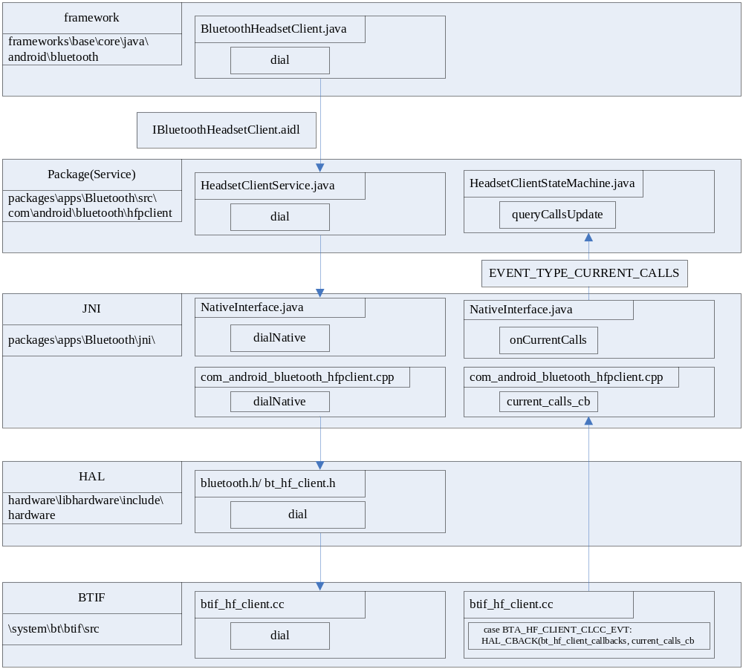

This is HFP process upon BT stack(BTIF), it contains the source file path.
From top layer to bottom layer, the sample command is dial. From bottom layer to top layer, the sample notification is call status(CLCC).

General knowledge

AIDL

Reference
https://github.com/SpikeKing/wcl-aidl-demo, demo code.
https://developer.android.google.cn/guide/components/aidl
《Android开发艺术探索.pdf》，作者：任玉刚

待研究
JNI
反射机制
StateMatchine
初始化流程
Bt stack底层流程
IPC通信

该博客分析了bluedroid中的线程代码：
https://blog.csdn.net/zcc450959507/article/details/79402406

https://blog.csdn.net/zcc450959507/article/details/79402406

Acronums & Abbreviations
HAL ：HardwareAbstraction Layer

Btif ：Bluetoothinterface

Bta ：Bluetoothapplication

Btu ：Bluetoothuper layer

Bte ：Bluetoothembedded layer

Btm ：Bluetooth devicemanager

CO ： callout\CI: call in

HF ： HandsfreeProfile

HH ：HID HostProfile

HL ：HealthDevice Profile

AV ：audio\vidio

Ag ：audiogateway

Ar ：audio/videoregistration

Gattc ：GATT client

Gatts ：GATT server

BLE ：Bluetooth Low Energy

References
https://developer.android.google.cn/guide/topics/connectivity/bluetooth, Android 8.0 Bluetooth APIs introduction.
https://source.android.google.cn/devices/bluetooth, Android 8.0 Bluetooth architecture.

Revision History

Rev Level | Date | Updated by | Section/  Page | Description
1.00 | 2019.7.9 | Fjiang2 | all | Init draft.
1.01 | 2019.7.11 | Fjiang2 | 3 | Add section 3 HFP

