**Morro Bay Yacht Club Testing Report**

Jakob Frabosilio, Student Assistant  
Cal Poly SLO Mechanical Engineering Department  
11/4/2024

**Summary**

The radar unit was tested at the Morro Bay Yacht Club on 10/27. The results show that small waves (1-2Hz, 2-10cm peak-to-peak) can be accurately measured on still water given proper configuration of the radar; Figure 0 shows a highlight of the test results. Additionally, the water level height decreasing with the tide was clear over the course of data collection; tide data can be accurately measured with the radar unit in its present form.

The testing was critical for finding optimal settings for the radar unit configuration and for identifying bugs in the firmware implementation. Future testing is planned at the Monterey Bay Aquarium Research Institute (MBARI) in Moss Landing from Nov. 15-17th (King Tides event) to test the long-term data collection of the radar unit.

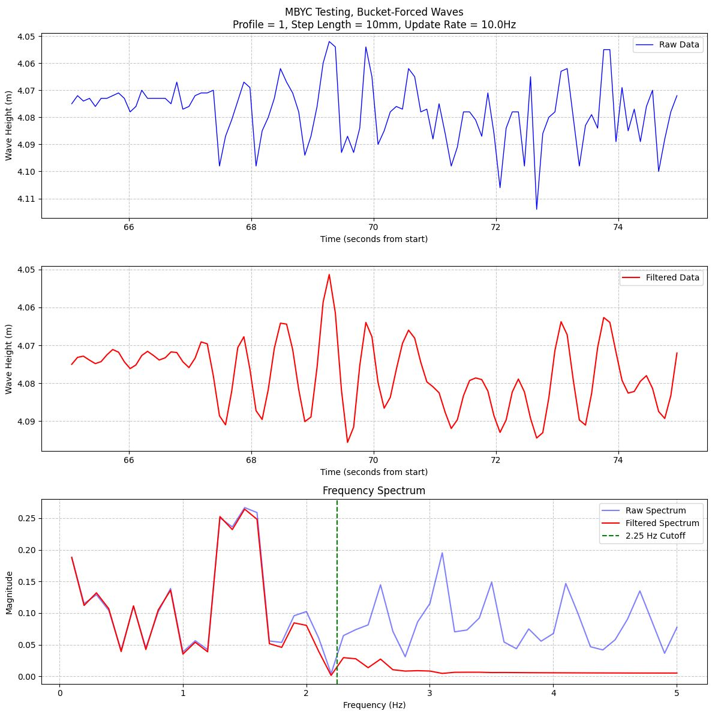

Figure 0. Best results from MBYC testing; profile = 1, update rate = 10Hz

**Introduction**

On Sunday, October 27th, the low-cost water level gauge (“radar unit”) was tested at the Morro Bay Yacht Club with Dr. John Ridgely and Dr. Serena Lee. The purpose of the testing was to determine if small, rapid displacements in the water could be detected by the radar unit from a considerable distance away.

The radar unit was attached to an elevated dock approximately 4m above the surface of the water, sticking out approximately 50cm from the edge of the dock. The unit was powered using a 25W solar panel and a 5V solar power battery bank to ensure no power loss. The final implementation will use a solar panel with considerably less wattage – this panel was used for convenience. See Figure 1 for an image of the radar unit in its testing position.

Due to the still nature of the water below the dock (inside of a harbor on a windless day, protected from external waves by a floating dock), a bucket was attached to the end of a rope and was used to create controlled waves. The bucket was partially filled with water and was hoisted up and down repeatedly at a regular interval to create waves of a relatively known amplitude and frequency (roughly 2-10cm peak-to-peak amplitude and 1-2Hz frequency). See Figure 2 for an image of the bucket in the test environment. Note that some of the waves created by the bucket can be seen in the background of the image.

Figure 1. Radar unit suspended over the water surface, attached to the deck of the Morro Bay Yacht Club

Figure 2. Bucket and rope in foreground, used for controlling waves, with radar unit and waves in the background

**Test Plan and Procedure**

After an initial set-up and calibration period to ensure good measurements, a series of tests were performed to determine the optimal radar configuration settings. Three different settings were varied throughout the testing:

* Maximum Profile (1, 3, 5)
  + Determines the duration and shape of the radar burst. A higher profile setting (5) increases the signal-to-noise ratio but decreases the maximum update rate.
  + Additionally, higher profile settings can make it difficult to distinguish between multiple objects in a scene, as seen in Figure 3.
* Maximum Step Length (5mm, 10mm, 15mm)
  + Determines the maximum distance between radar measurements. A lower maximum step length results in more measurements taken for a given measurement range, increasing the power consumption and decreasing the update rate, but returning more accurate measurements for small displacements.
  + The radar works by sending out pulses and measuring the return in discrete intervals. If the start range of the radar is set to 1m and the end range is set to 2m, the step length determines how that range is subdivided. For a max step length of 100mm, the radar would test the return strength at 1m, 1.1m, 1.2m, etc. until it hits 2m.
  + The radar unit uses phase data to interpolate between these measurements. If an object is located at 1.05m, the radar unit can still detect it using a step length of 100mm, despite the object not appearing directly at a measured distance.
* Update Rate (5Hz, 10Hz)
  + Determines how often measurements are taken. Limited by other configuration settings (profile, step length, measurement range), and increases power draw as it rises.
  + Higher update rates are required to measure waves with higher frequencies. To measure waves with a frequency of 2Hz, a minimum 4Hz update rate is required. Generally, higher frequencies produce cleaner data in this application.

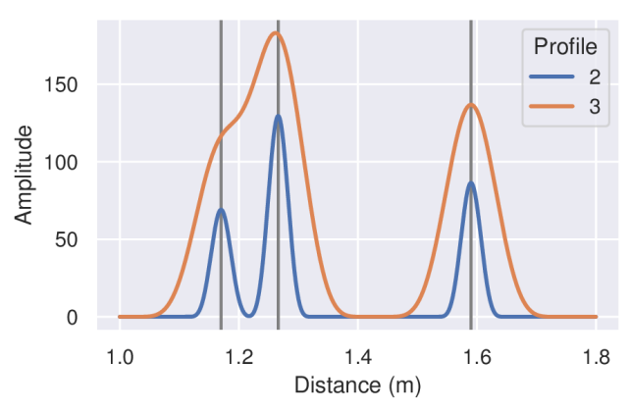

Figure 3. Mock data for different maximum profile settings, three objects in measurement range; Profile=2 captures all three objects, while Profile=3 incorrectly combines the first and second object

Note that there are other configuration settings beyond these three for the radar unit; these three are simply the most important to tune for this application, especially given the power consumption requirements.

A total of 12 tests were conducted using combinations of the above settings. The table below summarizes the configuration for each test, as well as its start time.

|  |  |  |  |  |
| --- | --- | --- | --- | --- |
| Test Number | Start Time (PDT) | Max Profile | Max Step Length | Update Rate |
| 1 | 12:57pm | 3 | 5mm | 5Hz |
| 2 | 1:00pm | 5 | 5mm | 5Hz |
| 3 | 1:04pm | 1 | 5mm | 5Hz |
| 4 | 1:09pm | 3 | 10mm | 5Hz |
| 5 | 1:12pm | 5 | 10mm | 5Hz |
| 6 | 1:16pm | 1 | 10mm | 5Hz |
| 7 | 1:22pm | 3 | 15mm | 5Hz |
| 8 | 1:27pm | 5 | 15mm | 5Hz |
| 9 | 1:31pm | 1 | 15mm | 5Hz |
| 10 | 1:38pm | 5 | 10mm | 10Hz |
| 11 | 1:45pm | 1 | 10mm | 10Hz |
| 12 | 1:49pm | 3 | 10mm | 10Hz |

For each test, the following procedure was carried out:

* Place the bucket in the water approximately 3m from the center of the radar unit, measured horizontally
* Wait until the water below the sensor is still before beginning the test
* After starting data collection, wait approximately 10-20 seconds to collect still water readings (no waves, minimal noise; flat surface)
* Raise and lower the bucket approximately 20cm (peak-to-peak) using the rope at a rate of 1-2Hz for approximately 20 seconds
* Wait for the water to settle, approximately 20 seconds
* Raise and lower the bucket as before, but with a greater amplitude (and more splashing / noise)
* Continue collecting data for 20 seconds after the second round of bucket hoisting

Figure 4 shows the results of an average test as measured by the radar unit. Note that the y-axis is flipped; the radar unit currently measures the distance from the unit’s lens to the surface of the water, so a wave with positive displacement (or a rising tide) means that the measured distance decreases. In the future, the elevation data of the radar unit will be incorporated to convert the relative-distance measurements into absolute height measurements (relative to average sea level).

Figure 4. Test 6 full results from radar unit

**Results and Analysis**

All tests produced similar results for the first portion of the procedure (measuring only the still water) – the average noise in these readings is around 1cm peak-to-peak for all tests. Figure 5 shows the first five seconds of data collection for three different tests. The profile, step length, and update rate have little-to-no effect on the noise floor for still water.

To determine which settings are most “optimal” or “accurate” is difficult, given that the true wave amplitude and frequency were only estimated visually. However, a few key items are known that will aid in analysis:

* The true wave frequency (waves created by the bucket hoisting up and down) is between 1-2Hz; if the primary frequencies in the radar data are between these values, then the wave is likely being recorded properly.
* The true wave amplitude is roughly between 2-10cm peak-to-peak; if the amplitude of the measured waves is significantly higher than this range, then there is likely significant noise in the measurements.

The maximum profile appears to have a large impact on the quality of the measurements. Figure 6 shows a comparison between profile settings of 1, 3, and 5; as the profile increases, the noise during these wave measurements increases dramatically. Note that the profile=5 test measured wave amplitudes much higher than 10cm peak-to-peak.

Additionally, a frequency analysis of these tests shows that the true wave frequency (between 1-2Hz) is much more prevalent in the profile=1 test than the profile=5 test; see Figures 7 and 8 respectively for these tests. Given these results (and the fact that higher profiles increase the power consumption and lower the maximum update rate significantly), it is recommended that the profile be set as low as possible.

The step length did not appear to have a large impact on the accuracy of the results. Figure 9 shows a comparison of three different step length settings with profile = 1. The wave amplitudes and frequency components are comparable for the three tests. Future testing, with a way to verify the true height of the waves, is required to determine optimal settings for the step length. At present, it is recommended that the step length be set as high as possible to decrease power consumption and increase the maximum update rate.

The update rate has a large impact on the quality of the results, given the wave frequency of 1-2Hz. An update rate of 5Hz was slightly low to cleanly capture the waves created by the bucket; increasing the rate to 10Hz yielded much better results. Compare Figures 10 and 11; the higher update rate (combined with a low-pass filter to remove high-frequency noise components) produced very clear measurements of the bucket-forced waves. It is recommended to set the update rate as high as possible to accurately capture the profile of high-frequency waves. 10Hz appears to be a good compromise between power consumption and accuracy.

All testing was conducted over the course of an hour; on the day of testing, the high tide was around 9am and low tide was around 2pm. The estimated water level drop across the testing period, using tide data from tide-forecast.com, was approximately 0.12m. Figure 12 shows all of the testing data concatenated, with the tide drop clearly present.

The lack of a smooth line is due to the changing configuration of the radar for each test; changing the measurement profile affects the “average” readings of the water level. For the highest profile (Tests 2, 5, 8, and 10), the average water level measured was slightly higher than adjacent tests. With higher profiles, more energy is sent in the radar burst; it is assumed that these higher energy levels reflect off the surface of the water earlier (with lower profile bursts penetrating the water slightly more). The tide data can be easily measured using any settings of the radar unit, but the profile slightly affects the average water height reading. Further testing and improved implementation are required to accurately characterize this behavior.

Figure 5. First five seconds of data collection for Tests 3, 5, and 7 (only varying profile)

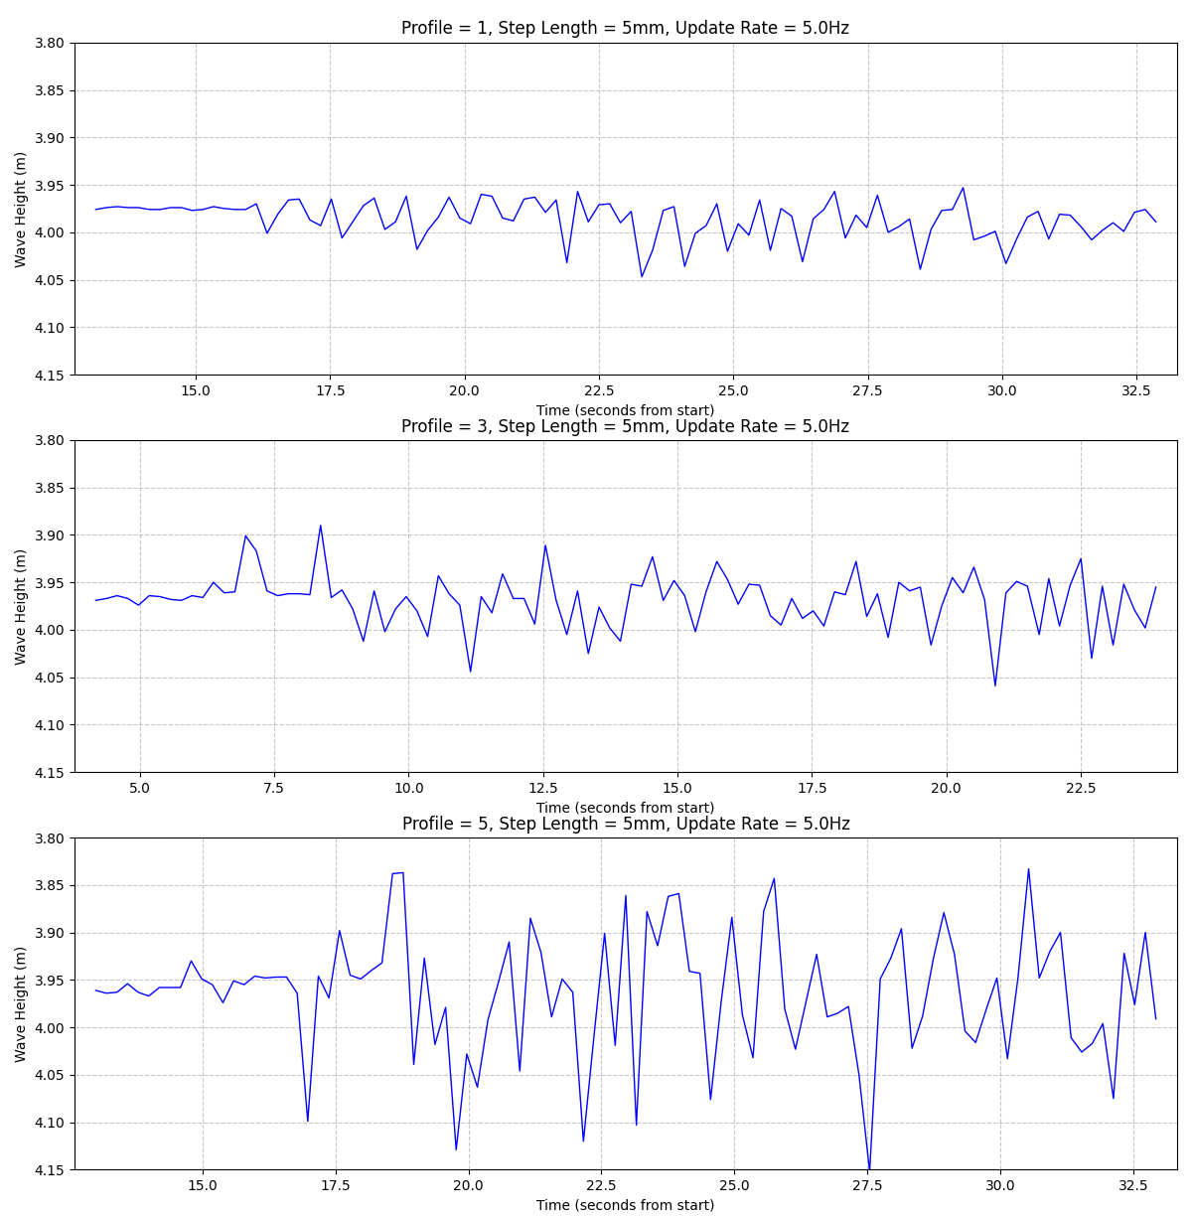

Figure 6. First bucket-hoisting portion of Tests 3, 1, and 2 (only varying profile); larger profiles resulted in much higher noise and less accurate measurements

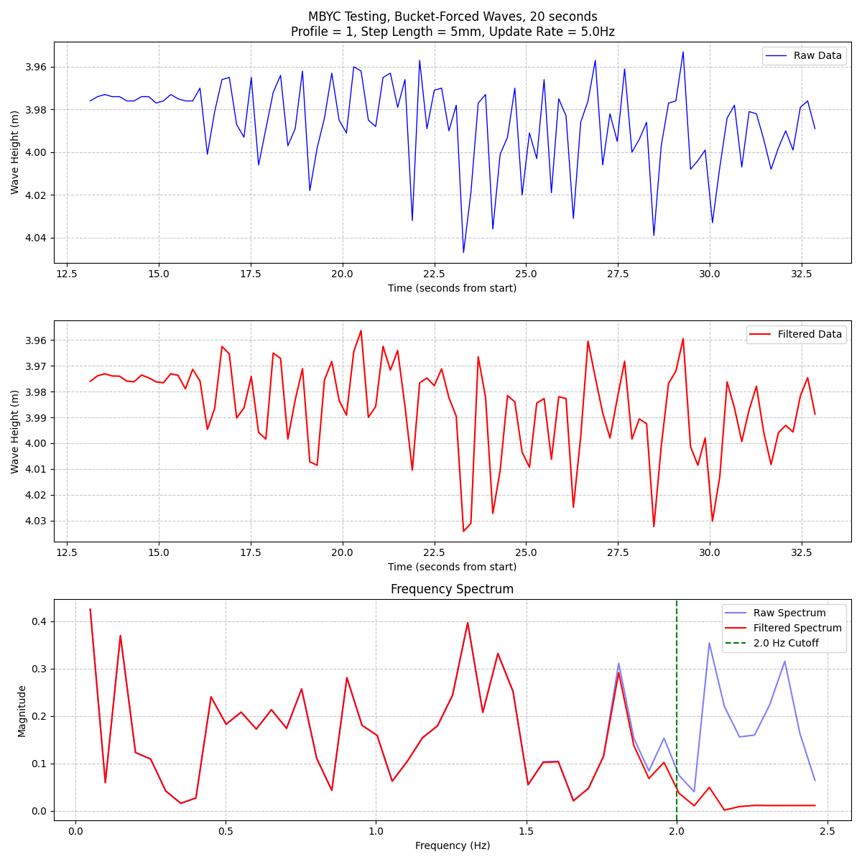

Figure 7. Frequency analysis of portion of Test 3 (profile = 1); large spikes between 1-2Hz showing that the waves were accurately recorded

Figure 8. Frequency analysis of Test 2 (profile = 5); much less significant spikes between 1-2Hz, showing that the waves were not recorded as accurately as the profile=1 test

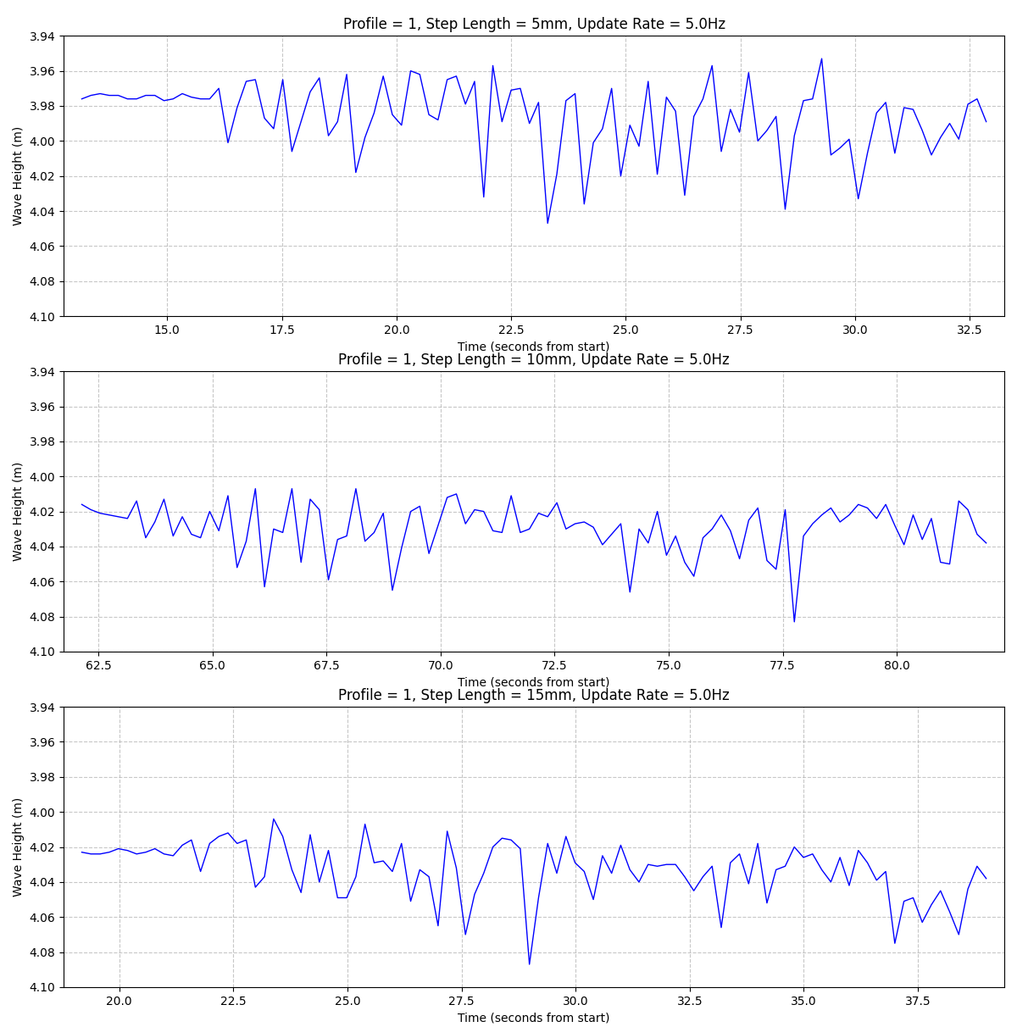

Figure 9. First bucket-hoisting portion of Tests 3, 6, and 9 (only varying step length); little difference between test results

Figure 10. Portion of Test 6 (5Hz update rate), waves visible but with lower temporal resolution

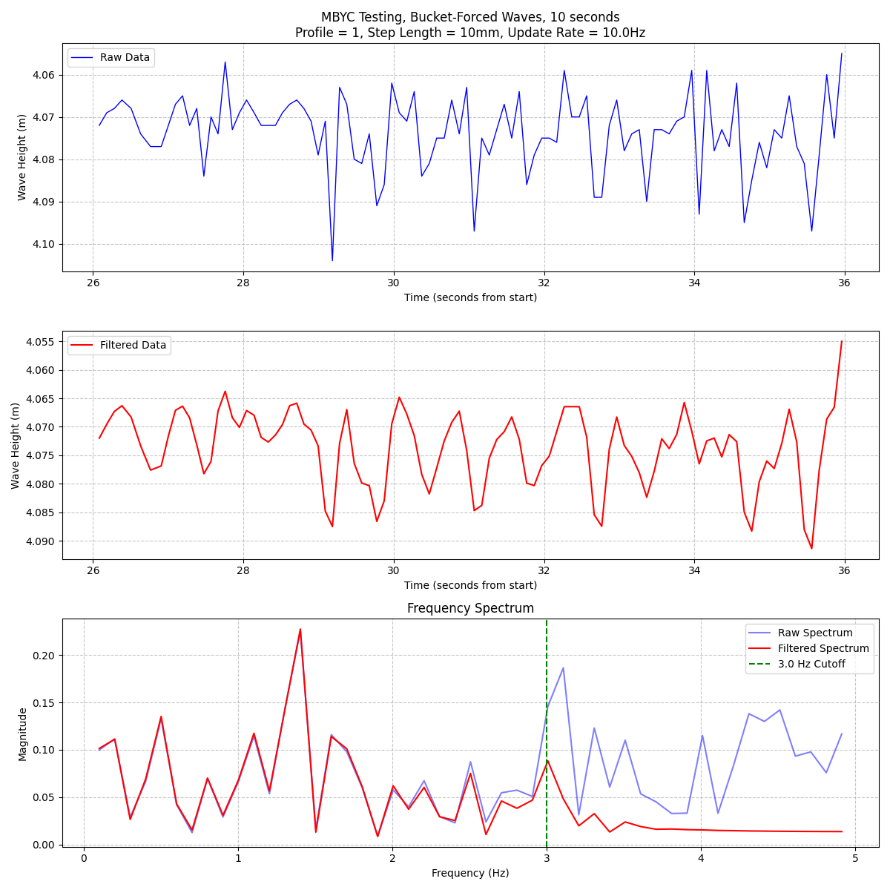

Figure 11. Portion of Test 11 (10Hz update rate); waves visible, with low-pass-filtered data giving much higher temporal resolution

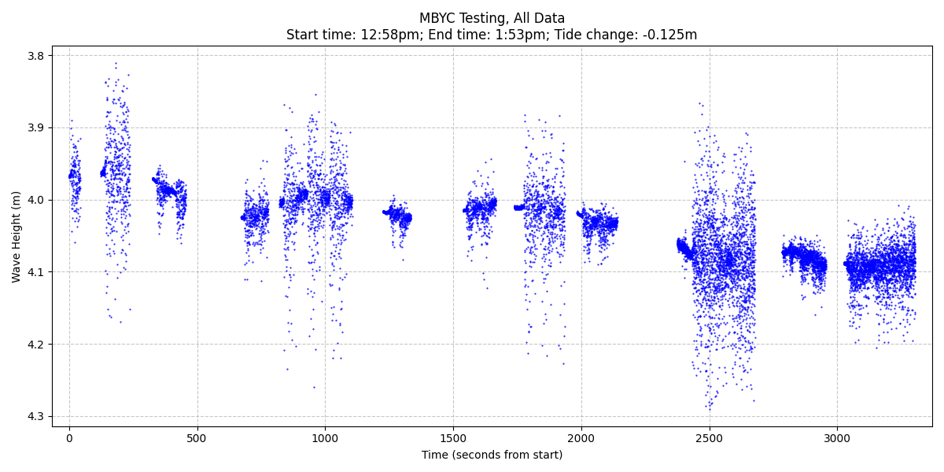

Figure 12. All test data collected at the MBYC, concatenated, measured from initial testing time

**Future Plans and Conclusion**

Performing the testing at the MBYC was critical for optimizing the settings of the radar unit and for identifying several bugs in the code (file naming issue, GPS parsing error, etc.). These bugs will be fixed before the next field test is performed.

The following features are planned to be implemented on the radar unit before the next field test:

* Measure and account for the elevation of the radar unit as measured by the GPS receiver
* Implement low-power improvements to decrease power consumption
* Rework the code to use multitasking and to improve the SD card data writing process
* Characterize the power draw from each component (ESP32, STM32/radar, GPS) to further reduce power consumption

After these features are implemented, additional features (such as automatic range setting, which will improve power consumption, maximum update rate, and ease of deployment) are planned.

Finally, contact has been made with researchers at MBARI to deploy the radar unit at their Moss Landing facility during the King Tides event on November 15-17th, 2024. I will be in the Monterey Bay area that weekend and am in the process of organizing the deployment of the radar unit to collect tide data over a (unbroken) two-day period. This testing will be a fantastic test of long-term deployment in a controlled environment. The unit will be deployed in a similar fashion to the MBYC testing, except with the unit being enclosed in a waterproof container (similar to the current sonar implementation by Dr. Lee’s students).