User Guide

**Installation Instructions for Windows and Linux:**

1. download all files (Documentation folder may be excluded)
2. Ensure Python3.6 or higher and pip3 is installed on your computer
3. Install pipenv if not already installed.
   1. open command prompt (terminal)
   2. type **pip3 install pipenv**
   3. For Windows users: A warning may appear in the console instructing you to add the path to the PATH variable. (Example path: C:\Users\J&J\AppData\Local\Programs\Python\Python38-32\Scripts) **Copy the path given and follow the instructions marked by the bullet points below:**
      * + Right-click on the "Computer", "My Computer" or "This PC" icon → select "Properties"
        + Click on "Advanced system settings" (on the left side)
        + In the "System Properties" window, click on "Environment Variables" (near the bottom)
        + In the "Environment Variables" window, search for PATH under "System Variables". Select it and click on "Edit…".
        + Click "New" and paste the previously copied path from the warning message
        + Close Command Prompt window and open a new one
4. Navigate into the FraudDetector folder file using the command line
5. Type **pipenv sync** into the command line to install the necessary dependencies and to create a virtual environment for the application.

**Using the application:**

To start the application:

* navigate into the application file python project (Example: home/(your username)/FraudDetector*)*
* Type **pipenv run python main.py** to start the application. Please note, the application will take several seconds to load the first time it is started.

The application includes a demo username and password. Additional credentials can be added to the credentials.csv file. The passwords must be encrypted with base64 before adding to the CSV file. To login using the demo credentials enter “e683gq” the Employee Id field, enter “test” into the Password field, and press the Submit button.

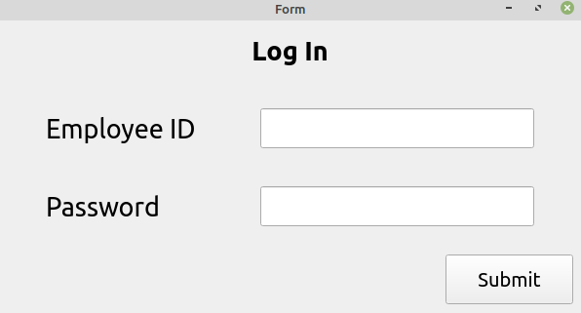

After successfully login in, you will be taken to the Dashboard tab.

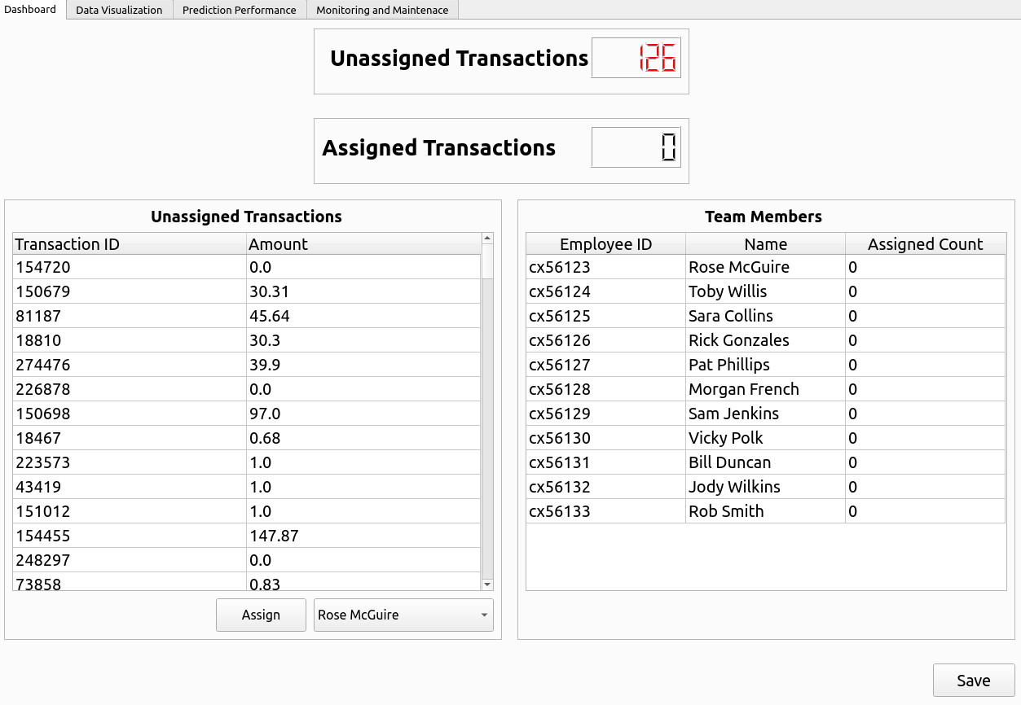

The Dashboard tab has a counter for unassigned and assigned fraudulent transactions, a table listing all unassigned transactions, and a table listing all team members a transaction can be assigned to. To assign a transaction, choose a transaction by clicking on it in the table, choose an employee from the drop-down menu below the table, and press the assign button. Please note you may assign multiple transactions to an employee if multiple transactions were chosen from the table. Once assigned the appropriate fields on the page will be updated. Press the save button if you would like to commit the assignment to persistent memory.

You can navigate to different pages inside the application by clicking on the corresponding tab at the top of the current page.

After clicking the tab title “Data Visualization”, you will be taken to the screen below.

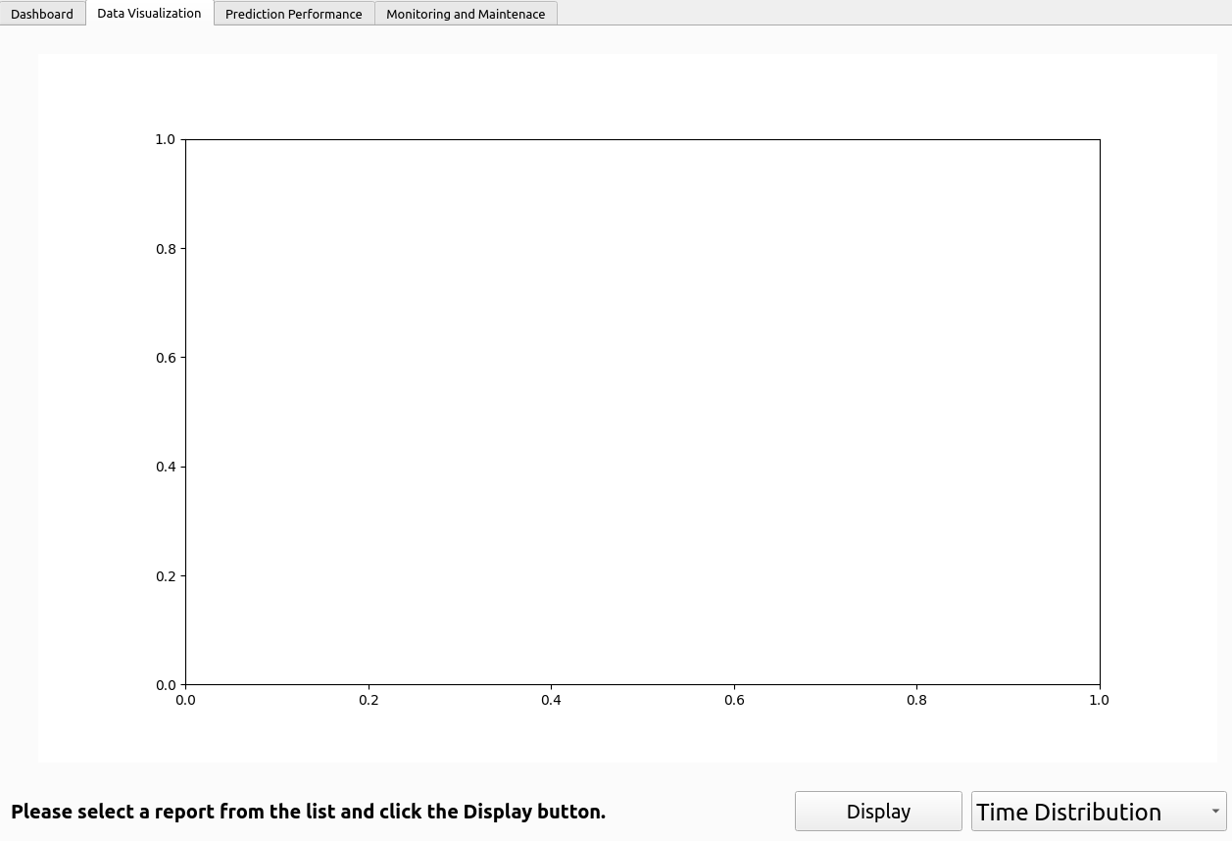

To view a graph, choose the type from the drop-down menu in the bottom right corner of the screen. Then click the Display button. The first graph may take a moment to appear since it is querying the data set and performing calculations, but subsequent graphs should display instantaneously.

After clicking the tab title "Prediction Performance", you will be taken to the following screen.

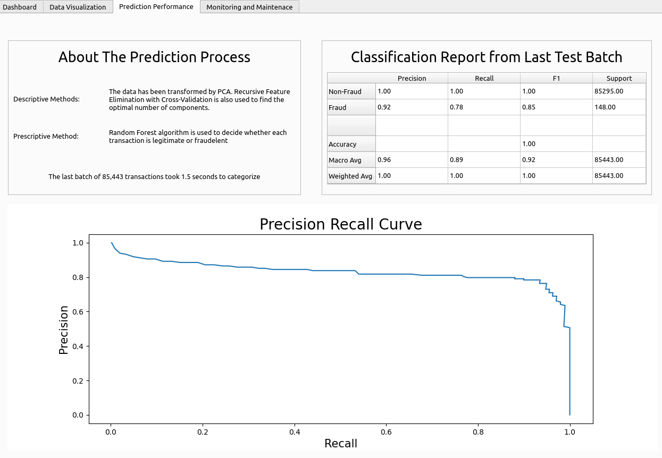

After clicking the "Monitoring and Maintenance" tab, you will be taken to the following screen. On this page, the user can report a transaction as either false positive or false negative. Once reported, the precision and recall scores in the neighboring layout box will automatically update. There are also brief instructions and contact information to IOU's fraud detection technical support help desk.

