**Group Case Study 1**

Alisa Steensen

Carmen Mendoza

Jose Franco

Usiel Figueroa

December 09, 2024

Module 11.1 Assignment:Milestone #3

CSD310 Database Development and Use

1. **Supplier Delivery Report**

**Description:** This report provides an overview of the components supplied by each supplier, the quantity of components delivered, and the reorder levels. It helps the company monitor supplier deliveries and manage inventory more effectively by identifying if certain components are approaching low stock and require restocking. As it highlights whether a component needs restocking based on its current quantity shipped and the predefined reorder level. This report aids in ensuring that the company does not face production delays due to a lack of essential supplies.

**Key Insights:**

* Expected Delivery.
* Component Type.
* Actual Delivery, helping to identify components that need restocking.
* Delivery Gap, indicating if an item is running low and needs to be reordered.

**Screenshot (Supplier Delivery Report)**

1. **Employee Work Hours Report**

**Description:** This report presents the total hours worked by each employee, categorized by their employee ID. This data helps in understanding workforce allocation, productivity, and the need for resource adjustments within departments. By comparing the number of hours worked in each department, management can identify areas where additional support may be needed or if any departments are overstaffed. It also provides insight into employee work distribution, which is important for decision-making related to compensation, promotions, or reallocating resources.

**Key Insights:**

* Employee ID.
* Last 4 Quarters.
* Total hours worked, helping identify employees with heavy workloads or underutilization.

**Screenshot (Employee Work Hours Report)**

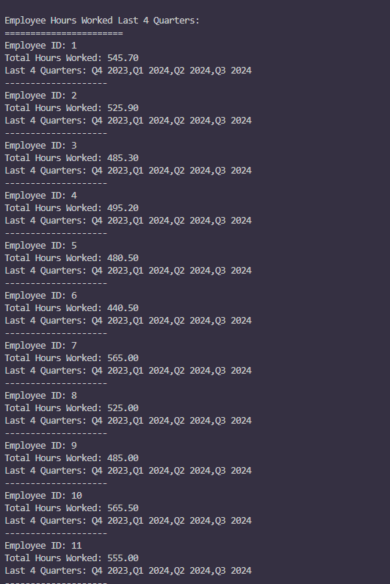

1. **Wine Sales Performance Report**

**Description:** This report analyzes the performance of each wine product sold. Providing a clear picture of how different wines are performing over time. This report is particularly useful for business decisions related to marketing, inventory management, and future sales forecasts. By understanding which wines are performing well in each month, the company can adjust marketing strategies, focus on promoting specific wines, or optimize their supply chain to meet demand.

**Key Insights:**

* Wine names and their sales quantities.
* Total Shipped, showing trends and peaks in demand.
* Total sold, demand forecasting, and sales strategies.

**Screenshot (Wine Sales Performance Report)**

**References**

# Resources: Forta, B. (n.d.). Sams Teach Yourself SQL in 10 Minutes, Fifth Edition. Retrieved from <https://platform.virdocs.com/read/1347763/21/#/4/2/10/14/2/2,/1:0,/1:0>

(n.d.). *11.3 Keywords and Reserved Words*. MySQL. Retrieved December 9, 2024, from <https://dev.mysql.com/doc/refman/8.0/en/keywords.html#keywords-8-0-detailed-I>