# EPHYS ANALYSIS GUIDE FOR OCT-CAP PAPER

**Step 1:** Follow EPHYS ANALYSIS GUIDE steps 1 – 3 if first time running the code

**Step 2:** Fill in user inputs

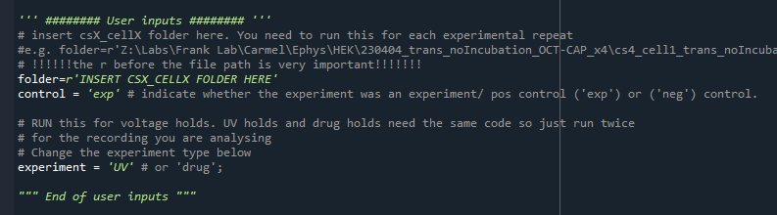

**Step 3**: Run code:

Ctrl + A

F9

*Note*: You need to run this code for each experiment repeat. i.e. once per CSX_CELLX

And then once per UV, or drug trial

**Step 3 (optional):** If your final current value does not seem correct

If you’re running an experiment trial i.e. you have some change in the time course and your endCurrent output in the ‘holding_current_values_{expType}_pA.csv’ doesn’t look correct.

Uncomment lines 98-101 and manually enter the start index and end index. These should be the values you want to average across. You can get these values from plt.plot(current)