Joe Fraser

3/14/22

**Assignment: Building a Web Page Exercise, Part 1**

W3 Validated Screenshot BEFORE:

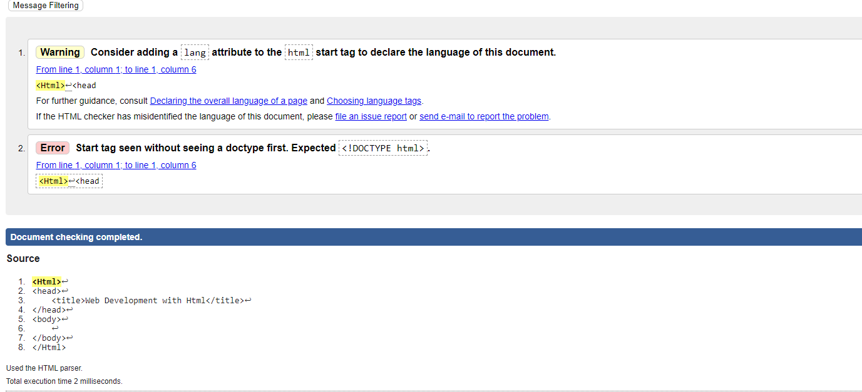

After:

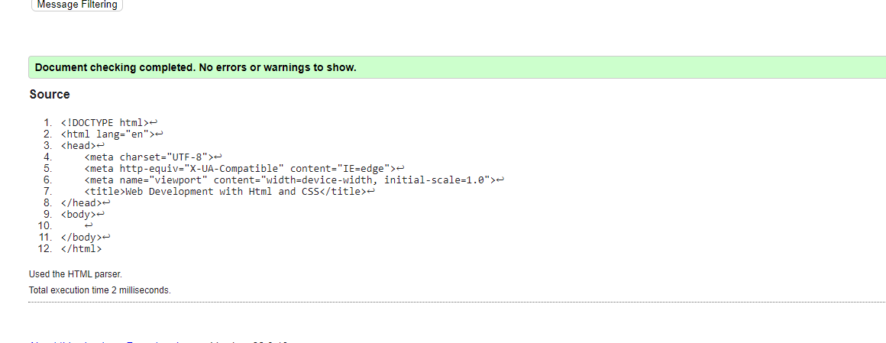

H1 with Title:

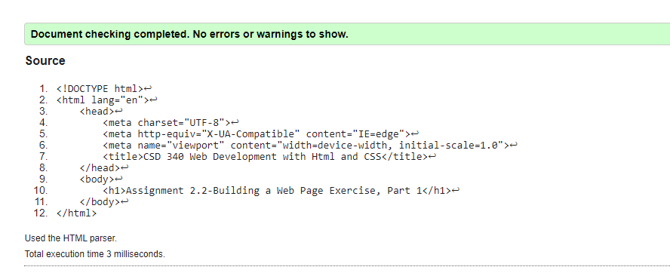

Browser view:

