1. Write the HTML for the following screen.

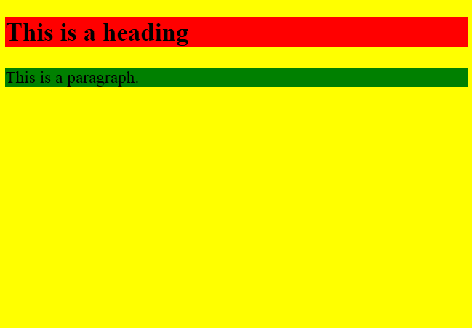

1. Write HTML for the following text and images below? The first image has a square border and the second image has no border.

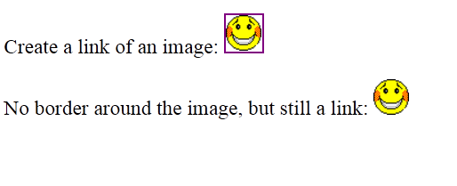

1. Write the HTML for the following text. Do **not** consider the outermost border:

|  |  |  |  |  |  |  |  |  |  |  |
| --- | --- | --- | --- | --- | --- | --- | --- | --- | --- | --- |
| Each table starts with a table tag. Each table row starts with a tr tag. Each table data starts with a td tag.  **One column:**   |  | | --- | | 100 |   **One row and three columns:**   |  |  |  | | --- | --- | --- | | 100 | 200 | 300 |   **Two rows and three columns:**   |  |  |  | | --- | --- | --- | | 100 | 200 | 300 | | 400 | 500 | 600 | |

1. Write the HTML for the following text. Do **not** consider the outermost border :

|  |  |  |  |  |  |  |  |  |  |  |  |  |
| --- | --- | --- | --- | --- | --- | --- | --- | --- | --- | --- | --- | --- |
| **This table has no borders:**   |  |  |  | | --- | --- | --- | | 100 | 200 | 300 | | 400 | 500 | 600 |   **And this table has no borders:**   |  |  |  | | --- | --- | --- | | 100 | 200 | 300 | | 400 | 500 | 600 | |

1. Write the HTML for the following text. Do **not** consider the outermost border :

|  |
| --- |
| **Numbered list:**   1. Apples 2. Bananas 3. Lemons 4. Oranges   **Letters list:**   1. Apples 2. Bananas 3. Lemons 4. Oranges   **Lowercase letters list:**   1. Apples 2. Bananas 3. Lemons 4. Oranges   **Roman numbers list:**   1. Apples 2. Bananas 3. Lemons 4. Oranges   **Lowercase Roman numbers list:**   1. Apples 2. Bananas 3. Lemons 4. Oranges |

1. Write the HTML for the following image shown below. **Note:** The characters in a password field are masked (shown as asterisks or circles). Do **not** consider the outermost border :

|  |
| --- |
| Username:  Password: |

1. Write the HTML for the following image shown below. Do **not** consider the outermost border :

|  |
| --- |
|  |

1. Write the HTML for the following image shown below. Do **not** consider the outermost border :

|  |  |  |  |  |  |
| --- | --- | --- | --- | --- | --- |
| |  |  | | --- | --- | | top | | | left | right |  |  | | --- | |  | |

|  |  |  |  |  |
| --- | --- | --- | --- | --- |
| |  |  | | --- | --- | | topleft | topright | | botleft | botright | |

Bottom of Form