Setup MongoDB on Windows Step by Step

1. Download the lastest version of MongoDB from the given link [MongoDB Download](http://www.mongodb.org/downloads)

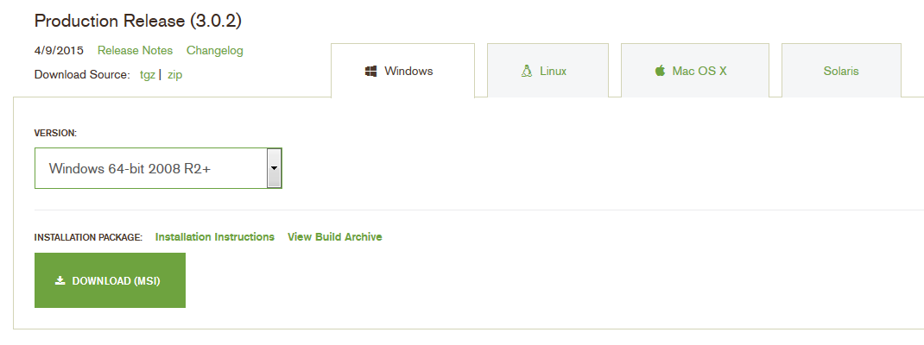

1. Click on download and download it to **C:\download** or any folder of your choicefolder.
2. Double click **mongodb-win32-x86_64-2008plus-ssl-3.0.2-signed.msi** and select run to install mongodb

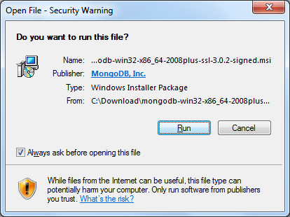

1. Click the next button

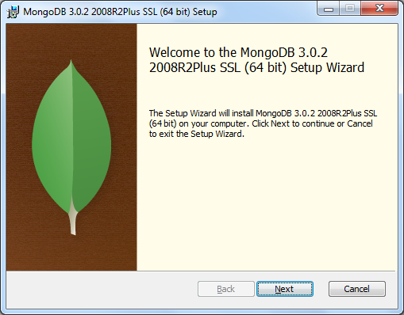

1. Accept the license agreement and click next

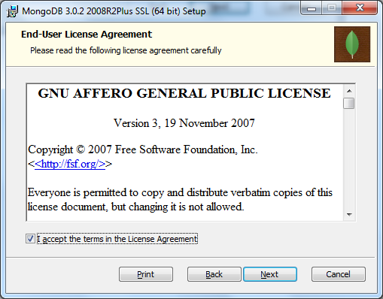

1. Select **complete** to setup MongoDB to default location. Click custom to install mongodb to the folder of your choice and the component you need.

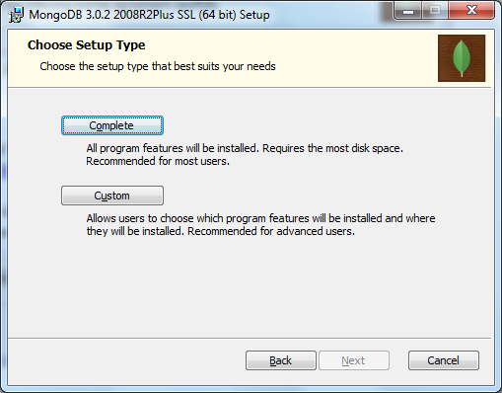

1. Click install

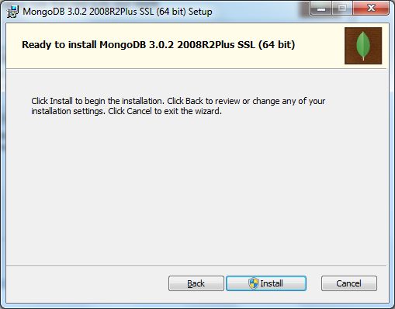

1. Click yes when the installer prompts whether to update registry
2. Click finish

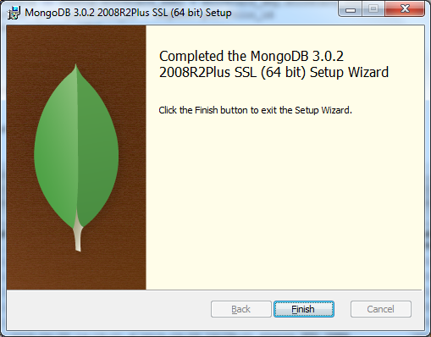

1. Create the following folder hierarchy in you system: **C:\data\db**

Mongodb uses this folder to store its database file.

Your Mongodb instance is ready.

**Note:**

1. The default mongodb installation folder is **C:\Program Files\MongoDB**

Starting mongodb

1. Navigate to **C:\Program Files\MongoDB\Server\3.0\bin** folder
2. You will see the follow files, click mongod.exe to start mongo DB:

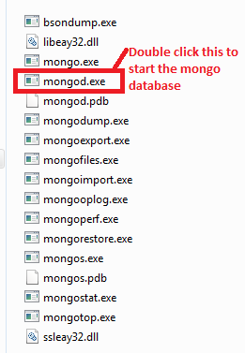

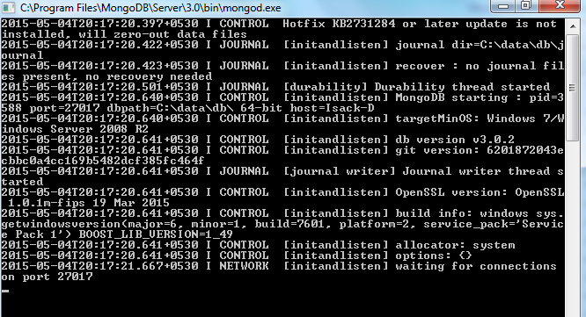

1. Click mongo.exe to start mongo DB shell prompt :

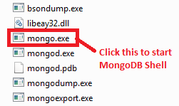

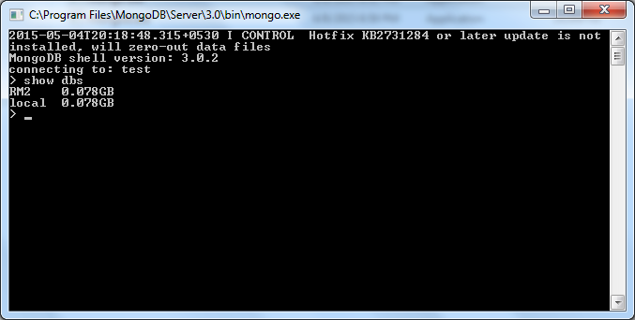

Setup MongoDB Client on Windows Step by Step

1. Download the lastest version of RoboMongo Client for MongoDB from the given link [RoboMongo Link](http://robomongo.org/)

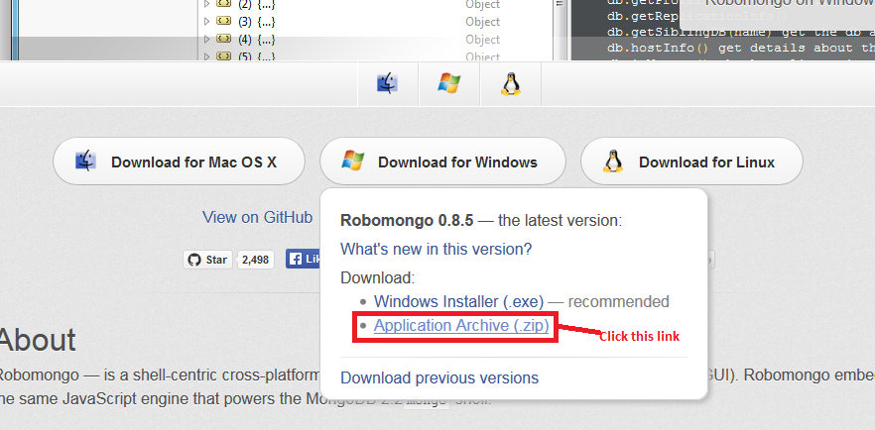

1. Extract the zip to a folder (Ex: D:\Robomongo-0.8.5-i386)
2. Navigate to the extracted folder and double click **Robomongo.exe**
3. Click Create link as show in snapshot below:

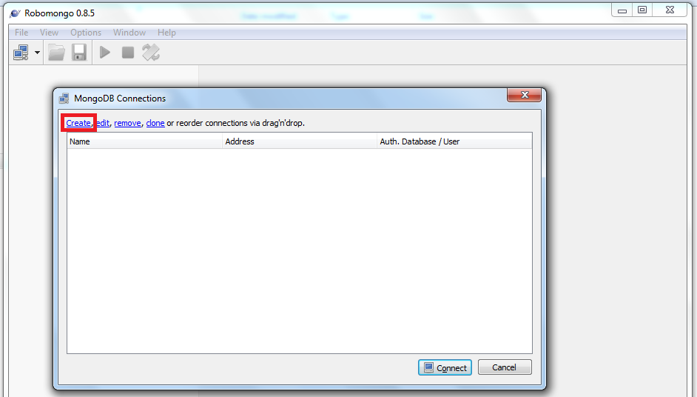

1. Enter Connection Name, IP Address and Port on which the MongoDB server is running as shown below and click save:

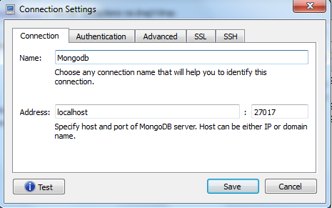

1. Your connection will be listed as shown in red below:

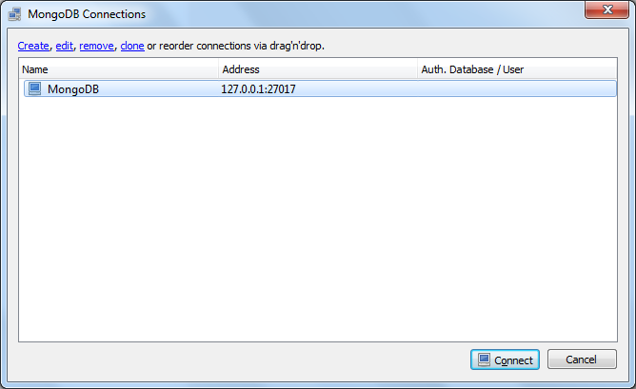

1. Select your connection and click connect, the selected database will be shown as below:

