Contents

Project Requirements 2

Requirements 2

Website Visualizations 3

Schedule 4

Datasets/Sources 5

Other Sources 6

Crime Categories 6

Statistics 6

High-Level Tasks / Libraries 6

Roles & Responsibilities 6

Availability 7

Actions 7

Website Inspiration / Ideas 8

DEPRICATE. NO LONGER NEEDED. 9

13-JUL 9

# Project Requirements

1. Must include Python Flask-powered API, HTML/CSS, JavaScript, and at least one database.
2. Project should fall into one of the four tracks:
   1. A custom “creative” D3.js project (i.e. nonstandard graph or chart)
   2. A combination of web scraping and Leaflet or plotly
   3. A dashboard page with multiple charts that update from the same data
   4. A “thick” server that performs multiple manipulations on data in a database prior to visualization (**must be approved**)
3. Includes at least one JS library that we did not cover.
4. Must be powered by a data set with at least 100 records.
5. Must include some level of user-driven interaction, e.g. menus, dropdowns, text boxes.
6. Final visualization should ideally include at least three views.

# Requirements

Can someone put these items into the project board located in Sanureets Git?

Please review, and discuss in slack if this is what we want. Edit/modify as needed.

|  |  |  |  |  |  |
| --- | --- | --- | --- | --- | --- |
| **Owner** | **Description** | **User Input** | **Output** | **Location** | **Due** |
|  | Data Table: (columns)   * Crime Type * Description * Date time * Address * City * State * Case Number * Police Beat * Latitude * Longitude | Select Navigation button “Data”, which will display data table.  Table data changes based on user input, selecting:  Previous 1 2 3 4…100 Next | Data table shows 10 rows at a time. Remaining rows shown when appropriate page number is clicked. | Data Page |  |
|  | Top 5 Violent crimes | Select Navigation button Analysis, which will show page of various charts | Pie Chart? | Analysis Page |  |
|  | Top 5 Property crimes | Select Navigation button Analysis, which will show page of various charts | Pie Chart? | Analysis Page |  |
|  |  |  |  |  |  |
|  | Group crime counts by type:   * Aggravated Assault * Homicide * Robbery * Auto Theft * Larceny * Arson | Select drop down menu to display layer. | Marker on map. Selection achieved by drop-down menu. Each marker has it’s own color | Home Page |  |
|  | Time series of crime count by date | Select Navigation button Analysis, which will show page of various charts |  |  |  |
|  | Oakland Police Beat Map | Select check box to display layer. | Layer on top of map. 1st choice static single pict  2nd choice interactive boundaries, with | Home Page |  |
|  | Crime type by type |  | Plotly |  |  |
|  |  |  |  |  |  |
|  |  |  |  |  |  |

# Website Visualizations

Police beat boundaries. Single image

Source: <https://oakgis.maps.arcgis.com/apps/OnePane/basicviewer/index.html?appid=12ae8a087be44043abc6996c5e499d5c>

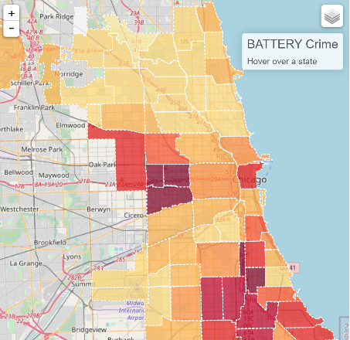 This image shows Police beat boundaries. This may be possible to do using Mapbox. Google Maps can do this as well. I did it many years ago, see [here](https://www.google.com/maps/@37.7232752,-121.8631245,6198m/data=!3m1!1e3!4m2!6m1!1s1Jn49rxrP_O2LrsgqE_KxpELf0OgOuWKQ).

Source:

<https://crime-dashboard.herokuapp.com/index.html>

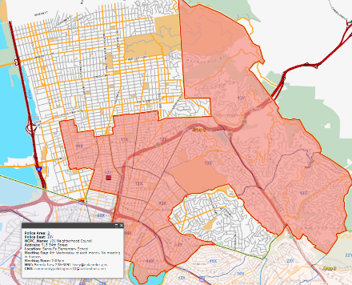

Police area boundaries. Oakland has 5 Areas, which is composed of multiple beats. The following image shows map layers for the 5 areas as opposed to individual beat layers.

Source:

<http://gisapps1.mapoakland.com/policedistricts/>

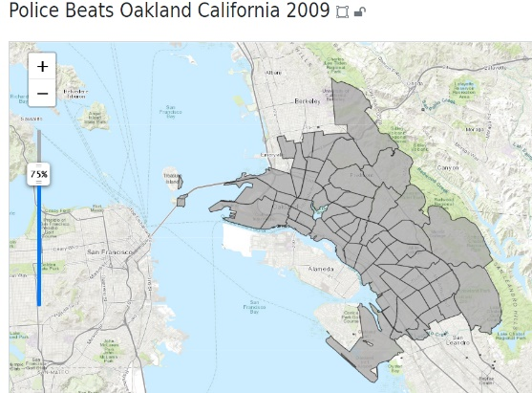

Police Beats is a single overlay. The file has been downloaded as a GeoJson file, located in the static, js folder. It is named, opd_boundaries-geojson.json

Source:

<https://maps.princeton.edu/catalog/ark28722-s71s46>

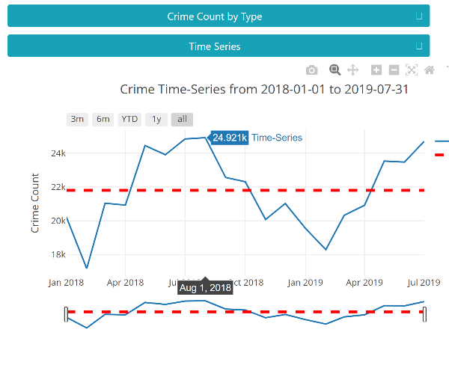

Time Series

Source:

https://crime-dashboard.herokuapp.com/index.html

# Schedule

* Team dry run: 22-July
* Class Presentation: 24-July

|  |  |  |  |
| --- | --- | --- | --- |
| **Day** | **Description** | **Tasks** | **Status** |
| 10-Jul | Brainstorm topics, research data sets | * Select topic |  |
|  |  | * Find data set |  |
|  |  | * Find inspiration |  |
|  |  | * Sketch idea visuals |  |
|  |  | * Create 1-page proposal |  |
| 13-Jul | Create 1-page proposal | * Articulate chosen topic and rationale |  |
|  |  | * Provide link to data sets and a screenshot of metadata if it exists |  |
|  |  | * 3-4 screenshots of relevant, “inspiring” visualizations that frame the creative fodder. |  |
|  |  |  |  |
|  |  |  |  |
|  |  |  |  |
|  |  |  |  |
|  |  |  |  |
|  |  |  |  |
|  |  |  |  |
| 22-Jul | Team dry run |  |  |
|  |  |  |  |

**TEAM**: MattJ, SanureetB, VeerpalS, JohnC

# Datasets/Sources

|  |  |  |  |  |  |
| --- | --- | --- | --- | --- | --- |
| **#** | **Description** | **Type** | **URL** |  |  |
| **1** | Oakland Crime | API | <https://data.oaklandca.gov/Public-Safety/CrimeWatch-Maps-Past-90-Days/ym6k-rx7a> |  | Do |
| **2** | Hospitals | CSV | Matt to provide |  |  |
| **3** | Oakland Census Data | CSV | <https://www.census.gov/quickfacts/oaklandcitycalifornia> |  |  |
| **4** | Open Justice – Types of crime | CSV | <https://openjustice.doj.ca.gov/data> |  |  |
| **5** | Oakland PD (OPD) Beat Boundaries | Website | <https://maps.princeton.edu/catalog/ark28722-s71s46> | GeoJSON of the Oakland Police beat boundaries. Already added to static js folder |  |
| **6** | OPD Info | Website | <https://www.oaklandca.gov/resources/find-a-police-area-or-beat> | Contains beat maps and policing areas |  |
| **7** | How to reduce violent crimes | PDF | <http://www2.oaklandnet.com/oakca/groups/police/documents/webcontent/dowd007487.pdf> |  |  |
| **8** | Education stats | Website | <http://www.ed-data.org/district/Alameda/Oakland-Unified> | Data visualized in charts. Raw data can be found here:  <https://www.cde.ca.gov/ds/ad/downloadabledata.asp> |  |
| **9** | Geospatial data |  | <https://oakland-oakgis.opendata.arcgis.com/datasets/oaklandcitylimits/explore?location=37.770882%2C-122.207400%2C11.85> | Download options include GeoJSON |  |

# Other Sources

1. Placeholder

# Crime Categories

1. Violent crime
   1. Murder
   2. Rape
   3. Robbery
   4. Assault
2. Property crime
   1. Burglary
   2. Theft
   3. Vehicle theft

# Statistics

1. Reported incidents

2. Oakland per/1K people

3. California per/1k people

4. National per/1k people

# High-Level Tasks / Libraries

1. Finalize hypothesis
2. Identify data sources
   1. Pull data
   2. Clean & munge data
3. Create database
4. Decide/agree on data to expose
   1. Crime type
   2. Oakland PD beat overlay
5. Web page
   1. Website architecture – plan/design site info structure
   2. Decide on presentation elements
6. Python Flask API
7. HTML/CSS/JavaScript
   1. Bootstrap
   2. Leaflet

# Roles & Responsibilities

1. SQL: Veerpal
2. Github: Sanureet
3. Visualization: Matt
4. HTML: John / Sanureet
5. Sources: John
6. ETL:

# Availability

- Matt: after 8pm

- Sanureet: after 7:30

- John: after 5:00, available during day if needed.

# Actions

1. Github – Sanureet. Done
2. List possible sources – John. Done 12-Jul
3. Everyone: Review data sources; provide feedback which data we should use. Done
4. Pulled json [Oakland Crimewatch map data](https://data.oaklandca.gov/Public-Safety/CrimeWatch-Maps-Past-90-Days/ym6k-rx7a) – John. Done 12-Jul
5. Project plan/timeline- John. EOD 11-July

# Website Inspiration / Ideas

1. [Leaflet Crime Dashboard](https://crime-dashboard.herokuapp.com/index.html).
2. [Leaflet Crime](https://hermionewy.github.io/crime/index.html) Website (great visual examples using Leaflet)
3. [Leaflet usage](https://www.city-data.com/crime/crime-Oakland-California.html)
4. [Visualization - Menus](https://www.opendatanetwork.com/entity/1600000US0653000/Oakland_CA/crime.fbi_ucr.count?crime_type=Aggravated%20assault&year=2018)
5. [Oakland PD Beat Boundry Map](https://oakgis.maps.arcgis.com/apps/OnePane/basicviewer/index.html?appid=12ae8a087be44043abc6996c5e499d5c) (Uses boundary map overlay, drop down widgets, possible reuse icons/images)
   1. https://gisapps1.mapoakland.com/oakgis/rest/services/Prod/OPDDistrictsBdrysBeats/MapServer/export?dpi=96&transparent=true&format=png32&layers=show%3A0%2C1%2C2&bbox=-13621618.2234245%2C4545155.192395562%2C-13609292.752613531%2C4556429.654067611&bboxSR=102100&imageSR=102100&size=645%2C590&f=image
6. [Website Ideas 1](https://spotcrime.com/CA/Oakland) (Cool icons)
7. [Crime Analytics Visualization](https://www.neighborhoodscout.com/ca/oakland/crime#:~:text=With%20a%20crime%20rate%20of,here%20is%20one%20in%2013.) (Charts, tables)

# DEPRICATE. NO LONGER NEEDED.

### 13-JUL

1. ~~Crime against Asian population; increase/decrease. Time period dependent~~
2. ~~Crime per/1k, based on income-level, education-level~~
3. ~~Crime per/1k vs CalFresh usage (not sure if possible). Not possible. Confirmed county data only available~~
4. ~~Crime per/1k, by type, based on location and or income-level (need to specify)~~
5. ~~I’m thinking that we not need a hypothesis since we are only providing visualization to the data.~~