Summary report

Gulf of Mexico Fishery Management Council

Report last ran on 2018-03-09

The Gulf of Mexico Fishery Management Council is considering a State Management Program (<http://gulfcouncil.org/wp-content/uploads/Recreational-State-Management-for-Red-Snapper-1-16-2018.pdf>) to allow individual states to establish seasons and bag limits to provide more flexibility to their anglers. This amendment (<http://gulfcouncil.org/wp-content/uploads/Recreational-State-Management-for-Red-Snapper-1-16-2018.pdf>) contains two actions. The first addresses the recreational sector components that a state management program would manage and the second considers methods to allocate the harvest among the Gulf states.

This report summarizes the selected options in Action 2 to determine a state based allocation for recreationally harvested red snapper. This report is based on Alternatives the Council will consider at their April 2018 Council meeting in Gulfport, MS. The user selected options are described in Table 1. The allocation (on percent basis) for each selected option is available in Table 2 and Figure 1.

Table 1. Selected options to calculate allocation of recreationally harvested red snapper among five coastal US states adjoining the US Gulf of Mexico.

|  |  |  |  |  |  |
| --- | --- | --- | --- | --- | --- |
| Component | Years | Biomass | Trips | Landings | Option |
| Total | 1986 - 2009 | 50 | 25 | 25 | 1 |
| Total | 1986 - 2009 | 50 | 25 | 25 | 2 |
| For-hire | 2006 - 2009 | 50 | 25 | 25 | 3 |
| Private | 2006 - 2009 | 50 | 25 | 25 | 4 |
| Private | 2006 - 2009 | 50 | 0 | 50 | 5 |

Table 2. Allocation of recreationally harvested red snapper among five states. The values selected for each variable is described in Table 1.

|  |  |  |  |  |  |  |
| --- | --- | --- | --- | --- | --- | --- |
| Allocation | FL | AL | MS | LA | TX | Option |
| Total Allocation | 33.36 | 16.58 | 2.88 | 17.62 | 29.56 | 1 |
| Total Allocation | 33.36 | 16.58 | 2.88 | 17.62 | 29.56 | 2 |
| For-hire Allocation | 41.31 | 12.99 | 0.68 | 15.43 | 29.58 | 3 |
| Private Allocation | 44.03 | 11.30 | 1.78 | 18.65 | 24.23 | 4 |
| Private Allocation | 45.09 | 10.22 | 2.30 | 18.35 | 24.05 | 5 |

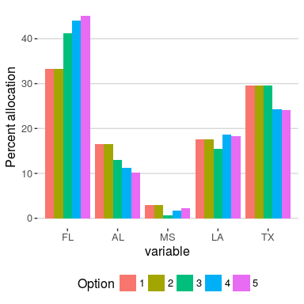

Percent allocation. Settings are selected options are described in Table 1.

This report was generated from the red snapper decision support tool (v3.0) available at <http://portal.gulfcouncil.org/RedSnapperDecisionSupportTool/>. You can submit comments about this proposed amendment here: <https://docs.google.com/forms/d/e/1FAIpQLSdS4V2vpjJdeXYwGd4126vvkOlp5328cd0pCvAka7S2JpOIVg/viewform>.

Plases send technical questions or concerns about this website or report to [john.froeschke@gulfcouncil.org](mailto:john.froeschke@gulfcouncil.org).

