Executive Summary of Students’ Behavior during Website Usage

With the environment cleanly established, the actual journey of the students reveals that learning did not occur instantly, nor it progressed in a steady rate. Nevertheless, the interaction of the students with the website was steady as both for 2510 and 2520 cohorts, the unique number of students were steady. The amount of times students, however, was not steady and instead it was shaped like the alphabet “M”. During the first and last term of the cohort, (for 2510, it would be September and November and for 2520, it would be February and April) the amount of times students visited the website was at its peak. This would be high likely due to the assignment dates as they would have to read related pages and submit the papers on time. While it is reasonable to say that some students visit the website even not during the due date weeks, this trend generally infers that most students visit the website when the assignments are due.
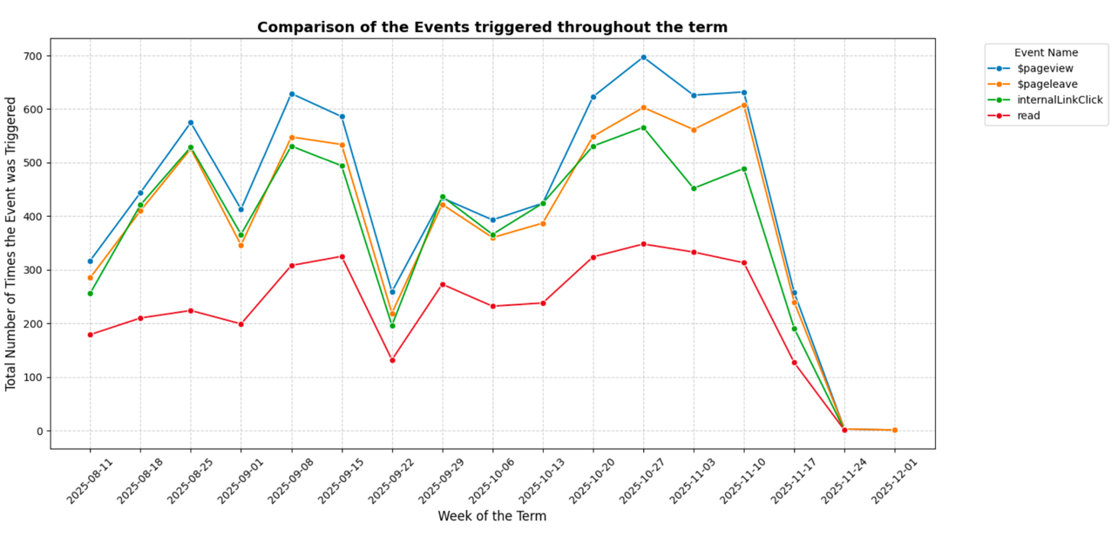
Figure 1 : General trend of pageview, pageleave, internalLinkClick, and read (this graph is shown to let the reader know about how similar each events’ graphs look like)
In addition to the amount of visits of students, the data highlights how many time students may have entered and left the page. For the entire term for both 2510 and 2520, the frequencies of the pageview and pageleave events tracked with nearly perfect correlation, creating a symmetrical shape, which tells us how their sessions were more continuous instead of irregular. Furthermore, when the students visited the website, they explored internal resources, as shown in the internalLinkClick data. For both 2510 and 2520 cohorts, the internalLinkClick graph looked similar to that of pageview and pageleave, letting us reasonably conclude that when students started visiting the pages, they also explored further to understand more about the content at the same time.
While exploring more about the pages in the website, the students also utilized a lot of nutshells especially during the paper due dates. The nutshells’ titles were all related to writing a paper, which is reasonable to assume that students used it mainly for writing their drafts before submitting the papers for a letter grade. Another trend that emerged for nutshells was that the frequency of these nutshells were the highest during the last part of the semesters. This means that most nutshells were used for assisting students in writing their final paper.
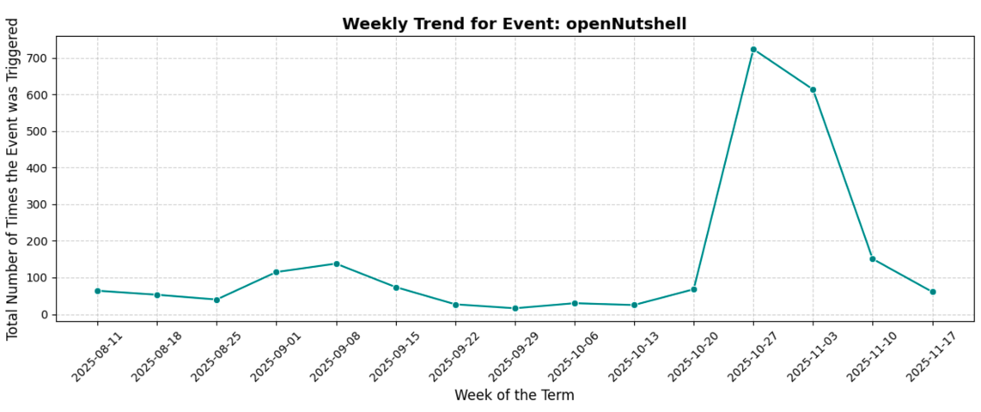
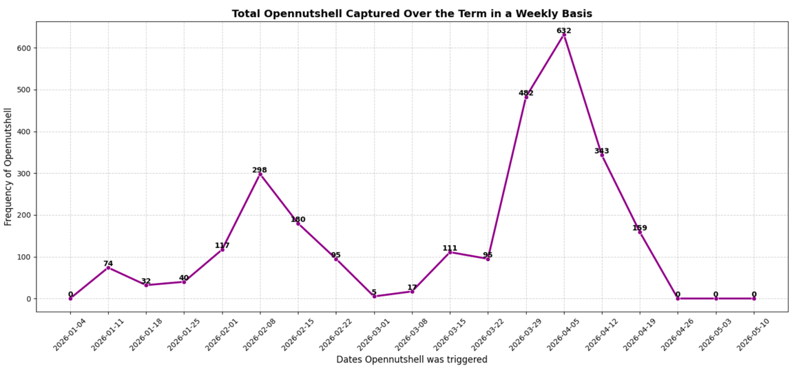
Figure 2 : Showing the general trend of openNutshell for both cohorts (2510 on top, 2520 on bottom)

In conclusion, the general analysis shows how every unique students have been using the website accordingly throughout the term for both 2510 and 2520 cohorts. Pages were viewed accordingly, and features such as the nutshells were used during the right timing among the students (during the assignment due dates). However, some features had some limitations in terms of measurement. For instance, in case of the read event, how it gets triggered is that when the number of pixels that has been shown to the user is more than 50% of the total amount of pixels of that particular page. But, if we have pages that are not scrollable, the read event automatically gets measured as more than 50% of the page has been shown despite the user did not even get started reading nor scrolling. These limitations shall be solved for potential improvement of the future website analysis.

