**Template**: Bathy Fence Creator Template

**Version**: 10.3.1 ArcGIS Desktop, ArcGIS Server

**Produced By:** John Fry, Esri

**Date**: November 19, 2015

# Introduction

In order to create maritime intelligence information products, one may need to run suitbaility analyses of likely events occurring. In order to define suitable areas, one may need to pass data into a tool which gives a logistic output: 1- yes an event can occur, or 0, an event cannot occur. An example would be finding areas in bathymetry that are too shallow for a platform. A user passes a variable for the draft of the vessel into a less than or equal geoprocessing tool, and the tool finds areas that are too shallow for the vessel to operate. The output areas then could be used for further GIS analyses or converted to polygons to be used as geofences in applications such as the GeoEvent Extension for ArcGIS Server.

This template contains:

* Sample bathymetry dataset –
  + obtained from NOAA Data came from NOAA National Geophysical Data Center. Data were subset to a smaller size and converted to a TIF.
  + Citation: Grothe, P.G., L.A. Taylor, B.W. Eakins, K.S. Carignan, D.Z. Friday, and M. Love, 2012. Digital Elevation Models of Monterey, California: Procedures, Data Sources and Analysis, NOAA National Geophysical Data Center technical report, Boulder, CO, 15 pp.
  + Copyright Notice
    - As required by 17 U.S.C. 403, third parties producing copyrighted works consisting predominantly of the material produced by U.S. government agencies must provide notice with such work(s) identifying the U.S. Government material incorporated and stating that such material is not subject to copyright protection within the United States. The information on government web pages is in the public domain and not subject to copyright protection within the United States unless specifically annotated otherwise (copyright may be held elsewhere). Foreign copyrights may apply.
* One can download a bathymetry dataset for the entire world at General Bathymetric Chart of the Oceans (GEBCO) <http://www.gebco.net/data_and_products/gridded_bathymetry_data/>
* Bathymtery Geofence Creator geoprocessing tool

# Getting Started

The Bathy Fence Creator template is a template for creating geofences from an input bathymetry raster. One can use model as a template and edit the model to be used for other purposes. The information presented in this template is based on standard Esri Commercial off-the-shelf (COTS) technologies and commercial data. All scenario data is notional.

Before you begin using the template, review the following sections:

* Release Notes
* Hardware and software requirements
* Installing the template

Once you have installed and set up the template, this documentation contains a section that explains how to begin using the template.

* Bathy Fence Creator Template Notes

# Release Notes

Please provide feedback, suggestions, and issues for this template on Github.

<https://github.com/jfrygeo/BathyFenceCreator>

# Hardware and software requirements

System requirements for this template include:

1. ArcGIS Desktop 10.3.1
   1. Spatial Analyst Extension
2. ArcGIS Server 10.3.1
3. Optional: A bathymetry Image Service

# Installing the template

To install and set up the template, you must download and extract its associated files, as described in the following procedure.

Steps:

1. Review Hardware and software requirements in this guide to make sure your system supports the template.

2. Use Windows Explorer to create a folder to which you’ll download the template. Unzip the Bathy Fence Creator Template zip file. It is recommended (especially if you plan to use several Esri templates) that you create the following folder structure on the C: drive of your local computer:

C:\ArcGIS Templates\BathyFenceCreator

3. Double-click the BathyFenceCreator.mxd map document in the BathyFenceCreator folder.

# Bathy Fence Creator Template Notes

The Bathy Fence Creator Template includes sample data so you can easily try out the tools.

The BathyFenceCreator folder contains sample data, this document, a maps folder and a toolbox folder.

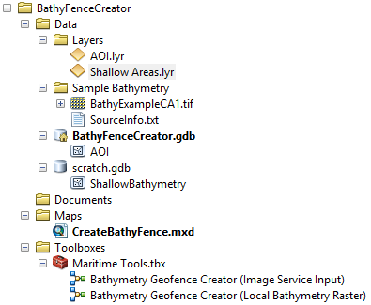

# Template Contents

|  |  |  |
| --- | --- | --- |
| **File Name** | **File** | **Description** |
| AOI.lyr | ArcGIS layer file | Stores the symbology and points to the dataset “AOI” in the “BathyFenceCreator.gdb” . This is used to drive the symbology of an interactive AOI operation when one uses the two tools in the toolbox. |
| Shallow Areas.lyr | ArcGIS layer file | Stores the symbology and points to the dataset “ShallowBathymetry” in the “BathyFenceCreator.gdb” . This is used to drive the symbology of an of the feature class outpur when one uses the two tools in the toolbox. |
| BathyExampleCA1.tif | Tif | Sample dataset obtained from NOAA National Geophysical Data Center . |
| BathyFenceCreator.gdb/AOI | Feature Class | An AOI feature class used to drive an “AOI” operation in the two tools in the toolbox. |
| Scratch.gdb/ShallowBathymetry | Feature Class | Output feature class showing areas that are too shallow. This is the output of both of the tools in the toolbox. |
| CreateBathyFence.mxd | Esri Map Document | Esri map document that contains the sample dataset and basemap. |
| Bathymetry Geofence Creator (Image Service Input) | ArcGIS model | Model that finds shallow areas and outputs a feature class of too shallow areas. The input in this model requires an image service. An image service example could be Esri’s TopoBathy image service. It can be used by Esri ArcGIS Online subscribers. (<http://www.arcgis.com/home/item.html?id=c753e5bfadb54d46b69c3e68922483bc>)  One can also publish their own image service, or WCS. This tool could be adapted to use WCS by using the “Make WCS Layer tool.” |
| Bathymetry Geofence Creator (Local Bathymetry Raster) | ArcGIS Model | Model that finds shallow areas and outputs a feature class of too shallow areas. The input is a local bathymetry raster. |

Notes:

* The model assumes that values for bathymetry are negative values (i.e. depths below water are negative numbers).
* Bathymetry not for navigation.

# Using the Bathy Fence Creator Template

1. Open the CreateBathyFence.mxd
2. Navigate in ArcCatalog, within ArcMap to the tool “Bathymetry Geofence Creator (Local Bathymetry Raster)”
3. Double click the tool
4. Specify the following inputs.
   * **Input Bathymetry Raster:** Use the “BathyExampleCA1.tif” supplied in the map.
   * **AOI:** Draw a box within the area of the sample dataset.
   * **Input Depth Value (in meters):** The sample dataset is in meters. Specify the depth. The tool is using a “Greater Than” process which calculate all values greater than the specified input and gives them a “1”; while all values less than the input get a “0.”
   * **Shallow Areas:** This is the output of the process. It is pointing to the “Scratch Geodatabase” which is a working directory on the machine which you are running this tool.

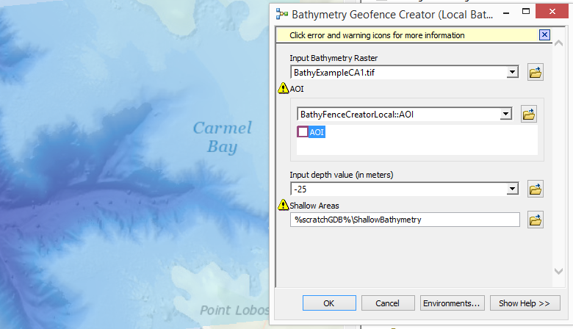

1. Press “OK”

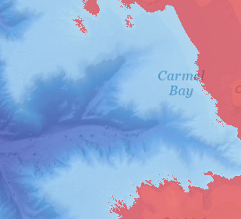

1. Publish the model as a geoprocessing service. Help documentation is here: <http://server.arcgis.com/en/server/latest/publish-services/linux/a-quick-tour-of-publishing-a-geoprocessing-service.htm>
2. Navigate to the “Geoprocessing” tab at the top ArcMap
3. Click on “Results”
4. Navigate to “Current Session”
5. Right-click on Bathymetry Geofence Creator Local Bathymetry Raster and
   * click on “share as”
   * select “Geoprocessing Service”
   * click “Publish a Service”
   * choose a connection to your ArcGIS Server
   * Give the geoprocessing service a name (i.e. ‘BathyFenceCreator”)
   * Choose an existing folder, or create a new one
6. In service editor, you can fine tune the capabilities of your service.
   * In parameters, you can specify you that you want to see the results via a results map service. This will allow you to view the results quickly in a web client. 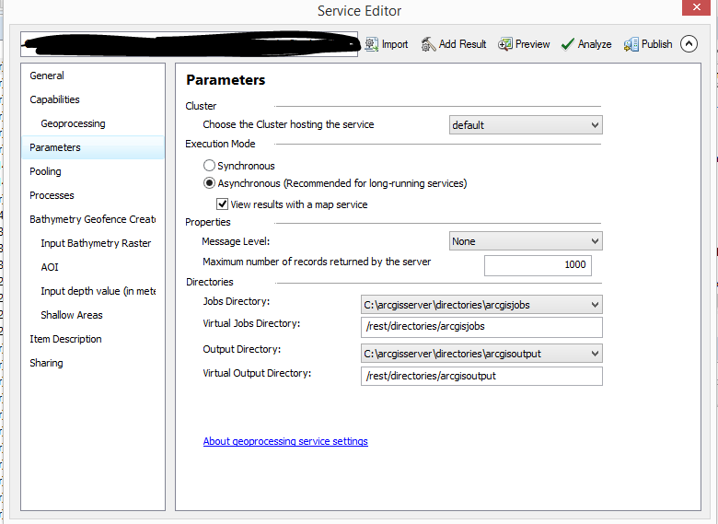
   * Press “Analyze” after you have defined the variables that are needed.

**Note:**

* When publishing the “Bathymetry Geofence Creator Local Bathymetry Raster” model, ArcMap with transfer all data used in the tool to the ArcGIS Server. In this sample case, it will be just the sample bathymetry dataset. This tool will only work on the extent of the sample bathymetry dataset. Ideally, one would publish an Image Service of the entire world, and use that as input to the model. The model “Bathymetry Geofence Creator (Image Service Input)” shows an example of the model working with an image service.
* Another way one can setup the model without using an image service would be to register a folder that contains bathymetric datasets inputted into a Mosaic Dataset with the ArcGIS Server, and then use the Mosaic Dataset as an input to the model “Bathymetry Geofence Creator Local Bathymetry Raster.” A mosaic dataset is an ArcGIS data model that spatially and temporally aggregates raster data.