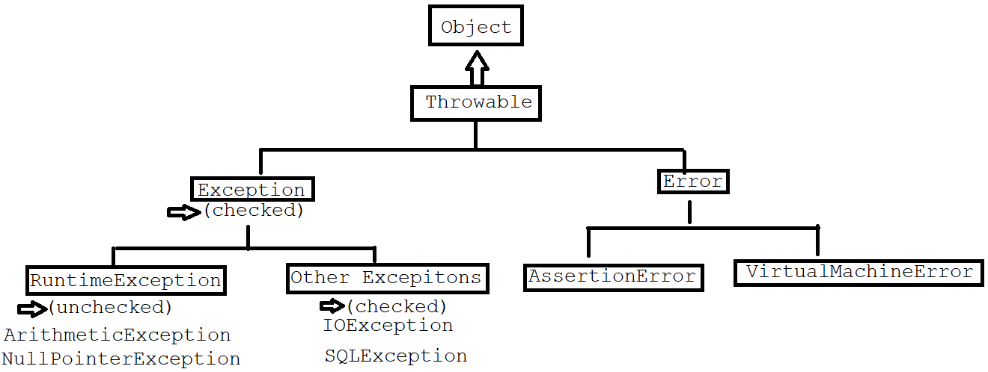

Actual Server

Client Program

Alternative Server

try {

code to connect to actual server

}

catch(ServerNotFoundException e) {

code to connect to alternative server

}

start

Normal code

try block Code that might

cause exception

is exception found? yes

no Handler code

catch block

Normal code

End

ArithmeticException ae = new ArithmeticException();

throw ae;

catch(ArithmeticException e) {

…

}

e

int sum(int a, int b)

sum(10, 20);