
MEMORANDUM
3/18/2026
TO: | Hasan Mohammad, Professor
FROM: | Erik Heuchert, Lucas Heuchert, Jacky Liang, John Tomas, Matthew Moore
COPIES:
SUBJECT: | ME-423 Final Project Report
Qarm Tic-Tac-Toe

Summary:

This project began as a basic automated robotic-arm segregator designed to identify objects by color and place them into different locations. As the quarter progressed, the scope of the project changed significantly. Instead of completing a simple pick-and-place sorting task, our team developed a robotic arm that can play tic-tac-toe against a human player. Using the QArm and its RGB camera, the robot detects the board and game pieces, then places its pieces based on the current state of the game. The final design combines robotic movement, camera-based detection, and game logic into one system.

Motivation:

At the beginning of the project, our team set out to build a robotic color segregator capable of detecting objects based on color and sorting them into designated locations. To support this idea, we designed and 3D printed small human-shaped pieces in different colors as sample objects. The initial phase of the project focused on fundamental robotic functions such as arm movement, pick-and-place operations, and basic color detection.

After receiving feedback that the project lacked sufficient depth, we reevaluated our approach and expanded the concept into a more advanced system. We transitioned to developing a tic-tac-toe playing robot, which builds upon the same core principles but introduces additional complexity. The system uses an RGB camera to recognize the game board and detect piece positions, while the robotic arm places pieces accurately in response. The blue character pieces represent the human player, while the robot uses gold pieces, adding a personalized and engaging design element.

This project integrates multiple areas of mechatronics. Mechanically, the robotic arm must achieve precise and stable movements to avoid disturbing the board. From a controls perspective, the system must execute repeatable and accurate positioning. From a vision standpoint, the camera processes images to detect board states and piece locations. From a programming perspective, the project combines motion control, image processing, and game decision-making into a unified system.

By evolving from a simple sorting task to an interactive game-playing robot, the project became more challenging and better aligned with course expectations, while still leveraging the original design elements and components.

Robot Design

Our design is centered around the QArm shown in Figure 1 which is a 4 degree-of-freedom articulated arm in a roll-pitch-pitch-roll configuration (base, shoulder, elbow, wrist) with a dual-finger gripper and an RGB-D camera. In this configuration, the first three joints primarily position the end effector, while the wrist joint is mainly used to orient the gripper at the target location. This is a good match for our application because the project depends on repeatable grasping and placement while objects appear at variable positions within the workspace.

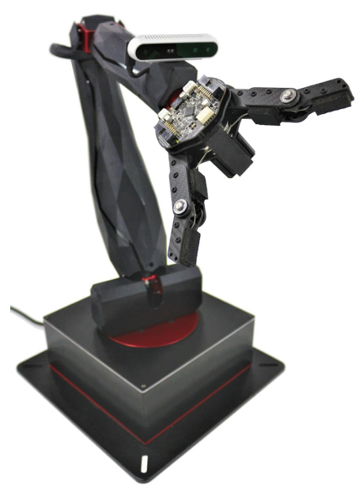
Figure 1. Quanser QArm 4DOF serial manipulator

Figure 2 shows a rough sketch of the robot’s workspace and deadzone. The workspace is where the end effector can reach or perform its function, while the deadzone is the area within the workspace where the robotic arm might encounter a singularity.

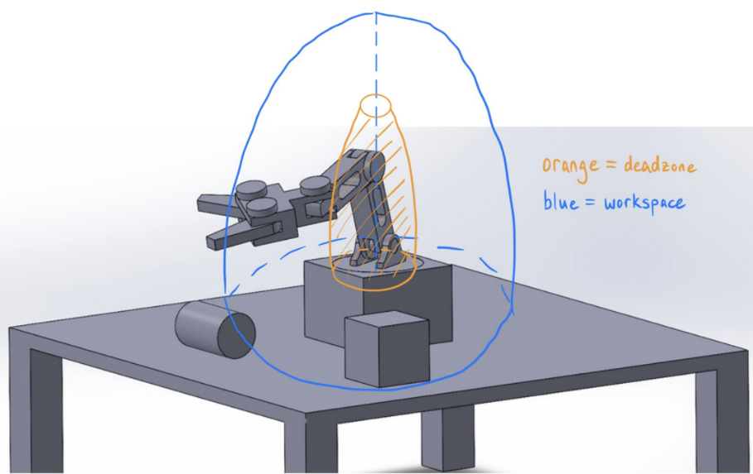
Figure 2: Workspace and Deadzone of the robotic arm
Theory:
Robot Kinematics and Forward Kinematics
To support autonomous pickup from variable locations, we need a reliable mapping from joint angles to end-effector pose in 3D space. We model the arm as a serial manipulator and use a standard Denavit–Hartenberg (DH) formulation to compute forward kinematics. In general form, the end-effector transform can be written as:
T⁰ₑ(q) = T⁰₁(θ₁) · T¹₂(θ₂) · T²₃(θ₃) · T³₄(θ₄)
where θ₁…θ₄ are the joint angles (base, shoulder, elbow, wrist), and each transform T(i−1)ᵢ is built from the DH parameters (link length, twist, offset, and joint angle). The end-effector position is the translation component of T⁰ₑ(q), typically written as:
p(q) = [x(q), y(q), z(q)] ᵀ
A useful simplification for our configuration is that wrist rotation primarily changes orientation rather than position. This means end-effector position planning can focus heavily on the first three joints, while the wrist can be treated as an orientation choice for grasping and placement.

Desirable End-Effector Motions (Setting Up for Inverse Kinematics)
A key requirement for consistent grasping is smooth end-effector motion near pick and place actions. A robot arm cannot realistically “teleport” between points without causing sudden velocity and acceleration changes, which can lead to vibration, overshoot, or missed grasps. For this reason, we use manipulator-space trajectory planning: we define the desired end-effector motion first, then use inverse kinematics to generate the joint commands that follow the path.
We define the desired end-effector path as:
p(t) = [x(t), y(t), z(t)]ᵀ
For smooth point-to-point motion, each coordinate can be modeled with a cubic polynomial:
p(t) = a₀ + a₁t + a₂t² + a₃t³
We select coefficients using boundary conditions, so the motion starts and ends smoothly. A common choice is:
- p(0) = pᵢ
- p(T) = $p_{f}$
- p′(0) = 0
- p′(T) = 0
The zero-velocity endpoint conditions reduce “snap” at the beginning and end of each segment, improving grasp reliability. For a full pick-and-place cycle, we generate cubic segments between waypoints (home → pick → home → place → home) and execute them sequentially.

Figure 3 shows a diagram and the symbolic parameters of the provided Qarm. From the forward kinematic approach, the DH parameters table is determined as shown in Table 1.

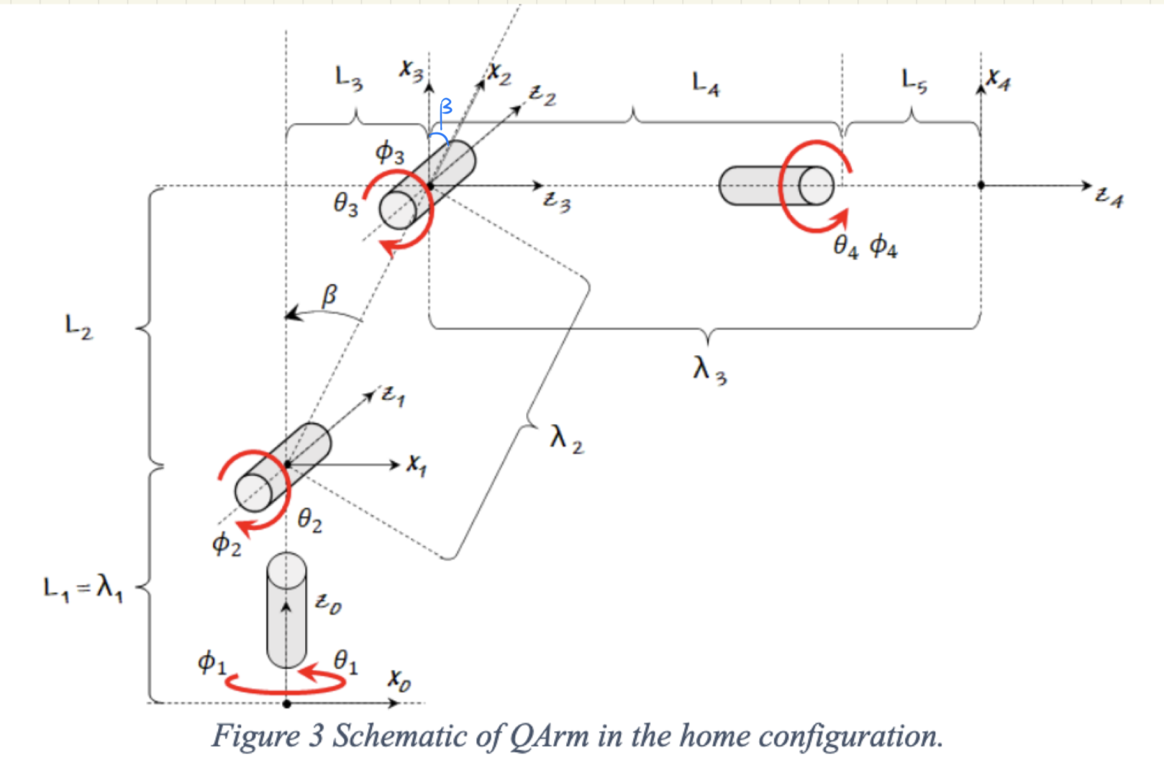
Figure 3. Schematic of QArm in home configuration

Table 1. Symbolic DH Table
Link | θ | d | a | α
0-1 | θ₁ | λ₁ | 0 | -π/2
1-2 | -π/2 + (β + θ₂) | 0 | λ₂ | 0
2-3 | -β + θ₃ | 0 | 0 | -π/2
3-4 | θ₄ | λ₃ | 0 | 0

Below are additional parameter definitions.
$$λ_{1}= L_{1}$$
$$λ_{2}= \sqrt{L_{2}^{2}+ L_{3}^{2}}$$
$$λ_{3}= L_{4}+ L_{5}$$
$$β= arctan\left.\left(\frac{L_{3}}{L_{2}}\right.\right)$$

When given a desired XYZ coordinates, the analytical approach of inverse kinematics allows us to solve joint angles. For our robotic system, these are the locations of the tokens on the stage and the different cells of the Tic-Tac-Toe board.
$$P_{d}=\left[\begin{matrix}x_{d} \\ y_{d} \\ z_{d}\end{matrix}\right] ,$$
where $x_{d}$, $y_{d}$, and $z_{d}$ is a specified distance from the center of the Qarm base in the x-direction, y-direction, and z-direction respectively.
The goal for this approach is to determine the four joint angles given as
$$θ or q=\left[\begin{matrix}θ_{1} \\ θ_{2} \\ θ_{3} \\ θ_{4}\end{matrix}\right]$$
Since the first joint rotates the arm about its vertical axis, the base angle, $θ_{1}$, can be determined with the following:
$$θ_{1}=atan2\left(y_{d},x_{d}\right) .$$
Thus, the horizontal radial distance can be found using
$$r=\sqrt{x_{d}^{2}+y_{d}^{2}}$$
while the vertical distance from the shoulder prismatic joint can be found using
$$z=z_{d}-λ_{1} .$$
After identifying the first joint angle, the rest of the system can be modeled as a planar 2-link problem with the end effector and will use the horizontal radial distance and vertical distance calculated earlier. To calculate the distance in magnitude from the shoulder to the end effector, the following equation can be used.
$$D=\sqrt{r^{2}+z^{2}}$$
Applying the law of cosines to the triangle formed by $λ_{2}$, $λ_{2}$, and D,
$$D^{2}=λ_{2}^{2}+λ_{3}^{2}- 2λ_{2}λ_{3}\cos{(π-}θ_{3}) .$$
Since $\cos{(π-}θ_{3})= -cos{(}θ_{3})$, the third joint angle, $θ_{3}$, can be simplified to
$$\cos{θ_{3}}=\frac{r^{2}+z^{2}-λ_{2}^{2}-λ_{3}^{2}}{2λ_{2}λ_{3}}$$
$$θ_{3}=±\cos^{-1}\left(\frac{r^{2}+z^{2}-λ_{2}^{2}-λ_{3}^{2}}{2λ_{2}λ_{3}}\right)$$
The angle from the shoulder to the desired location can be found using
$$α=atan2(z,r)$$
, while the interior triangle angle can be found using
$$δ=atan2\left(λ_{3}\sin{θ_{3}},λ_{2}+λ_{3}\cos{θ_{3}}\right).$$
Therefore, the second joint angle, $θ_{2}$, should be the difference between the two but also needs to account for the $β$ angle as defined in the DH parameter table.
$$θ_{2}=α-δ-β$$
For the end effector wrist joint, the joint angle, $θ_{4}$, will be constant and remain unrotated unless prompted to do due to obstacle interference. The angle can be found using
$$θ_{4}=γ-δ-β,$$
where $γ$ is the total pitch of the end effector and is set to zero.

In conclusion, the inverse kinematics of the QArm was derived using a geometric approach combined with the symbolic DH parameter model. The offset shoulder geometry defined by L₂ and L₃ was replaced by an equivalent link $λ_{2}= \sqrt{L_{2}^{2}+ L_{3}^{2}}$ with a constant offset angle $β= arctan\left.\left(\frac{L_{3}}{L_{2}}\right.\right)$. The base joint angle θ₁ is determined from the horizontal projection of the desired end-effector position using $θ_{1}=atan2\left(y_{d},x_{d}\right)$. The remaining problem is reduced to a planar two-link inverse kinematics problem in the radial–vertical plane. The elbow angle θ₃ is obtained using the law of cosines, and the shoulder angle θ₂ is computed using triangle geometry with a correction for the offset angle β. Finally, the wrist angle θ₄ is chosen such that the desired end-effector pitch γ is achieved. This results in a closed-form solution that converts desired Cartesian coordinates into joint angles.

ARM Motion:

The objective of the motion of the arm was to pick up pieces of Professor Hasan that have not been played, on the “stage” shown in Figure 4-a. and move the pieces to a location on the board shown in Figure 4-b, which would indicate a move in the tic-tac-toe game. Each of these locations is given a designation and location in the XYZ coordinate space.

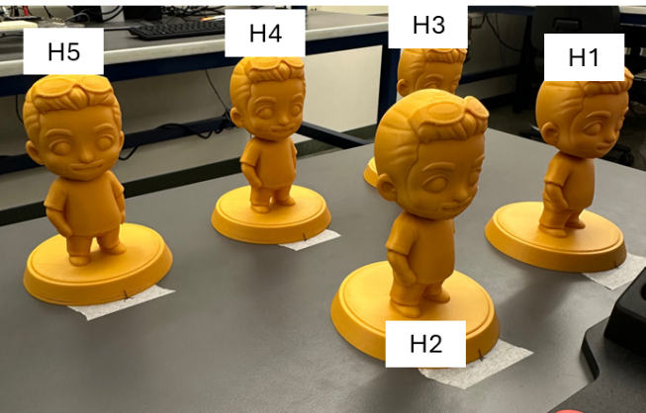 | 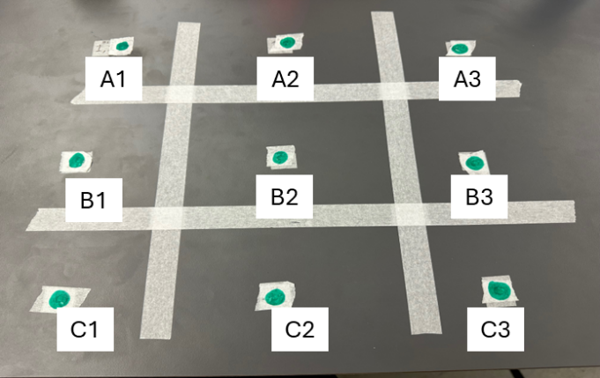
Figure 4-A. Pieces in the Staging Area | Figure 4-B. Labeled Locations on the Board

The motion of the robotic Qarm is governed by inverse kinematics and also by explicitly defining joint angles. Inverse kinematics is the determination of the arm joint angles required to move the arm to reach the desired end effector position in the XYZ coordinate system within the workspace of the robot.
Inverse Kinematic functions are provided by Quanser specifically for the QArm robot. This function takes the current location of the arm as a seed and a target XYZ coordinate. The function then generates steps at 200 Hz defining joint angles along the path from the seed joint angles to reach the desired XYZ coordinate. This provided inverse kinematic function was used in conjunction with the function in Figure 5. which executes the logic to write joint angle locations to the robot, the read write function is another provided by Quanser to control the QArm using Python.

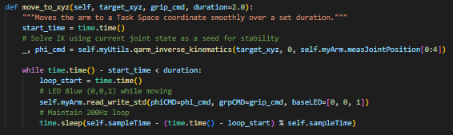
Figure 5. Function to move arm to location in XYZ coordinate system.
This method of defining movement for the robot was a good choice for the tic-tac-toe project, since the coordinates of the pieces to be picked up could be numerically defined as well as the coordinates of the locations on the board. These coordinates and other defined joint angles were stored in a Python Dictionary for easy storage and access, this dictionary is shown in Figure 6.

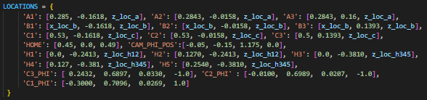
Figure 6. Python Dictionary with Location and Angle Definitions

The logic was the same for the entire operation, pick up a piece, go to the home configuration, then go to the location on the board. While this logic worked smoothly for most of the operations conducted, there were still specific locations at which the arm would run into other pieces. To avoid this problem, teach was used to place the arm into a location of an intermediate step manually and then record the arm joint angles to recreate the position. Explicitly defining positions to avoid collision in intermediate steps, then moving to the desired EE position provided additional path planning to avoid all collisions.

For example, when the Qarm picks up a token and moves outward, any token that would be in its path would be knocked over; thus, the end effector is set to move diagonally off to the side before lifting the token, moving to the desired location on the board, and dropping the token. The majority of collisions were caused by the black box under the robot’s end effector as shown in Figure 7.

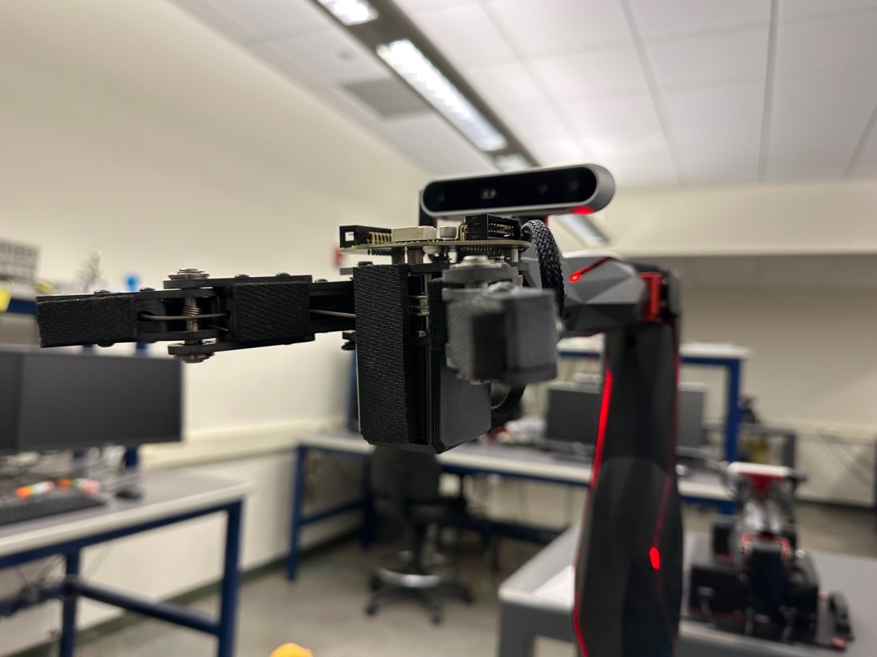
Figure 7. Robotic Arm part causing interference with placed tokens
At the end of the game, we also added a victory motion for the robot whenever the robot wins. This was meant to make the system feel more complete and give a clear visual signal that the game had ended. The dance starts from the stored camera joint position, CAM_PHI_POS, because this is already a safe and repeatable pose for the arm. From that position, the robot performs an exaggerated nodding motion by changing the third joint angle around its normal value of 1.175 while also changing the second joint to make the motion look larger. Instead of just doing one small movement, the robot moves through multiple up and down positions so the nod looks more obvious to the user.
After the nodding motion, the robot also makes a short side to side celebration and then opens and closes the gripper several times. The gripper action is controlled through the grip_cmd value, where one command opens the gripper and the other closes it. This part was added mostly for presentation, but it also showed that the arm and gripper could still be controlled correctly after the game logic was finished. Overall, this feature did not affect the tic-tac-toe algorithm itself, but it improved the final demonstration by making the robot feel less static and more interactive.

Color Detection:

The color detection package we are using is Open CV. It establishes a connection to the camera, then captures the frame in a 3D NumPy array with height and width of pixels, and the BGR channels from our RGB Camera, as shown in Figures 8 and 9.

self.cap = cv2.VideoCapture(index, backend)
Figure 8. Initialize the camera

ret,frame=self.cap.read()
Figure 9. Capture a frame from the camera

We then chose to convert it to the HSV to allow us to change the parameters for our chosen colors easier, since they are a mix of RGB, as shown in Figure 10.

self.hsv=cv2.cvtColor(frame, cv2.COLOR_BGR2HSV)
Figure 10. BGR conversion to HSV

The H is the hue, the color from 0 to 360 degrees, with 0 at red, 120 Green, and 240 Blue. This scale is much easier to control than finding the blend of RGB values that make our golden color. The S is the saturation of the color, helping eliminate glare and shadows that have lower saturation, as well as helping to separate the objects from the background. These parameters help eliminate background colors, isolating our chosen object. Finally, the V is the value of the lighting, which can change how the camera sees shadows or bright lighting. Because our lighting is somewhat variable across the frame, we chose a rather large range for the V values, keeping the parts of our figure that had shadows and points that got a majority of the light. Overall, by setting floor and ceiling values for our given color with the H, S, and V parameters, as shown in Figure 11, we could reliably determine outlines of our given objects.

self.lower_gold=np.array([10 ,50, 150])
self.upper_gold=np.array([35, 255, 255])
Figure 11. Created HSV boundaries for the color

Even though it was easier to create the hue boundaries in HSV, one way that made it easier to determine the saturation and brightness levels was placing the object in the middle pixel, and displaying the HSV values detected. Starting with this as a reference made it even easier to fine tune and reliably remove any background noise. We then used these bounds to mask the HSV frame using the in range function shown in Figure 12.

mask=cv2.inRange(self.hsv, self.lowercolor, self.uppercolor)
Figure 12. Masked frame

Using this function we made a get_mask() function that takes inputs of the chosen color you want to make a mask for, and the given frame, see Camera Class in Appendix A. Once a mask was established, we could then use the contours function to create a tuple of contours, shown in Figure 13.

contours, hierarchy=cv2.findContours(thresh, cv2.RETR_TREE, cv2.CHAIN_APPROX_SIMPLE)
Figure 13. Generate a tuple of countours

To further eliminate any noise, we tested to see if these contours had an area big enough, otherwise they were discarded. The area was found using the contour area function, Figure 14, which returns an area in square pixels.

area=cv2.contourArea(c)
Figure 14. Contour Area

Results of the contour detection are given below in Figure 15.
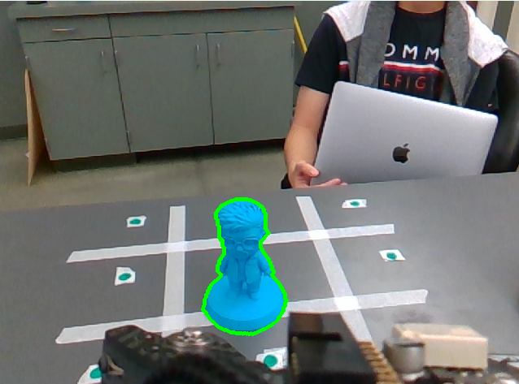
Figure 15. Contour detection

Combining these two functions of contour definition, we created a get_outline() function which took the mask and frame parameters, and returned a list of valid contours, see Camera Class in Appendix A. Next centroids were established of those valid contours, by first gathering the values to be used in the first moment of area equation.
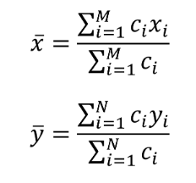
Figure 16. Equation for finding the centroid in x and y

We then used the built in in function, Figure 17, to get the denominator and numerator of these centroids, the numerator being the weight of the pixel coordinate value, and the denominator being the contour area in pixels.
mu= [cv2.moments(c) for c in contours]
Figure 17. Moments function

Packaging this into our get_centroid() function took an input of the list of contours and outputted a list of corresponding centroids in x and y pixel dimensions, see Camera Class in Appendix A.

Results of the centroid detection are shown below in Figure 18.
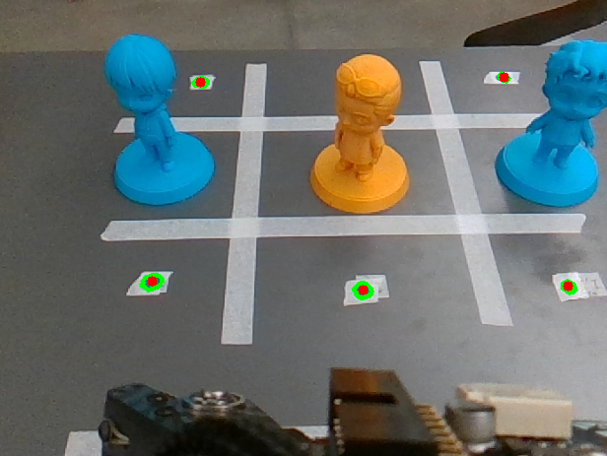
Figure 18. Centroid detection for color green

The other color detection functions we created were specific to our camera frame. First, an order_centroid() function was made to correctly order the centroid to match the grid, see Camera Class in Appendix A. It normalizes the y for each row on the grid, then orders the centroids correctly by ascending x values. The inputs are just the centroid list, and it returns an ordered centroid list. Next a stable_frame_centroids() function was created to ensure that the centroids we are reading are reliable , see Camera Class in Appendix A. This ensures that there are repeated frames with the same centroids, making the reading more reliable. It takes input of the color and then derives the centroids from our previous functions. Finally, a color_on_top() function was created to detect color on the top middle part of the frame, see Camera Class in Appendix A. The reason for this is that when an object is placed in the middle grid, the centroid in the top middle grid is also covered. This means there is no way to distinguish between when one object is placed in the middle versus two objects of the same colors placed in the top middle and middle grids. We initially tried to solve this be referencing the depth of the frame, but this was too unreliable. The solution we chose was detecting if there was color on the top pixels of the frame, as an object placed in the top middle grid gets cut off based on our camera frame.

Depth Detection:

The depth sensor on the Intel RealSense D415 camera was used to differentiate similar colored objects from each other. The pyrealsense2, numpy and cv2 libraries were used to extract depth information as seen in Figure 19. First, the depth frame and array of depth values were obtained through the get_depth_frame() method, which called methods from the pyrealsense2 library. This method returns an instance of the pyrealsnse2 library called depth_frame, which is needed for built-in methods such as get_distance(). It also returns a NumPy array of depth values in millimeters. Furthermore, the get_distance() method takes an input of the depth_frame and the row and column indices of where you want to get the depth. It uses the built-in get_distance() method from the pyrealsense2 library. Finally, the live_depth_feed() method uses the cv2 method to continuously gain depth frames and converts them to a colormap as seen in the figure below.

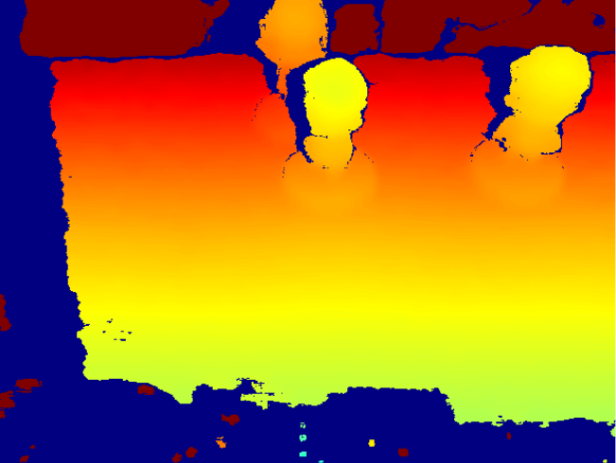
Figure 19. Snapshot of the live depth feed colormap

This information was used in collaboration with the information gained from color detection to gain a clearer picture of what pieces are on the board. All of this was defined in the get_true_contour() function, see Camera Class in Appendix A. First, we take the depth array only inside our color contours. Then we find the depth contours within that area and thicken the edges. Thickening is needed for the next step where we subtract this edge from the color contour, ensuring that there is enough pixel difference to create new contours. Finally, new contours are generated based on the subtracted edges, differentiating between two objects of the same color but with different locations. Unfortunately, this was too unreliable as our pieces had a lot of variable of depths, preventing the system from only seeing our two distinct objects.

Tic-Tac-Toe Algorithm:

Because Tic-Tac-Toe is a two-player, turned-based and deterministic game, the minmax algorithm can be used to allow the robot to play perfectly. The minmax algorithm evaluates how good the move is by assuming that the opponent is playing perfectly. It weights each move by subtracting the number of turns from the original score of 10 for a robot win, and gives a negative 10 score plus the turns for a robot loss. This results in the robot wanting to win faster, and it doesn't penalize the robot as much for a long loss. The minmax function is from the robot's perspective, so the human player will want to minimize the robot's score while the robot will want to maximize its own score. The algorithm uses recursion to test the future sequences that could occur from the robot placing a piece at one of the available moves. It then plays the game and recursively loops through the possible outcomes and will weigh the move based on that. It assumes perfect play by choosing the move with the maximum score for the robot and the move with the minimum score for the human. The function will then return the worst-case score for the robot of that move, as it assumes the player will play perfectly, and this is the best score the robot can guarantee. To finish the entire algorithm, a best_robot_move() method is called to loop through all the available moves for the robot, gain the score from minmax, and output the highest score.

To utilize this algorithm, several helper methods were implemented, see tic_tac_toe_alg Class in Appendix A. The methods in the class take in the current state of the board through a NumPy list called moves, which contains a 0 for empty, 1 for a human move, and 2 for a robot move. From this, the available_moves() method can determine what moves are available for the robot, the winner() method determines if there was a winner, and the is_draw() class determines if the game ends in a draw. The available_moves() method is straightforward in identifying which indices have a 0. The winner() method takes in the 8 possible winning outcomes and tests to see if the moves array matches it, and the is_draw() method checks if no winner has been determined. The apply_move() method will take in the moves array and the index of the best move and will then mutate the array such that it leaves a 2 in the right index.

Game Controller

All of the above code and classes are combined in a game controller class, see Appendix A. It handles and calls classes and methods when necessary, based on the run_game() loop. This loop runs indefinitely with built-in UI, allowing the user to play multiple games back-to-back. The theory behind the loop is to constantly check if there has been a winner or a draw. It will then loop through, getting the user placement and available spaces from the camera class, and calculating the best move for the robot to allow it to properly play against the user. It does this through a NumPy array called moves. This array holds a 0 for an empty space, a 1 for the player move, and a 2 for the robot move. The cycle of looking at the user move, calculating and placing the robot move until a draw or a win is detected.

Some helper methods are needed for this loop to run. First, the get_computer_move() will get the best move based on the input of the moves array. This is needed as an input for the move_robot() method. The move_robot() function uses the pick and place functions to correctly move the robot pieces to the algorithm's best choice, using the coordinate dictionary.

Furthermore, the set_centroids() method gets and returns an array of centroids from the grid. It will get the location of each centroid and will be a length of the amount of centroids present.

The find_missing() method will find the missing centroid of the original grid and put a 1 in the cell that is missing. This missing cell corresponds to the cell where the user placed their token. It does this by using the initial centroid location as the generated initialization. It then gets a new centroid map again from the set_centroid() method and calculates the distance of each centroid to the original centroids through the Pythagorean theorem. Finally, it compares this distance and tests to see if that centroid is close enough to the original centroid, and those that do not fit within the threshold are the missing centroids. This will then place a 1 in those spots if they don’t already have a piece present. One exception to this is the edge case, where the camera cannot see two cells due to the figure overlapping the green centroid. This is where we check if there is color present at the top of the camera's frame. If there is color than a token is at the top cell, but if not, then it is just in the middle.

Project Performance and Results
Overall, the project performed well and successfully met the primary goals of the final design. The team developed an autonomous tic-tac-toe playing robot that integrates robotic motion, camera-based detection, and game logic into a single system. The robotic arm was able to pick up tokens from the starting area and place them accurately into the correct board positions. During testing, the system demonstrated reliable and repeatable pick-and-place performance, and the robot consistently followed the tic-tac-toe algorithm to make valid moves and complete games against a human player.
A key achievement of the project was improving the placement accuracy of the tokens. Initially, the robot released tokens from too high above the board, causing them to wobble or potentially fall off the table. This issue was resolved by adjusting the end-effector position so that tokens were placed closer to the board surface and at a controlled angle, resulting in more stable and precise placement.
The vision system also played a critical role in the project’s success. The RGB camera was used to distinguish between two classes of tokens: blue (human player) and gold (robot). Early testing revealed challenges when using a gray token, as it blended with the gray table surface and made color detection unreliable. To address this, a gold token was introduced, providing strong contrast and significantly improving detection accuracy. After this change, the camera system was able to more consistently identify token positions and board states.
In addition to color detection, the system used contour detection to identify token shapes. However, some limitations were observed. For example, when two tokens were stacked or closely aligned, the system could interpret them as a single object, leading to incorrect board recognition. Similarly, when the center cell was occupied, it could partially block the camera’s view of tokens in the back cells, affecting centroid detection and positional accuracy.
While the overall performance was strong, there are areas for improvement. The robotic arm speed was sufficient but could be optimized further through additional tuning. Some movements required intermediate waypoints to avoid collisions with existing pieces on the board or tokens in the staging area. Additionally, the user interface was primarily tested within the team, so broader user testing could help refine usability. Future improvements could include faster motion control, enhanced vision calibration for varying lighting conditions, a more robust user interface, difficulty settings, and more robust object detection to handle occlusions and stacked pieces.
Despite these limitations, the project successfully demonstrated a complete and functional mechatronics system capable of autonomously playing tic-tac-toe in a reliable and repeatable manner.

Documentation of Implementation

Below is a list of the libraries and hardware used for this project. Note that below is a brief description, and more detail is included in the theory section.

Libraries | Description
Pyrealsense2 | This library was used to obtain depth information from the Intel RealSense D415 camera. Methods such as get_distance(), and pipeline(), which is a class to initialize the camera.
NumPy | This library was used to work with OpenCV cv2 as it represents the frame in a NumPy array.
CV2 | This library was used for color detection, and many of the classes and methods used are shown above in the theory section.
Quanser Hardware, QARM | Software provided by Quanser, sourced from Dr. Hasan. Contains several functions including read/write functionality for the arm, inverse kinematic functions specifically for the QARM geometry, and facilitates I/O using python.

Hardware | Description
Quanser QArm 4DOF serial manipulator | A 4DOF serial manipulator that can pick up and place our tic tac toe pieces, and maneuver through the workspace.
Intel RealSense D415 camera | This camera contains an IR projector and two IR receivers for RGB and depth detection. We used both for object detection but ended up using only RGB due to depth noise issues.

Appendix

Appendix A: GitHub repository: https://github.com/mattthewmoore/tictactoe_QARM.git

Sources/References:

- Pereira, V., Fernandes, V. A., & Sequeira, J. (2014). Low cost object sorting robotic arm using Raspberry Pi. In 2014 IEEE Global Humanitarian Technology Conference – South Asia Satellite (GHTC-SAS) (pp. 1–6). IEEE. https://doi.org/10.1109/GHTC-SAS.2014.6967550
- OpenAI. (2026). ChatGPT (GPT-5.2) [Large language model]. Prompt: “Help with a timetable for a vision-based robotic arm sorter.”
- Akshaymogaveera. (2021). Akshaymogaveera/object-sorting-using-robotic-arm-and-image-processing: Sorting objects of different colors using robotic arm and using Computer Vision (image processing). GitHub. https://github.com/akshaymogaveera/Object-sorting-using-Robotic-arm-and-Image-processing?tab=readme-ov-file
- Edje Electronics. (2025, January 8). How to train YOLO object detection models in Google Colab (YOLO26, YOLO11, YOLOv8) [Video]. YouTube. https://www.youtube.com/watch?v=r0RspiLG260
- Naveen. (2025, November 13). Ros 2 pick and place system with Edge Impulse. Hackster.io. https://www.hackster.io/naveenbskumar/ros-2-pick-and-place-system-with-edge-impulse-312bc4?utm_source=chatgpt.com
- Robotics, E. (2024, May 23). Educational sorting system using UltraArm P340. Hackster.io. https://www.hackster.io/Elephant-Robotics-Official/educational-sorting-system-using-ultraarm-p340-1a87dd?utm_source=chatgpt.com
- Quanser Inc. QArm User Manual. Version 2.0, 14 Jan. 2021, Quanser Inc.
- Ultralytics. (n.d.). Python usage. Ultralytics Docs. https://docs.ultralytics.com/usage/python/
- ME 423 Lab 4 – Cubic Spline (Manipulator-space trajectory planning and waypoint-based pick-and-place).
- OpenAI. (2026, March 18). ChatGPT response to a prompt about the Tic-Tac-Toe minimax algorithm [Large language model]. https://chat.openai.com/

