

**EPL653: Computer Games**

**Software Technology**

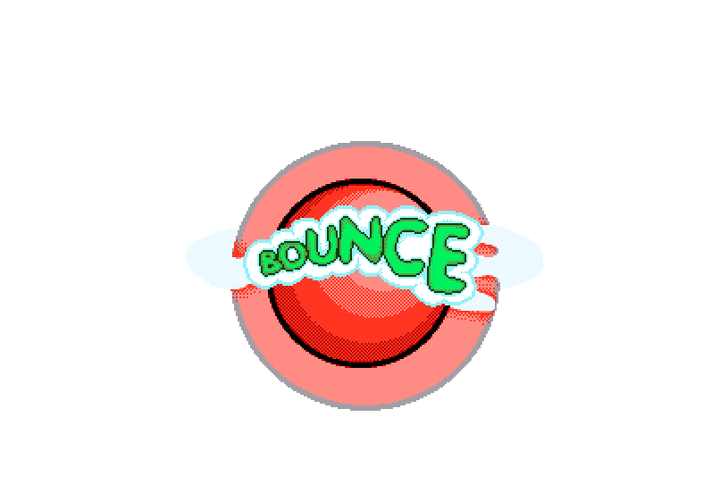

Due Date: 17/05/2018

Agathoklis Vakanas ID: 963188

Aliki Gregoriou ID: 932728

Jiayi Fu ID: 1300137

Contents

Introduction 3

Game Flow 4

Character and Controls 6

Main Gameplay Concepts and Platform Specific Features 8

Game World 9

Interface 12

Mechanics and Power- ups 15

Enemies 17

# Introduction

Remember playing Bounce on your old Nokia phone? This game is a fan-made remake of the Bounce game, which will travel you back in time and bring back your childhood memories.

Bouncy is a game where you control a small ball in a dangerous world. You bounce and roll the ball around each level, avoiding enemies and collecting the rings you need to unlock the exit to the next level. Use rubber blocks to bounce higher or even reverse gravity.



# Game Flow

The player can move the ball by pressing the right, left or jump button. In the first level, there is no pressure as the player seeks out their first rings and picks them up in order to learn the basic ideas of the game and how to play it. When we collect all the rings the door to the next stage will unlock and by going through that door the stage will complete and we will advance to the next level.

With each level, the difficulty is increased as more obstacles and stronger enemies appear to stop us from completing the level. The rings as harder to find and some special items give you power ups to help you to collect specific rings.

We have two scoring systems:

1. Star system:
   1. First Star: Complete the level
   2. Second Star: Complete the level without lose a life
   3. Third Star: Complete the level without lose a life and collect all the collectables

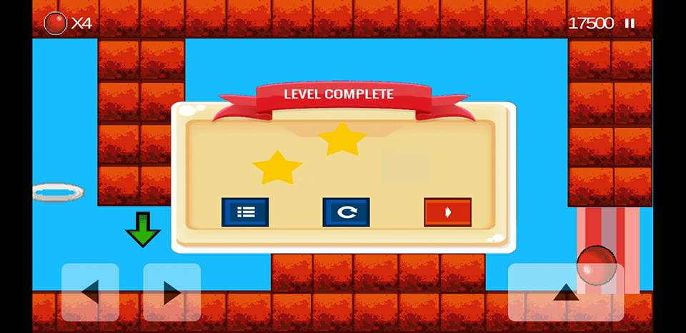

1. Leaderboard:

The player earns points for each collectable item, in order to increase the difficulty, each of this point is calculated by

Collectable point \* current lives

Once the player complete the game or lose, we sum the points from each level and store it in the Leaderboard. The Leaderboard keeps track the top ten scores.

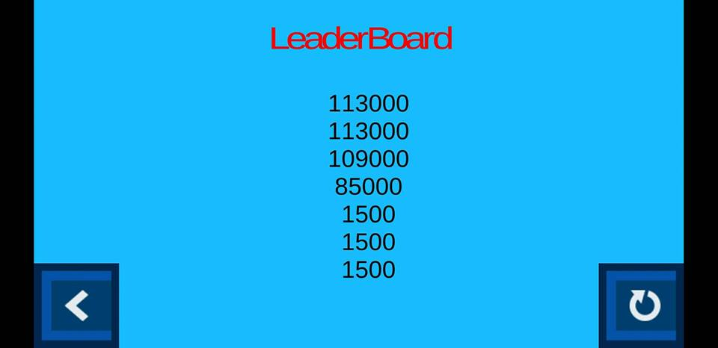

# Character and Controls

**Bouncy:** A starting bouncing ball player can customize his ball's color. The player can choose the color of bouncy by clicking on Bouncy in the Homepage. By collecting specific items Bouncy can change its size to go through some smaller rings and areas.

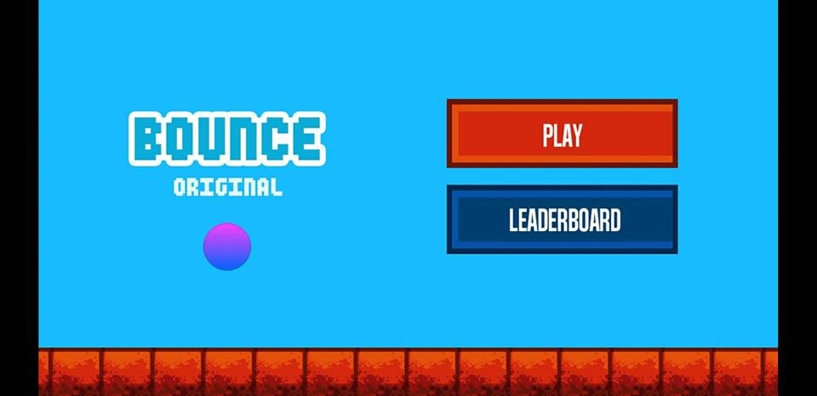

   

Bouncy can move right, left or bounce by pressing the counterpart button shown on the screen. In the first level, there is no pressure as the player seeks out their first rings and picks them up. The no pressure rule in the first level is done to help the player to understand and learn the basic ideas of the game.

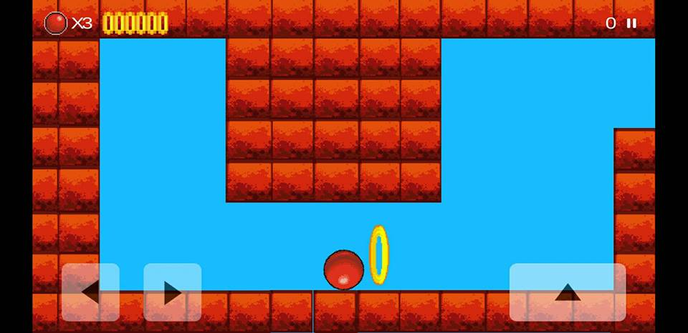

Right Button

Jump Button

Left Button

Bouncy can gain many power-ups like increasing his jumping ability or changing his size. More details about these power-ups can be found in the power-ups subsection.

# Main Gameplay Concepts and Platform Specific Features

Story mode:

The player will start from the first level and try to complete the game. Every level will have increased difficulty. If the player restarts the game, the first level will loaded, and the points will also restart and set to zero.

Game Genres:

* Arcade
* Puzzle

Platform:

* The game can run mainly on Smartphone devices.
* The game can also run on Windows.

# Game World

Our world consists of three stages which are linearly connected. By going through the locked door of each level, we continue to the next stage. Every level contains enemies with special abilities that try to stop us from collecting the rings and escaping through the door. Also there are areas that Bouncy can obtain different power ups in order to complete the stage. The enemies and our power ups are explained later in the Game Development Document.

Many different items can be found in each level:

1. **Crystal Balls:** Collecting them will earn you an extra life, although you may only have a maximum of 5 lives at a time. You receive 1000 points for collecting a crystal ball, as well as an extra life.



1. **Checkpoint:** These are the square crystal things. Collecting these will only earn you 500 points, but they prevent you from restarting the level as they are checkpoints that save you game image at that point in time.

**** 

1. **Rings:** These are the most important items in the whole game. As the object of the game is to progress to the next level, you have to collect rings in order to fulfil that goal. You have a set amount of rings to collect in each level, and there is the exact number of rings in that level. For example, if you have to collect 6 rings to pass a level, then that level in question will only have 6 rings in it.
2. 
3. **Door:** Silver doors that can only be unlocked upon collecting all the rings in a single level. They are also the only way to progress to the next level.



**Water:** When Bouncy is big it flowed but when it is small, it sinks.

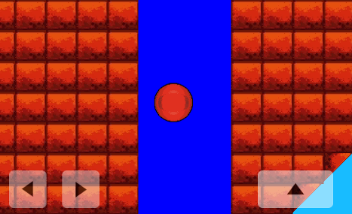

**Bouncy Blocks:** the Bouncy can jump higher when it interacts with these blocks. But when we leave the blue boxes and return to the normal ones this power up is lost

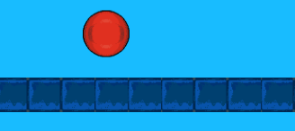

In addition, you can find more info about our enemies and the power Ups in the enemy subsection.

# Interface

Bouncy is 2D third-person camera designed game for Smartphone devices and is only available in English. Developed in Unity 5.2.3f1.

User Interface:

We aim for the UI to be minimal and represented through in-game assets. Data that needs to be presented to the player will be offloaded as much as possible through graphics and sound effects. The player determines the color of Bouncy.

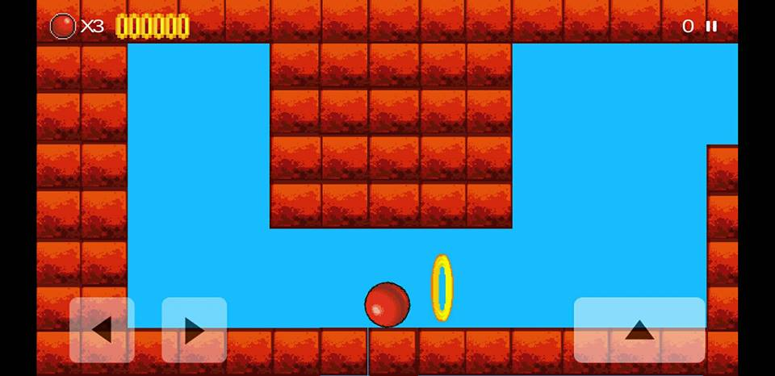

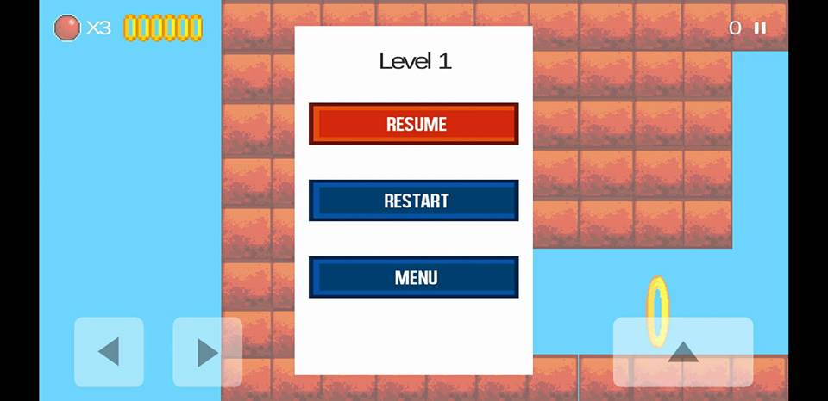

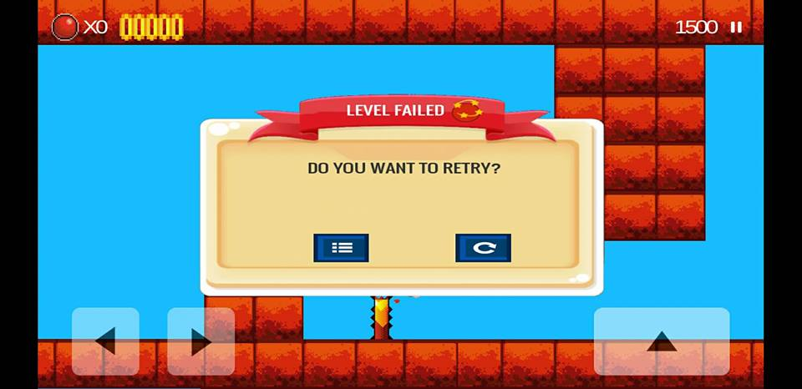

HUD:

We will display the current game score, the remaining lives of the player, the remaining rings of the stage and the time. These should be as small as possible not to distract the player.

2D Assets:

Because our game is 2D, every object’s body/presentation in our game (e.g. Bouncy, items, enemies) is created by using sprites. Then we added the functionality. The sprites that we used can be download for free at the following website:

<https://www.spriters-resource.com/mobile/bounceoriginal/>

Moreover, the link contains pictures about the layout of each level that the original game had.

Also, we used the Unity Standard Assets CrossPlatform in order to make our game run on Smartphone devices.

Audio Design:

Sound Effects will vary but be expected. Specifically, when Bouncy finds a ring or gets hit by an enemy we will hear a different sound effect. These sound effects are found in the collectable items and the rings.

Music Design:

Even though the original game doesn’t have music playing in the background, we decided to add smooth, ambient, synthesized music that will play during the entire course of a game. As we processed the stages, the background music becomes quicker. The levels, the Homepage and the leaderboard have different background music.

The music that we used can be download for free at the following website:

https://www.bensound.com/

# Mechanics and Power- ups

Gameplay mechanics:

1. **Animation** : Portal opening when we collect every ring in current level
2. **Collision Detection**: Everything we touch. E.g. rings, collectable items, walls
3. **Audio Rendering for Games**: Sound effect in collectable items and the rings. Also background music in each scene.
4. **Physics in Games**: Bouncy and Jack are moving with Physics, they have rigidbody.
5. **Particle Systems:** In level 3 we added a fountain of youth in order to make our game prettier.

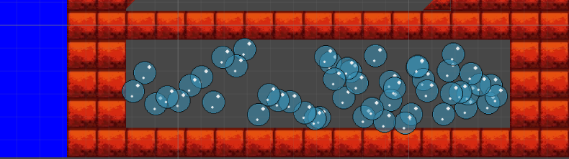

Power - Ups:

As we have mentioned above Bouncy can gain different abilities. To activate a power-up, just touch it. Below is a small sample of these power ups:

**Shrink:** When Bouncy touches a funnel, he shrinks. This is extremely helpful because there are smaller rings that Bouncy can’t pass in his normal size.



**Stretch:** When Bouncy touches a pipe he stretches. This is extremely helpful because Bouncy wants to regain his normal size.

U:\git\epl653_bounce\Bouncy\Assets\Sprites\pumper@2x.png

**Power Speed:** When the player touches the box, it gains speed for 10 seconds. The player can see the remained time of this powerUp from the yellow bar below

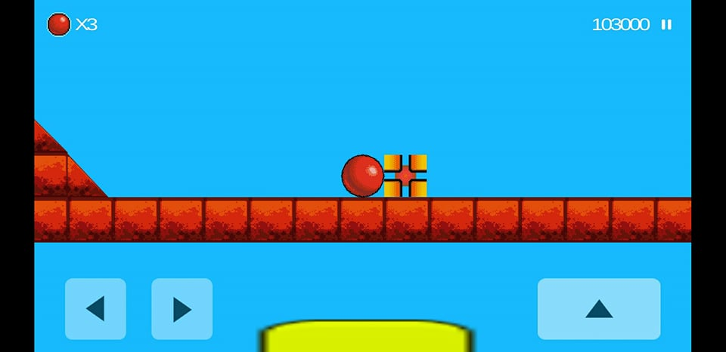

# Enemies

Each enemy has its devastating attacks and intelligence. Below is a small sample of our enemies:

**Needles:** Motionless but block your movement. They are brownish and are like a stick. Avoid touching them because they will pop you.

**U:\git\epl653_bounce\Bouncy\Assets\Sprites\thorn@2x.png**

**Jacks:** Jacks are like a silver arrow and you can encounter them from Level 2 onwards. They are similar to needles, as they can pop your ball. However, they usually move vertically and are bigger than needles. Therefore, it is harder to escape from.

