Stroke Research

Below is a brief literature review into the cost-effectiveness of utilizing extra diagnostic procedures, with a focus on CT perfusion, when choosing patients for treatment for acute ischemic strokes. This literature review shows examples of research into this question, the different ways stroke data has been used to answer this question, and their findings. The aim of this piece of work is to help justify the need for further research into the use of CT perfusion in the NHS, as well as to help guide and prompt potential methods of carrying out such research.

- A 2018 paper ‘Cost-effectiveness of targeted thrombolytic therapy for stroke patients using multi-modal CT compared to usual practice’

This paper looked at how cost effective it is to use multimodal computed tomography imagining (MMCT) as a way of selecting patients for treatment compared to ‘usual clinical practice’ – which in this case is said to be a non-contrast brain computed tomography (NCCT). MMCT includes the use of a CT perfusion machine. The authors performed a cost-utility analysis, looking at the quality-adjusted life years (QALYS) for each scenario, and the associated costs of each scenario. The authors used a range of willingness-to-pay values (that being how much an extra year of quality life would be worth to a person in monetary value) and found that the net benefit from using MMCT was always positive, i.e. cost effective. This paper used data from the International Stroke Perfusion Imaging Registry (INSPIRE).

- A 2010 paper ‘Cost-effectiveness of multimodal CT for evaluating acute stroke’’

This paper investigated a similar situation. The authors used a Markov model to compare MMCT with NCCT in a group of hypothetical nonhemorrhagic stroke patients with 3 hours since symptom onset who were potential candidates for IV tPA (tissue plasminogen activator). Using their model, they found that over a 3-month time horizon, the use of MMCT (CT scans including the use of CT perfusion) had lower costs (-$1716) and generated higher QALYs. This paper assessed cost effectiveness in a similar way to the last, by comparing costs of the extra diagnostic procedures to the benefits (in terms of an individual’s willingness to pay) of extra quality-adjusted years added. For a willingness to pay of $100,000 per QALY, the model showed that MMCT was the cost-effective choice 100% of the time. Over a lifetime period in the authors’ hypothetical model, MMCT had lower cost (-$2058), increase QALYs, and for a willingness to pay of $100,000 per QALY, was the cost-effective choice 90.1% of the time.
The author’s model:
The diagram below illustrates the chain of events their hypothetical patients could go through depending on which diagnostic procedure was followed, NCCT or MMCT.
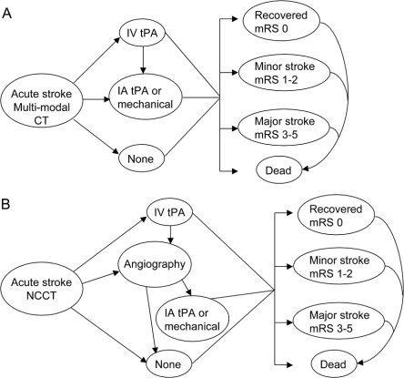
The costs, probabilities, and utilities applied to this framework are shown in the table below:
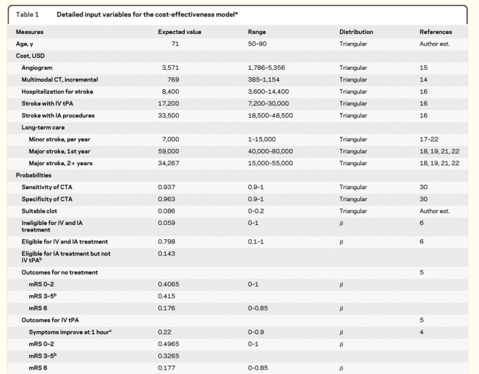
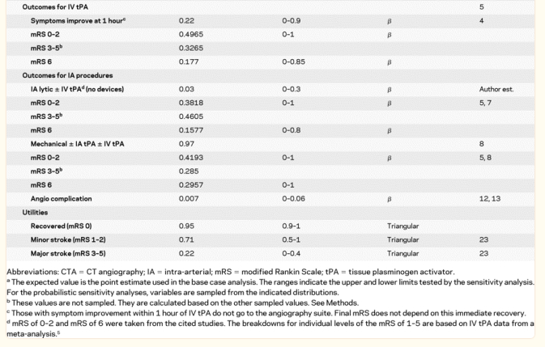

- A 2010 paper ‘Cost-Effectiveness of CT Perfusion for Selecting Patients for Intravenous Thrombolysis: A US Hospital Perspective’
This paper also looks at the cost-effectiveness of using CT perfusion (CTP) to select patients for stroke treatment. Despite the increase in imagining costs that are associated with using CTP compared to NCCT, and the potential for delay in treating patients, the use of CTP to select patients was found to ‘decrease mortality and improve functional outcome in patients on discharge from the hospital’, with costs to the hospital being comparable. When the treatment time window was extended from 3 hours to 4.5, the use of CTP was shown to be cost saving for the hospital. In the same way as above, this paper estimates cost-effectiveness by comparing the additional costs that CTP brings with the added QALYs, in terms of willingness to pay. The authors note that when considering the full benefits of improved outcomes that CTP can offer, even with a far lower willingness to pay, that of $50,000 per QALY, it is still cost-effective due to the reduced medical costs in the long run.
The authors’ model:
Rather than using the more standard Markov model, that was used in the previous paper, this paper uses a decision tree model. The table below shows the costs and outcomes associated with the two diagnostic scenarios; usual care compared to the use of CTP:

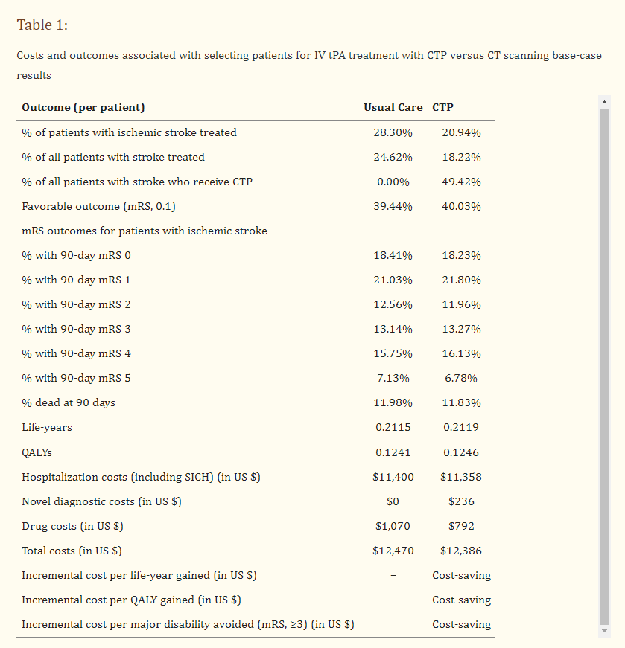

The authors used their model to run 10,000 simulations with hypothetical stroke patients. In just under 60% of these simulations, CTP had lower costs and increased QALYs that standard CT. CTP selection was cost-effective in 89% of simulations, with it being cost saving in 78%. The results are displayed in the graph below, showing the effect the use of CTP had on cost and QALYs:
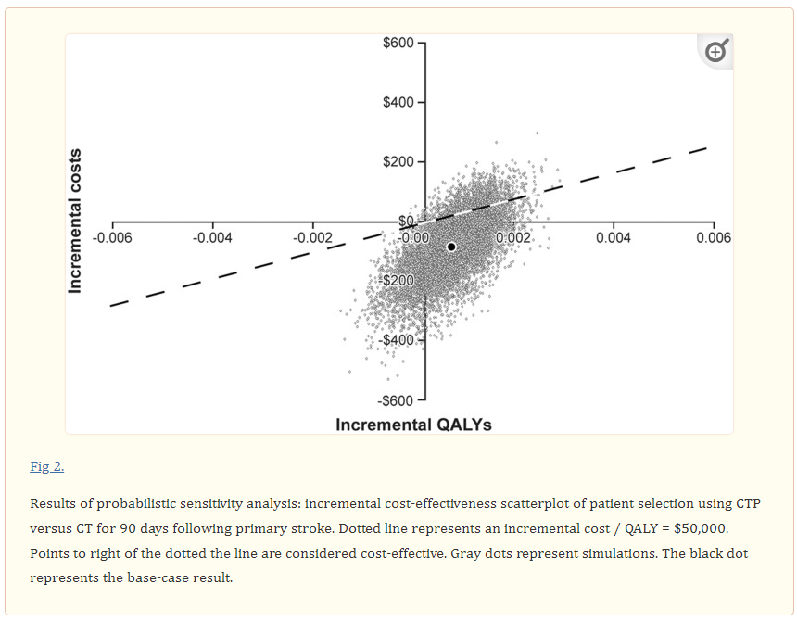

- 2012 UK based paper ‘Economic Impact of Using Additional Diagnostic Tests to
Better Select Patients With Stroke for Intravenous Thrombolysis in the United Kingdom’

The authors of this paper ran simulations on their decision-making tree model to investigate the costs and benefits of the use of CTP and MRI in the treatment of acute stroke patients. They ran 10,000 simulations to see the difference in costs and outcomes of different diagnostic procedures. The diagram below shows the decision tree used for their model:

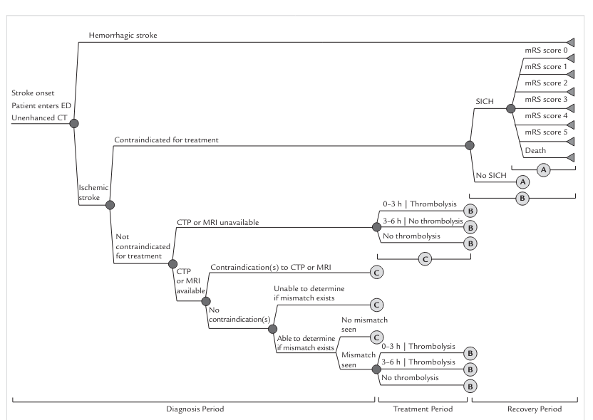

The authors state in their results that ‘We found that with better selection of patients for thrombolysis, there is a potential benefit in terms of reducing costs and improving disability and QALYs.’ The authors do note that this model assumes that these technologies (CTP) are readily available for patients as they arrive at the hospital and there are no additional costs to accessing them (eg. The cost of more specialized stroke care physicians being available). They note that this is unlikely to be the case. However, they say the point of the paper is to show that when this technology is available to patients and staff, it is cost effective to make use of it. Below are the results from the study, showing CTP generating lower costs and higher QALYs from their simulations.
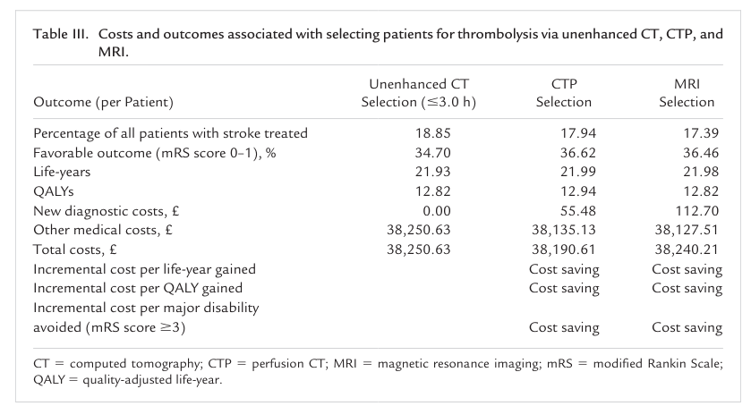

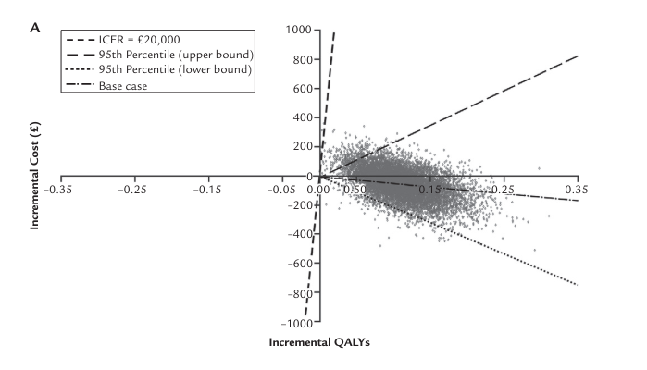

These results show that CTP is associated with lower costs, as well as increased QALYs, very much in line with the rest of the literature covered so far, even with findings from U.S. hospitals. While UK-based research is preferable when building an argument for the cost-saving nature of CTP in the NHS, it is reassuring to see that the results of this research question seem to be incredibly similar between US hospitals and UK.
Out of all the papers covered so far, this paper just discussed warrants the closest look. Not only due to it being based in the UK, but also because the breakdown of methodology and costs is the most detailed.

- A 2024 Netherlands based paper ‘Cost-effectiveness of CT perfusion for the detection of large vessel occlusion acute ischemic stroke followed by endovascular treatment: a model-based health economic evaluation study’
This paper compares the different outcomes of using CTP alongside regular clinical diagnostics including CT angiography (CTA) and non-contrast CT (NCCT, rather than regular clinical diagnostics alone, to select patients for stroke treatment.
The authors used a Markov model, running simulations for hypothetical patients, with the different pathways shown below:
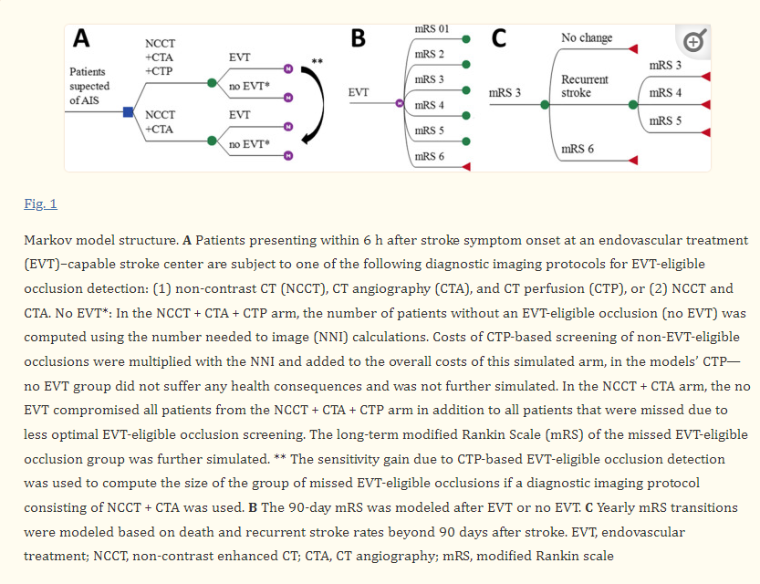

Below is the formula the authors used to calculate the net monetary benefit from the use of CTP.
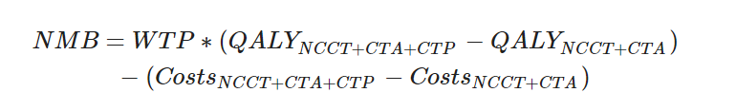
NMB: Net Monetary Benefit
WTP: Willingness to Pay (this was set to €80,000, which at the time of writing this is roughly £68, 640).
NCCT: Non-Contrast CT
CTA: CT Angiography
CTP: CT Perfusion

The authors illustrated their incremental cost-effectiveness ratio (ICER), (the difference in costs divided by the difference in outcomes, in this case QALYs) in a scatter graph below:
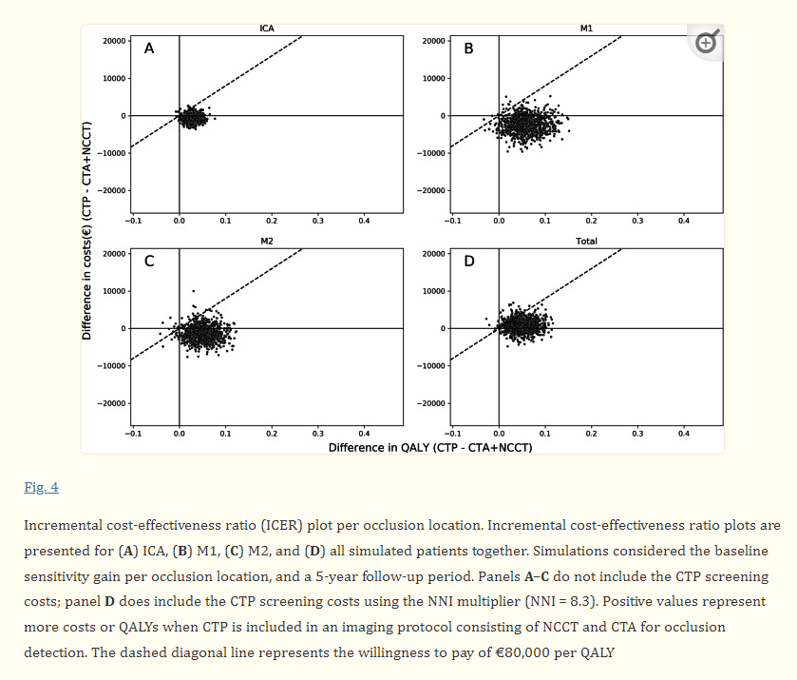

Panel D represents the ICER when the CTP screening costs are included, with the majority of simulations having costs still fall below the WTP per QALY (the dotted diagonal line).

The authors listed their key points as:
• Using CT perfusion to detect an endovascular treatment-eligible occlusions resulted in a health gain and cost savings during 10 years of follow-up.

• Depending on the screening costs related to the number of patients needed to image with CT perfusion, cost savings could be considerable (median: € − 3857, IQR: [€ − 5907; € − 1916] per patient).

• As the gain in quality adjusted life years was most affected by the sensitivity of CT perfusion-based occlusion detection, additional studies for the diagnostic accuracy of CT perfusion for occlusion detection are required.

General Summary
The summary above shows some examples of how previous research has utilized stroke data to illustrate the potential gains that using CTP to select patients for stroke treatment can have. The results overwhelming point to CTP resulting in lower costs, as well as QALYs increasing. The research uses robust models to run simulations on a variety of possible outcomes, weighted with probabilities derived from stroke data, to show the positive outcomes of using CTP.
While these results can offer compelling evidence that increased usage of CTP within a stroke unit could be not only cost-effective but in fact cost-saving, there may be some issues with the methodology that need addressing. In terms of weighing up costs and benefits, the current research typically uses the average willingness to pay for an extra year of life, quality adjusted. It is not clear how this would be contextualized in the NHS’s needs for decisions to be cost neutral where possible. The argument could be made that there is much evidence to suggest that CTP leads to better treatment outcomes, greater clinical efficiency and short- and long-term savings in the form of faster patient turnover and lower chances of long-term disability. However, further research will need to be done to try and justify and quantify exactly how much these factors will reduce costs for hospitals.

