102Day-04-Operationalise-CLU

AI102-Day04-99-ResourceGroup-Deleted.png
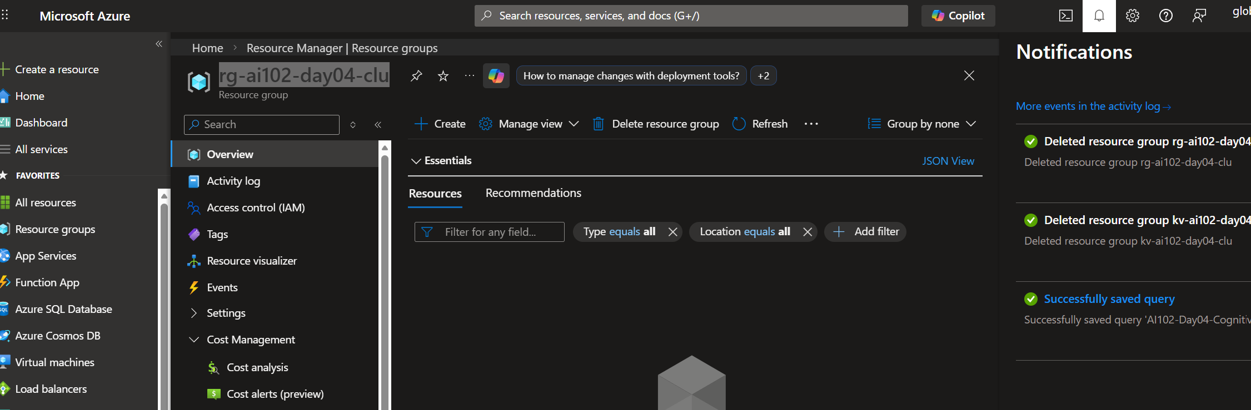

AI102-Day04-Phase02-06-RBACAssignment.png
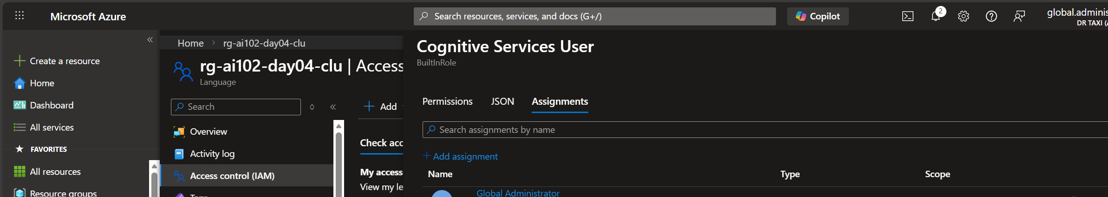
AI102-Day04-Phase02-05-KeyVaultSecret.png
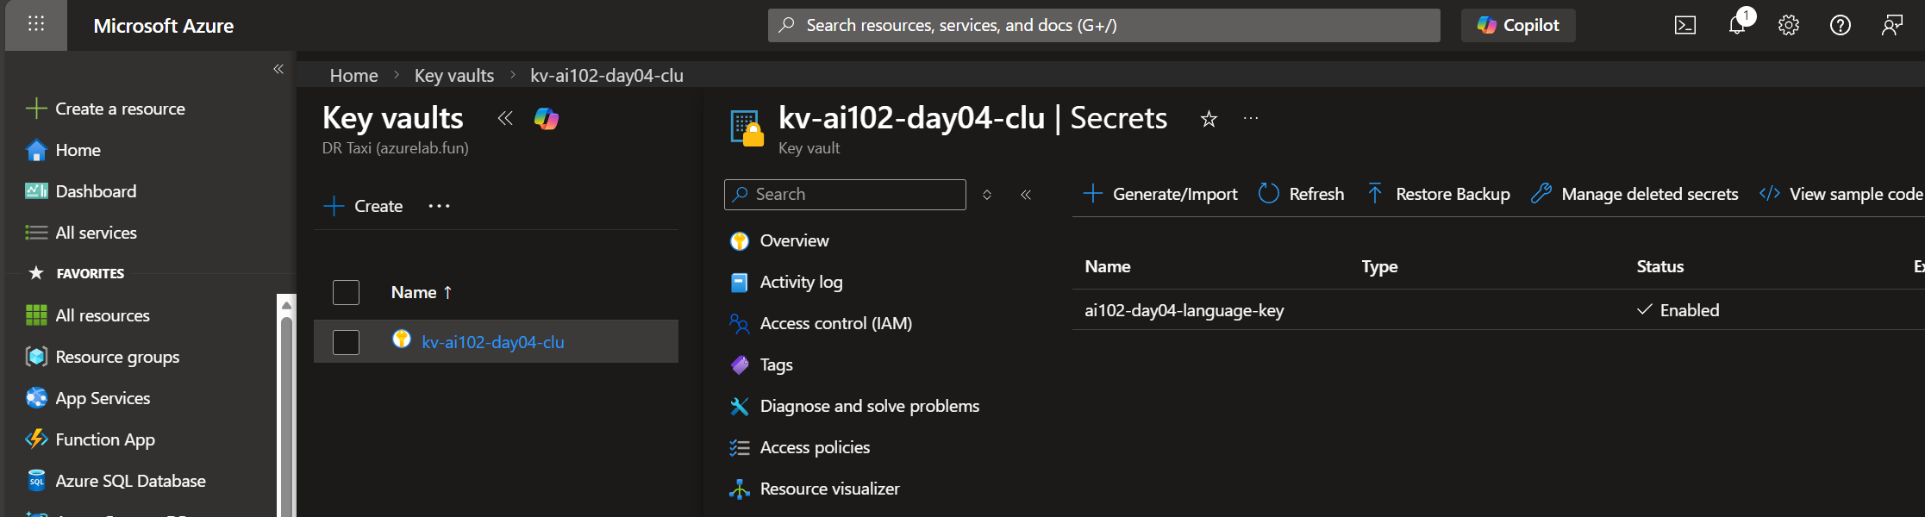

AI102-Day04-Phase02-04-KeyVaultCreated.png
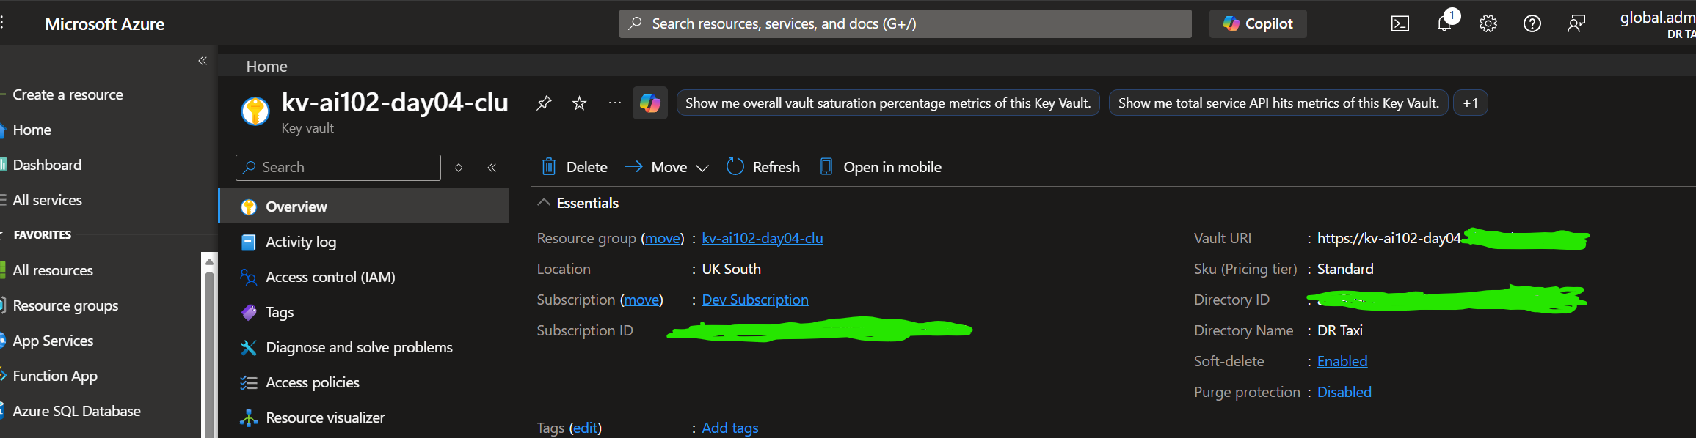

AI102-Day04-Phase02-03-BudgetOverview.png
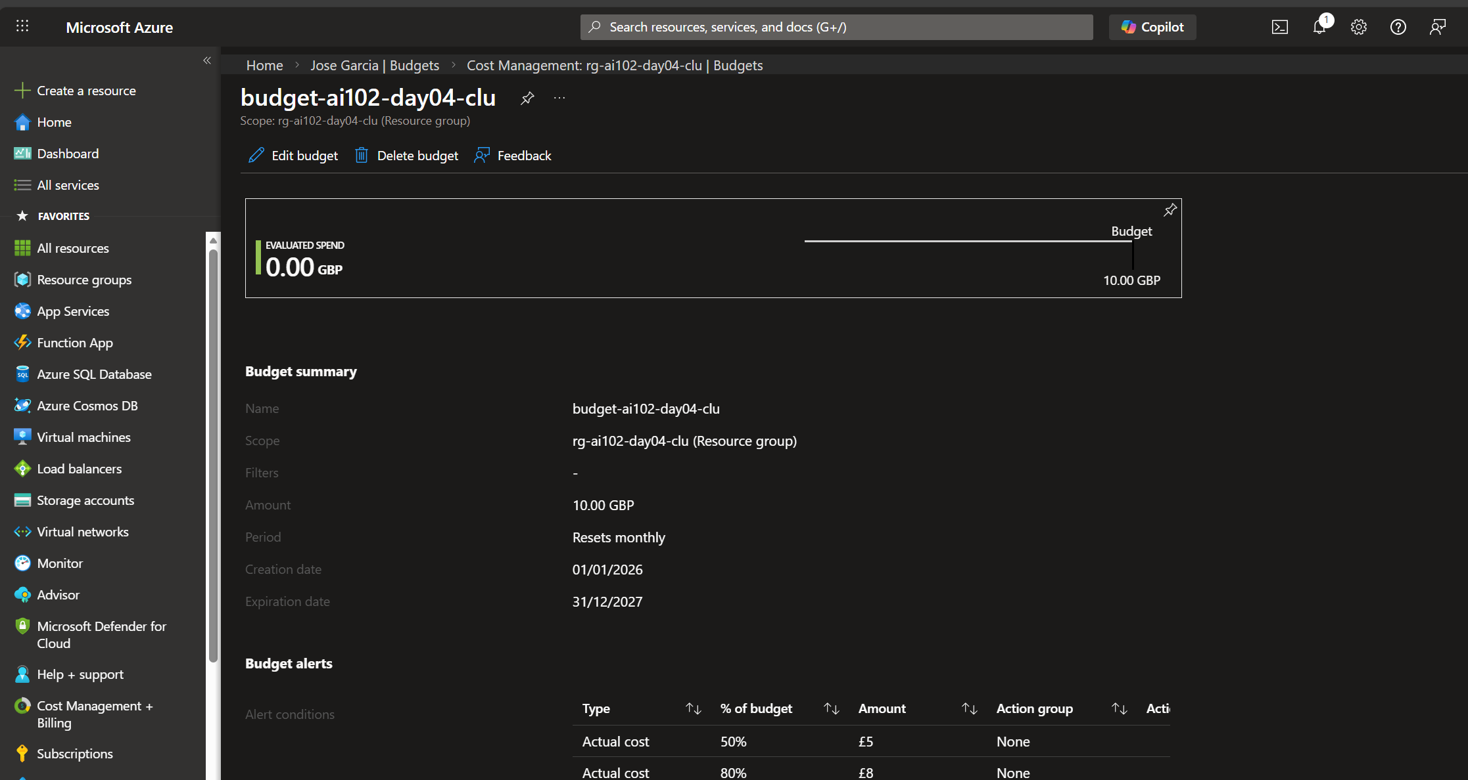
AI102-Day04-Phase02-02-LogAnalyticsQuery.png
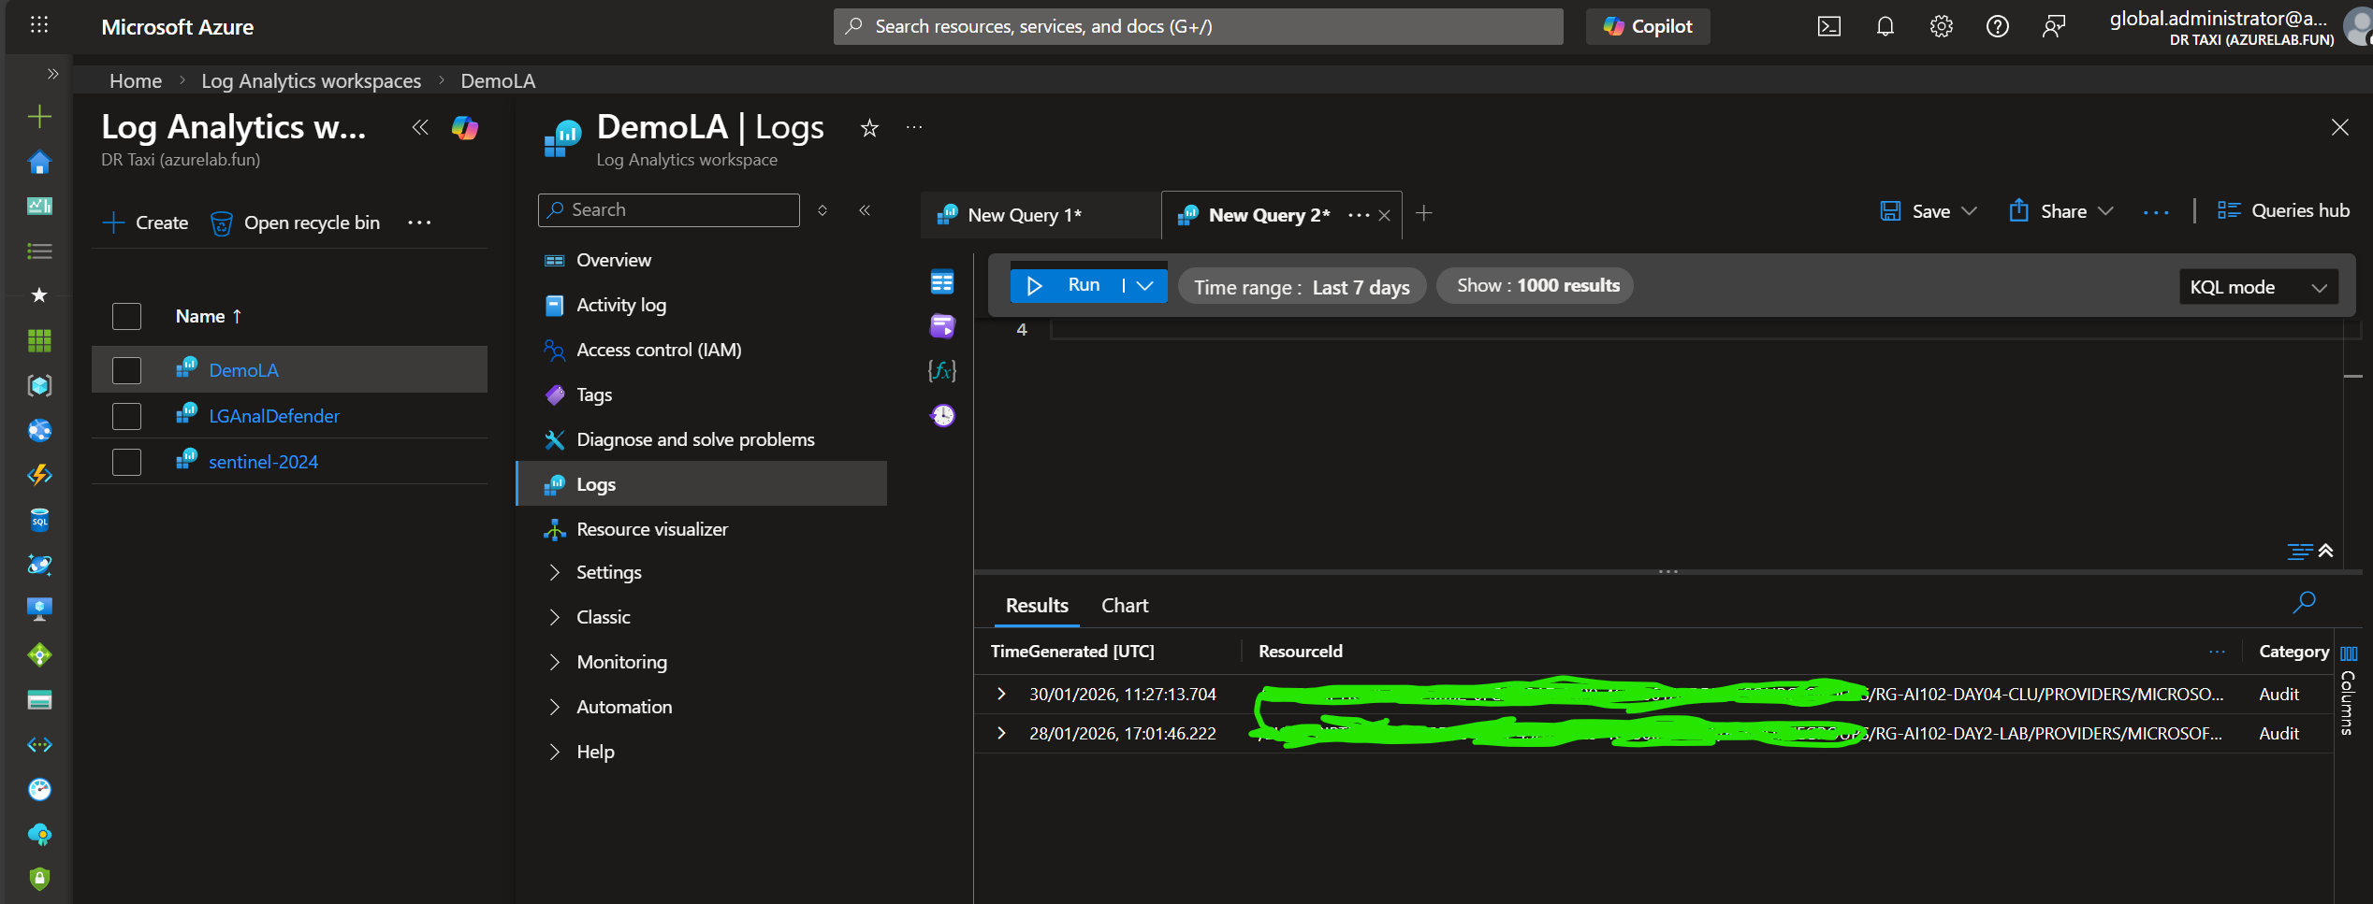

AI102-Day04-Phase02-02-LogAnalyticsQuery.png
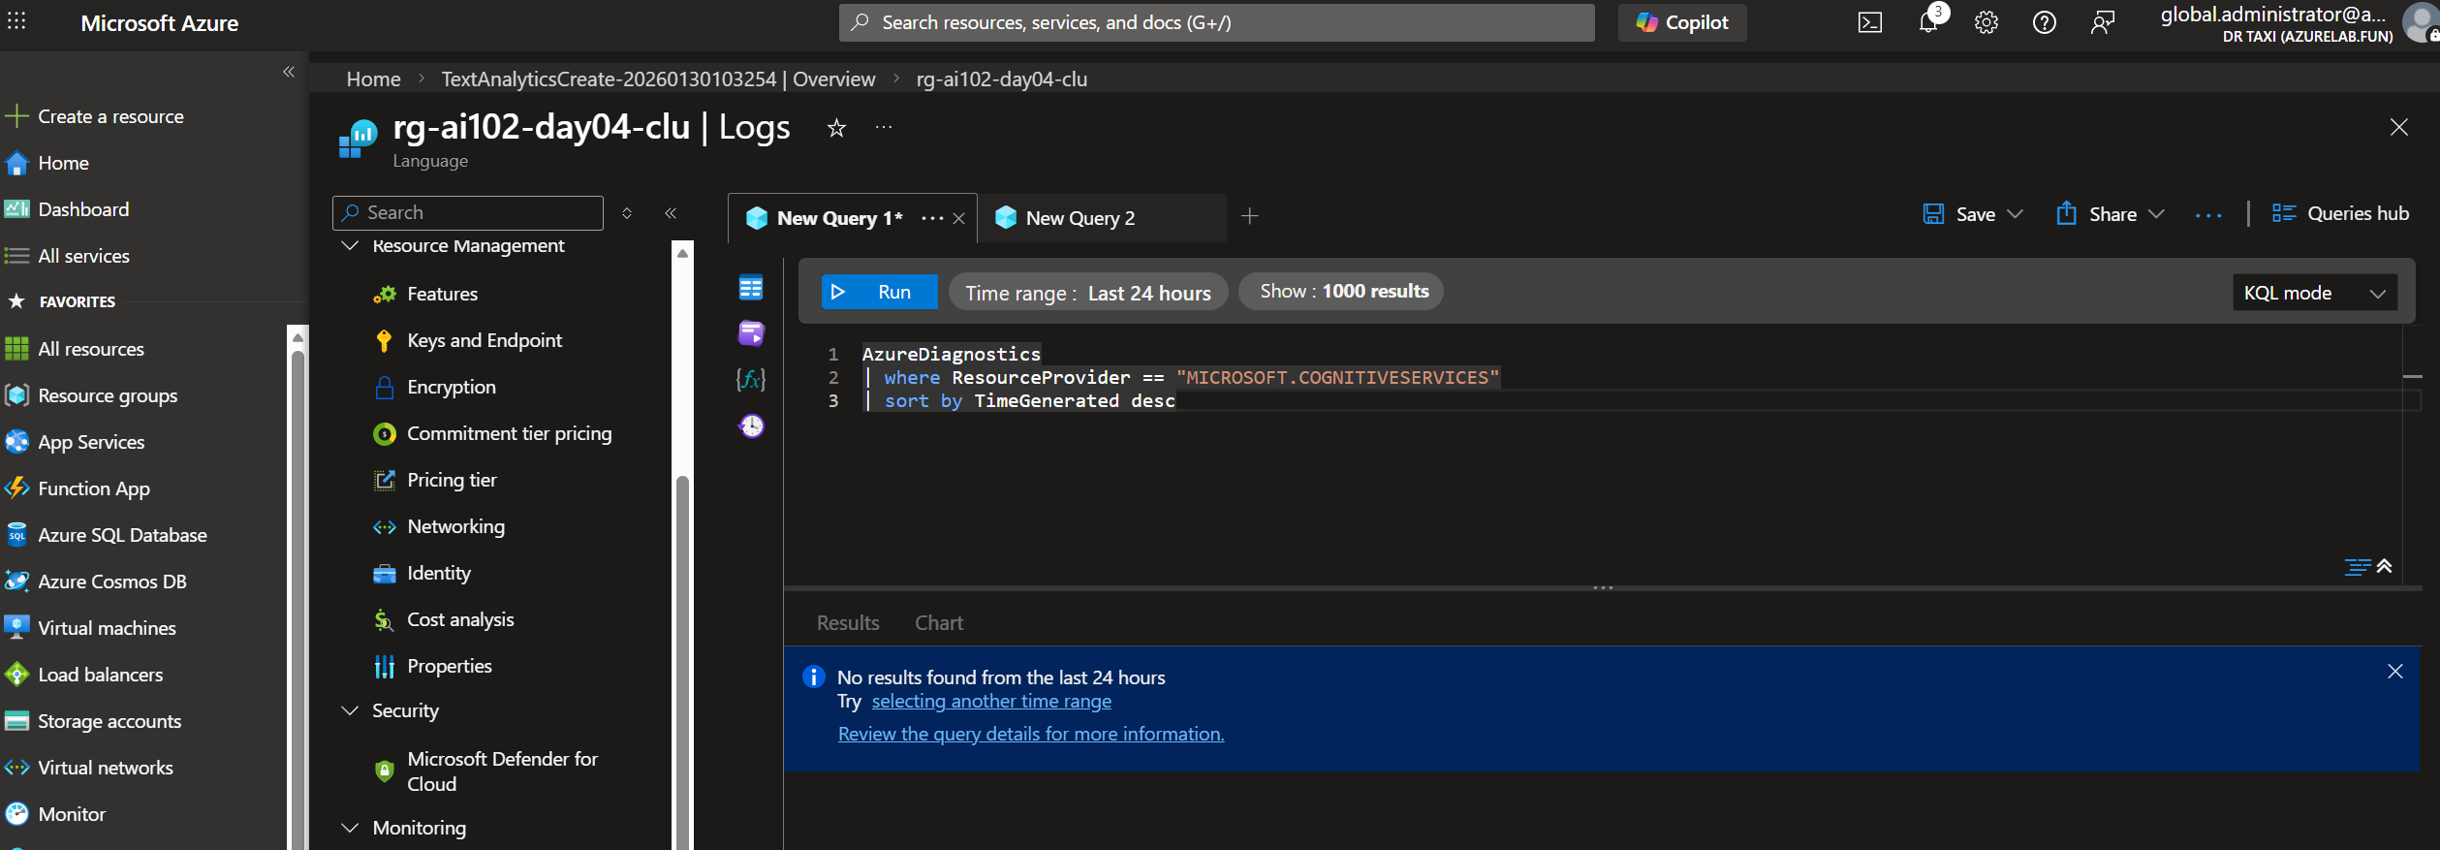
AI102-Day04-Phase02-01-DiagnosticsEnabled.png
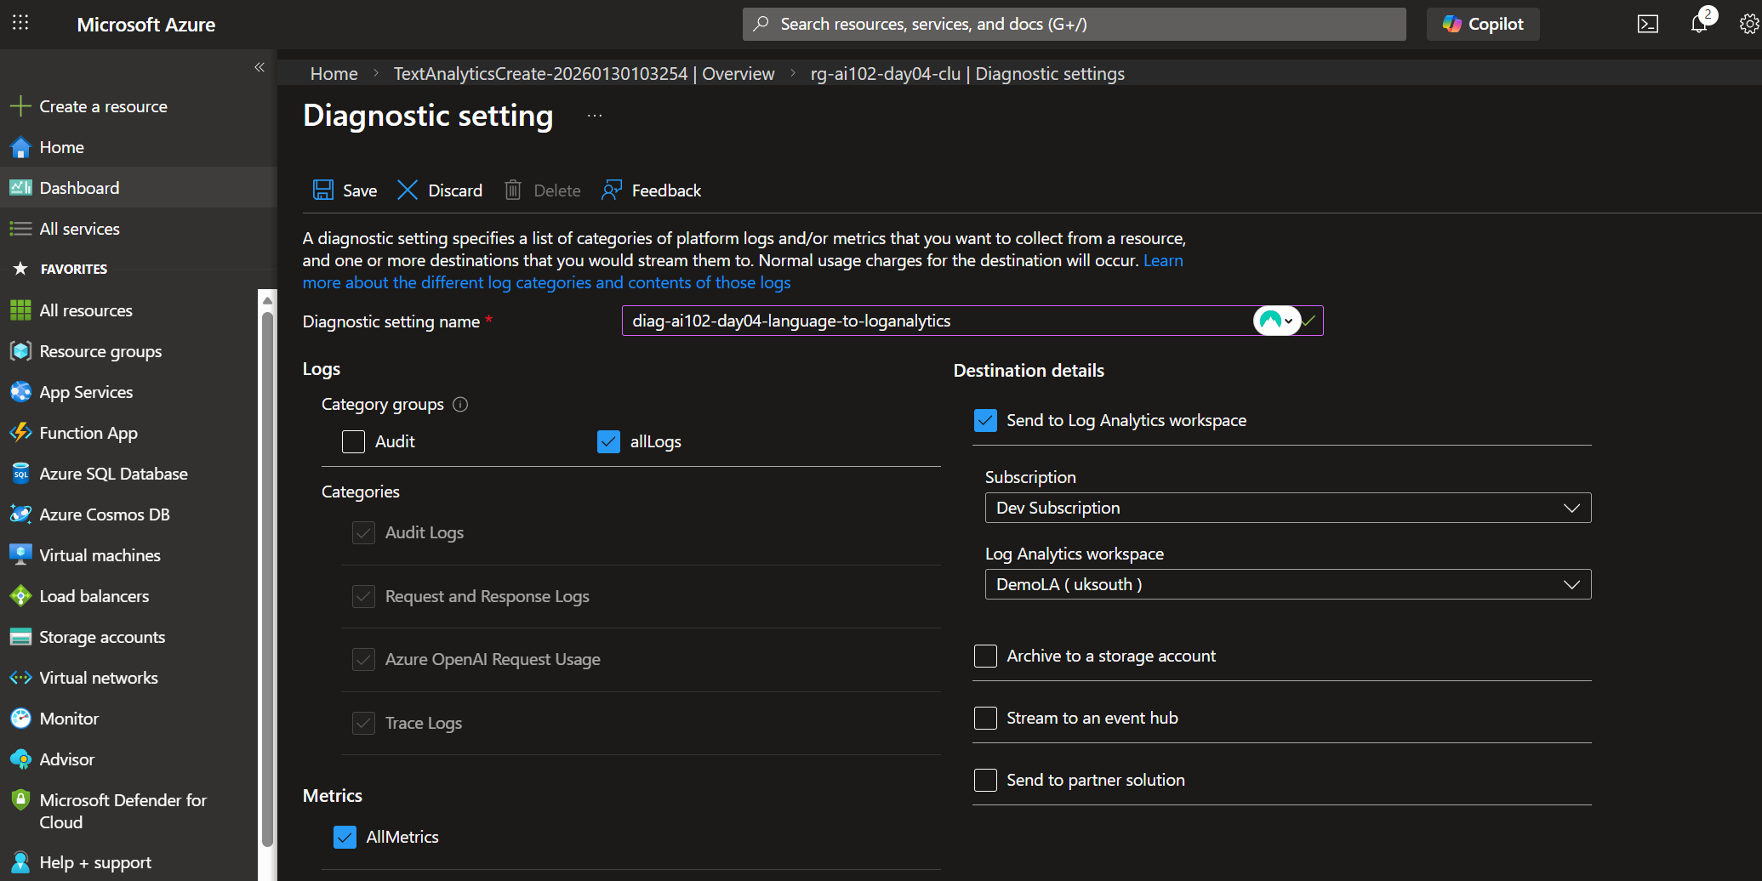
AI102-Day04-Phase02-00-LanguageResourceCreated.png
