AI102-Day08

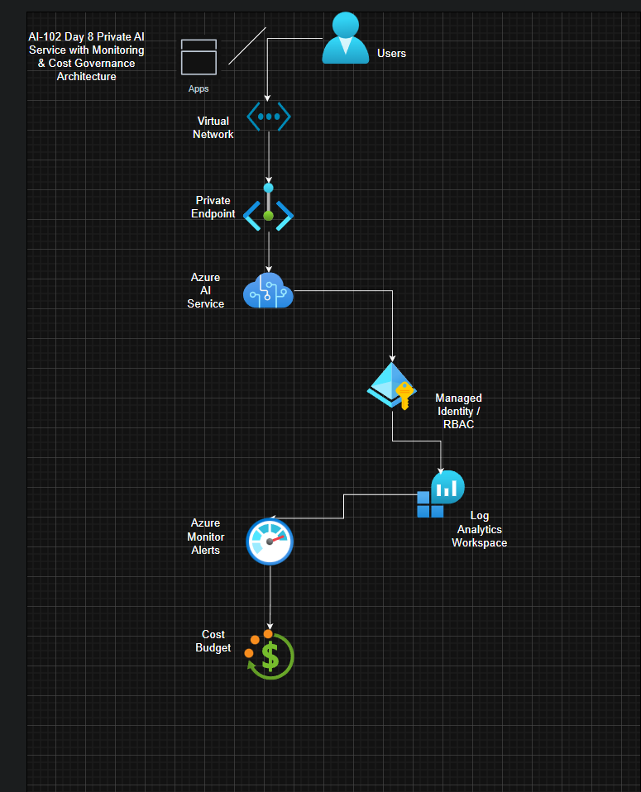

AI102-Day08-10-RBAC.png
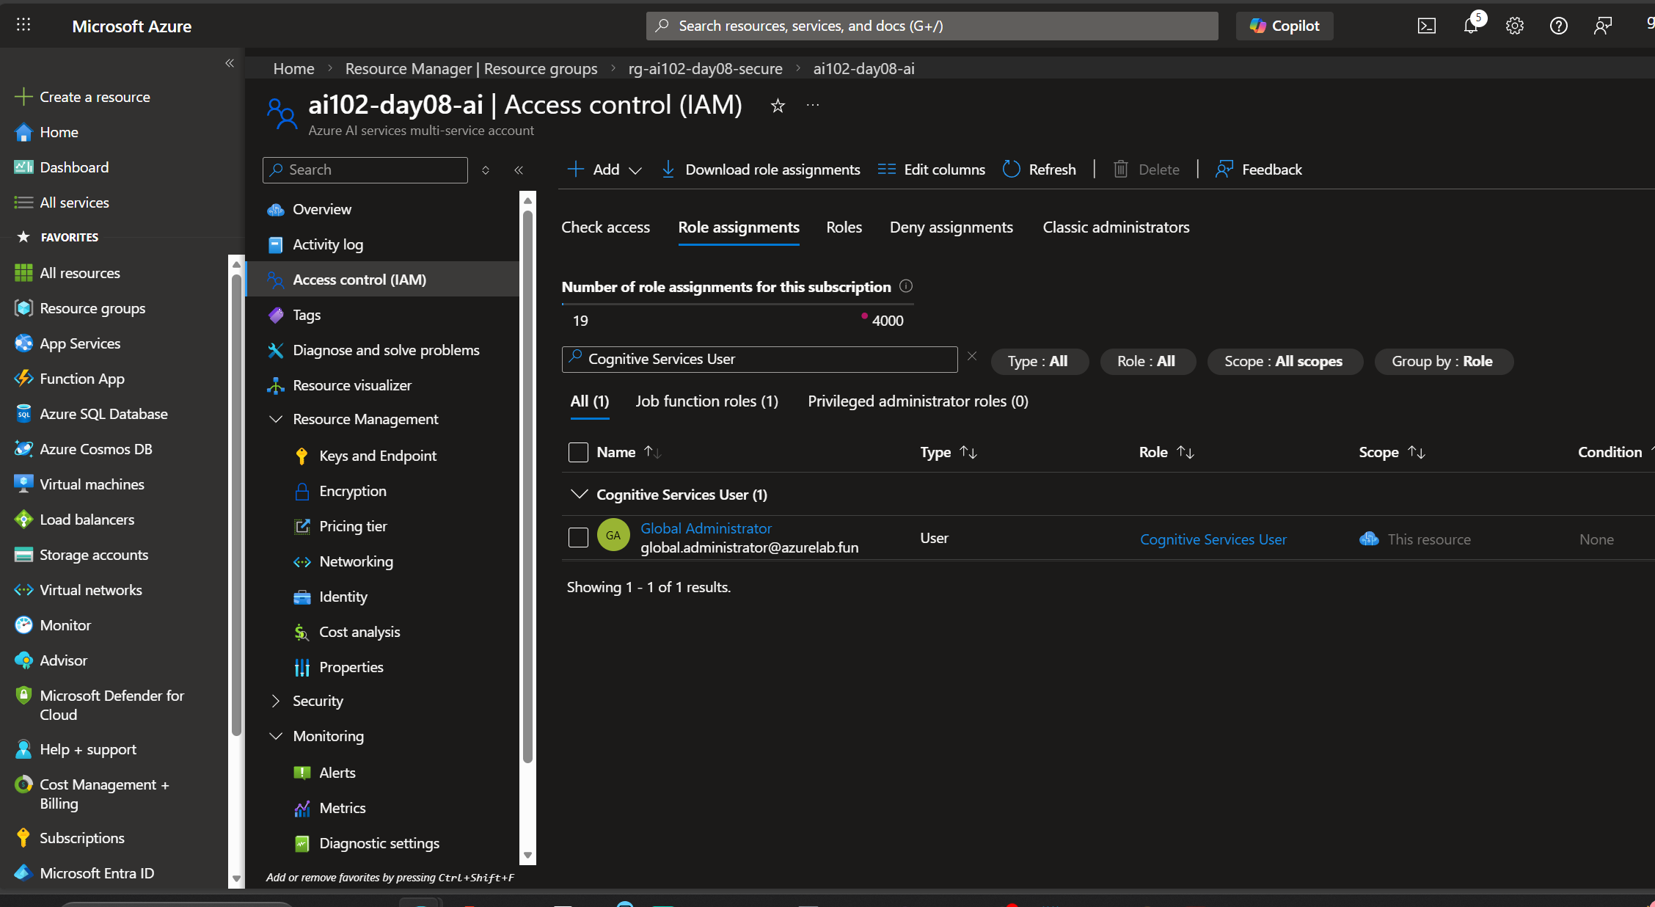

AI102-Day08-09-PrivateEndpoint-DNS.png
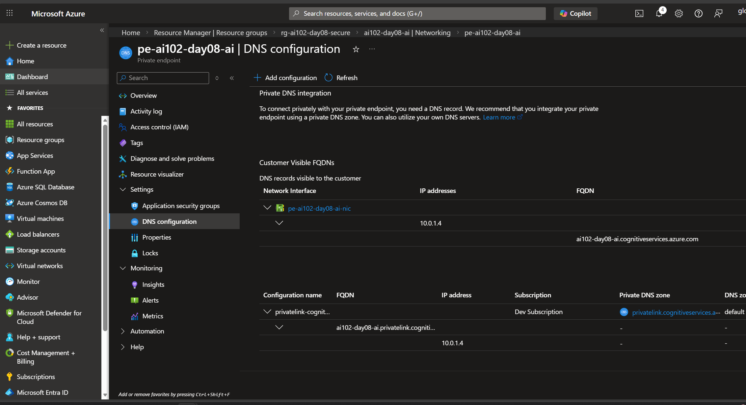

AI102-Day08-08-Budget.png
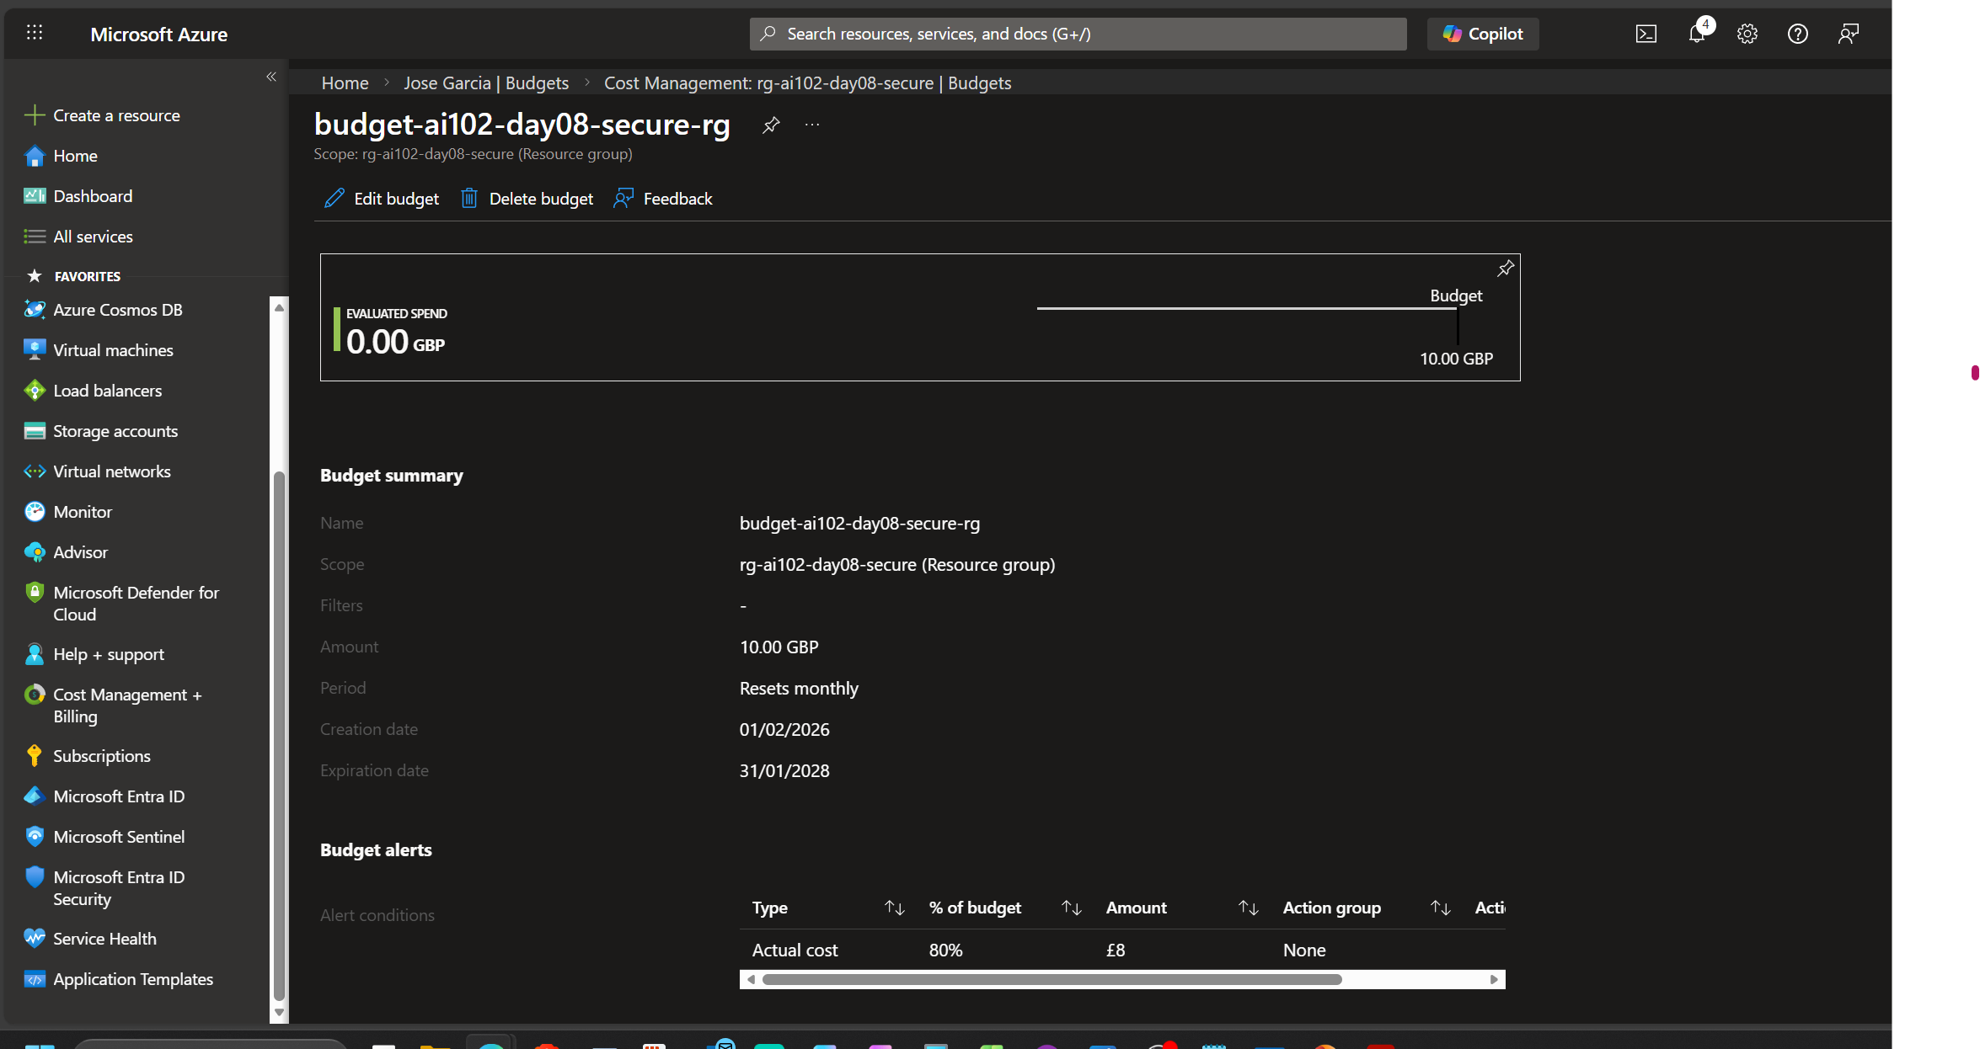

AI102-Day08-07-RBAC.png
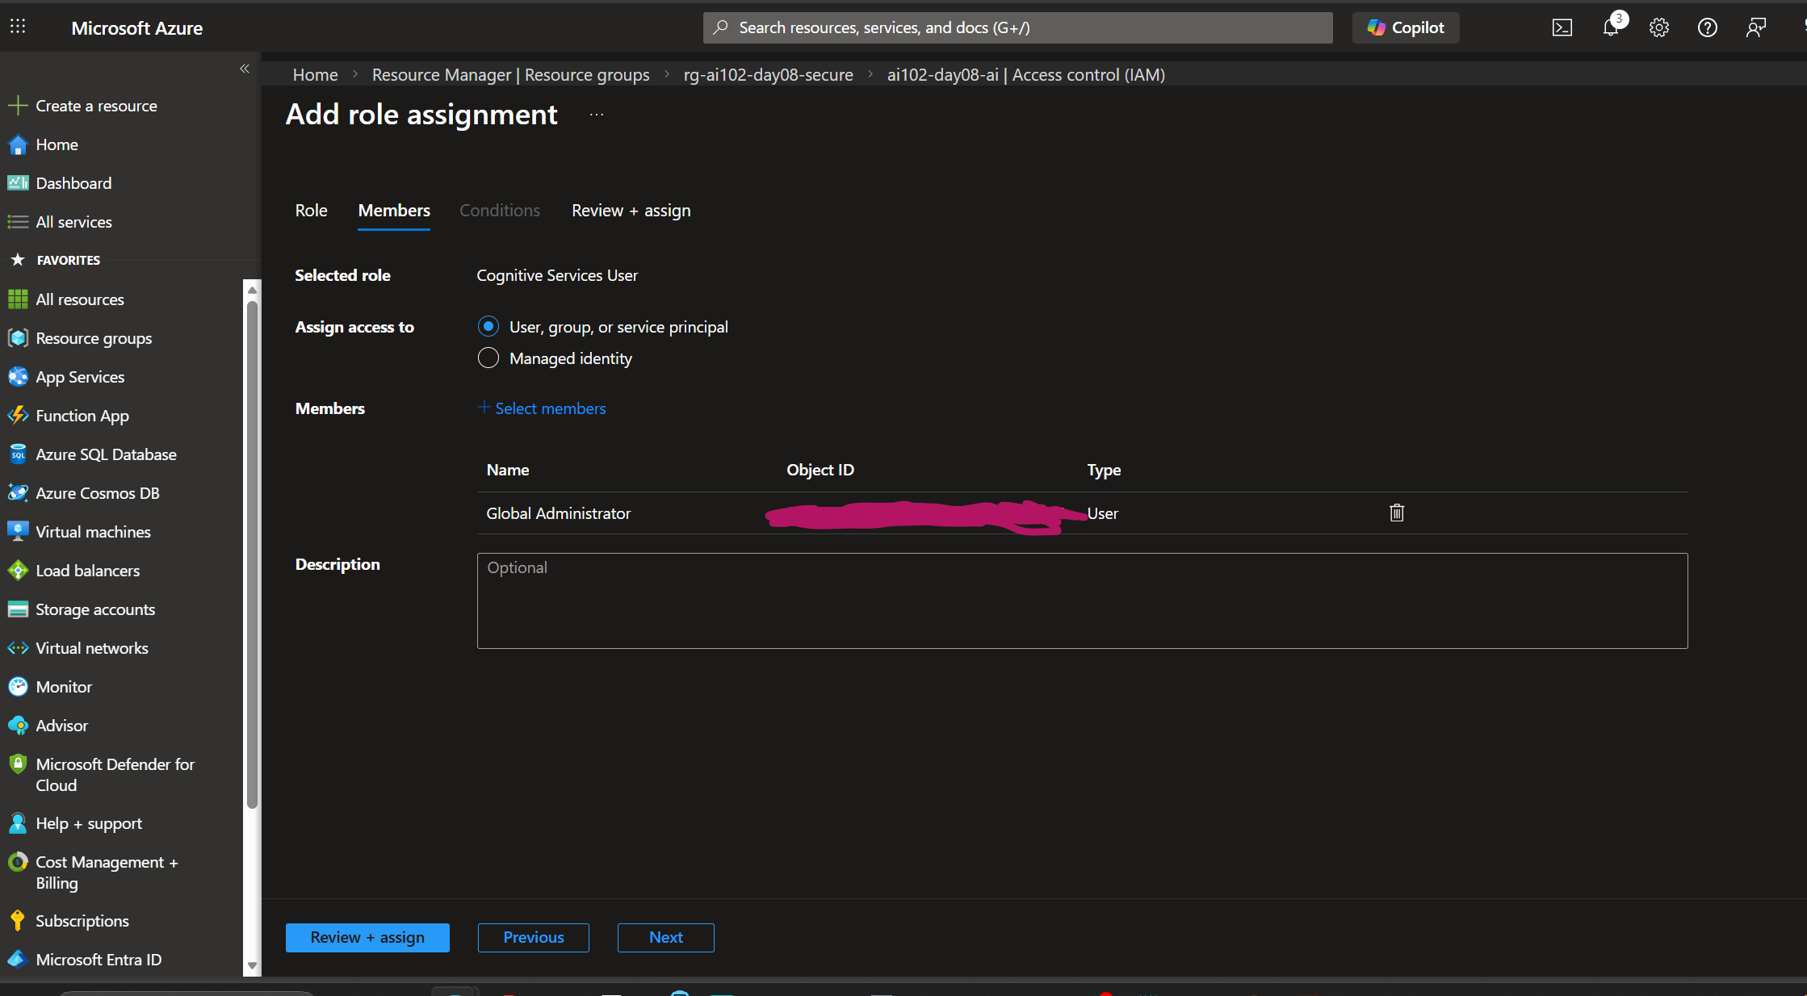

AI102-Day08-06-PrivateEndpoint.png
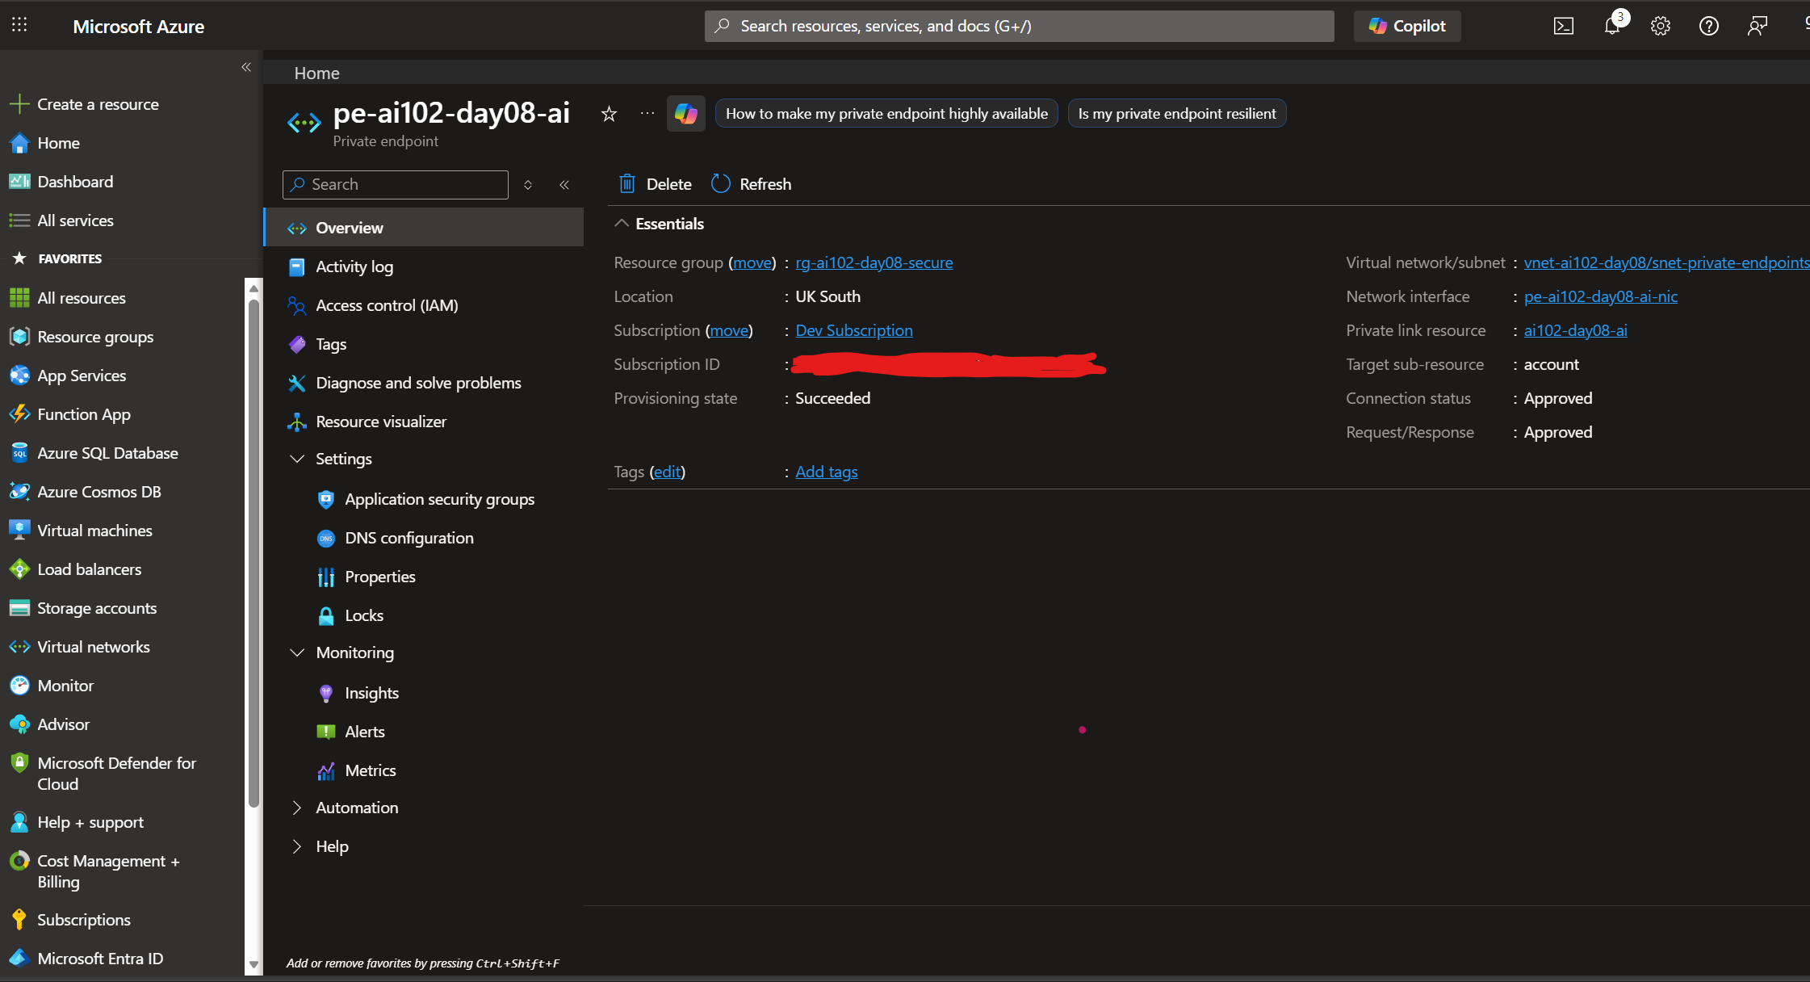

AI102-Day08-05-Networking.png
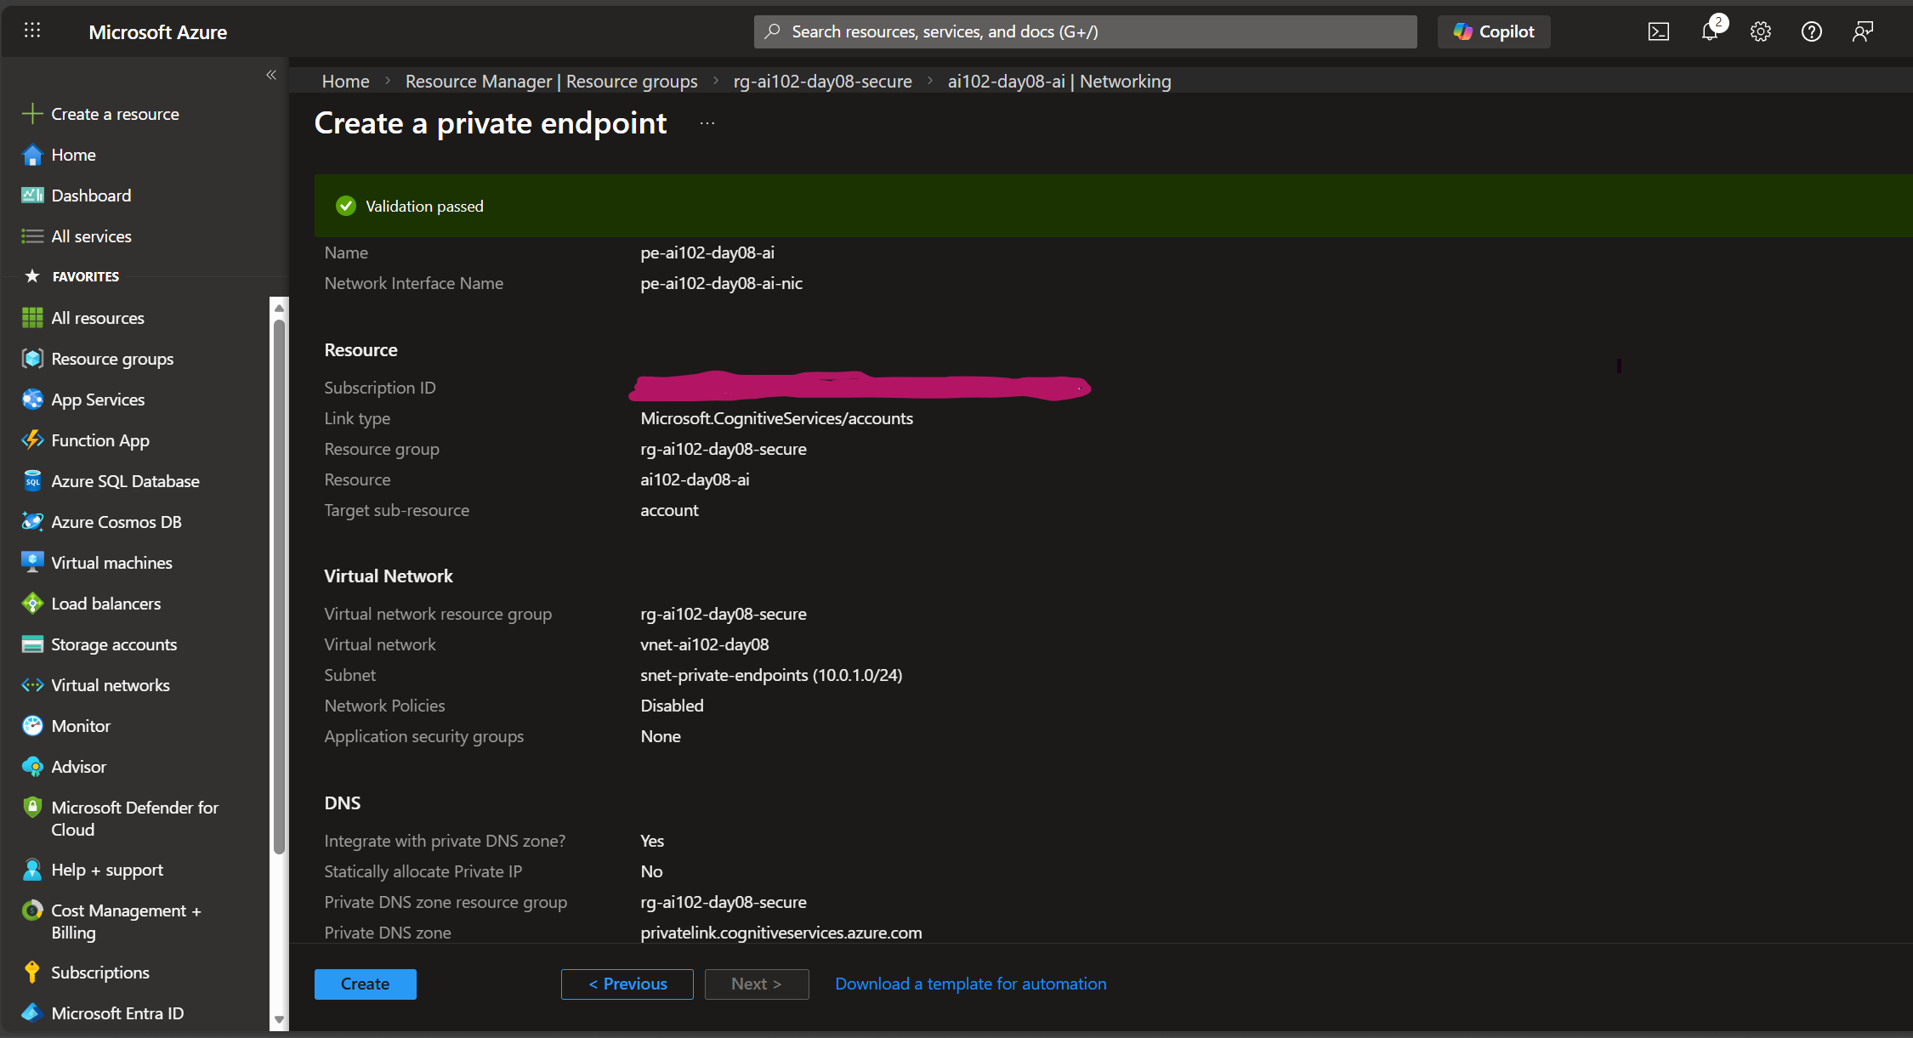

AI102-Day08-04-BeforeDiagnostics.png
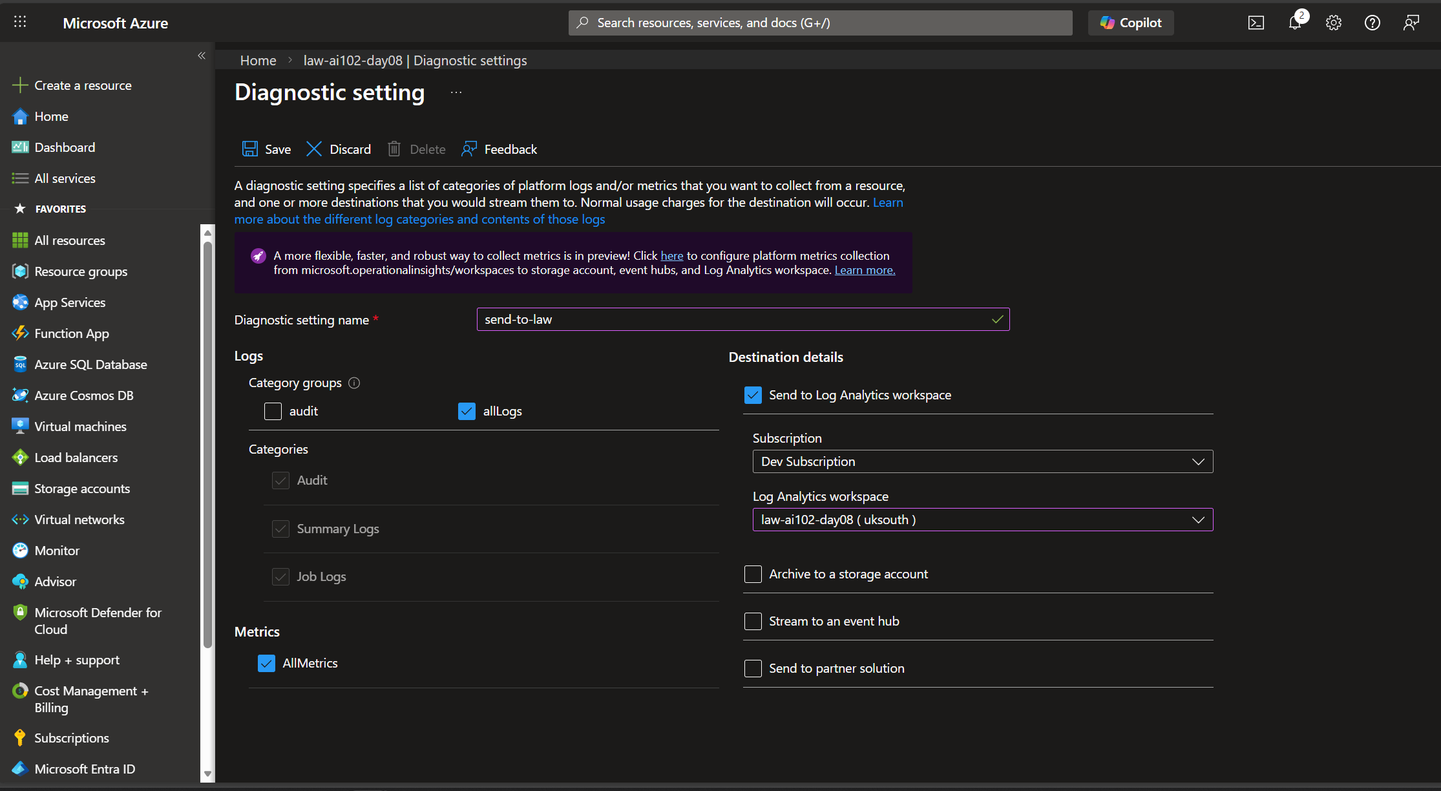

AI102-Day08-03-LogAnalytics.png

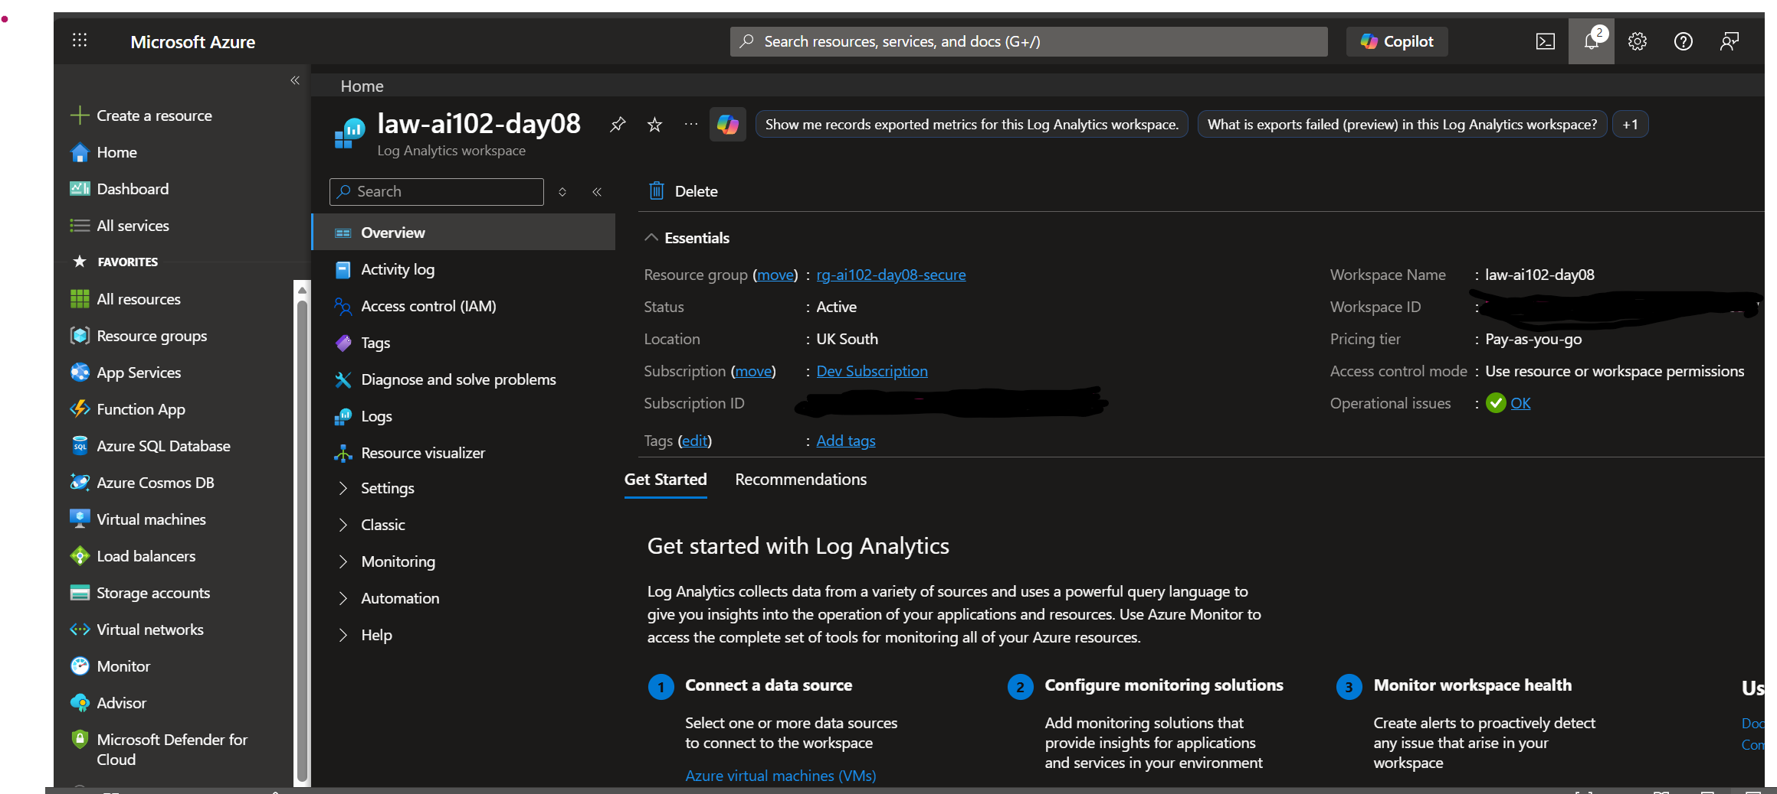

AI102-Day08-02-AIService.png
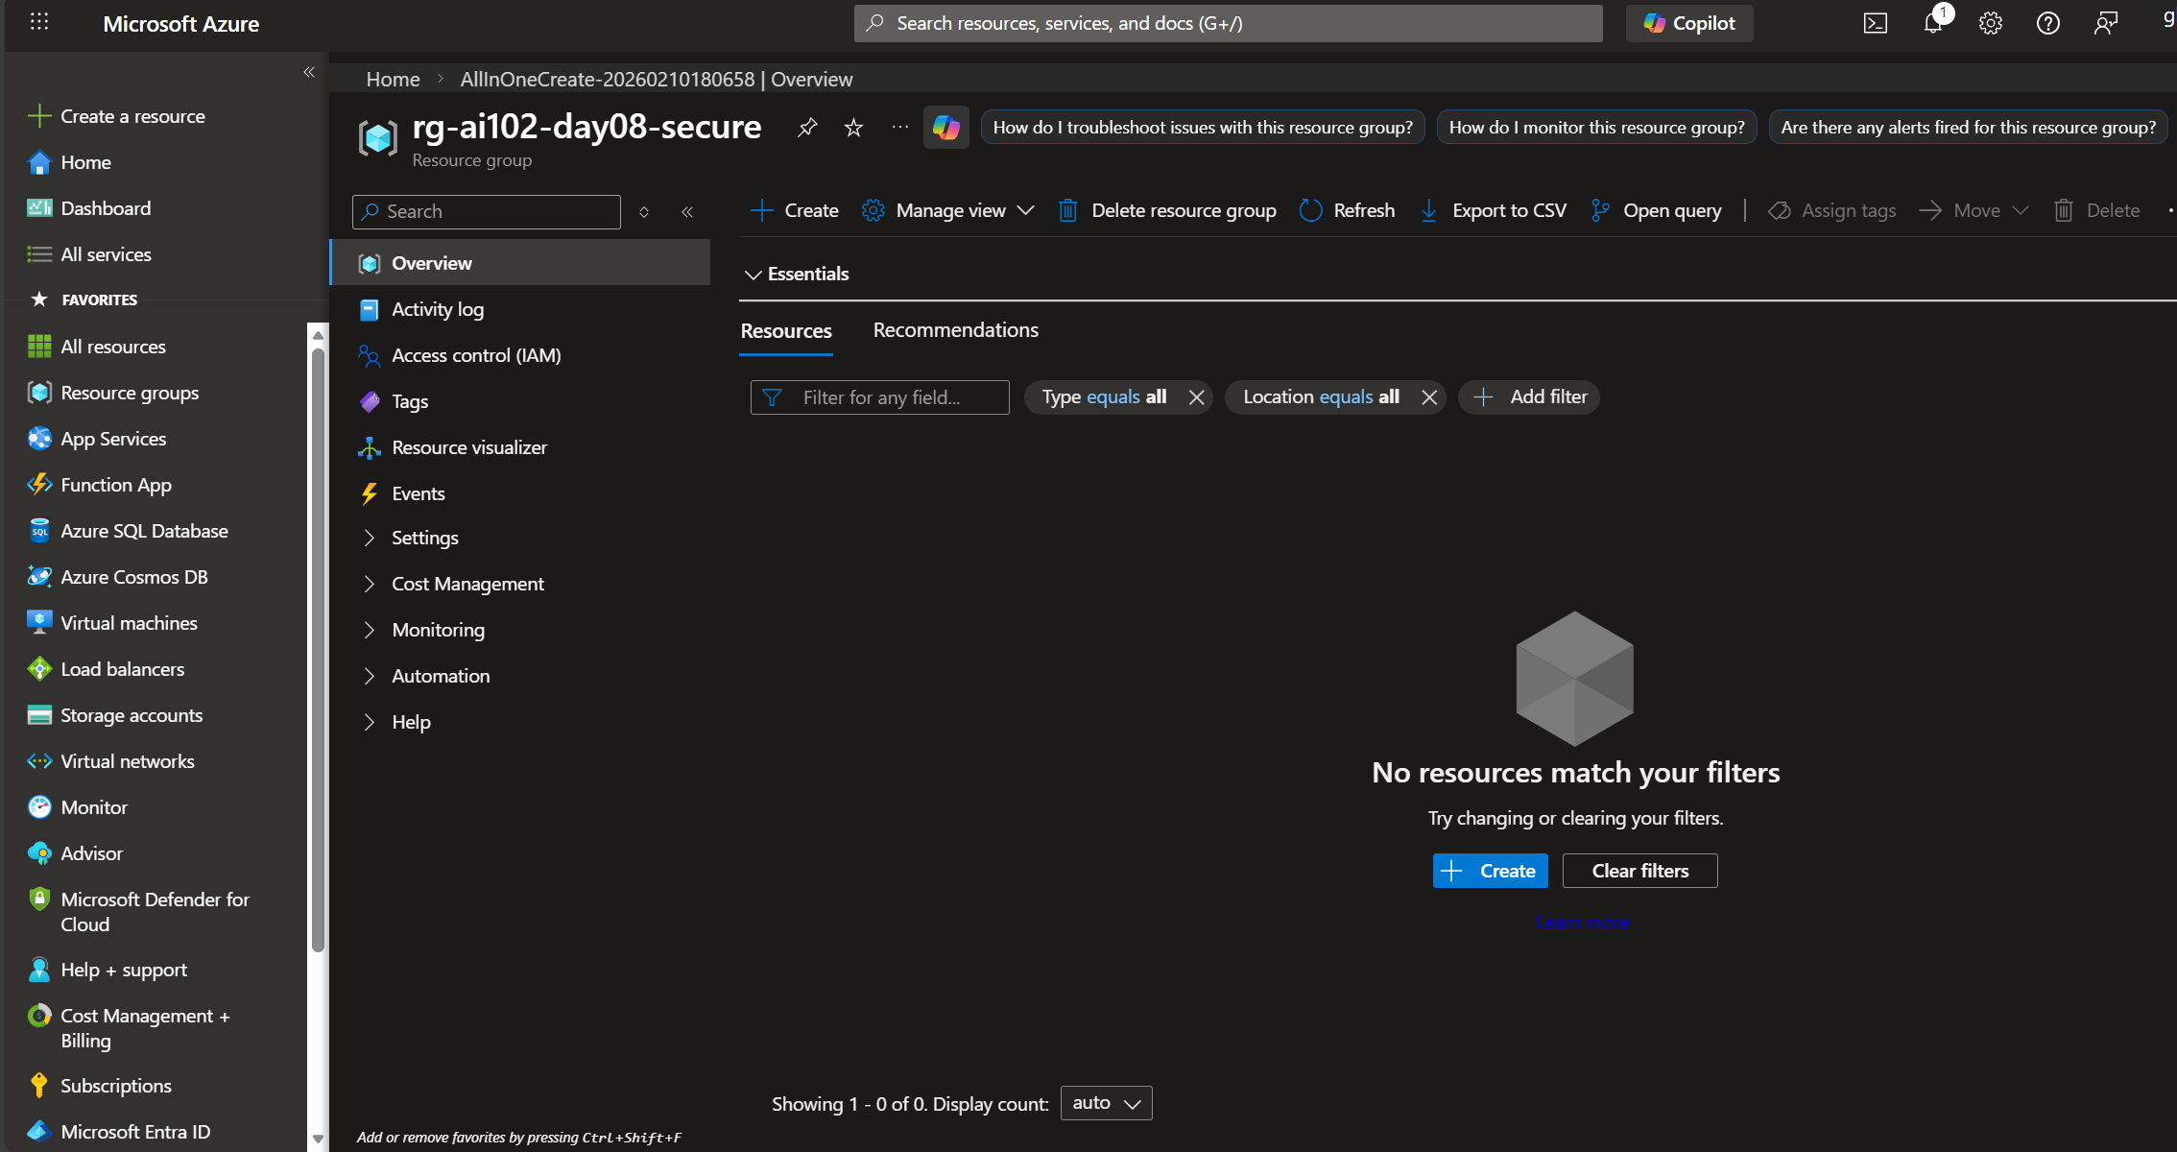

AI102-Day08-01-RG.png
