LAB 1 — Deploy Azure AI Language Service (Secure-first)
Overview blade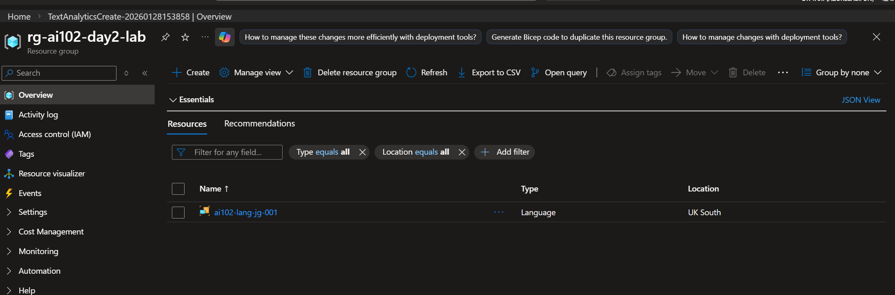
Pricing tier
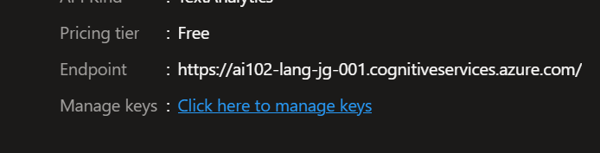
Keys & Endpoint
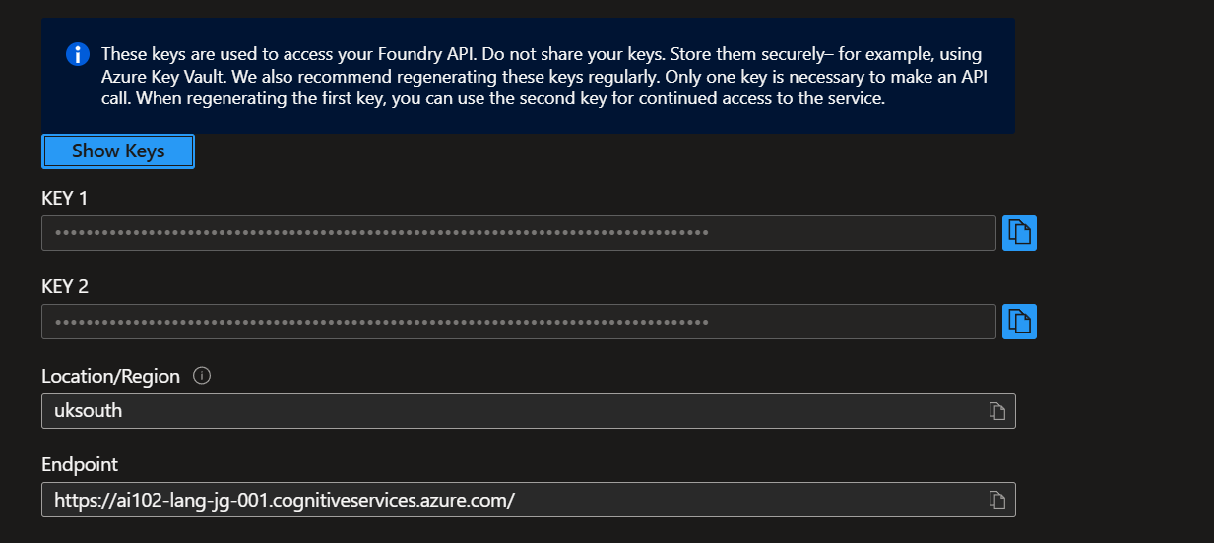
Networking
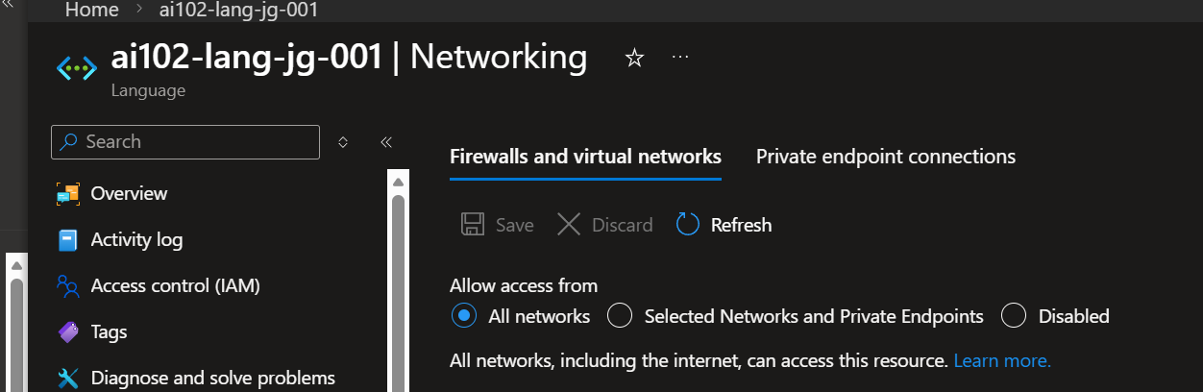
Tags
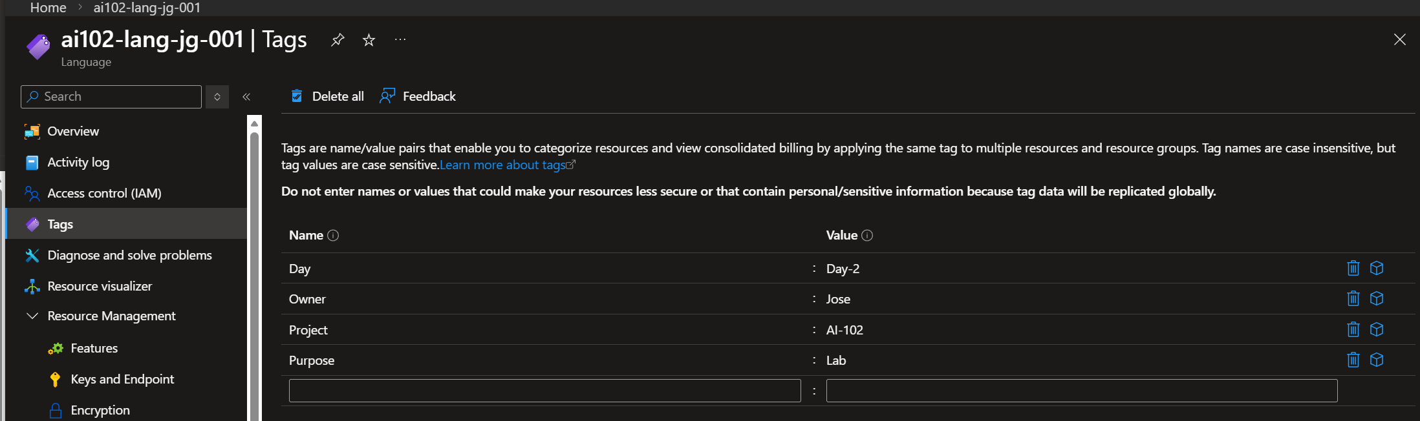
Role assignments showing your name.

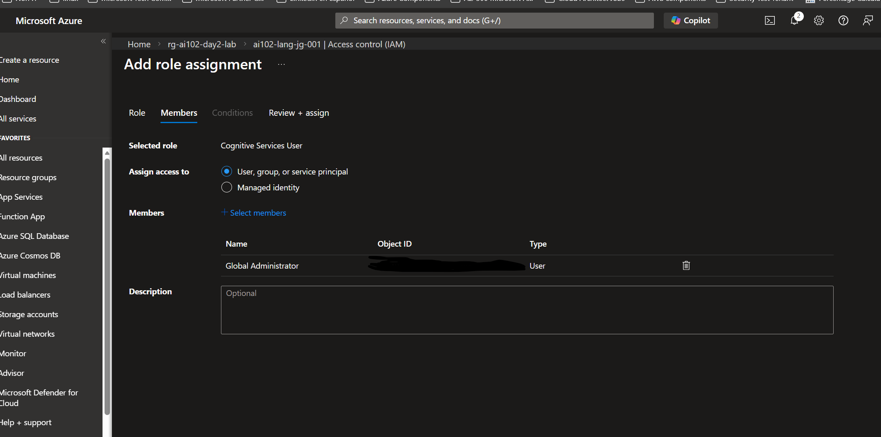

Diagnostic settings blade
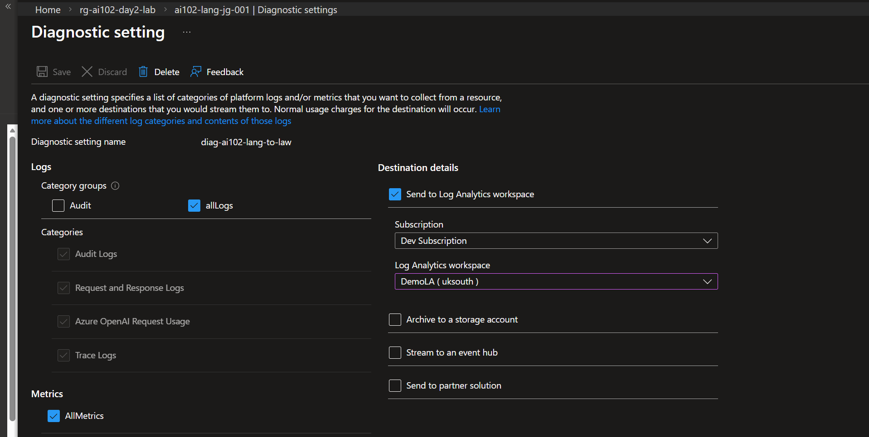

08-resource-group.png
