Tennis Match Win Probability Prediction Report

# Model Performance

Voting Ensemble Accuracy: 0.9555555555555556

Confusion Matrix:

[[17 0 0 0 0 0]  
 [ 0 14 0 0 0 0]  
 [ 0 0 16 0 0 0]  
 [ 0 0 0 16 0 0]  
 [ 0 0 0 0 11 0]  
 [ 0 0 1 2 1 12]]

Classification Report:

precision recall f1-score support  
  
 23581.0 1.00 1.00 1.00 17  
 47603.0 1.00 1.00 1.00 14  
 89632.0 0.94 1.00 0.97 16  
 106755.0 0.89 1.00 0.94 16  
 352776.0 0.92 1.00 0.96 11  
 407573.0 1.00 0.75 0.86 16  
  
 accuracy 0.96 90  
 macro avg 0.96 0.96 0.95 90  
weighted avg 0.96 0.96 0.95 90

# Feature Importance Analysis

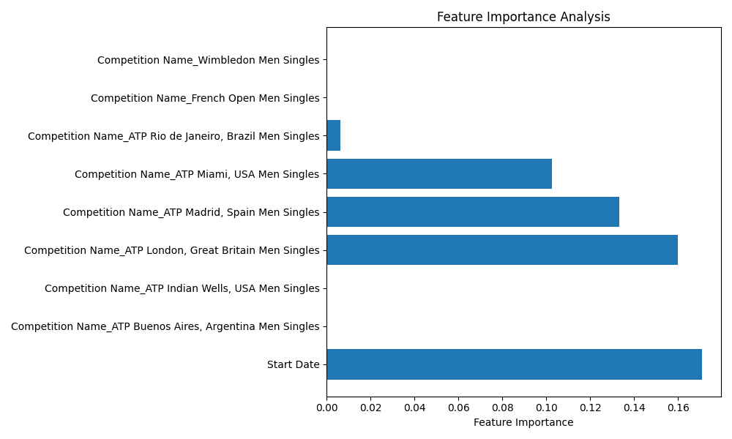

# Predicted Win Probabilities for Upcoming Matches

Start Date Competition Name Win Probability  
0 2020-02-18 Rio Open 0.095167  
1 2020-02-20 Rio Open 0.095169  
2 2021-03-25 Miami Open 0.096501  
3 2021-04-08 AnyTech365 Andalucia Open 0.096621  
4 2021-04-27 Millennium Estoril Open 0.096798  
5 2021-07-20 Croatia Open 0.097842  
6 2021-07-23 Croatia Open 0.097889  
7 2021-07-27 Generali Open 0.097953  
8 2021-08-25 Winston-Salem Open at Wake Forest University 0.098457  
9 2021-08-26 Winston-Salem Open at Wake Forest University 0.098476  
10 2021-10-10 BNP Paribas Open 0.099439  
11 2021-10-29 Vienna Open 0.099922  
12 2021-11-02 BNP Paribas Masters 0.100030  
13 2022-02-14 Rio Open 0.103823  
14 2022-02-19 Rio Open 0.104063  
15 2022-03-19 BNP Paribas Open 0.105534  
16 2022-04-01 Miami Open 0.106294  
17 2022-04-13 Monte Carlo Masters 0.107043  
18 2022-04-20 Barcelona Open 0.107502  
19 2022-04-22 Barcelona Open 0.107636  
20 2022-04-24 Barcelona Open 0.107772  
21 2022-05-05 Mutua Madrid Open 0.108544  
22 2022-05-06 Mutua Madrid Open 0.108616  
23 2022-05-07 Mutua Madrid Open 0.108689  
24 2022-07-19 European Open 0.115148  
25 2022-07-24 European Open 0.115684  
26 2022-07-30 Croatia Open 0.116346  
27 2022-07-31 Croatia Open 0.116458  
28 2022-08-10 Canadian Open 0.117612  
29 2022-08-20 Western & Southern Financial Group Masters 0.118824  
30 2022-10-24 Swiss Indoors 0.128335  
31 2023-02-16 Argentina Open 0.154127  
32 2023-02-23 Rio Open 0.156155  
33 2023-02-25 Rio Open 0.156746  
34 2023-02-26 Rio Open 0.157043  
35 2023-04-01 Miami Open 0.167890  
36 2023-04-28 Mutua Madrid Open 0.177586  
37 2023-05-07 Mutua Madrid Open 0.181038  
38 2023-06-20 Queen's Club Championships 0.199550  
39 2023-08-11 Canadian Open 0.224857  
40 2023-08-12 Canadian Open 0.225377  
41 2023-08-16 Western & Southern Financial Group Masters 0.227469  
42 2023-08-17 Western & Southern Financial Group Masters 0.227994  
43 2023-08-18 Western & Southern Financial Group Masters 0.228521  
44 2023-08-19 Western & Southern Financial Group Masters 0.229049  
45 2023-08-20 Western & Southern Financial Group Masters 0.229577  
46 2023-10-11 Shanghai Masters 0.257994  
47 2023-11-13 Masters Cup 0.275104

# Win Probability Distribution

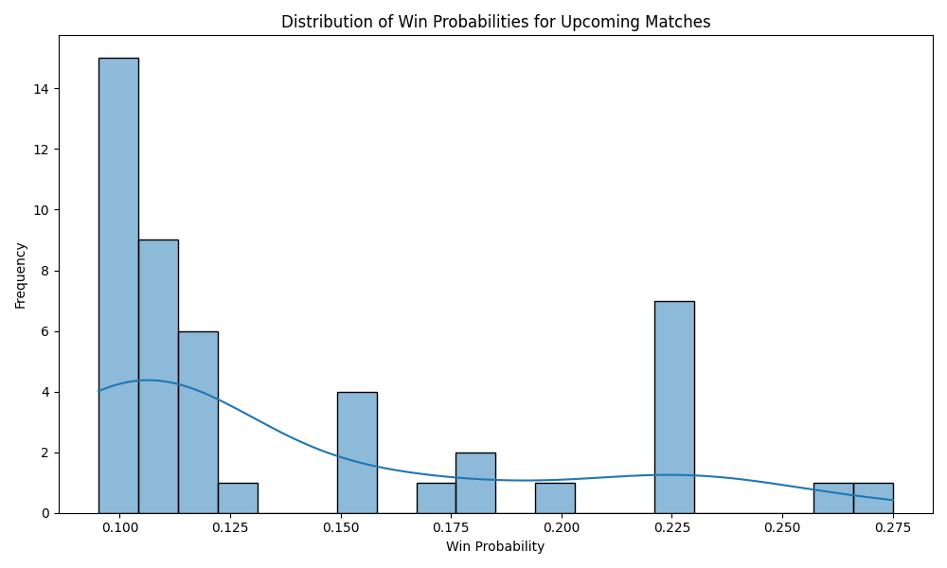

## Distribution of Win Probabilities for Rio Open

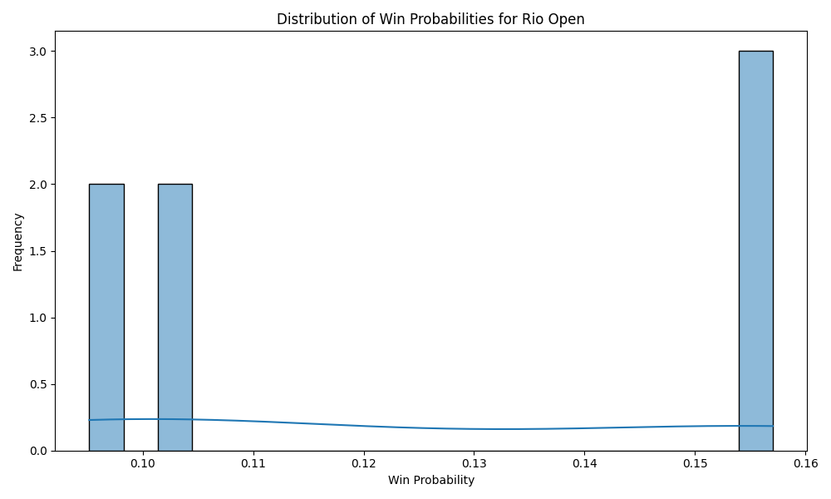

## Distribution of Win Probabilities for Miami Open

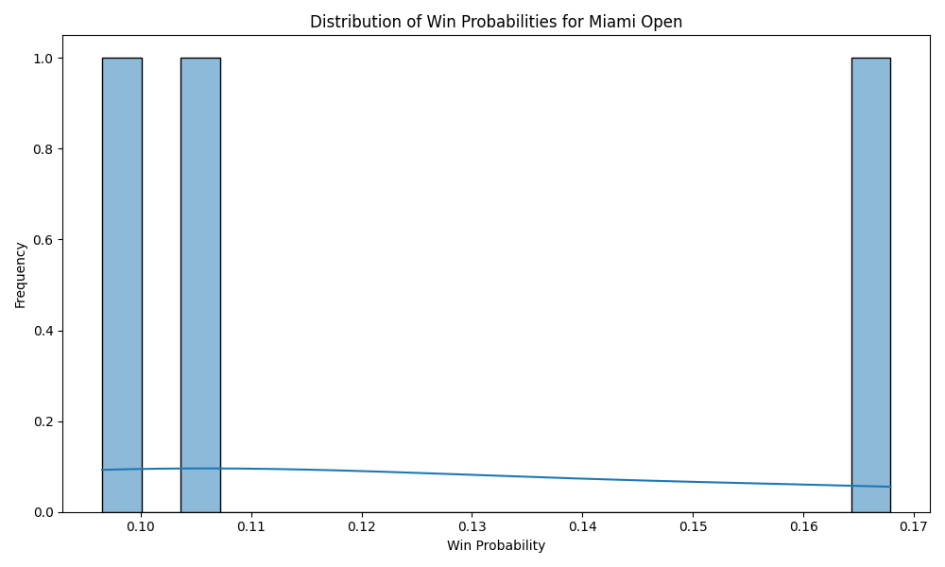

## Distribution of Win Probabilities for AnyTech365 Andalucia Open

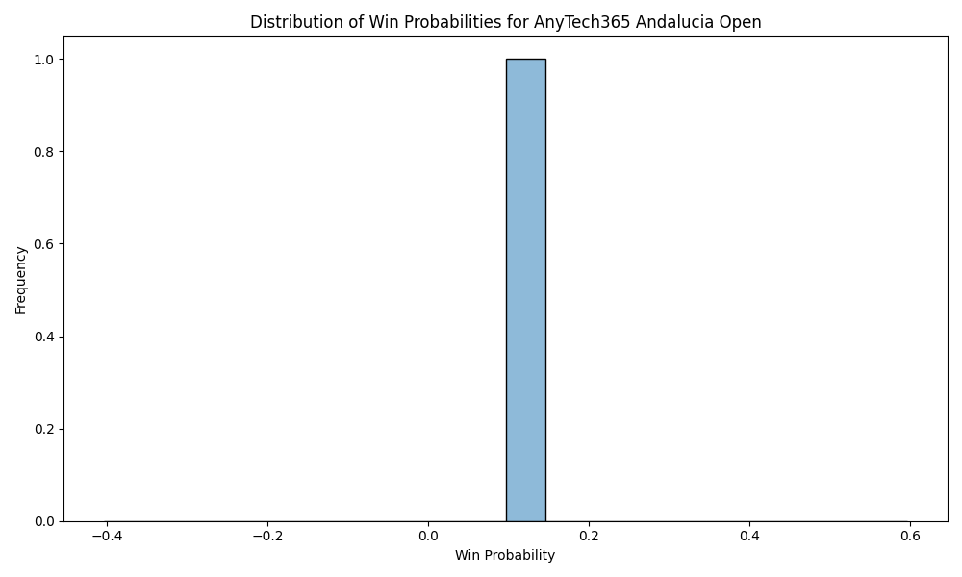

## Distribution of Win Probabilities for Millennium Estoril Open

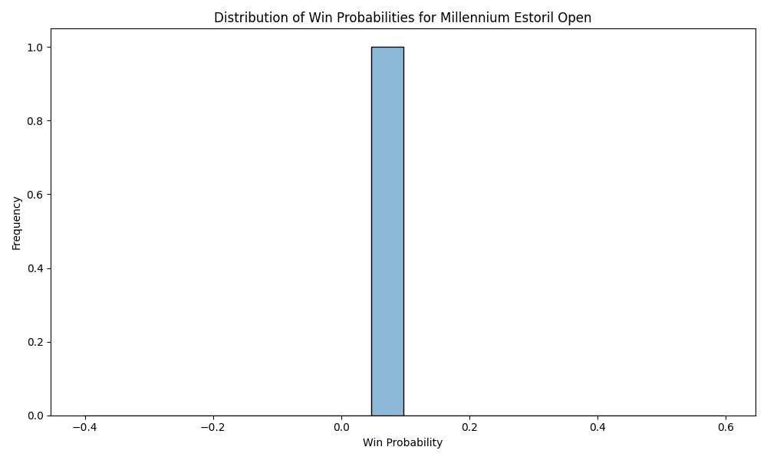

## Distribution of Win Probabilities for Croatia Open

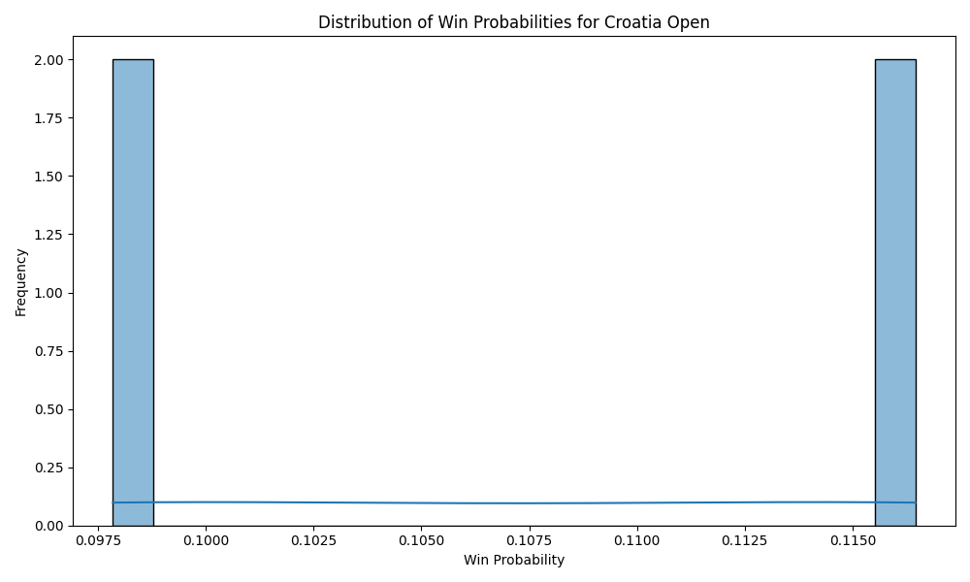

## Distribution of Win Probabilities for Generali Open

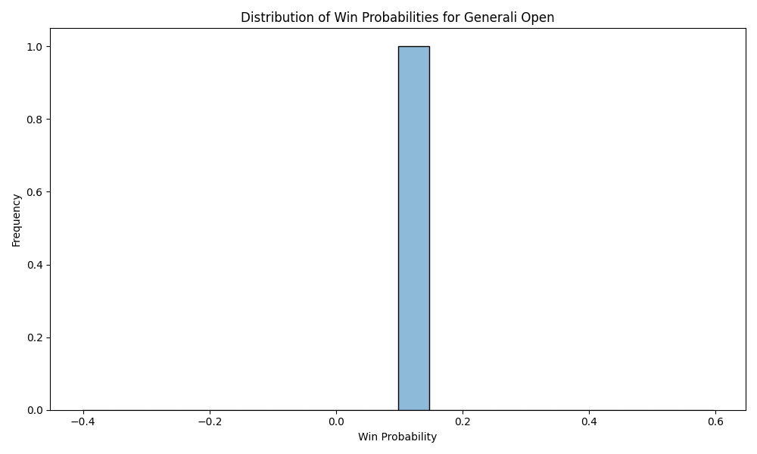

## Distribution of Win Probabilities for Winston-Salem Open at Wake Forest University

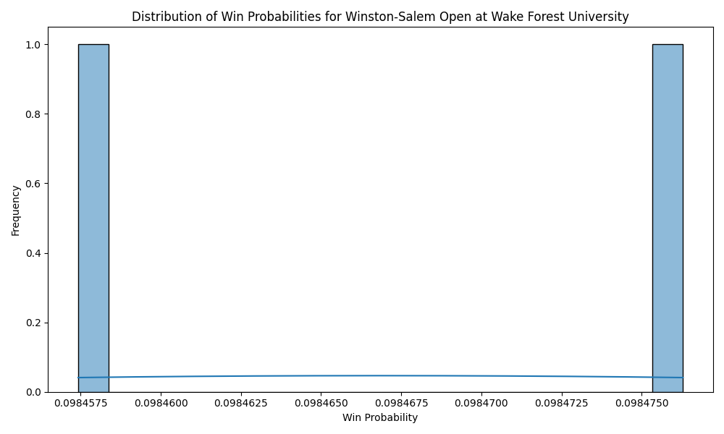

## Distribution of Win Probabilities for BNP Paribas Open

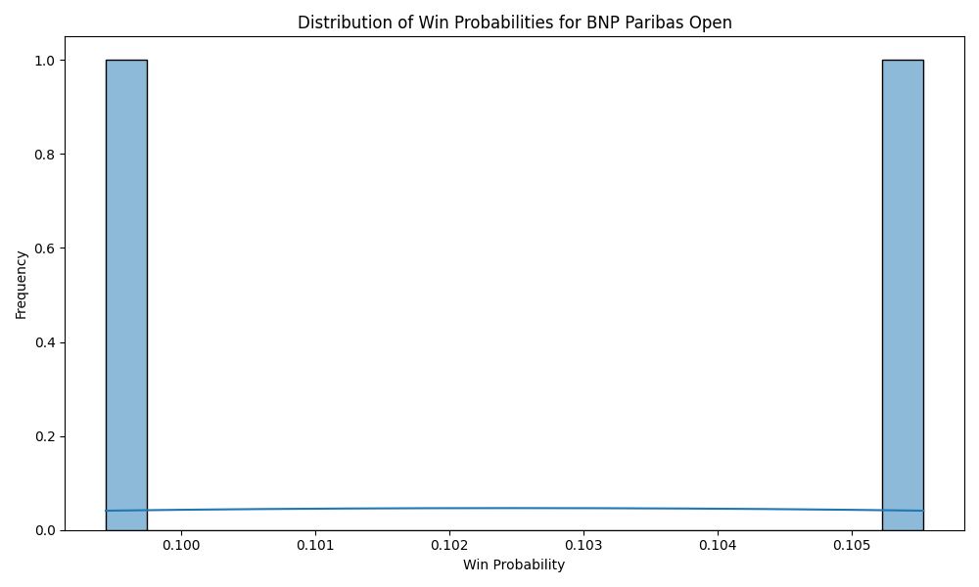

## Distribution of Win Probabilities for Vienna Open

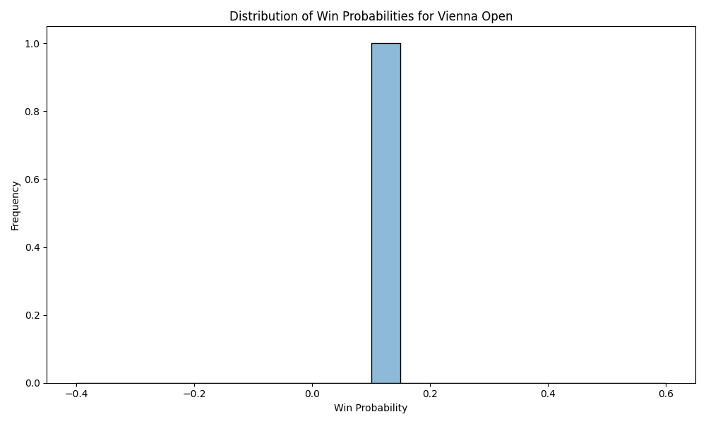

## Distribution of Win Probabilities for BNP Paribas Masters

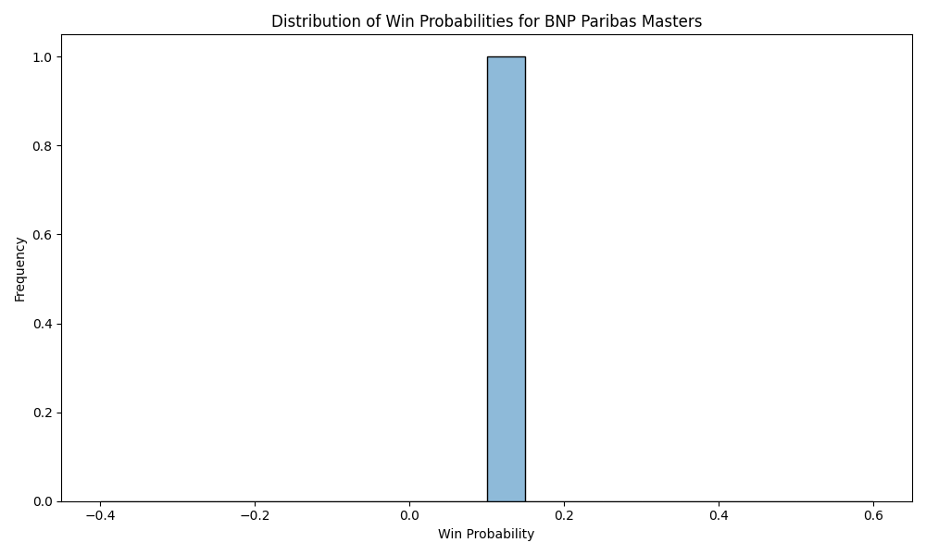

## Distribution of Win Probabilities for Monte Carlo Masters

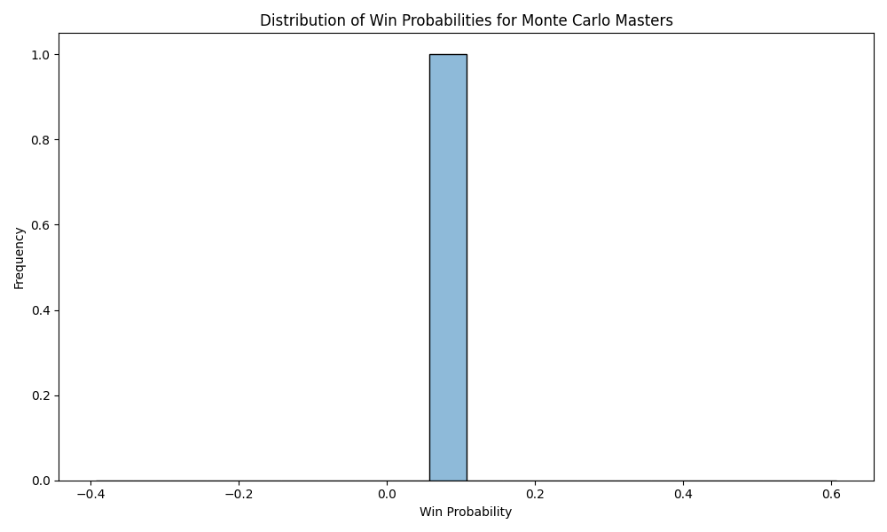

## Distribution of Win Probabilities for Barcelona Open

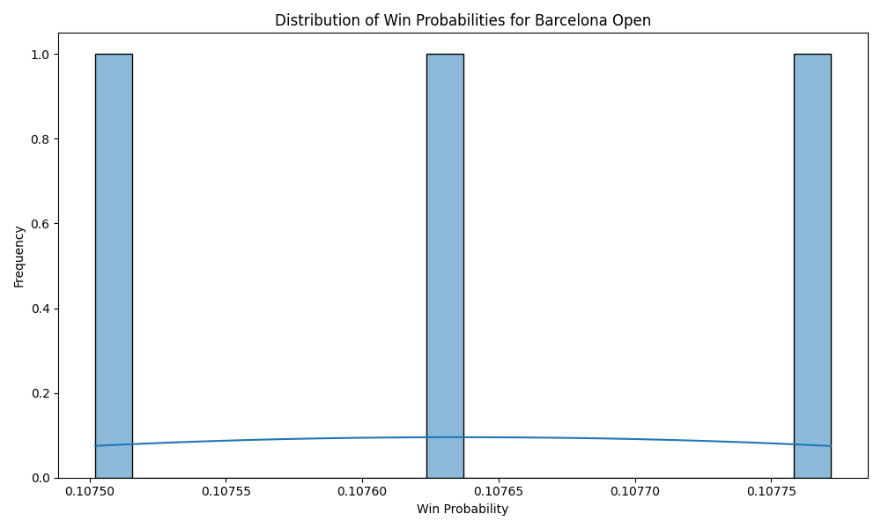

## Distribution of Win Probabilities for Mutua Madrid Open

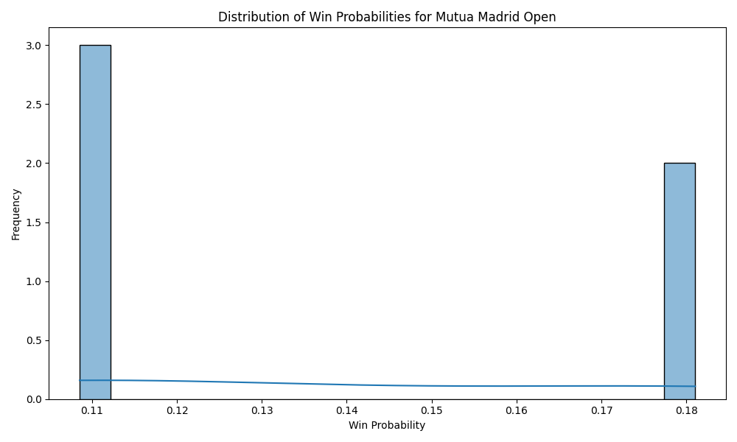

## Distribution of Win Probabilities for European Open

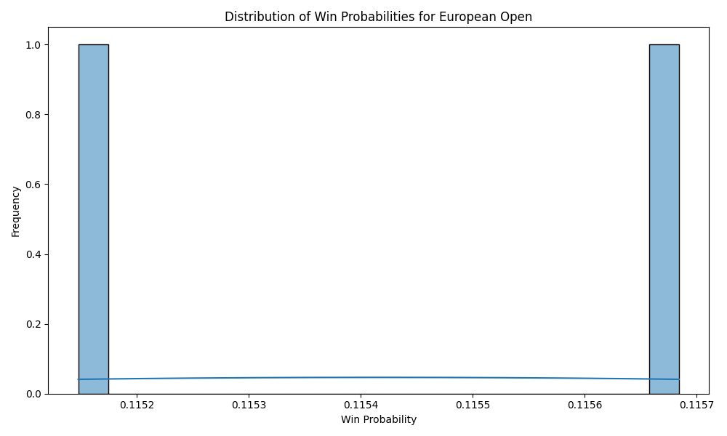

## Distribution of Win Probabilities for Canadian Open

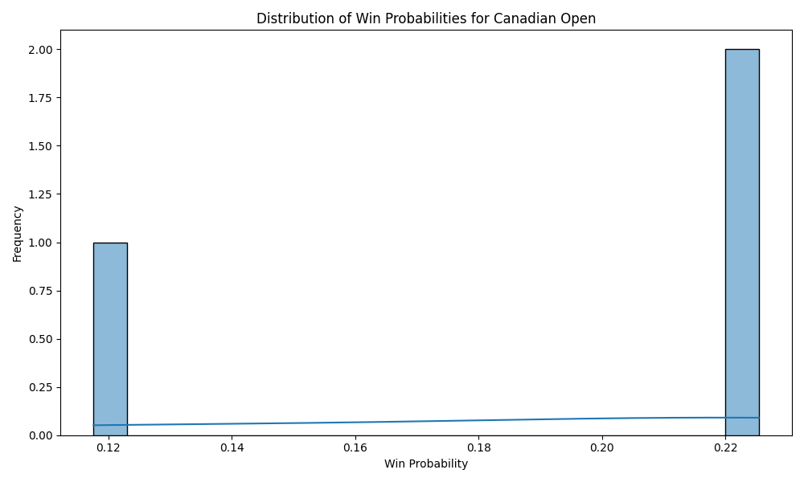

## Distribution of Win Probabilities for Western & Southern Financial Group Masters

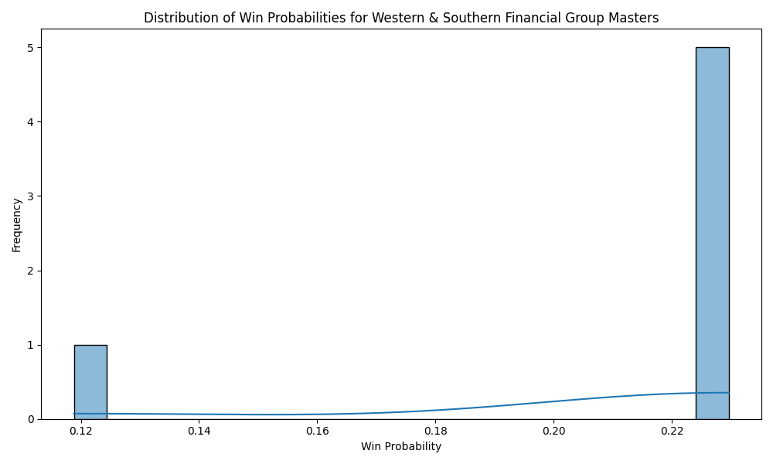

## Distribution of Win Probabilities for Swiss Indoors

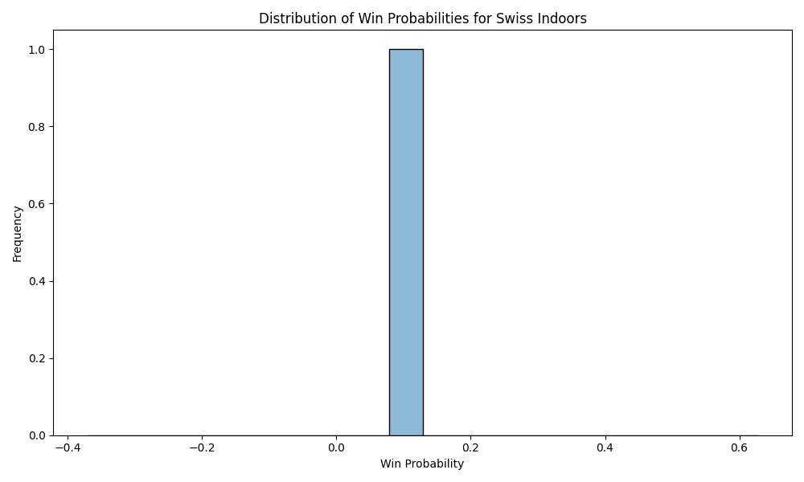

## Distribution of Win Probabilities for Argentina Open

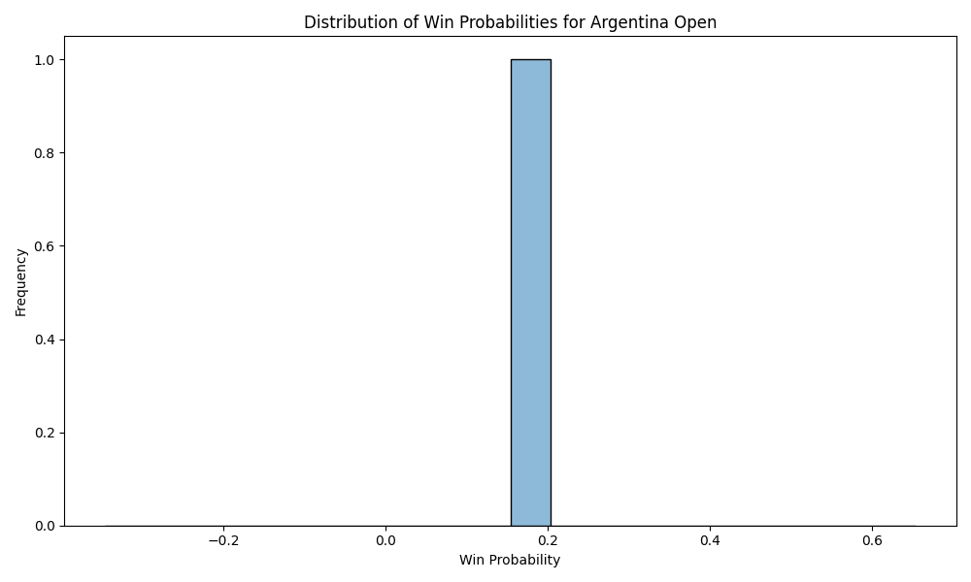

## Distribution of Win Probabilities for Queen's Club Championships

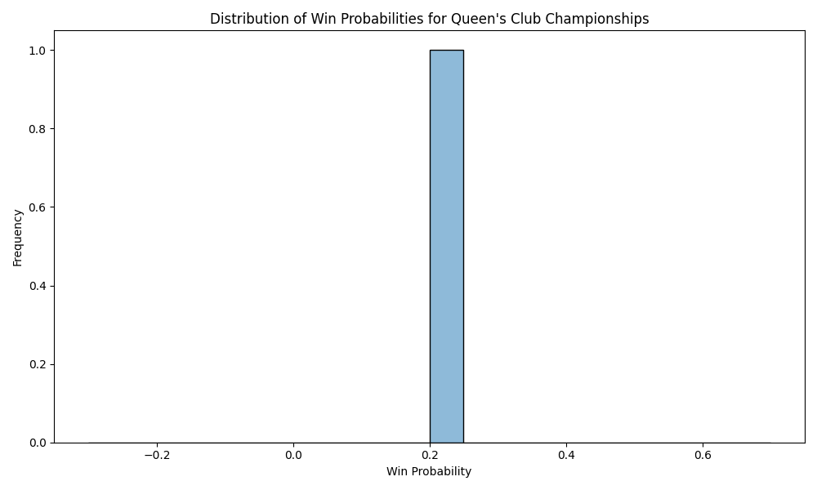

## Distribution of Win Probabilities for Shanghai Masters

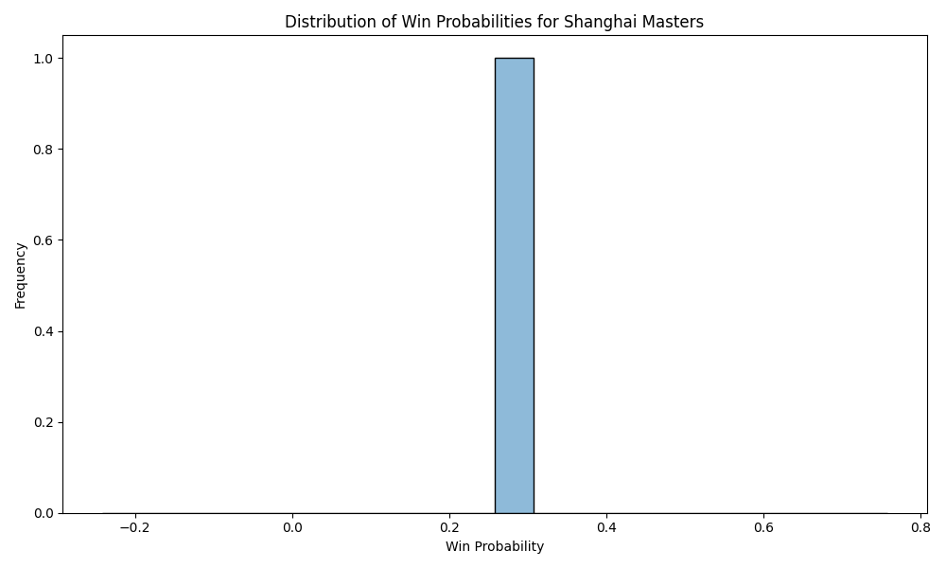

## Distribution of Win Probabilities for Masters Cup

