Q1: DONE BY SANGHAMESHWAR KORWAR AND KRISHNAVAMSI POLEPALLI

Web - 1

The flights are not moving because there is a problem in code that it is taking the co-ordinate values to NAN(not a number) so to rectify that problem I used parse Int so that it is converting that number to integer. Finally the flights are moving.

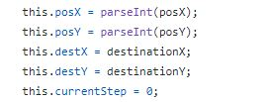

Also changed var flights = JSONObject.flight to var flights = JSONObject.flights;

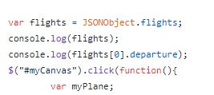

Web - 2

The background image is not displaying because there the path for the image is given wrong so here is the code we need to change to display the background image. In the drawmap function there is a problem with the path.

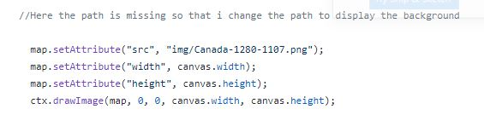

Web - 3

Here we need to set the time and the duration when to reach, if we set the time and the duration then all the three flights will move to the destination on the particular time.

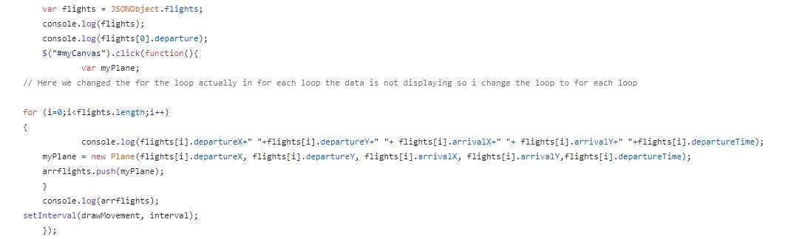

output Screens

