**Q2. DONE BY SAI PRASAD KONERU AND JOBIN GEORGE**

**RQ1 :**User will no longer need to manually enter the age , instead user will enter the date of birth.

**Impact :** When user changes the input from age to date of birth, we need to calculate the age from the given date of birth. Initially age was directly given, which is used to calculate the accumulated salary of a person.

**Solution :** Added a new variable dob in User model , with getter and setter method. Also removed the setAge() method from User model. In the getAge() method, the age of a person is calculated.

**RQ 2** : Update the logic of salaryAccumulated based on province.

Details : The age of retirement of QA - 55 and ON-58

**Impact :** This function worked on the same age of retirement for all province. And now the retirement age is different for the provinces, which result in different output from the previous.

**Solution :** 1. According to RQ1 user now enter the date of birth instead of age. So with the date of birth entered I have used the getAge() method to calculate the age.

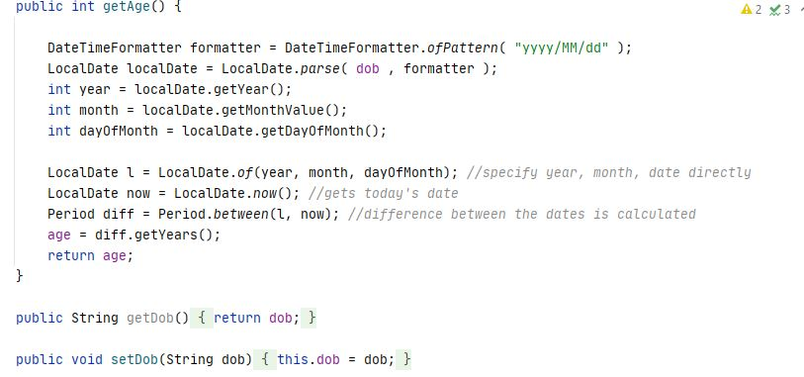

2. Compared the province with the data entered on the address model to “Quebec” and “Ontario” using if statement.

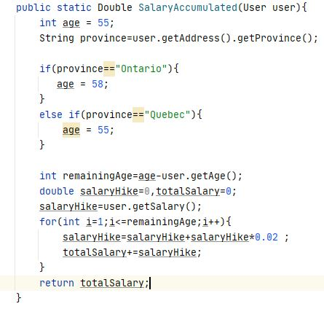

WEB -4

Cause of error : The reason for the bug was that user 2 used user 1 address object.

Solution : Created address object for user 2 and fixed.

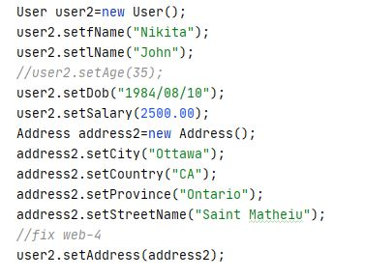

WEB 5

* NullPointException

Here the error was that the user wasn’t passing any address. So the country was passing a null value.

So first I added the try and catch block, because for the Boolean function to work it need the string to get the result true or false, which in this case none. So the error occurred.

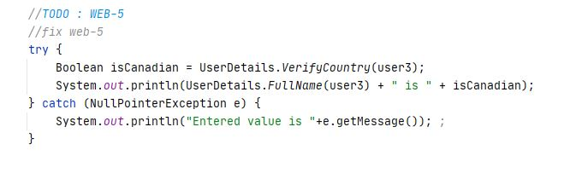

Also I added user 3 address data.

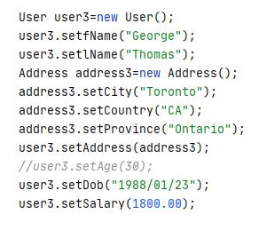

UML Diagram:

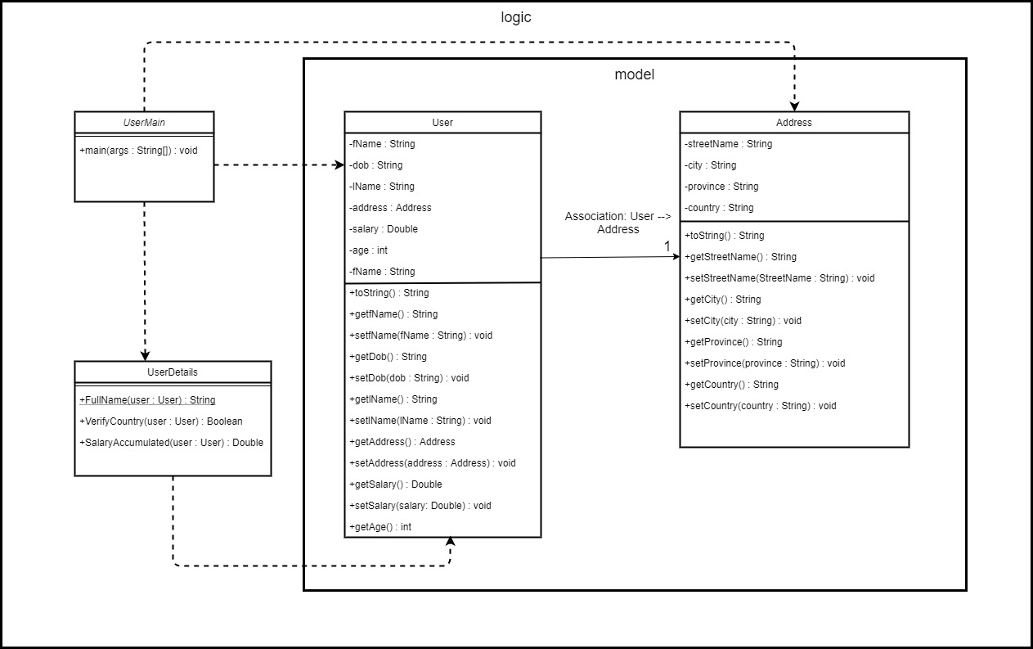

4 classes:

1. UserMain
2. UserDetails
3. User
4. Address

Dependency Analysis:

digraph "UserInfo.jar" {

// Path: UserInfo.jar

"project.logic.UserDetails" -> "java.lang.Boolean";

"project.logic.UserDetails" -> "java.lang.Double";

"project.logic.UserDetails" -> "java.lang.Object";

"project.logic.UserDetails" -> "java.lang.String";

"project.logic.UserDetails" -> "java.lang.invoke.CallSite";

"project.logic.UserDetails" -> "java.lang.invoke.MethodHandles";

"project.logic.UserDetails" -> "java.lang.invoke.MethodHandles$Lookup";

"project.logic.UserDetails" -> "java.lang.invoke.MethodType";

"project.logic.UserDetails" -> "java.lang.invoke.StringConcatFactory (not found)";

"project.logic.UserDetails" -> "project.logic.model.Address (UserInfo.jar)";

"project.logic.UserDetails" -> "project.logic.model.User (UserInfo.jar)";

"project.logic.UserMain" -> "java.io.PrintStream";

"project.logic.UserMain" -> "java.lang.Boolean";

"project.logic.UserMain" -> "java.lang.Double";

"project.logic.UserMain" -> "java.lang.NullPointerException";

"project.logic.UserMain" -> "java.lang.Object";

"project.logic.UserMain" -> "java.lang.String";

"project.logic.UserMain" -> "java.lang.System";

"project.logic.UserMain" -> "java.lang.invoke.CallSite";

"project.logic.UserMain" -> "java.lang.invoke.MethodHandles";

"project.logic.UserMain" -> "java.lang.invoke.MethodHandles$Lookup";

"project.logic.UserMain" -> "java.lang.invoke.MethodType";

"project.logic.UserMain" -> "java.lang.invoke.StringConcatFactory (not found)";

"project.logic.UserMain" -> "project.logic.UserDetails (UserInfo.jar)";

"project.logic.UserMain" -> "project.logic.model.Address (UserInfo.jar)";

"project.logic.UserMain" -> "project.logic.model.User (UserInfo.jar)";

"project.logic.model.Address" -> "java.lang.Object";

"project.logic.model.Address" -> "java.lang.String";

"project.logic.model.Address" -> "java.lang.invoke.CallSite";

"project.logic.model.Address" -> "java.lang.invoke.MethodHandles";

"project.logic.model.Address" -> "java.lang.invoke.MethodHandles$Lookup";

"project.logic.model.Address" -> "java.lang.invoke.MethodType";

"project.logic.model.Address" -> "java.lang.invoke.StringConcatFactory (not found)";

"project.logic.model.User" -> "java.lang.CharSequence";

"project.logic.model.User" -> "java.lang.Double";

"project.logic.model.User" -> "java.lang.Object";

"project.logic.model.User" -> "java.lang.String";

"project.logic.model.User" -> "java.lang.invoke.CallSite";

"project.logic.model.User" -> "java.lang.invoke.MethodHandles";

"project.logic.model.User" -> "java.lang.invoke.MethodHandles$Lookup";

"project.logic.model.User" -> "java.lang.invoke.MethodType";

"project.logic.model.User" -> "java.lang.invoke.StringConcatFactory (not found)";

"project.logic.model.User" -> "java.time.LocalDate";

"project.logic.model.User" -> "java.time.Period";

"project.logic.model.User" -> "java.time.format.DateTimeFormatter";

"project.logic.model.User" -> "project.logic.model.Address (UserInfo.jar)";

}