WHID
(What Have I Done)

Users Manual

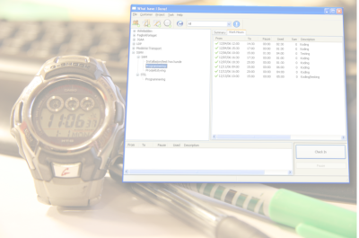

By Jarle (jgaa) Aase
About this manual

Author: Jarle Aase (jgaa@jgaa.com) http://www.jgaa.com/
Product homepage: http://whid.jgaa.com
Copyright: Copyright 2007 – 2009 by Jarle Aase. All rights reserved.
This manual is licensed under the “GNU Free Documentation License 1.2”.
- http://www.fsf.org/licensing/licenses/fdl.html

Please report spelling errors, subjects that are missing, errors in the content or suggestions on how this manual can be improved to jgaa@jgaa.com.

Published:
    - Version 1.00 – September 31st 2007
Table of contents
1.About WHID 4
1.History 4
2.Technology 5
3.The idea behind WHID 6
4.Future versions 6
2.Quick guide to getting started 7
1.Installation 7
1.Windows 7
2.Linux 7
2.First use 7
3.Creating Customers, projects and tasks 8
4.Starting the “meter” (adding work-hours) 13
5.Summary information for the current week 15
6.Adding work hours manually 15
7.Billing 16
8.Finding an existing invoice 19
9.Browsing work-hours 20
3.Configuration 22
1.Single-user and multi-user 22
2.Database Engine 22
3.Switching to MySQL 23
4.Installing for more users 24
5.Logging 25
6.Email 25
7.Communication 26
4.Rates 26
1.Defining Rates 26
2.How rates are inherited 29
3.How can I validate the applied rates? 29
5.Users 30
6.Backup and restore 32
7.New versions and the database 33
8.Bugs and suggestions 34
1.Custom development 34
2.Using parts of Whid in closed source projects 34

About WHID

History
In 1998, I felt that I totally lost control with time. My Free/Open Source projects lagged behind their time-schedules, and I was unable to account for how I spent my time. I also needed some way to keep track of the time I spent on commercial projects. At that time I also wanted to learn more about C++ and the Standard Template Library stl. I spent a few months writing a small program in C++/MFC/stl that kept track of my time usage. I named the program “wtm- War Time Manager”, and the intention was to release it as free software. But my experience with free software at that time was not too good. Releasing something meant lots of work; all kind of people would contact me for support or “business opportunities”, and I simply had far enough of this constant rush of emails with my existing software. So I used the program myself and only gave it away to a few people I knew that were in need for it.

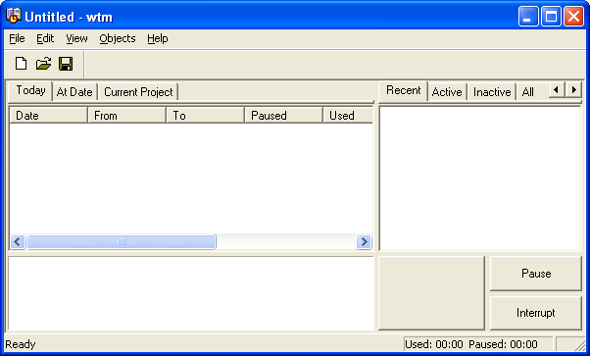Illustrasjon 1: A screenshot from the original WTM application
In the spring of 2006 I read the book “User Interface Design” by Soren Lauesen, and a single illustration in that 600 pages book inspired me to think about a new time management application. WTM was able to do lots of things, but it was unable to give me a quick summary about my current status. The example in Sorens book was so obvious, and elegant, that I simply thought “I want that!”.
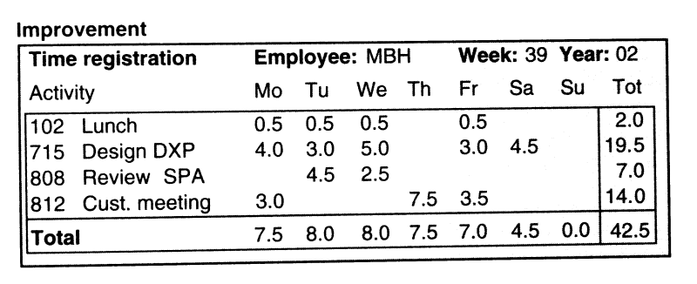Illustrasjon 2: Illustration from the book "User Interface Design" page 123
In 2006 I had stopped using WTM many years ago, and I was in fact in need for a time management and accounting application. The last few years I had been using a web based application that was really horrible. I searched for a Open Source or cheap Shareware program that would fit my needs without finding any. So in december 2006, I spent a week writing WHID.

Technology
When I first decided to write a new application, I was just about to start using C# for some of my commercial projects. I figured that the point and click approach in Visual Studio 2005 would be ideal for a simple application like this, and made a prototype in a few hours. But I was unable to connect the views of customers, projects and work-hours. When I consulted a more experienced C# developer, he told me that it would require considerable, good old fashion programming. So I dropped C# and decided to use C++ in stead. The design goals were:
- Multi-platform. I use both Linux and Windows, and need to use the application on both.
- Three-layer Client/Server design. - Also a full separation between the user-interface and the business-logic. That means more work while the application is made, but makes it a lot easier to maintain later on.
- SQL database storage. The problem with WTM was that it stored all data in memory while it was running, and after a few years it started to consume too much memory.
- Multi-user, so that it can be used by a company with more than one employee.
- Simplistic. The program must be good at what it is designed to do and nothing else. There is too much bloatware out there.
- Multi-language support. It must be easy to translate the program into new languages.

I ended up with this design:
  - GUI (Graphical User Interface) based on wxWidgets. This is a multi-platform GUI toolkit that makes it relatively easy to use the same C++ source code under Windows (Microsoft) and Xwindows (Linux).
  - Multi-language support is handled by wxWidgets/GNU gettext. The log-file and some critical error-messages are in English to simplify support. The initial release comes in English and Norwegian.
  - ICE (Internet Communications Engine) as middleware. This is a toolkit that separates and encapsulates the business-logic. Currently I run the server and client in the same physical application, but it is easy to separate the two in a future version if the demand should arise. It also have the nice side-effect that the program can be scripted with C#, Visual Basic, php and Python! The business-logic is easily available for other programs, and a web-counterpart is therefore very easy to make.
  - Database abstraction trough “warlib” (my C++ library). The default database is “sqlite”, an embedded SQL database that keeps its data in a single data-file. MySQL is also supported, and this is what I use (it's a lot faster than sqlite, but require MySQL to be installed somewhere). Data can be migrated between the databases trough the database backup/restore feature.
  - The initial release is for Windows. The application compiles and runs under GNU/Debian Linux “etch” and will soon be available as pre-compiled binaries for Debian. But I have to fix a few bugs before the Linux version is released.

The idea behind WHID
The idea behind WTM and WHID is very simple: When I start to work on a project I click on the project and the “Start” button. Then the meter is running until I press the “Done” button. If I am interrupted by a new customer, I click on his project and press the “Start” button again. The previous meter for the project is put on hold, and the meter is running for the new one. When I press the “Done” button, the previous project becomes the current project, and the meter is running again. If I take a break, I press the “Pause” button and the meter is put on hold.
WHID is also a program designed for people who work with projects in an office. People like me. I'm lazy, and therefore I've made WHID as easy to use and foolproof as I can. I like to work with my source code. I don't like to to write lists of hours or bills or accounting at all.

Future versions
I've designed WHID to meet my demands. I believe that lots of people have similar demands, and since I found no Open Source program that met my requirements, WHID is released as Open Source. I spent a little extra time to add multi-user support and a few other features that hopefully makes it attractive to a broader audience. It's easy to add new features. It will probably take about 2 – 3 months of work to extend it to fit the needs for time-accounting for large companies (including the software needed for “dumb” terminals where the employees clock in and out).
My company; Jgaa's Internet Ltd in London, UK, can extend and customize WHID to meet your specific requirements. Features purchased by one company will normally go into the Open Source version in the next release so that everyone who use the application can share the benefit.

Quick guide to getting started
This is probably the only part of this manual you have to read in order to use WHID.

Installation
You will normally install WHID from a pre-built install package. If you are a hard-core hacker, you can download the source-code and build it for yourself.

Windows
Download and run whid-*.msi, where * is the latest version number. You can downlod this from http://whid.jgaa.com/.

Linux
At this time, no pre-bulit version is available for Linux. You must build from the source-code.

First use

The first time WHID is started, it will complain that there is no database and offer to create one. Choose a login-name (typically your initials), enter your full name and your normal salary pr. Hour. This information is required in order to create the database on your system. This is not a product registration, and the information is not transmitted anywhere.
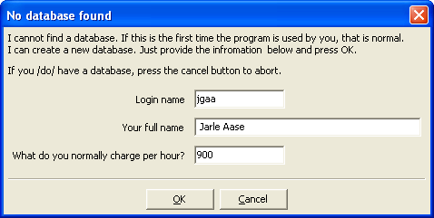Illustrasjon 3: The dialog that pops up the first time WHID is started
If you later run WHID in single-user mode, all work-hours are registered on the user registered here. If you switch to multiuser-mode, you can use this user as one of the users in the system. (I will come back to single/multi-user mode later).

Creating Customers, projects and tasks

When you press OK WHID will have no data, so all lists will be empty.
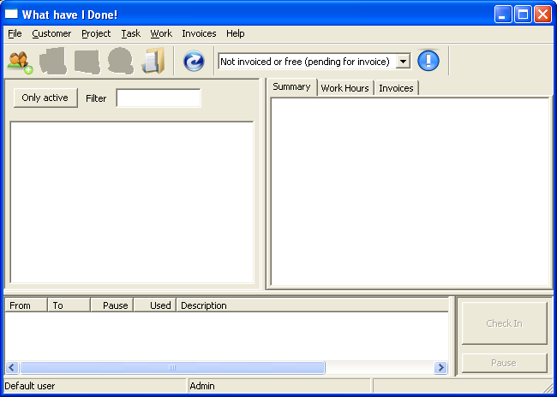
The first thing you should do is to add a customer. Press the New Customer button.
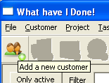
Enter a name for the customer

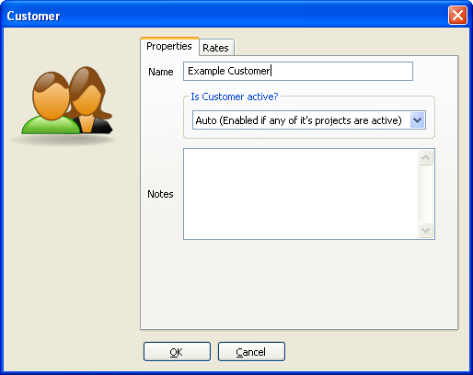
and assign a rate to it. The rate defines what you normally charge the customer for a work-hour.

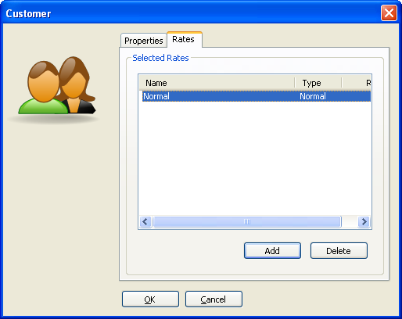

You may have to add a new rate for this customer. Press the “Add” button in the Customer/Rates tab.

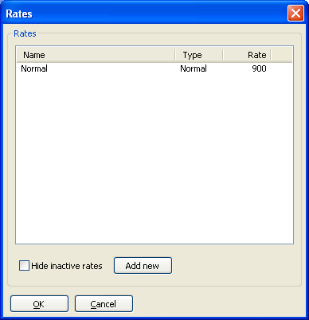

The press “Add New”.

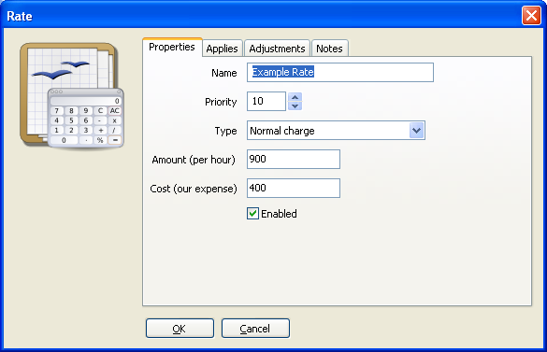
Give the Rate a unique name, enter the charge (amount) for each work-hour and (optionally) your own cost. The cost is used to calculate the profit in reports.
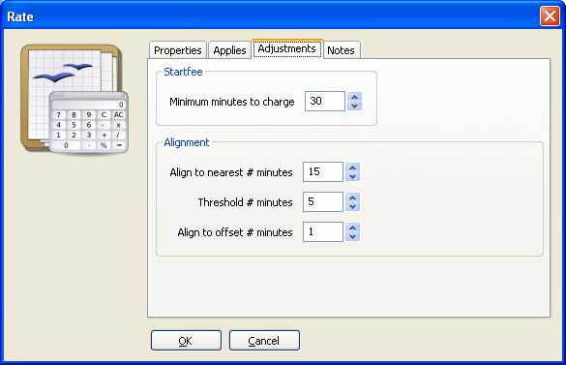
In the “Adjustments” tab you can define the minimum time to charge (like 30 minutes or an hour) and the alignment to put on the bill (like up/down to the nearest 15 minutes).

Now that you have a customer, you can add a project. Click on the customer and press the !”New Project” button.
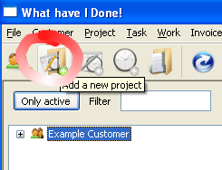

Give the new project a name, and optionally a default rate. (My projects will normally use the default rate for the customer, but there are exceptions, like small changes on web-pages, where I use rates aligned on 30 minutes in stead of 1 hour).
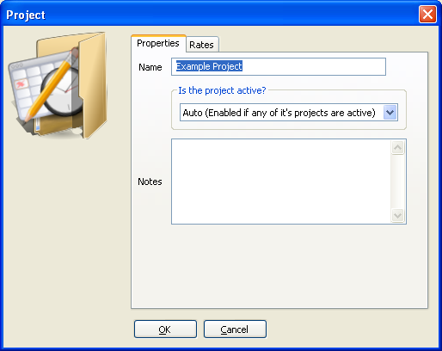
Select the newly added project and add a new Task.

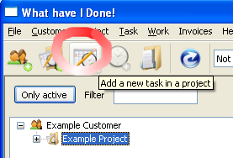

Give the task a name. As you may notice, you can override the rate also at this level.

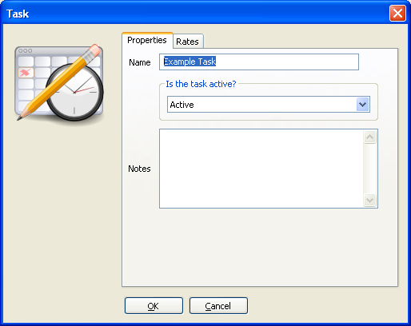

Starting the “meter” (adding work-hours)
A “Task” is the level where you add work-hours. Just select the task, and press the “Check In” button to start working.

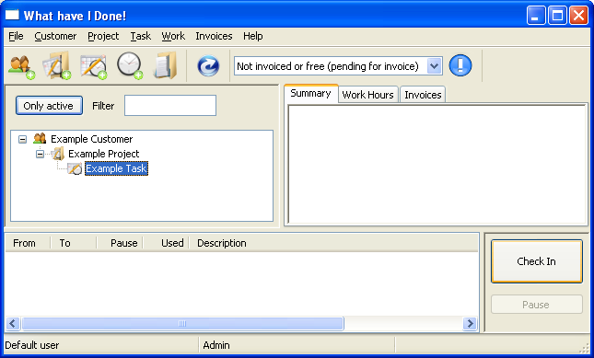

In the Work Dialog, you may specify what you will do (or what you actually did, depending on when you entered the text). You can also adjust the From Time. The To Time will be set automatically when you mark the task as finished.
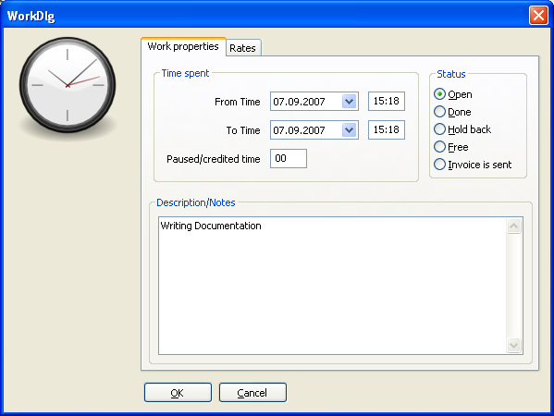
The work will now be listed in the Work Stack on the bottom.
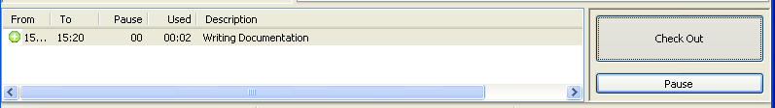
To finish the work, click on the item and then the “Check Out” button. (It's the same button you used to start a work item. The button will change functionality depending on the situation.

If you are interrupted, you can press the “Pause” button. The “meter” will then stop and the paused time will be subtracted from the time spent on the task. Press the “Pause” button again to end the pause.

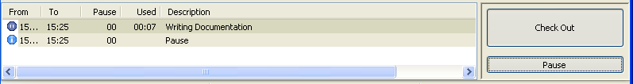
If you select a new task when you are working on one, the task you were working on originally is paused, and the new task becomes active for the “meter”.

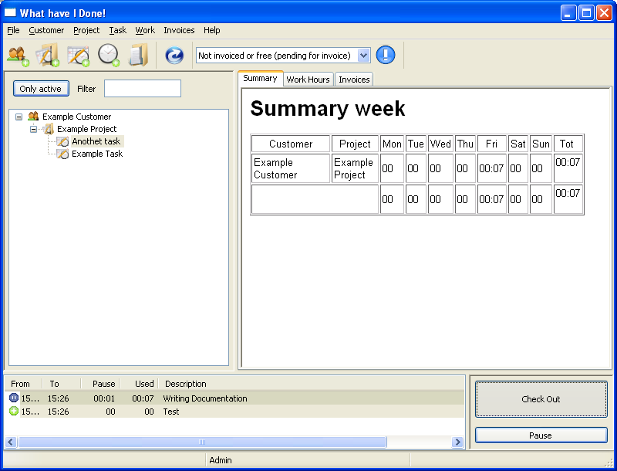

Summary information for the current week
If you select the “Summary” tab in the main view, and press the Refresh button, a summary for the work performed this week is generated. This is an easy and practical report to give you an idea of how you are doing. See the previous illustration.

Adding work hours manually
In order to add work-hours manually (with start and end-times), press the “Add Work Hours” button.
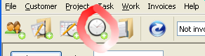
This works like the “Check In” button, except that the Work stack is omitted, and the end-time you enter is used.

Billing
Press the “Billing” button.
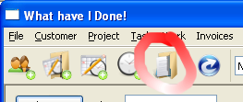
Select the time-span for the bill.
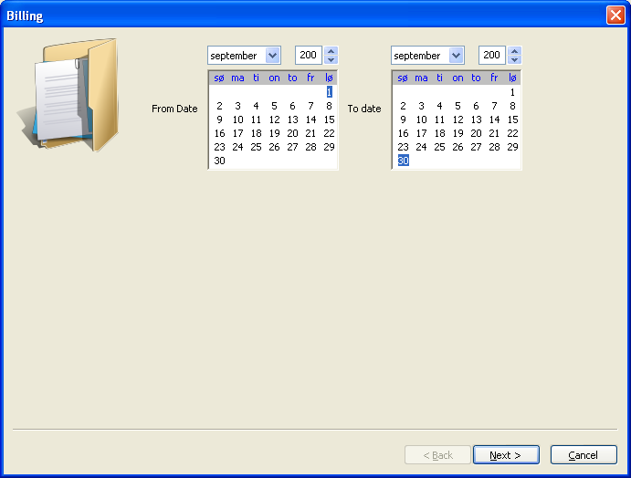

Select the projects you want to bill from the list of projects with billable work-hours in the specified period.
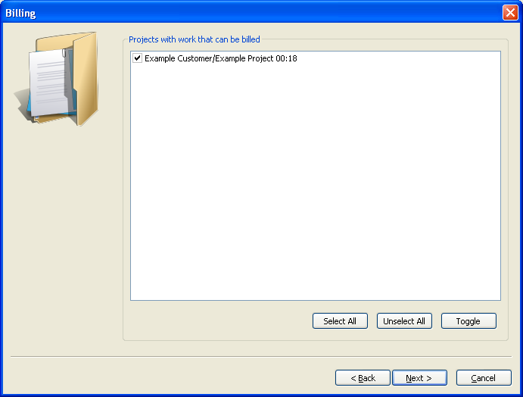
Verify that the summaries looks valid.

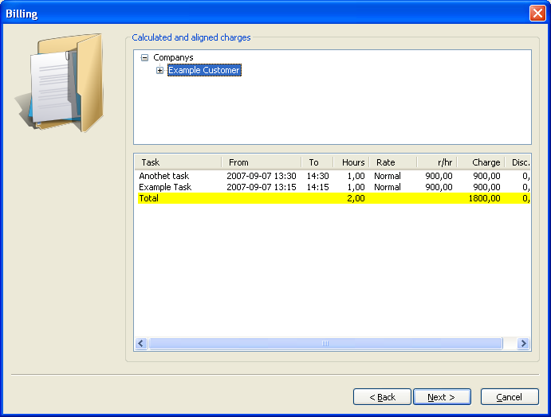
Whid will now generate one bill for each customer. You can select the bills you want to process.

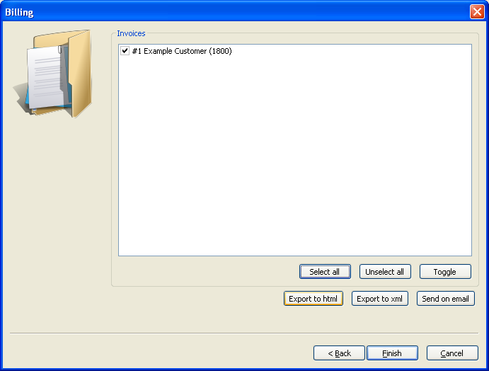
If you press “Export to html”, you can view the bill(s) in your web-browser.
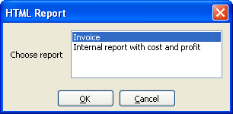
Before the report is formatted, you can specify the format. Normally you will use the “Invoice” for your customers and the “Internal...” report for your own use. The internal report is similar to the bill, but also shows the profit.
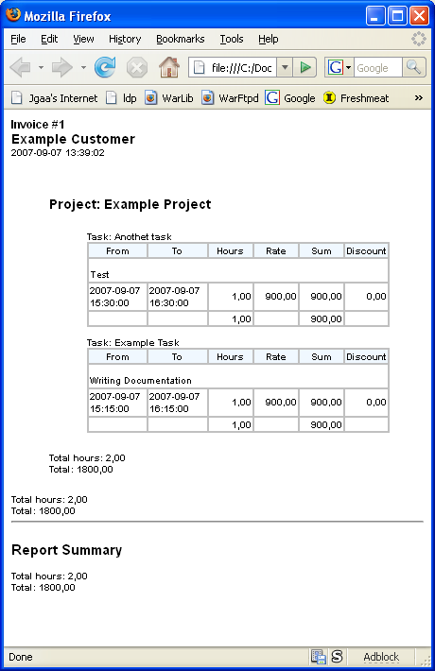
If you press the “Finish” button, the selected invoices are stored, and the billed work-hours marked as “Billed”.

Finding an existing invoice
Just select the “Invoices” tab in the main window and select a customer, project or task. All invoices that involve the selected item will show up in the Invoices list.
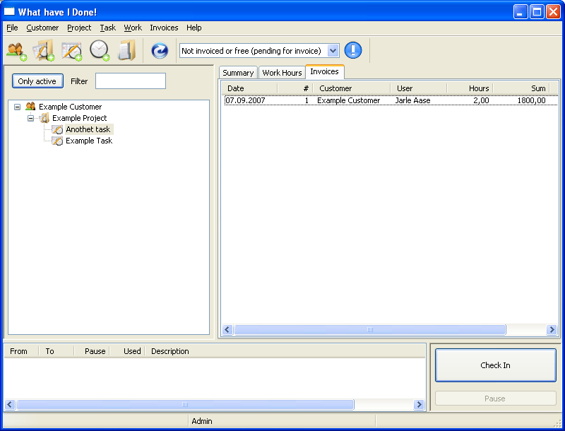

Browsing work-hours
Select the Customer, Project or Task of interest and choose the “Work Hours” tab.
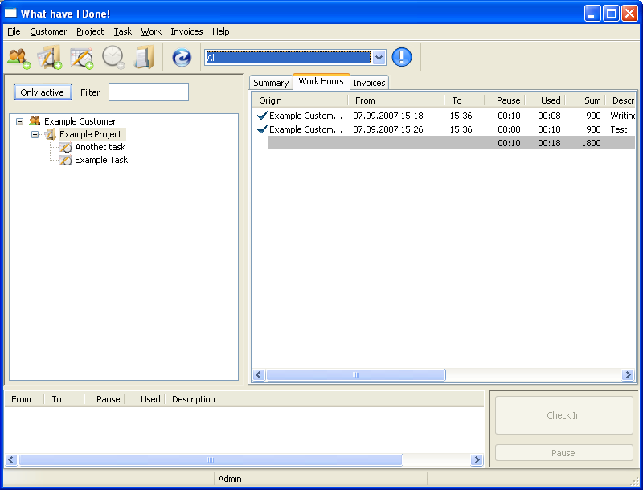
You can use the filter on the tool bar to choose the status of the work-hours you want to see. Normally the filter will show only work-hours that are not invoiced. In the example above, it shows all work-hours.

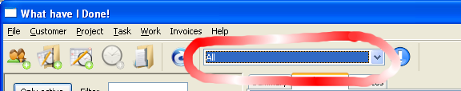

Configuration

Single-user and multi-user
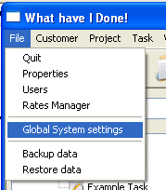
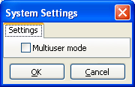
In the “Global System Settings” menu you can choose between single-user or multi-user mode. The change will take effect when you restart Whid.
In Single-user mode, Whid behaves like it have no concept of users. This mode is meant for personal use and one-man companies.
In multi-user mode, Whid will ask about login-name and password when it is started. That way it may distinguish between it's users. There is also a special user “Admin” with the default password “secret”. Your own password, for the user you created when Whid was first started, is also “secret”. If you use Whid in an environment with several persons, you should change the passwords.
Currently, there are no built-in reports that spans over several users. The bundled reports will show the data for the current logged in user. Making such reports however is trivial if you use the MySQL database-engine. In that case you can use programs like Crystal Reports (or even programs that actually works) to make whatever reports you want.

Database Engine
Whid supports two database-engines, “Sqlite” and “MySQL”. By default, it uses Sqlite.

Sqlite is a tiny database-engine that stores its databases in a single data-file. Whid calls that file “whid.db”. Under Windows it's located in the current users “Application Data” in a directory named “Whid”. My copy have this path:
C:\Documents and Settings\jgaa\Application Data\whid\whid.db

The path can be specified in users Properties, in case you want to use a common Sqlite database for several users.

Switching to MySQL
In order to use MySQL, you must have MySQL version 5 or later installed somewhere. MySQL is a high performance, free Open Source database available from mysql.com. It runs under all major operating systems, including Microsoft Windows and Linux.
Before you make the switch, you may want to back up the data from your existing database from the “File/Backup data” menu.

When MySQL is ready, enter the “File/Properties” menu and select the “Database” tab.
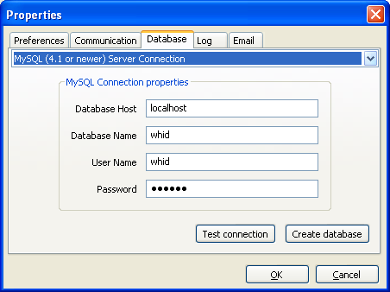
Choose “MySQL...” in the combo-box in the top of the dialog. When done, the dialog should look like the one above.

Enter the host name, database name and MySQL credentials you want to use for the new database.

Press the “Create Database” button.

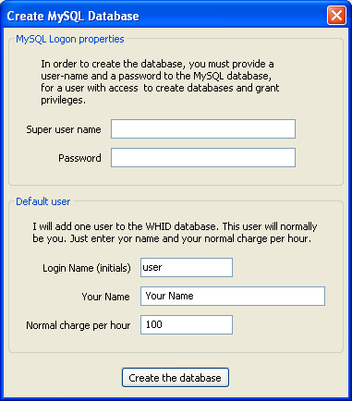
Enter the MySQL super-user credentials and a new user in order to create the database. If you intend to restore your backed up data, you don't need to worry about this user.
Press the “Create the Database” button.

Now, you can press the “Test Connection” button to verify that the database is OK. Press the “OK” button to save your change.

Quit Whid and start it again. When it starts up now, it will use MySQL.

You can now use the “File/Restore data” menu to restore the data you backed up.

Installing for more users
If you are installing Whid for several users, you may copy the user-setting file from one user and paste the to the new users “Whid” folder to save some time. The alternative is to start Whid and change the properties for each single user.
At my system this file is stored here:
C:\Documents and Settings\jgaa\Application Data\whid\whid-user-settings.xml

Logging
Whid can write status-information, errors, warnings and debug-messages (for trouble shooting) to a file. Open the “File/Properties” dialog and select the “Log” tab.

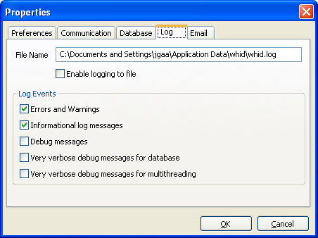

Email
Whid can send invoices directly on email to your customers. In order for this to work, you must enter a SMTP or ESMTP server and (optionally) user credentials for the server. (Other mail-gateways are not supported at the moment.)

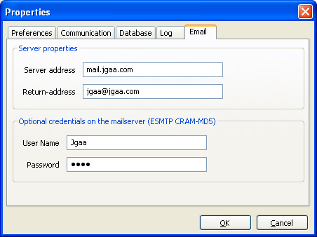

Communication
Whid has a scripting interface that can allow other programs to access its “business layer” interface directly. This is done trough the “Internet Communications Engine” (or Ice) from Zeroc. This interface is based on TCP/IP, and Whid will therefore listen to a TCP/IP port. On a normal PC you can use “localhost” as the hostname. That means that only programs local on your machine may use the interface. On terminal servers however, this interface may impose a security risk. I'm looking for a way to allow it to be disabled. (At the moment, Whid will not work without this interface enabled.)

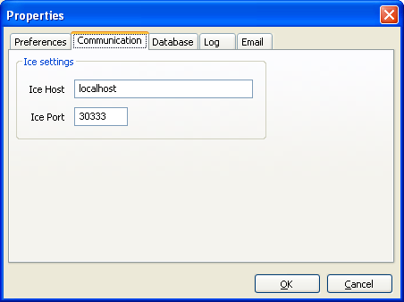

Rates
Rates can be easy, or they can contain complex rules. Whid allows for both. When I have used Whid, I have only used single rates with a pretty easy setup.
But Whid allows you to define complex rules that are applied automatically based on the day of week, time and so on.

Defining Rates
You open the rate-manager with the “File/Rates Manager” menu.

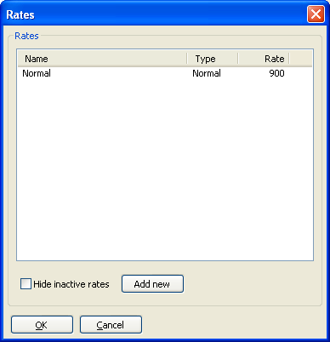
Press the “Add New” button to create a new rate. The “Rate” dialog pops up and allow you to define the properties for the rate.

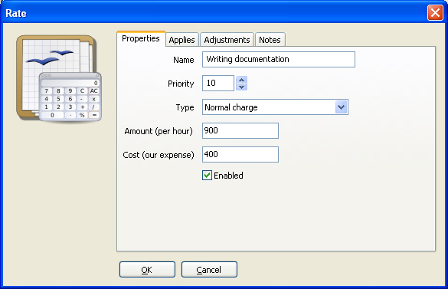
In the example above, I have called the rate “Writing documentation” with a fee of 900 (in my case Norwegian Kroner - NOK) and a cost of 400. That means that one hour of work at this rate gives a profit of 500 NOK.

In the “Applies” tab, you define when this rate applies. Several rates can be assigned to the same project, and this tab, along with the priority in the Properties tab, decides which rate(s) that are actually used.
The Priority is used when two rates of type “Normal Charge” (see the combo-box above) applies. The one with the lowest priority will be used. Also, if one rate has priority 1 and another 2, and both compete for the same work-hour, the one with priority 1 will be used and the one with priority 2 will be ignored.

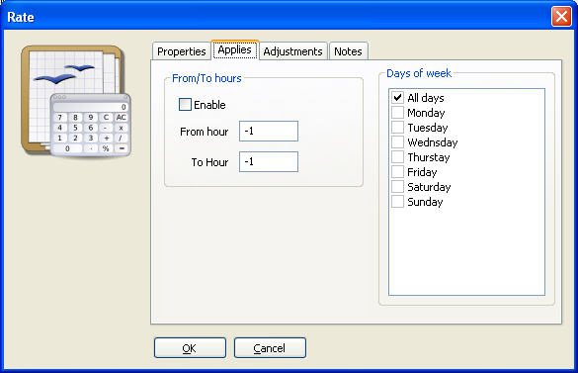
As you can see, you can define both weekdays and hours.
The “Adjustments” tab applies automatic adjustments to the work-hours.
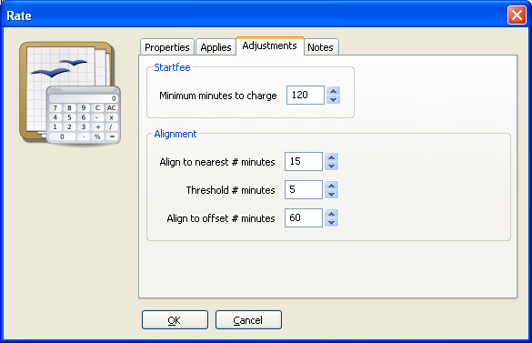
Normally you will work from times like 07:57 to 08:43. You rarely see from and to-times like this on invoices. The from and to times are aligned to 5, 10, 15 or maybe 60 minutes, so that the time must be adjusted to something like 08:00 – 08:45. That's what the “Align to nearest # minutes” option does.
The “Threashold” value decides if the actual value is aligned up or down to the nearest alignment offset. In the example above with 5 minutes, any value less than five minutes will go in the favor of the customer. From 5 minutes and up, the start and end-time is aligned in your favor.
The “Align to offset # minutes” option can be used to align up to the nearest # minutes. Many firms will use 60 minutes here, so that only whole hours are invoiced.
The “Start fee” allows you to set a minimum of what will be invoiced. In the example above, we will always charge at least two hours. After that, the time is rounded up to the nearest whole hour from the (aligned) start time.

How rates are inherited
The rates are defined on nodes in the Customer/project/Task tree and on work-items. Nodes and work-items without rates will inherit their rates from the nearest parent with rates.

How can I validate the applied rates?
If you go trough the billing procedure, you can press the “Export to xml” button. Whid will then output both the real times and the aligned times to an xml file. You can then inspect this file with an xml editor (Internet Explorer works fine) and see if the results are correct.

Users
In multi-user mode, you must log on as an existing user in order to use Whid.
You open the User Manager from the “File/Users” menu.

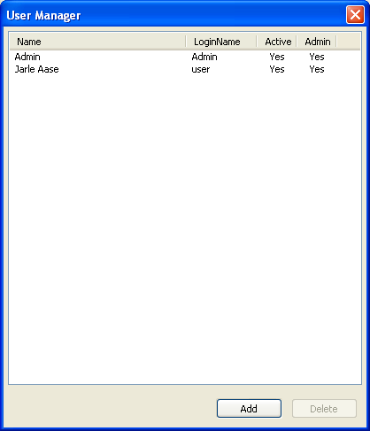
If you double-click on an existing user, you get this dialog:
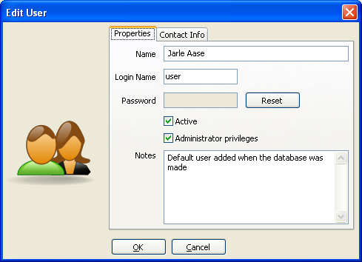
The “Name” is used wherever Whid needs to print the user-name. The “Login Name” is used to log in to Whid. The password is hidden. Whid will never display the password in clear text, or even transfer it from the database to the scripting interface. That's why you must press the “Reset” button in order to change the password.

“Active” means that the user can log in to Whid.
“Administrator Privileges” means that the user can run restricted operations, like adding or modifying rates, customers, projects, tasks, global settings and users.

The “Contact Info” tab lets you assign an email to the user.
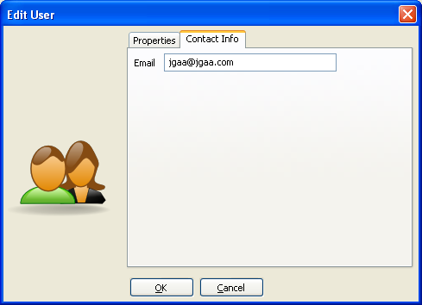
If an email is assigned, and this user use Whid to send bills on email, a copy of each email is sent to the user.

Backup and restore
The “File/Backup data” and “File/Restore data” menus are used to back up and restore data from Whid. The data is stored in an XML file, and it is independent of database engine (MYSQL or Sqlite). It's also supposed to be version independent. At least, you can assume that newer versions of Whid will be able to restore data backed up by previous versions.

New versions and the database
New versions of the program will typically depend on modified database structures. To ease deployment, whid comes with a file “whid_database.xml” that defines the structure of the database. Each time Whid is started, it will check the actual database against this file, and apply any changes.

Bugs and suggestions
Even if the code-quality of Whid is at an industrial level, there are bugs. You can report bugs to jgaa@jgaa.com or to the newsgroup alt.comp.jgaa. The same goes for suggestions.

Custom development
If you have unmet requirements, I might be able to implement your requirements to Whid, if you pay for the time spent on this work. Normally such features will go into the next free release. But this is negotiable.

Using parts of Whid in closed source projects
If you want to use Whid in a way that is incompatible with the Gnu Public License, like using parts of it in a closed source project, we might be able to negotiate an agreement. Note that you might have to purchase commercial licenses of libraries Whid depend on as well, such as Ice.

