Raman Pre-processing Workshop App – Tutorial Guide

Purpose
We created this app for you to interactive explore Raman preprocessing including alignment, background subtraction, baseline correction, Savitzky-Golay smoothing, truncation, zapping and normalisation. You will be able to load an example single-cell Raman dataset and run through all the steps to prepare your spectra for classification (step 2).

Installation
As we all work with University / business computers, there is a possibility that you may not have admin rights in your work computer. Try these three alternative approaches to install the Raman preprocessing app (some university computers will block installations, so we tried to provide alternatives):
Link: https://drive.google.com/drive/folders/1sBPv7slbnsSv9KbvvLz1cXlJrTjkTQzc?usp=sharing
- If you have Matlab already in your computer, the easiest way is to run this via Matlab. First download the GUI folder from the link. In Matlab, use
>> cd(dirPath)
to go to the directory inside the GUI. Then you can call the GUI by doing:
>> run("RamanPreprocessing_v3.mlapp")
- If you have admin rights, download the exe file and install the app. Mind that due to this app being created by researchers, you will get some warning, but this is normal. The app will ask you download a Matlab package mid-way through, and this is necessary to run the app.
- If this is not working, you might be able to download the 7zip file and unzip it. Then inside the app there is a build folder, and a file called RamanPreprocessing.exe. You might be able to just run it.
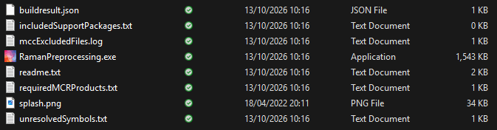
Double click on your app to run it. It might take 1 min to start, so be a bit patient.
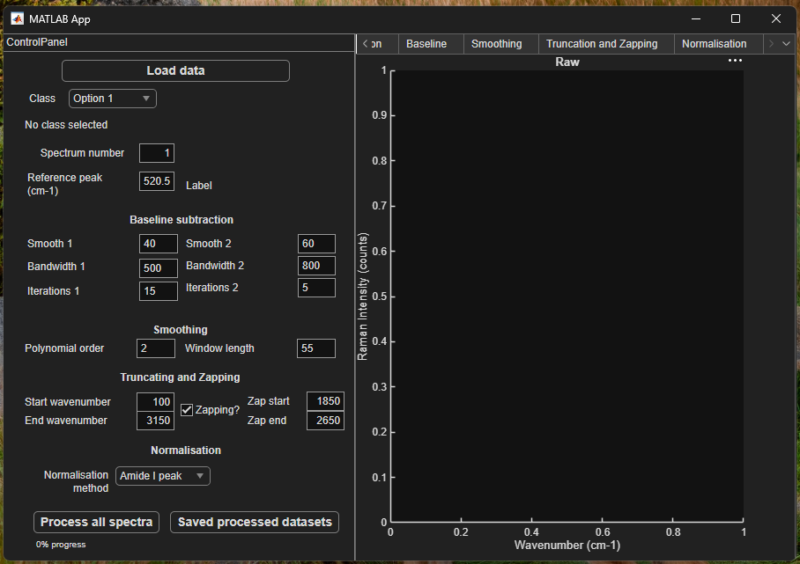

Loading Data
Right now the app has no Raman data. We prepared an example dataset in the link above called RawData.mat. Please download it.
Click Load Data and select the RawData.mat. Within this file, our experimentalist collected hundreds of Raman spectra of live colorectal cancer cell lines adhered to glass. We thank Ethan Tebutt for his contribution to this tutorial, as this data was one of the outputs of his MPhys project.
You could load this file into Matlab and explore it yourself. RamanSpectra{k,1} contains a spectrum organised as [wavenumber intensity], RamanSpectra{k,2} contains the class label (the cell line in this case), and RamanSpectra{k,3} contains the measured calibration peak (the silicon peak that we use to calibrate the system every day). We will use this information to pre-process the data.
Once the data is loaded, it will look like this, where the left shows the raw Raman spectrum chosen:
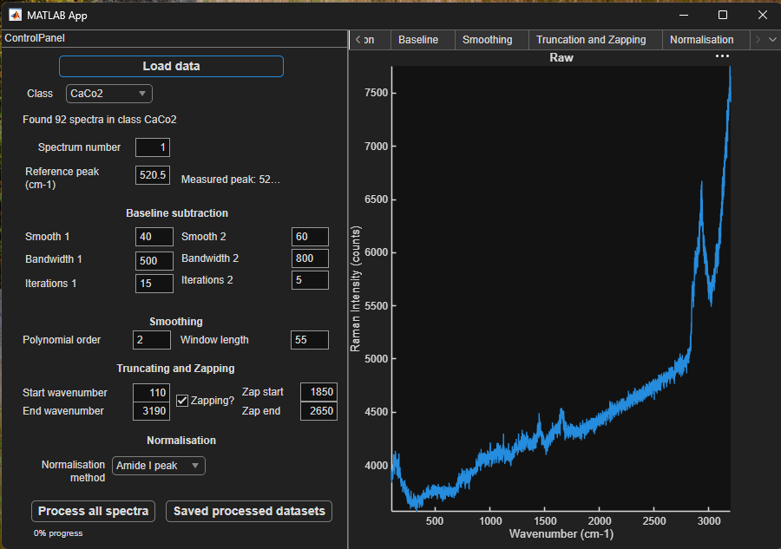

Selecting Spectra
The app identified the different classes and will show the number of spectra in each. Choose a Class from the dropdown. In this case, the class CaCo2 contains 92 spectra and we are seeing spectrum number 1. Try to change the spectrum number and the class to see the inherent variability within cell line and between cell lines.
FHC is a cell line representing healthy epithelium. Can you see differences between this cell line and the others?
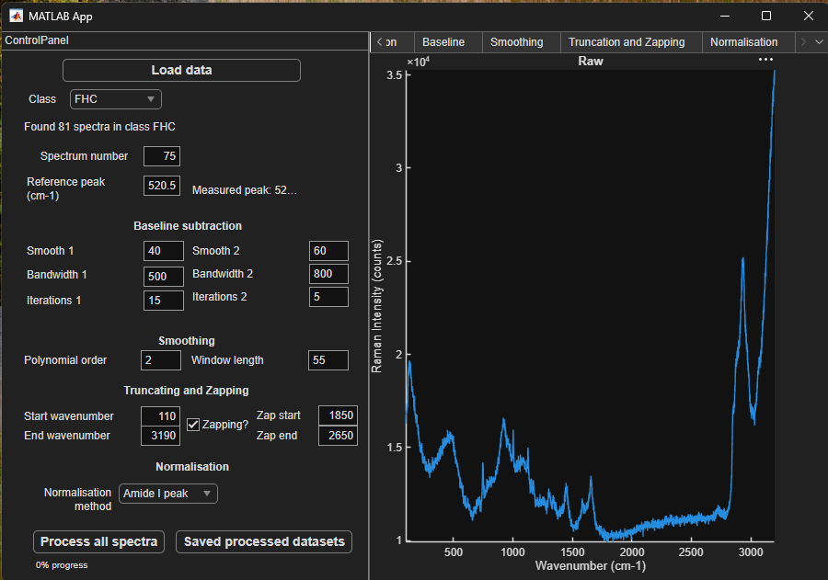

Alignment
On the top of the plot you can see different tabs. These represent the different steps of pre-processing organised from left to right. We are currently in the Raw tab. If we move to the Alignment tab we can process to the first step of pre-processing.
A lot of Raman microscopes require aligning the grating to the detector often to ensure the position of the peaks is accurate. This is done by using a reference sample. A common reference sample is silicon, with a sharp peak at 520.5 cm⁻¹, which was used for these data. Some microscopes may do this automatically on start. However, the alignment is not always perfect, and one day may achieve 520.3 while another day it achieves 520.8 cm⁻¹.
In addition, the output wavenumber data may have varying wavenumber values between days. For example, the first few values may look like this (in cm⁻¹):
Day 1: | Day 2:
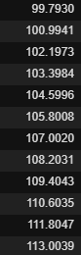 | 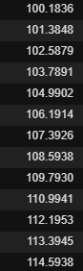
This first step of analysis allows us to:
- Correct for the small variations in analysis from day to day.
- Interpolate to a known chosen set of wavenumbers. Eg. 100.0, 100.5, 101.0, 101.5, …
If the alignment was good, this change will be very subtle, but it is still important. If you zoom into the plot on the characteristic phenylalanine peak at 1002 cm⁻¹ (use the mouse wheel), you will be able to see a small translation of the spectra in the wavenumbers axis.
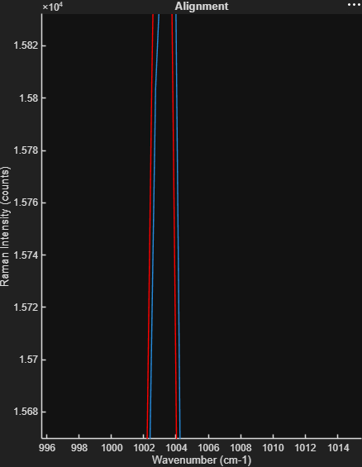

Background Subtraction (EMSC)
Raman will be sensitive to your experimental setup, and will pick up signal from the buffer and the substrate. In this case, this was measured with a visible laser (532 nm) and in a glass coverslip. The experimentalist measured background spectra at the same Z position in the absence of the cell for each dataset. In this case we are using Extended Multiplicative Signal Correction to remove the background contributions using the supplied background spectra. You can see the glass peaks (lower wavenumbers) and the water band background (high wavenumbers, with peak at ~3600 cm⁻¹). The substrate and buffer signal variability can overtake the cell signal at the analysis stage, so this is an important step, especially when working with polymer backgrounds such as PDMS.
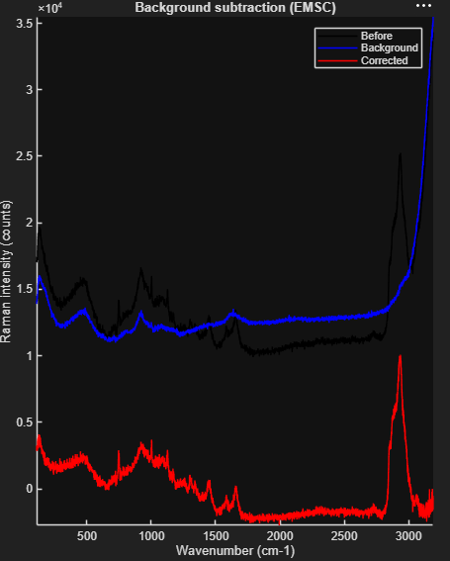
Credit: I wrote my EMSC code based on the publications listed below, please give credit if following this pipeline for publication:
Martens H., Stark E. Extended multiplicative signal correction and spectral interference subtraction: New preprocessing methods for near infrared spectroscopy. Journal of Pharmaceutical and Biomedical Analysis, 9(8), 625-635 (1991).
Skogholt J., Liland K.H., Indahl U.G. Pre-processing of spectral data in the extended multiplicative signal correction framework using multiple reference spectra. Journal of Raman Spectroscopy, 50(3), 407-417 (2019).

Baseline Correction
Samples may show baseline due to a number of reason, including autofluorescence and mie scattering of highly scattering particles. Baseline subtraction can be essential to make sure the Raman peaks are highlighted, and can help with any negative values from the background subtraction.
In this tutorial, a two-pass baseline correction is provided. This is an iterative minimum-envelope algorithm implemented in f_baseline_corr, developed at the Hannoversches Zentrum fur Optische Technologien (HOT), Leibniz Universitat Hannover; code attributed to M. Mazurenka, C. Suhr and M. Koch.
Feel free to modify the Smooth, Bandwidth and Iterations parameters for each pass and observe the effect on the estimated baseline and corrected spectrum. Notice that smaller bandwidths can start to remove intensity in broad peaks like the CH stretching region (~2900 cm⁻¹), while very large bandwidths may not remove broader components of the background.
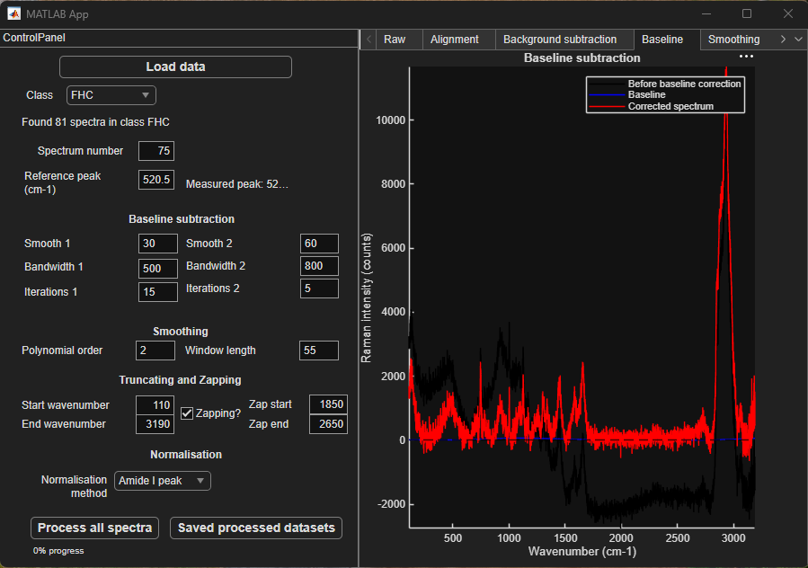

Smoothing
This is a potentially optional step. It is traditionally used to remove the high-frequency background and bring to light the Raman bands. A common approach uses a Savitzky-Golay filtering. You may adjust the Polynomial Order and Window Length. The window length should remain an odd integer and larger than the polynomial order.
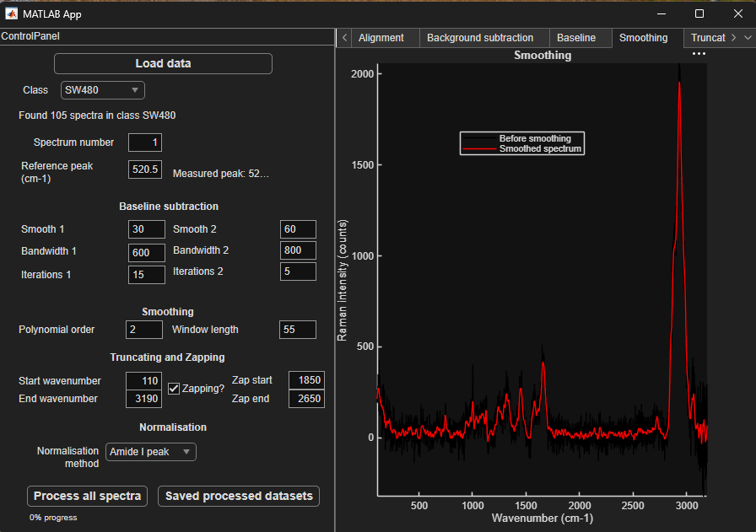
Reference: Savitzky A., Golay M.J.E. Smoothing and Differentiation of Data by Simplified Least Squares Procedures. Analytical Chemistry, 36(8), 1627-1639 (1964).

Truncation and Zapping
When training a classifier later, you may find that some parts of the spectrum contain background that was difficult to remove completely, and you may choose to truncate them or zap them. For example, the silent region (~1800-2650 cm⁻¹) is noise dominated in biological samples, but may be relevant when using isotope labelling and Raman tags. You can interact with this step choosing the Start wavenumber, End wavenumber and enabling Zapping to eliminate the silent region.
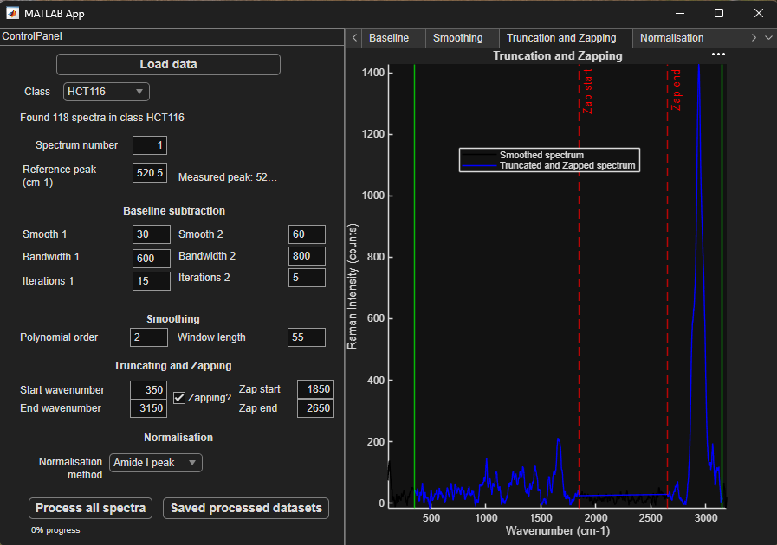

Normalisation
Raman is a semi-quantitative technique. This means that it can be quantitative under very controlled conditions, but that it is often interpreted following normalisation, so that each peak is always considered as a ratio to a reference peak.
In this code, we can perform normalisation using a few different approaches. For example, we normalise to the maximum of the Amide I band at 1660 cm⁻¹ (Amide I peak), or we can normalise to the area under the curve (Total area) or to a specific peak (Selected peak). Try them all and notice the y-axis for the normalised plot (bottom). For this dataset, I will be normalising to the Amide I band or total protein in the sample.
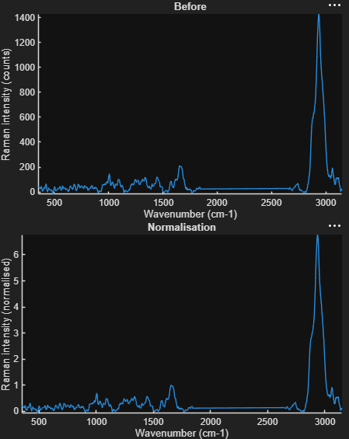
The current code is showing a single spectrum, but at this point we are ready to apply our pre-processing to all our cells. Click on Process all spectra and follow the progress (this might take a few minutes). Once finalised, it will show all the spectra overlapped and you will be able to see the effects of your normalisation.
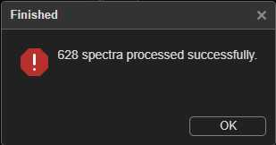
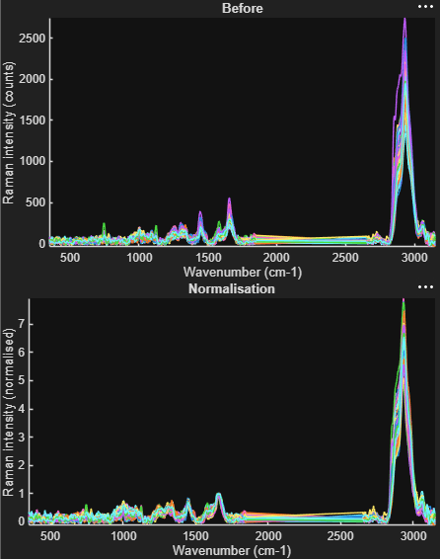

Processing and Saving
You can click Save processed datasets. The application automatically processes all spectra using the current settings before saving. The saved data will also contain all the chosen settings in the metadata so that the analysis is traceable. Choose a location and save the data with the name ProcessedData.mat to process to the classification part of the tutorial.

The Analysis tab – Multivariate analysis
We can now move to the analysis tab of this application. Here, we can start to apply a few multivariate methods, both supervised and unsupervised.
- Unsupervised multivariate methods: these run on the data identifying patterns without any additional information. The model does not know what class is what (aka cell lines), and will just find groups based on the data characteristics. For example, principal component analysis is a linear unsupervised multivariate method that separates samples based on variance, that is, identifies the dimensions of the data that vary the most and replots the data in these directions. These methods can be used to reduce the dimensionality of the data, which can be very important to run further models that can run poorly when too many variables are given. In this example, the variables are the Raman wavenumbers (thousands), that may be reduced to tens of principal components.
- Supervised multivariate methods: these run on the data with prior knowledge of the classes of each observation, and learn from this. These models are usually very powerful, but can easily learn too well a single dataset, so it’s important to evaluate them against data they have never seen. When using these models we will split our data into training groups and validation groups.

Principal Component analysis (PCA)
When running PCA we are just doing a change of dimensions, where each cell is no longer a full spectrum, but it is now a combination of scores in each of the dimensions of PCA (called principal coefficients). Each of these dimensions look like a spectrum and are called loadings.
$cell spectrum=score_{1}⋅loading_{1}+score_{2}⋅loading_{2}+score_{3}⋅loading_{3}+…$
Loading 1 will be the one that explains the most variability in the system, loading 2 will explain less variability, etc. The more loadings we consider, the more noise we are allowing.
Notice the each loading looks like a spectrum but has positive and negative peaks. If a cell has a positive score in a loading, it means that the positive peaks are present, while a negative score means it is the negative peaks that are present. Loadings can look like known spectra, which makes interpreting the results much easier.
However, PCA does not care if the variability comes from intended differences between the cell lines, or simply variations in background contribution!

UMAP
UMAP is also unsupervised but it is non-linear, which allows for better separation but often harder to interpret results. Here we can run UMAP directly onto all the spectral variables, or run it following dimensionality reduction with PCA (you can control this with the variance explained threshold: a lower threshold will keep fewer coefficients, and reduce the dimensionality further). Notice how much better UMAP runs when doing PCA first.
With UMAP it is very difficult to map the data back to spectral features. It can be nice to explore a dataset, but it is much harder to interpret than PCA.

Linear Discriminant analysis (LDA)
In order to run a supervised method, first we need to split our data. A typical approach is to use k-fold validation, where we split our data in k different groups, and train k different models. For the first model, we will merge all the data in the first k-1 groups to train it, and then we will use the model to classify the last group of data. This will help us estimate how good our model is. Larger k values means that more data is used to train, but also means that less data is used to check the validity of the model.
We can run LDA with our without PCA, but I strongly recommend running it following PCA. When running this model, we get an overall accuracy. As LDA is a linear model and PCA is linear too, we also get coefficients that have their own scores and loadings, and the loadings also have spectral shapes, aiding in interpretability of the data. Here, we are training LDA to separate each class from all the others (one vs all). You can see that for each coefficient you achieve a level of separation (histogram of scores) and a different loading shape.
In the next tab, we can also explore the classification table. A classification table helps visualise which classes are well separated and which ones are often mixed. Each row shows all the observations in the group being studied and where they were classified. We have a different classification table for each fold, but we can also calculate the overall classification table showing the percentage of cells classified correctly or incorrectly. Here you can see the validation fold size changing when changing the value of k.

Further Multivariate analysis
We will not have time to do this in the workshop, but I just wanted to bring this to your attention to show you how easy it can be to train your own other multivariate methods, such as discrimination trees or convoluted neural networks.
For this part of the tutorial, I will be using MATLAB and MATLAB’s Classification Learner. This allows for interactive training of different classifiers.
Open MATLAB.
We will start by loading the data onto MATLAB. To do this, you can drag and drop the file into the command Window. You can also navigate to our folder by clicking the Browse for folder button:
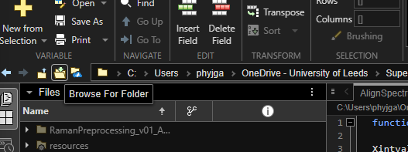
And then load the file by writing the following command in your command window:
load(".\ProcessedData.mat")
Now your Workspace should show a ProcessedData variable (a structure):
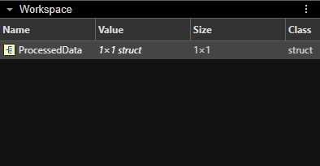
And we can double click on it to see what’s inside:
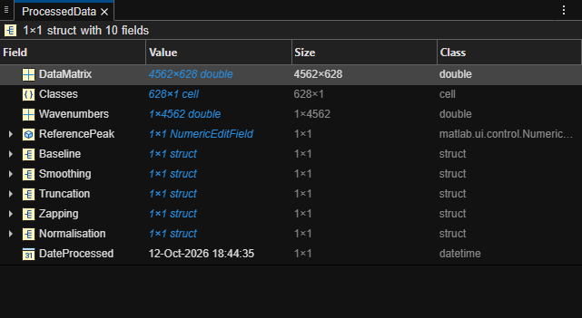
The 628 cell spectra are inside:
ProcessedData.DataMatrix
organised in columns. We also have the classes of each spectra (the cell lines) inside
ProcessedData.Classes
And the wavenumber vector common to all spectra (that’s why we aligned it) is inside
ProcessedData.Wavenumbers
Before we move forward, we will create easy variables to run the classifiers. In the Command Window, type the following lines, hitting enter in between. These will prepare the data as a table, assigning names for each variable (wavenumber) to make exploration of the data easier.
DataMatrix=ProcessedData.DataMatrix;
DataTable=array2table(DataMatrix.');
Classes=ProcessedData.Classes.’;
Wavenumber=ProcessedData.Wavenumbers;
DataTable.Properties.VariableNames=compose('%0.1fcm-1',Wavenumber);
clear DataMatrix

Classification learner
On the top, we will click on the APPS tab. We will search for the Classification Learner.
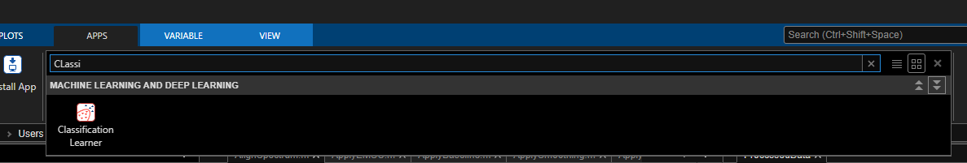
We will click on it and open it. This will open the classification Learner window:
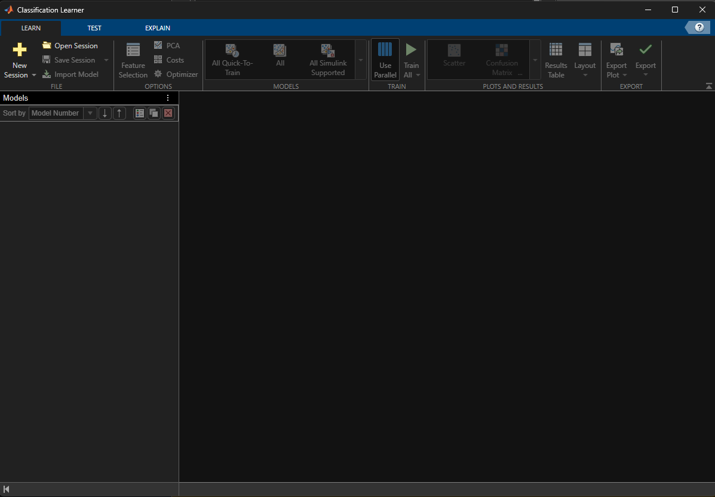
We will click on New Session and this page will open.
- We will choose DataTable as our Data set variable.
- For the Response, we will choose “From workspace” and choose the variable Classes.
- The Predictors now show the wavenumber for each variable.
- For validation, we can choose “Cross-Validation”, which means this will separate the dataset into folds (5 here, which is a standard). It will then train with one and validate with another in pairs until our model is good enough.
- We will also set aside test data that the model has never seen. This will allow us to estimate how good our model is by applying it to data it has never seen. I will set aside 10% of the data.
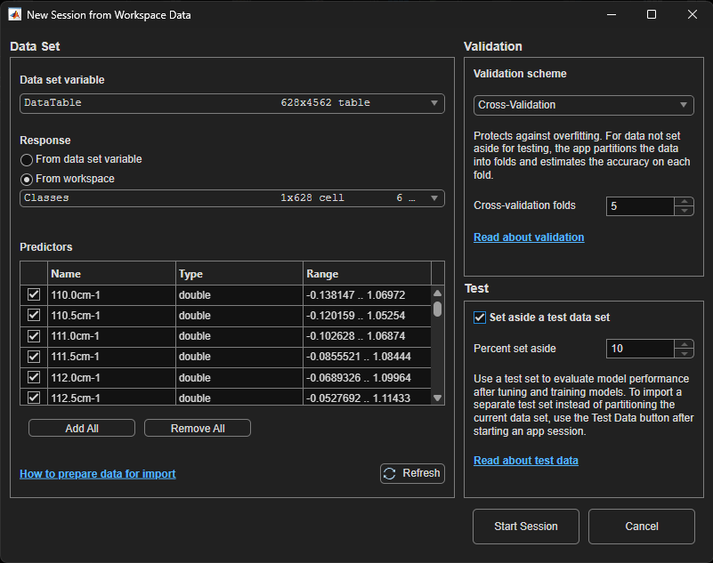
We will now click Start Session.
It automatically opened the data into a scatter plot choosing the two first wavenumbers in the axis. We can explore the data by choosing any wavenumbers we may want on the right panel by changing the X and Y predictors:
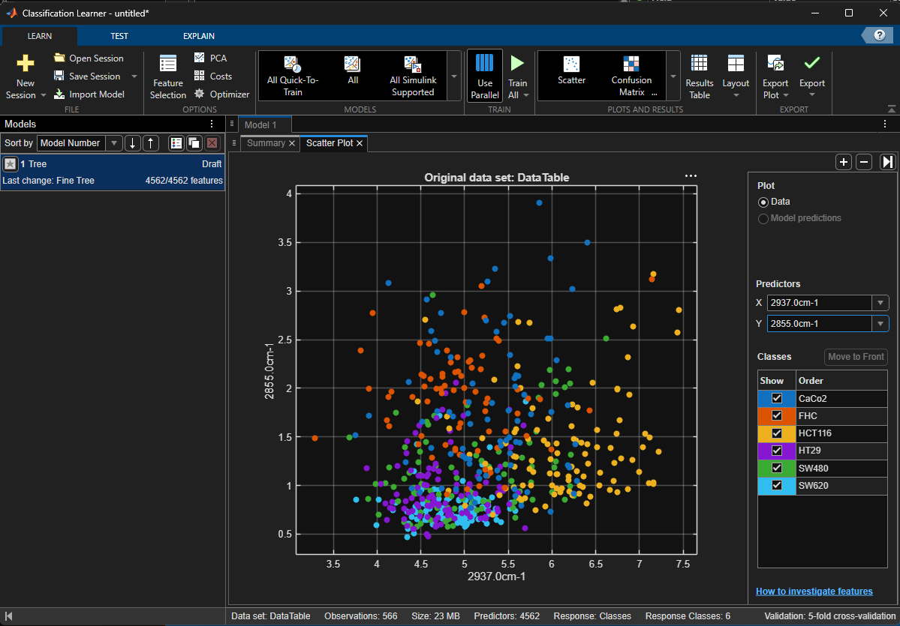
The system automatically created a simple tree model. If we click on the summary tab, we can see some of the settings. If we click “Train all” above, it will train the model.
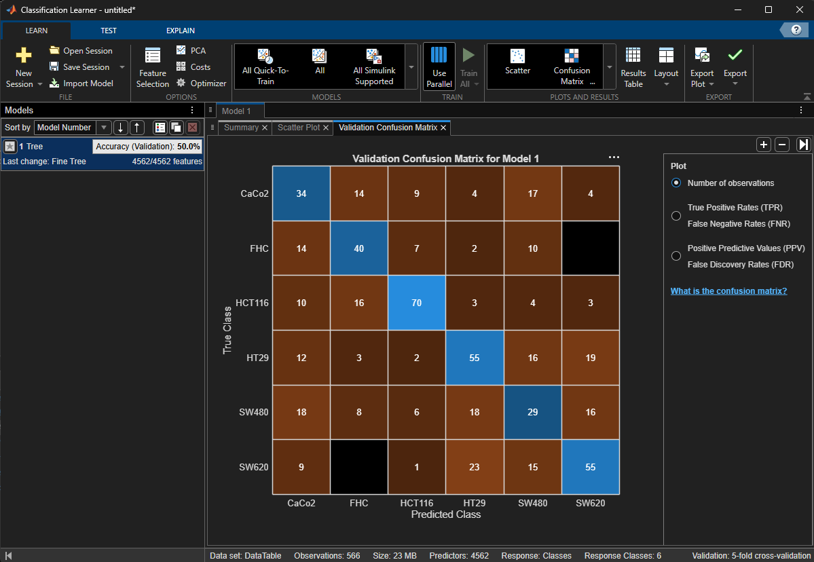
The model was trained, returning 50% of accuracy in the validation dataset. It showed the confusion matrix, showing how many observations in each class fell in the correct category (blue diagonal). We can choose to see the true positive and false negative rate for each class as well. This model is not finished, we need to test it in the testing dataset. We can go to the TEST tab on the top, and test selected:
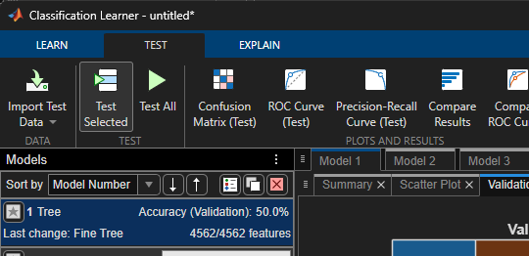
The testing gave me only 43% accuracy, which is even worse.
We can see that the model is not terrible, but neither it is great. Let’s try a basic model ourselves.
In the top menu, under the models we will now choose a linear discriminant:
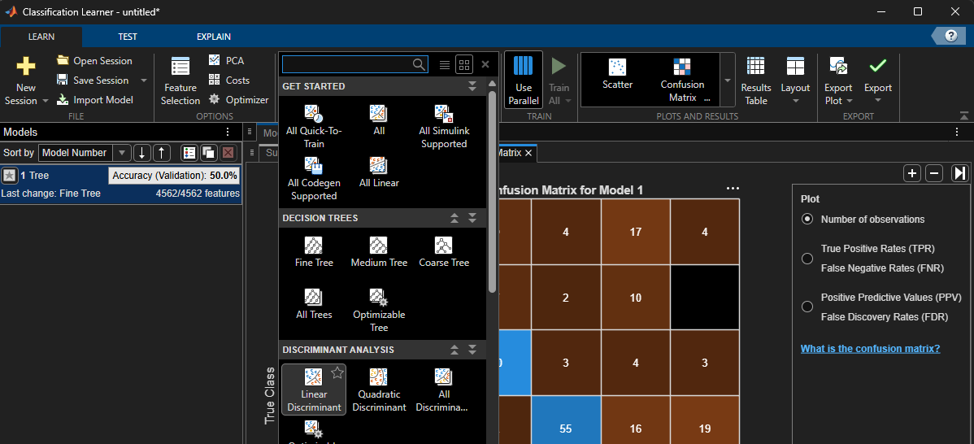
It created our model underneath this first tree model. We can click on it and choose its settings under the summary tab:
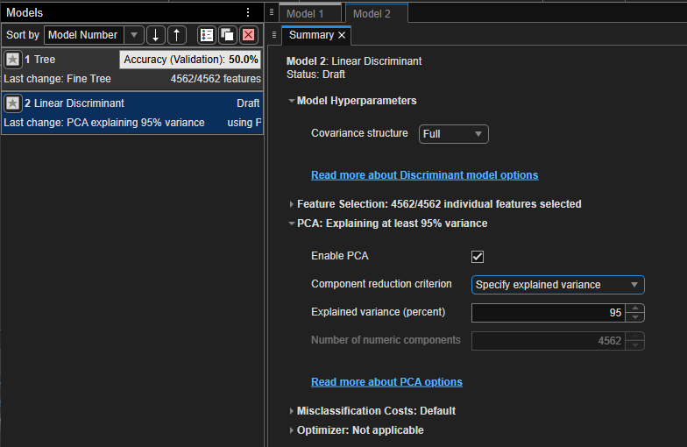
We will enable principal component analysis as a dimensionality reduction step. This allows the identification of the main sources of variability in our system. By keeping only the principal components that explain 95% of variability, we get rid of noise and reduce the number of variables, making training much more efficient.
We can now train the model:
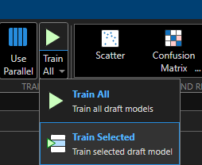
This tool allows us to obtain the classification results, and to classify new data on known models, but does not allow us to visualise some of the outputs of the model. The model is giving us 65% accuracy at the validation stage. I trained another Linear Discriminant model without using PCA as a test, and the validation accuracy dropped to 49%, highlighting how important it is for some of these models to do dimensionality reduction with PCA first.
As a rule of thumb, linear models are less powerful than non-linear models, so our accuracy will likely increase if the model is non linear. This can also make interpretation of the results harder.
For example, we could train a Support Vector Machine (SVM) with a quadratic kernel, with PCA enabled. I will choose One-vs-All so that it attempts to separate each cell type from all the others.
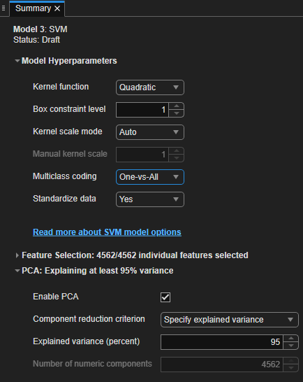
I will choose “Train selected” to train our new model. I am now getting 71% accuracy at the validation stage, which is an improvement from before. When looking at the classification matrix, we can see that the healthy model FHC is correctly classified 85% of the times, while other cell lines like HT29, SW620 and SW480 are often mixed up.
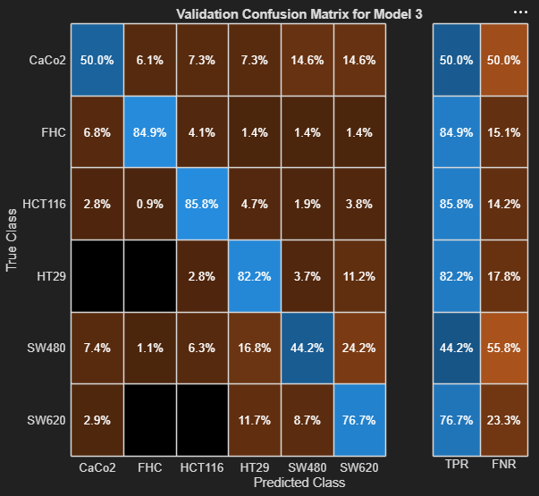
I invite you to explore the Classification Learner with the example data or with your own data, as you will be able to train lots of different models, included convoluted neural networks!

This goes beyond the scope of this workshop short demonstration, but feel free to reach out if you have any further questions.

Author: Julia Gala de Pablo
Email: j.galadepablo@leeds.ac.uk

