MONTY TADIER
Deputy for St Brelade
Jersey 2026 Election
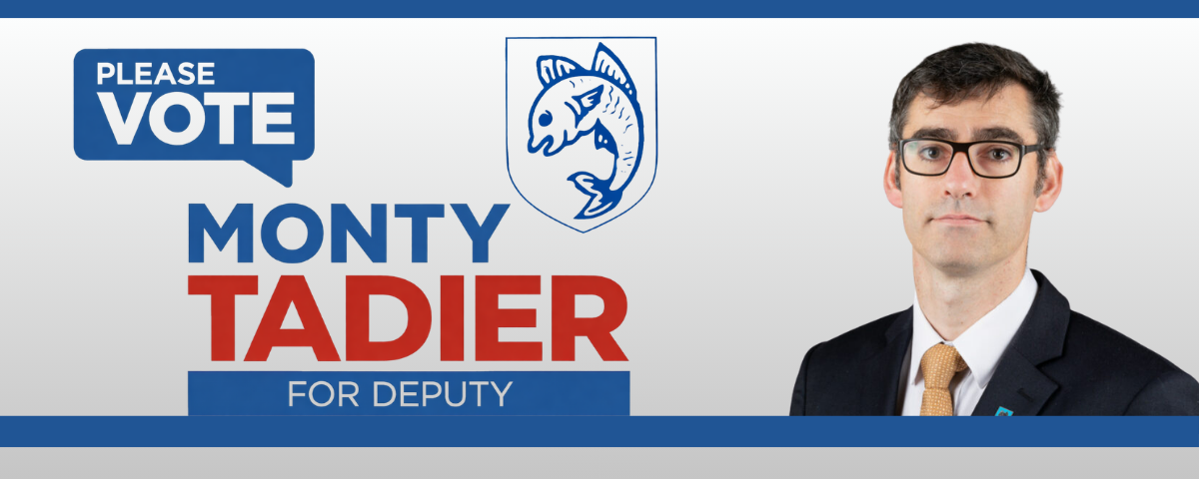
I'm standing for re-election as your Deputy for St Brelade
I'm ready to keep fighting for our community.
For nearly two decades, I've had the privilege of representing this parish in the States Assembly. Since 2008, I've worked to be the kind of representative St Brelade deserves: one who shows up, speaks up, and never stops listening.
Your trust over these 18 years has meant everything — and it has never made me complacent. If anything, the challenges facing Jersey today demand more determination, not less. I bring both the experience of what works and the energy to push for what must change.
This election is about the next four years — and I want them shaped by you. In the coming weeks, I'll be knocking on doors across St Brelade to hear what matters most to you: what's working, what isn't, and what kind of Jersey you want to see. My full manifesto will be delivered to every home in the parish, but you can explore my vision and values right here.
Your voice. Your parish. Your choice.
Fairness ◆ Equality ◆ Affordable Healthcare ◆ Environmental Protection ◆ Arts & Culture ◆ Accountability
— MY VISION

Positive Politics. Real Results.

I believe Jersey works best when its government genuinely listens — to pensioners, young families, working people, and everyone in between. For over 16 years I have brought that commitment to the States Assembly, fighting for a fairer island even when it means challenging my own government.
From securing sustainable arts funding to changing the law on medicinal cannabis, from protecting St Brelade's coastline from overdevelopment to pushing for affordable GP access — I measure success not in speeches, but in outcomes.
✓ Longest-serving St Brelade Deputy
First elected in 2008, re-elected four times — a record of consistent community service and trusted representation.
✓ Reform Jersey & independent-minded
A founding voice of Reform Jersey, committed to social-democratic values, green politics, and evidence-led decision-making.
✓ Accessible to every islander
Regular parish surgeries at St Aubin and Les Quennevais, always available by phone, email, and social media.
— ◆ —
— KEY PRIORITIES
What I'm Fighting For
Six areas where St Brelade — and Jersey — urgently needs principled, experienced leadership.
01 Affordable Healthcare
GP access must be free for those who need it most. I've worked with oncology patients and medical experts to bring radiotherapy on-island, and changed the law to allow medicinal cannabis prescriptions — transforming lives that were otherwise living with unbearable pain.
02 Housing & Cost of Living
Young families are being priced out of the island they grew up in. We need stronger protections for renters, genuinely affordable housing, and targeted support for working households facing the highest cost of living in a generation.
03 Environment & Coastline
St Brelade's coastline — La Pulente, Portelet, St Aubin's Bay — is a shared treasure. I've led protests against coastal overdevelopment and proposed that Jersey's agricultural fields must be kept for farming, not ground-mounted solar or speculative development.
04 Arts, Culture & Heritage
Culture is not a luxury — it's economic and social infrastructure. I secured permanent, sustainable funding for the arts sector at 1% of government revenue expenditure, and successfully defended it against government attempts to water it down in 2024.
05 Education & Languages
As President of the Assemblée Parlementaire de la Francophonie (Jersey Branch), I've championed compulsory second-language study to GCSE level, reversing a 20-year policy that has left Jersey out of step with Europe and weakened our cultural identity.
06 Accountability & Scrutiny
Currently Chair of the Economic and International Affairs Scrutiny Panel, I hold government to account on the decisions that shape islanders' daily lives — from public finances to international trade. Transparency is not optional.

— THE CHALLENGES WE FACE

Jersey at a Crossroads
The cost of living, the housing crisis, pressure on our health service, and the need to protect our environment — these aren't abstract political issues. They are the lived reality of St Brelade families every single day.
"Young families must be given hope of staying in Jersey and having a good quality of life. We must tackle the cost of living urgently."
■ Housing Crisis
Rents and house prices have risen far beyond ordinary wages. Tenants need stronger protections and more affordable supply — now.
■ NHS-style Healthcare Access
No islander should avoid seeing a GP because they cannot afford it. Waiting times and cost barriers must be tackled together.
■ Coastal Overdevelopment
Our Coastal National Park and shoreline must be protected from speculative development. The coastline belongs to all islanders — permanently.
■ Government Accountability
Too many decisions are made behind closed doors. Islanders deserve transparent, evidence-led government that answers for its choices.

16+  years serving St Brelade | 5×  elected to the States Assembly
£11.6m  secured annually for Jersey arts & culture | 800+  islanders backed Monty's petition to protect agricultural land
— ◆ —

Recent Achievements
◆ Changed the law to allow GPs to prescribe medicinal cannabis
◆ Secured permanent arts & culture funding at 1% of revenue expenditure
◆ Led coastal protection protests at La Pulente against overdevelopment
◆ Advocated for on-island radiotherapy provision with oncology patients
◆ Championed compulsory language study to GCSE to reverse 20-year decline
— ◆ —
— ABOUT MONTY

Jersey-Born. St Brelade Through & Through.
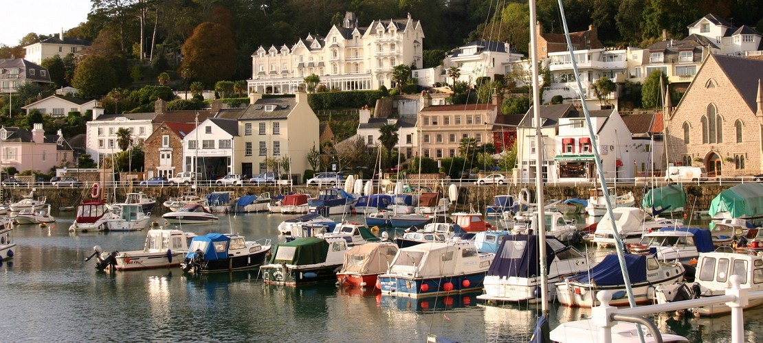
Montfort (Monty) Tadier was born in St Helier on 28 November 1979, grew up in St Brelade, and attended La Moye Primary School, Les Quennevais and Hautlieu Secondary Schools before reading Modern Languages at the University of Sheffield.
He identifies with green, social-democratic and socialist politics. A co-founder of Reform Jersey — registered in 2014 — he has been a consistent, principled voice for fairness and equality throughout his public life. He is also a qualified Jersey tour guide, musician and community organiser.
Monty holds regular constituency surgeries at The Boathouse in St Aubin and the Communicare Café in Les Quennevais, keeping him directly connected to the people he represents.
◆ Education: BA (Hons) Modern Languages, University of Sheffield
◆ Party: Reform Jersey (co-founder)
◆ Current role: Chair, Economic & International Affairs Scrutiny Panel
◆ Also: Qualified Jersey tour guide · Member, Assemblée Parlementaire de la Francophonie
◆ Contact: montfort.tadier@gov.je · 07797 844 358

Record of Service
2008 – present | Deputy for St Brelade (5 consecutive terms)
2024 – present | Chair, Economic & International Affairs Scrutiny Panel
2019 – 2022 | Assistant Minister for Economic Development, Tourism, Sport & Culture
2020 | Assistant Minister for Environment
2008 – 2013 | Education & Home Affairs Scrutiny Panel
2015 – present | President, Assemblée Parlementaire de la Francophonie (Jersey)

"I have always sought to be an active and accessible constituency representative — a strong voice for pensioners, young people and working families in St Brelade."
— Monty Tadier, Deputy for St Brelade
— ◆ —
Deputy Montfort TADIER
Deputy for St Brelade
Chair of the Economic and International Affairs Scrutiny Committee
Président de l'Assemblée Parlementaire de la Francophonie
© 2026 · Promoted by Monty Tadier · St Brelade, Jersey, Channel Islands
Designed and created by Coderra.je

