- Main Frame
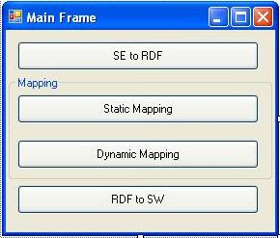
Main frame is the one pop-up in the very beginning. It contains four buttons, which represents three steps of the whole process. The whole approach can be done step by step. SE to RDF is used to extract all feature information of a CAD model in SolidEdge one by one, and store them in a RDF file, which is the instance level RDF document of SolidEdge. This RDF file keeps all design information of the model. Dynamic Mapping is the step doing the mapping between RDF document of SolidEdge and Library document of SolidWorks. The attribute information of both files, such as common attributes, redundant attributes and missing attributes are shown in the form. The match result and best matched feature in the library file are shown. A new instance level RDF document is generated automatically. RDF to SW is to translate the instance level RDF document of the second system into the CAD model of that system, and CAD model file to use in the future.

- SE to RDF
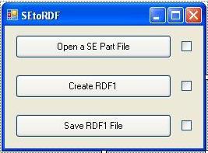
This is the first step, which contains three sub-steps. First one is open a SE part file, SolidEdge will be activated in this step and the model file will be opened. The second one is create RDF1, the program will go over all features contained in the model file, and extract all attributes and store them in a RDF format, after that, the model file will be closed in SolidEdge. The last step is to save the RDF format in a RDF file, you can choose the directory and file name to store.

- Dynamic Mapping
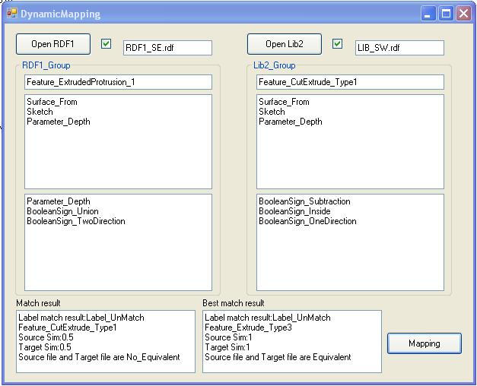
Dynamic mapping is the mapping between a RDF model file and a RDF library file. They can be loaded by press Open RDF1 and Open Lib2. Their file names will be shown on the right of the buttons. Then the program will find the first feature in RDF1, and compare it to all features in Lib2 one by one. In each comparison, the common attributes will appear under the feature name followed by redundant attributes of RDF1_Group and missing attributes of Lib2_Group. The result of each mapping are shown in the lower left and the best match result for this RDF1 feature are shown in the lower right. After comparing all features in Lib2, the best matched feature will stored and the source feature will transferred into the format of the matched feature. Then the program will go to next feature in RDF1 and repeat the steps above. When all comparisons are finished, a new RDF file contains all matched features will be created, and you can save it to a specific directory with a specific name.

- RDF to SW
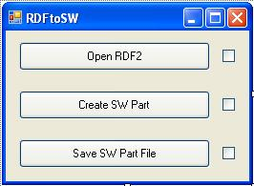
This step will build a SolidWorks part file. The first step is open the RDF file generated in the mapping process, when hit create SW part, SolidWorks will be activated and a blank file will be created. Then the program builds features in RDF2 one by one. When all features are build, this part file can be saved in a directory with the .sldprt extension. The saved part file can be read and revised in SolidWorks directly.

