# About the software tool

‘pro2sw’ is a software tool that converts simple 2D sections from Pro/Engineer’s native file format to SolidWorks’ format. This tool is meant to demonstrate the usefulness and success of the formal language approach to CAD interoperability. It is important to note that this software tool is intended for use converting simple 2D sections and not complete 3D part files. These 2D sections can only contain straight lines or boxes created using the line or rectangle tool. These lines do not need to be horizontal or vertical. Line and line to point dimensions can also be used. Simple constraints like “same point”, “point on entity ”, “horizontal” and “vertical” are covered by the conversion rules. These instructions are written for users with Windows 7 Professional, but they can be easily mimicked for other Windows versions.

Contents

About the software tool 1

Table of Figures 2

Necessary software 3

How to set up 3

How to run 10

About the results 14

Error messages 17

# Table of Figures

Figure 1: Software package location 3

Figure 2: Navigating to computer properties 4

Figure 3: Location of Advanced system settings 5

Figure 4: Location of Environment Variables 6

Figure 5: Location of the "New" button in Environment Variables 7

Figure 6: Location of the "pro2sw.bat" file being copied. Note the technique used to copy the file location 8

Figure 7: User variable being filled in with the proper information 9

Figure 8: Location of the "Run" button in the start menu 10

Figure 9: Shows the Run window; type "cmd", then click OK 10

Figure 10: Copy the location of the desired part file 11

Figure 11: Command prompt window showing "cd" command 12

Figure 12: Command prompt when the software tool begins running 12

Figure 13: Command prompt when the software tool has run through successfully 13

Figure 14: New folders and files populate the location of the original file 14

Figure 15: Location of the XML representation of the Pro/Engineer 2D sketch 15

Figure 16: Location of the SolidWorks XML representation of the 2D sketch 16

# Necessary software

Before running pro2sw, it is necessary to have Pro/Engineer and SolidWorks installed on your computer. Please have these programs closed when you intend to run the pro2sw conversion tool. No other software is necessary since this tool runs through the command prompt.

# How to set up

It is very important to follow the setup steps in order to get pro2sw working properly. Once the software tool has been installed, locate it and place it in a location that you can remember. In this example, it is located in a folder called “REU 2011” within the “My Documents” folder, as seen in Figure 1.

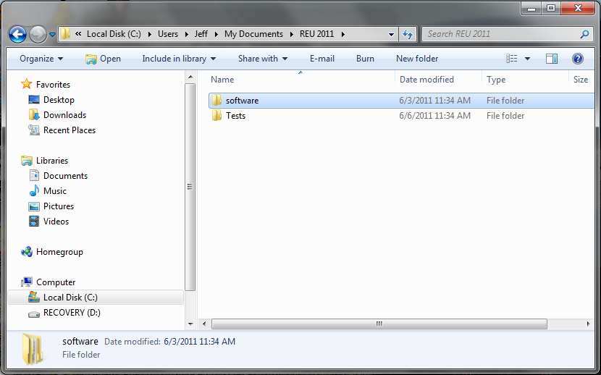

Figure : Software package location

Next, click on the start menu, right click on “Computer”, and then click on “Properties”. This is shown in Figure 2.

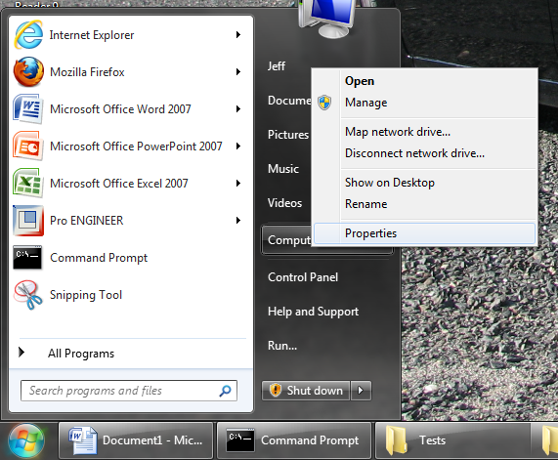

Figure : Navigating to computer properties

After going to computer properties, click on “Advanced system settings” which is located in the red box in Figure 3.

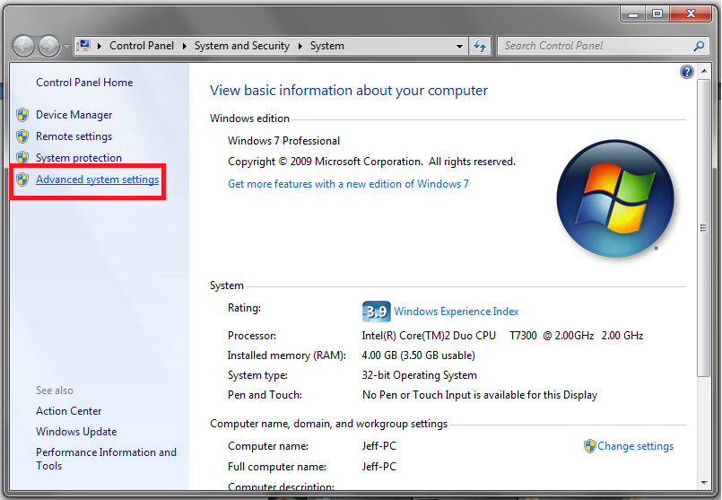

Figure : Location of Advanced system settings

Now, a window called “System Properties” will appear. Click on the “Advanced” tab, then click on “Environment Variables” as displayed in Figure 4 in the red box.

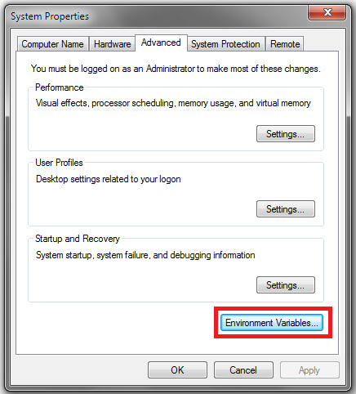

Figure : Location of Environment Variables

Once in the “Environment Variables” window, it is necessary to create a new user variable. Click the “New” button, highlighted in red in Figure 5.

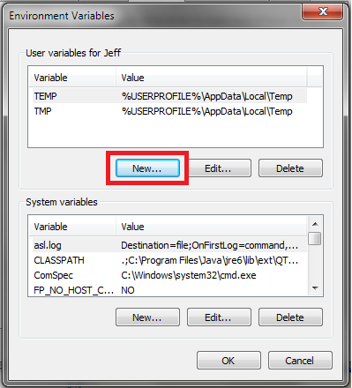

Figure : Location of the "New" button in Environment Variables

In the “Variable name” field, type “PATH”. In the “Variable value” field, copy and paste the location of the “pro2sw.bat” file, which was downloaded in the software package. In order to locate this file, go into the “software” folder, then into the “pro2sw” folder, then into the “versions” folder, then into the “bin_release” folder, then into the “pro2sw” folder, then into the “bin” folder. Now you should see the “pro2sw.bat” file. Copy this file location by right clicking in the file path line, then clicking copy, as shown in Figure 6. Now, paste this location into the “Variable value” field, as shown in Figure 7. Click OK in each window that was opened to accept the changes.

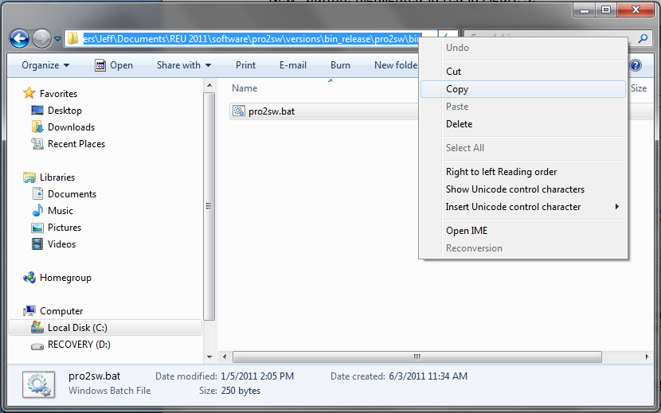

Figure : Location of the "pro2sw.bat" file being copied. Note the technique used to copy the file location

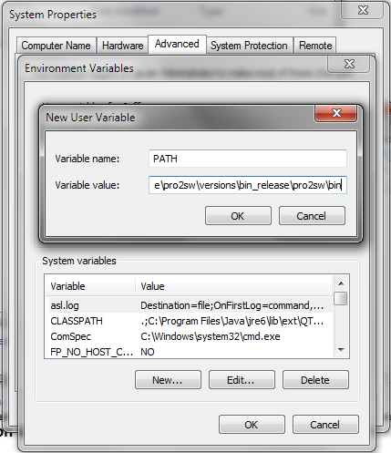

Figure : User variable being filled in with the proper information

Now your computer is ready to run the pro2sw software to convert 2D sections. Please continue to the “How to run” section to see the steps to take to convert a part file.

# How to run

First, you must open the command prompt on your computer. To do this, click on the start menu, then click “Run”, as shown highlighted in red in Figure 8. Type “cmd” as shown in Figure 9 then click OK.

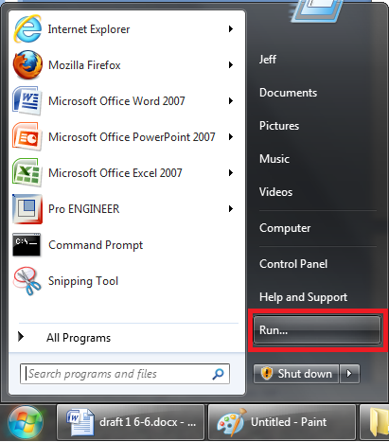

Figure : Location of the "Run" button in the start menu

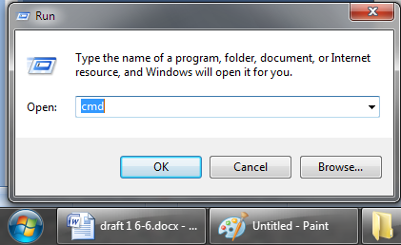

Figure : Shows the Run window; type "cmd", then click OK

Now the command prompt should be open. Next, we must change the current directory so that we can run the pro2sw tool on a part file. Locate the part file which you want to convert. Copy the file location (again by right clicking in the file path line) as shown in Figure 10.

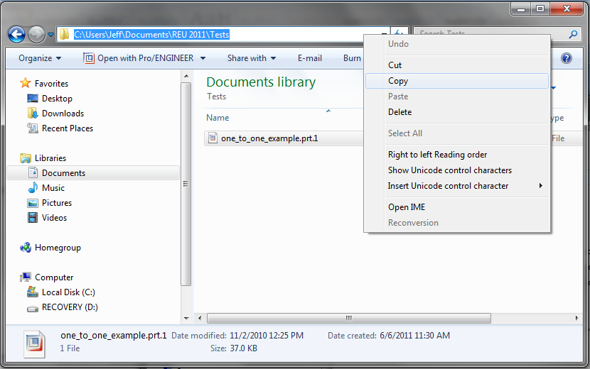

Figure : Copy the location of the desired part file

In the command prompt window, type “cd” followed by a space. Right click on your mouse to automatically paste the file location, then press enter. Your next line should display the location of the part file. This is shown in Figure 11.

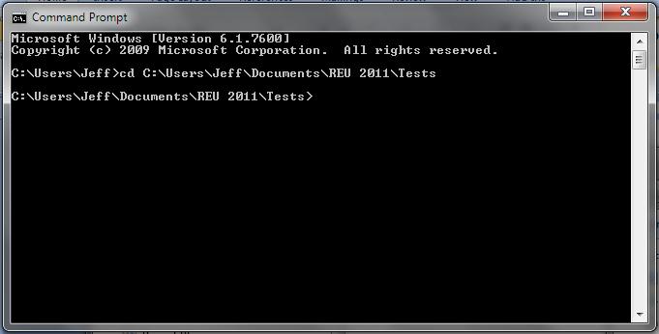

Figure : Command prompt window showing "cd" command

You are now prepared to run the software tool. Type “pro2sw” followed by a space, then begin typing the name of the file. Press the “Tab” key until the full name of the file appears. Press the “Enter” key and watch as the software runs. The first few lines that appear in the command prompt should look like those in Figure 12. When the tool runs successfully, your command prompt should look like Figure 13.

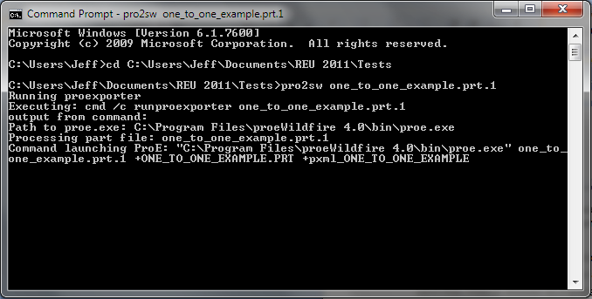

Figure : Command prompt when the software tool begins running

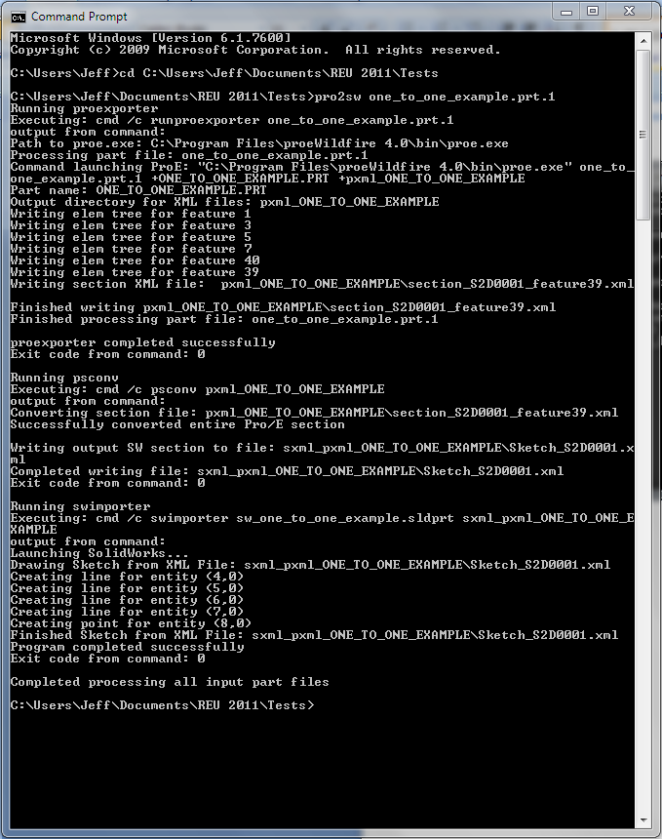

Figure : Command prompt when the software tool has run through successfully

# About the results

When you look at the folder where the original part file was located, there should be some new folders and files populating this area. These are shown in Figure 14.

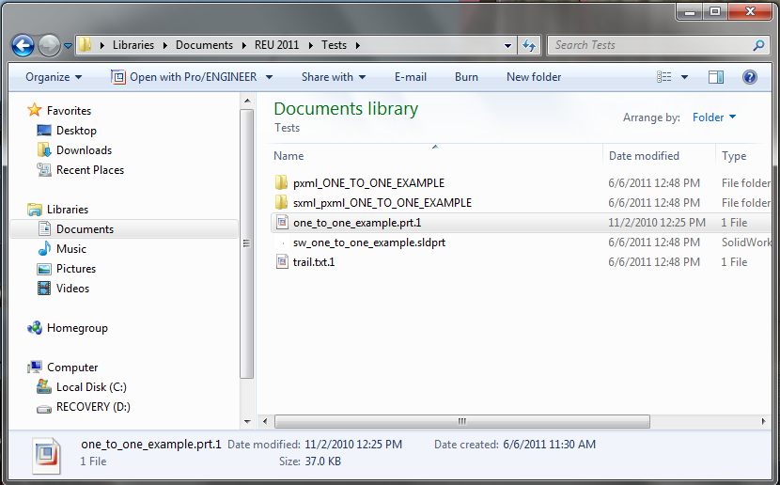

Figure : New folders and files populate the location of the original file

The Pro/Engineer XML representation of the part is located in the folder with the tag “pxml_PARTNAME”, where PARTNAME is the name of the part which you converted. Within this folder, there are XML representations of each of the features in this part. There are also representations of the 2D sketches within the part file. As recommended earlier in this manual, you should only have one simple 2D sketch in your part file. This will make the results very easy to understand. The 2D sketch will have a name like “section_S2D0001_feature39.xml”. Its location is shown in Figure 15.

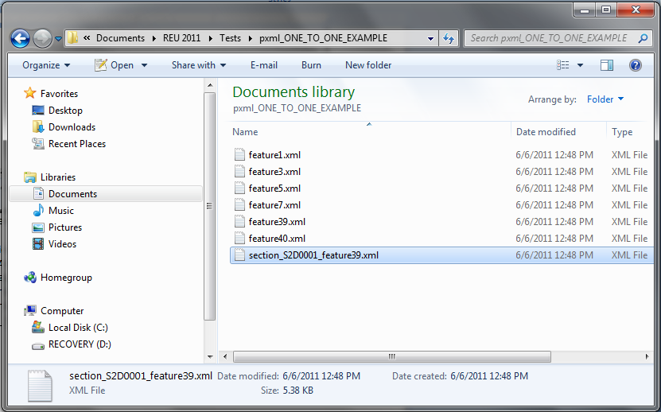

Figure : Location of the XML representation of the Pro/Engineer 2D sketch

You can click on this file to explore the XML representation of the 2D sketch. There is also a folder called “sxml_PARTNAME”. This folder contains the SolidWorks XML representation of the part. This XML representation was created using the formal language defined for this approach. Notice that only the sketch has been converted and all of the features have been ignored. This file should have a name like “Sketch_S2D0001.xml”. Its location is shown in Figure 16.

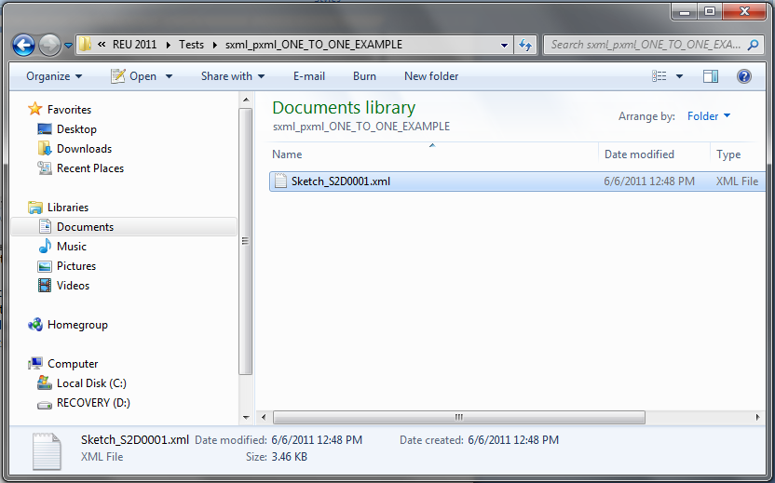

Figure : Location of the SolidWorks XML representation of the 2D sketch

There is also a file that has been created with the name “sw_PARTNAME.sldprt”, where PARTNAME is the name of the part that has been converted. This file can be opened in SolidWorks to display the converted 2D sketch. This sketch should be identical to the one originally created in Pro/Engineer.

# Error messages

* Things noticed when running a sketch that contains splines, circles etc that we have not covered:
  + No sxml created in folder
  + In command prompt
    - Running proexporter
      * Proexporter completed successfully
      * Exit code from command 0
    - Running psconv
      * Unknown entity type
      * Lots of exceptions
      * Exit code from command 0
* Things noticed when you have the improper PATH environment variable:
  + Does not run at all
    - “‘pro2sw’ is not recognized as an internal or external command, operable program or batch file.”
* Noticed if directory not changed
  + Have to type whole file name
  + Hangs after Pro/E opens, but eventually finishes and doesn’t create any new stuff