**Marketing KPIs & Metrics**

**Metric** – a metric is something you can count, such as actions or events. Like pressing the Leave a message button. A metric is just a number. And how you interpret this number is up to you.

* Provide information that can be digested
* Can be viewed historically, but do not identify future action
* Are extracted and organized by activity of process
* Are static and once extracted do not change

**KPI** - A Key Performance Indicator (KPI) includes insights. Typically, KPIs have normal values and can tell you about your business if you compare the actual value with the average value.

* Are initiated by high-level decision makers
* Offer comparative insights that guide future actions
* Incorporate goals and objectives
* Can be evaluated and reset over time using SMART methodology

**KPI Examples:**

**Conversion Rate (CR)**

Conversion rate is the simplest but not an unimportant metric. The conversion rate is the percentage of users that complete a desired action (purchase, download an app, submit a contact form).

CR = Number of conversions / Total number of visitors × 100%

**Click-Through Rate (CTR)**

This is a website metric. Clicks mean purchases to a certain degree. The click-through rate is the ratio of users who click a link to the total number of users who view it.

CTR = Number of clicks / Number of impressions × 100%

CTR is often used to measure the success of online ads. But it’s not the only metric to analyze PPC ads efficiency.

**Cost per Click (CPC)**

This KPI shows if you can save some money on paid ads. The cost per click shows how much you pay when your ad is clicked. CPC is used to assess the cost-effectiveness of an ad campaign.

CPC = Ad costs / Number of clicks

**Cost per Action (CPA)**

CPA is an indicator that shows the cost of completing a desired action. It also helps you to measure the effectiveness of the marketing funnel. It’s totally up to you which action you consider desired — signing up for a newsletter, requesting a callback, or something else.

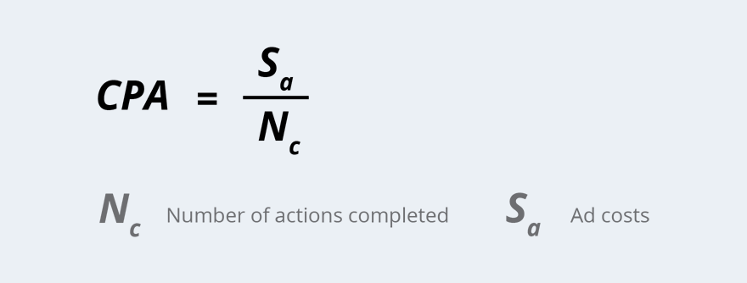

This simple metric is the basis for CPA marketing, where you pay for each conversion that comes from an affiliate source. The pitfalls of this method are that dishonorable affiliates might try to fool you with traffic.

**Cost per Lead (CPL)**

This is an even hotter KPI than the previous! Cost per lead is similar to cost per action, except that you pay for contact information of a person potentially interested in your offer.

CPL = Ad costs / Number of acquired leads

To calculate this metric, add all your ad expenditures on the way to registration for gated content, for instance, and divide the total expenditures by the number of acquired leads. This metric will show you if your lead acquisition efforts fall within your budget or if you’re spending too much. Keep in mind that a lead is only halfway to being a client and isn’t even a loyal follower.

**Customer Acquisition Cost (CAC)**  
The customer acquisition cost includes money spent on marketing and advertising. CAC is the cost of convincing someone to buy your product or service.

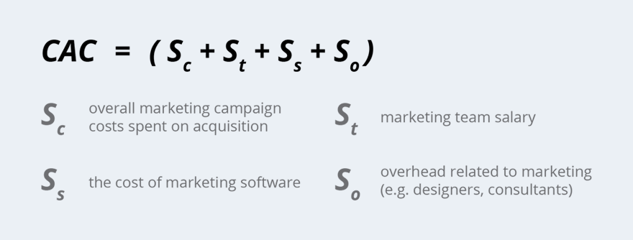

Calculating the total marketing budget can be stressful, but it’s worth trying. It can help you see the bottleneck values in your system.

**Abandon Rate**

This is the percentage of inbound calls that are canceled before connecting with a call center agent or the percentage of abandoned carts in the retail business.

*For call centers: Abandon rate = Abandoned calls / Total number of inbound calls × 100%*

*For retail businesses: Abandon rate = Number of abandoned shopping carts / Total number of initiated transactions × 100%*

You can see the positive side of the abandon rate in Google Analytics after setting a conversion goal for the shopping cart page. The best practice is to track the abandon rate depending on industry average values and audience cohorts over time.

**Return on Ad Spend (ROAS)**

Simple and understandable, this is one of most important digital marketing metrics for measuring ad performance. Return on ad spend is the amount of revenue your business gets for every dollar spent on ads. Use it as the main metric for each digital marketing campaign and you’ll feel the difference between effective and ineffective campaigns.

*ROAS = Revenue derived from the ad / Cost of the ad*

**ROI (ROMI for marketing)**

ROI is the queen of KPIs, even among those who have never heard about analytics! Return on investment is a performance metric that’s used to evaluate the efficiency of a particular investment.

*ROI = ((Gain from investment — Cost of investment) / Cost of investment )× 100%*

You can calculate ROI for almost each process. In most cases, ROI is normalized and must be above 100%. So before you start calculations, find the benchmarks for your particular case. Read more about ROI in our [article](https://www.owox.com/blog/articles/how-to-calculate-roi/).

**Average Revenue Per Account/User/Customer (ARPA, ARPU, ARPC)**

Average revenue per account (or per user or per customer) shows you the average revenue from an account.

*ARPA = Total monthly recurring revenue / Total number of accounts*

Check your ARPA now if you’re planning to raise prices. Then check it later. If raising prices was a bad idea, you’ll see it in the ARPA — unless the total monthly recurring revenue increases, the ARPA will fall.

**Time to Payback CAC**

This metric shows how long it’ll take to earn back marketing costs spent on acquiring a customer. The time to payback CAC metric is especially relevant for SaaS businesses with long sales funnels.

*Time to payback CAC = Customer acquisition cost (CAC) / (Average revenue per account (ARPA) × Gross profit)*

*Gross Profit = Revenue — Cost of goods/services sold*

**Monthly Recurring Revenue (MRR)**

The general concept is that MRR is a metric for recurring revenue components of a subscription business. It helps companies predict revenue and realign their sales plans.

*MRR = Total fees paid by customers monthly*

or

*MRR = ARPA per month × Total number of customers per month*

**Churn Rate**

The churn rate is the percentage of customers or subscribers who discontinue their subscriptions during a given period.

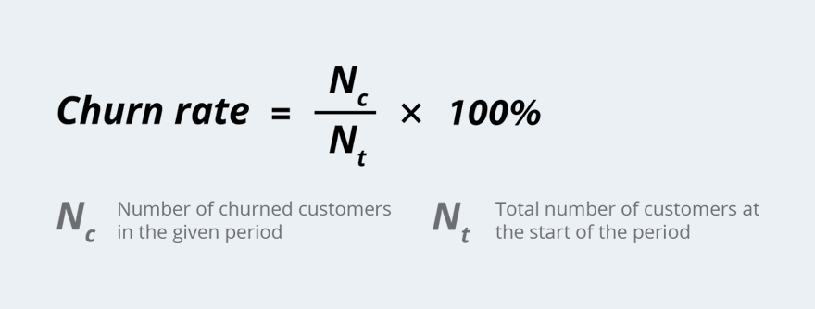

**Revenue-churn**

Also known as the MRR churn rate, where MRR is monthly recurring revenue, revenue churn defines the loss in revenue from churned customers and downgraded subscriptions.

*MRR churn rate = (Churned MRR in the period / MRR at the start of the period) × 100%*

**Share of Market (SOM)**

This metric shows how big your share of the market is.

*SOM = (Company sales / Sales in the entire market) × 100%*

You can calculate the percentage of the market you have and set the right goals to grow. The biggest problem is getting data on sales in the whole market.

**Share of Wallet (SOW)**

This metric shows you the percentage of dollars in customers’ pockets that they spend on you. You can get this data through marketing investigations or through focus groups. Focus groups are a tough but interesting way to collect data because your clients will tell you insights that you could never have imagined! Just take the first step to meet them.

*SOW = (Total cost of purchases a customer has made from your company / Total cost of purchases the customer has made in the same product or service class) × 100%*

Let’s say Ann spent $20 on your handmade cosmetics this month while she spent $120 on cosmetics in general. Your SOW would be 20/120 × 100% = 16.6%. Not as high as expected!

**Customer Retention Rate (CRR)**

How long do people keep returning to you? Or do they just buy and say goodbye? Getting new customers is much more expensive than reactivating existing customers. The customer retention rate is also called reversed customer churn.

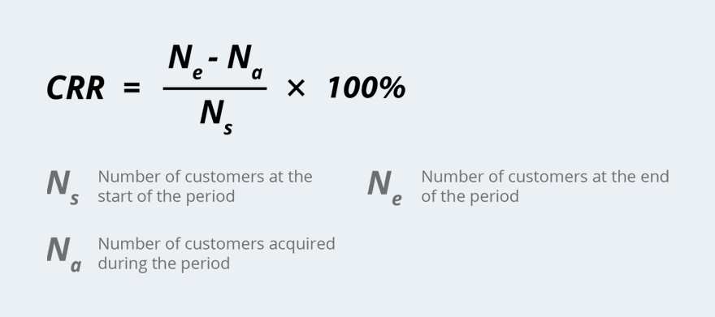

The perfect customer retention rate is 100%. It means that customers are loyal and stay with you for a while. But if it starts decreasing, pay more attention to your customer service. It worth trying to keep this KPI high.

**Customer Lifetime Value (CLV)**

Customer lifetime value can be historical (the sum of all profits from the purchases a customer has made) or predictive (the total revenue your business expects to get from the relationship with this customer).

*CLV = Average gross margin per customer / (Customer retention rate / 1 + Rate of discount — Customer retention rate)*

Why is CLV so important? Because the longer people stay with your company, the higher your revenue will be.