Movie Database

Tsz Yau Iris Chow ([tchow7@wisc.edu](mailto:tchow7@wisc.edu)), Jiayi Gao([jgao244@wisc.edu](mailto:jgao244@wisc.edu))

<https://orson.ischool.wisc.edu/~badger30/LIS464_FinalProject/index.php>

### Introduction

The movie industry is playing a major role in today’s economy. Each year, hundreds to thousands of movies are released, with differences in genre, language, or cast. As a moviegoer, we want to find information about movies in a single dataset and narrow it down to our favorite movies easily. However, we usually need to search in more than one website to obtain the information. And from the perspective of producers, directors, sponsors, and executives, we want to find an easy way to find out information about all the movies and update the database when new movies are released. This inspires us to create a single database for users worldwide for searching information about movies according to the title, director, main characters, casts, the production company.

Our movie database consists of 6 main tables. It includes Movies, Genres, companies, directors, and Actors. All of our data are real datasets from Wikipedia, IMDb, and Kaggle.

### Mission Statement

The purpose of the movie database is to provide a one-stop destination for searching movies and the corresponding information title, director, main characters, casts, the production company by typing in keyword, and maintaining a database to keep up with new movie information.

### Mission Objectives

* Allow user to search for movie information easily
  + Search for actors by Name
  + Search movies by Company or Genre
  + Search movies by Gross Revenue or look up Goss Revenues of movies
  + Search movies by Director’s Name or Keyword
* Provide detail information of each movie such as the director, character, genre, production company and revenue
* Simplify existing movie database such as IMDb or netflix to one database
* Have a uniform system for producer to add new movie information or update existing movie information

### ER diagram

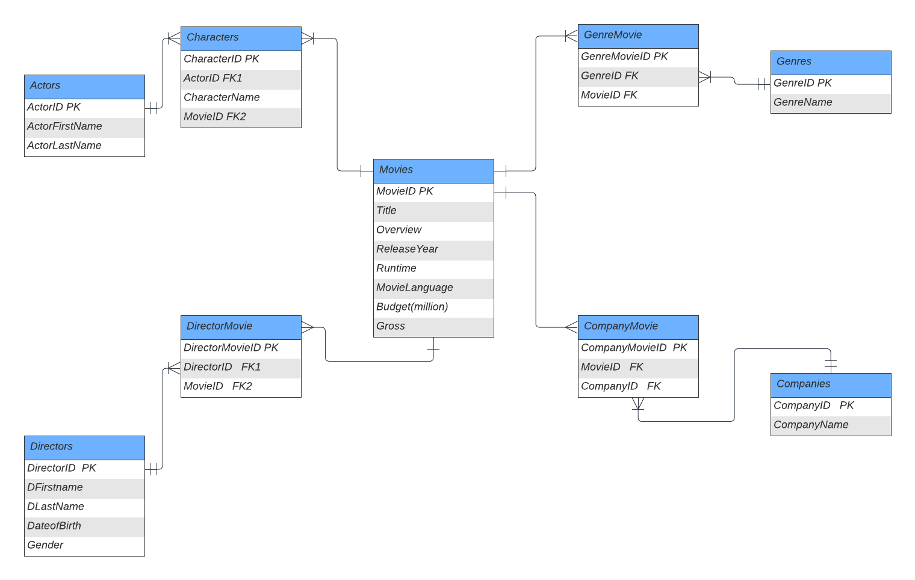

### Logical design

|  |  |  |  |  |  |  |  |  |
| --- | --- | --- | --- | --- | --- | --- | --- | --- |
| Table： Movie |  |  |  |  |  |  |  |  |
| Field Name | Description | Key Type | Data Type | Length | Null Support | Index | Default Value | Value Range |
| MovieID | Unique id for Movie | PK | int | NA | Not null | Yes |  |  |
| Title | Movie Title |  | char(50) | NA | Not null | Yes |  |  |
| Overview | Brief summary of the movie |  | Text(600) | NA | null | No |  |  |
| Runtime | Length of the movie in min |  | int | NA | Not null | Yes |  |  |
| ReleaseYear | The year the movie released |  | Year | NA | null | No |  | (1888,2022) |
| MovieLanguage | The language of the movie |  | char(20) | NA | null | Yes | English |  |
| Budget | The budget of the movie in million |  | Decimal  (5,2) | NA | null | Yes | 100.00 | (0.50,400.00) |
| Gross | Gross Revenue of the movie in million |  | Decimal  (5,2) | NA | null | Yes | 100.00 | (.5,400.00) |

|  |  |  |  |  |  |  |  |  |
| --- | --- | --- | --- | --- | --- | --- | --- | --- |
| Table:  MovieGenre | Description | Key Type | Data Type | Length | Null Support | Index | Default | Value Range |
| MovieGenreID | Unique id for MovieGenre | PK | int | NA | Not null | Yes |  |  |
| GenreID | Unique id for Genre | FK1 | int | NA | Not null | Yes |  |  |
| MovieID | Unique id for Movie | FK2 | int | NA | Not null | Yes |  |  |

|  |  |  |  |  |  |  |  |  |
| --- | --- | --- | --- | --- | --- | --- | --- | --- |
| Table:  Genre | Description | Key Type | Data Type | Length | Null Support | Index | Default | Value Range |
| GenreID | Unique id for Genre | PK | int | NA | Not null | Yes |  |  |
| GenreName | Genre of the movie |  | char | 10 | Not null | Yes |  |  |

|  |  |  |  |  |  |  |  |  |
| --- | --- | --- | --- | --- | --- | --- | --- | --- |
| Table:  DirectorMovie | Description | Key Type | Data Type | Length | Null Support | Index | Default | Value Range |
| DirectorMovieID | Unique id for DirectorMovie | PK | int | NA | Not null | Yes |  |  |
| DirectorID | Unique id for Director | FK1 | int | NA | Not null | Yes |  |  |
| MovieID | Unique id for Movie | FK2 | int | NA | Not null | Yes |  |  |

|  |  |  |  |  |  |  |  |  |
| --- | --- | --- | --- | --- | --- | --- | --- | --- |
| Table: Director | Description | Key Type | Data Type | Length | Null Support | Index | Default | Value Range |
| DirectorID | Unique id for Actor | PK | int |  | not null | yes |  |  |
| DFirstName | First Name of the actor |  | varchar | 25 | Not null | yes |  |  |
| DLastName | Mid and last name of the actor |  | varchar | 25 | not null | yes |  |  |
| DateofBirth | Date of birth of Director |  | date |  | Not null | No |  |  |
| Gender | Gender of Director |  | varchar |  | not null | No | Male | (Male,Female) |

|  |  |  |  |  |  |  |  |  |
| --- | --- | --- | --- | --- | --- | --- | --- | --- |
| Table:  CompanyMovie | Description | Key Type | Data Type | Length | Null Support | Index | Default | Value Range |
| CompanyMovieID | Unique id for CompanyMovie | PK | int | NA | Not null | Yes |  |  |
| CompanyID | Unique id for Company | FK1 | int | NA | Not null | Yes |  |  |
| MovieID | Unique id for Movie | FK2 | int | NA | Not null | Yes |  |  |

|  |  |  |  |  |  |  |  |  |
| --- | --- | --- | --- | --- | --- | --- | --- | --- |
| Table: Company | Description | Key Type | Data Type | Length | Null Support | Index | Default | Value Range |
| CompanyID | Unique id for Production Company | PK | int |  | not null | Yes |  |  |
| CompanyName | Name of the Production Company |  | varchar | 25 | Not null | Yes |  |  |

|  |  |  |  |  |  |  |  |  |
| --- | --- | --- | --- | --- | --- | --- | --- | --- |
| Table: Actors | Description | Key Type | Data Type | Length | Null Support | Index | Default | Value Range |
| ActorID | Unique id for Actor | PK | int |  | not null | yes |  |  |
| ActorFirstName | First Name of the actor |  | varchar | 25 | Not null | yes |  |  |
| ActorLastName | Mid and last name of the actor |  | varchar | 25 | not null | yes |  |  |

|  |  |  |  |  |  |  |  |  |
| --- | --- | --- | --- | --- | --- | --- | --- | --- |
| Table:  Character | Description | Key Type | Data Type | Length | Null Support | Index | Default | Value Range |
| CharacterID | Unique id for Character | PK | int | NA | Not null | Yes |  |  |
| CharacterName | Name of the Character |  | varchar | 25 | Not null | yes |  |  |
| ActorID | Unique id for Actor | FK1 | int | NA | Not null | Yes |  |  |
| MovieID | Unique id for Movie | FK2 | int | NA | Not null | Yes |  |  |

More details about the database:

1. One actor can play more than one character

2. One movie can have more than one director

3. One movie can have more than one production company

4. One movie can have more than one actor

5. One company can produce more than one movie

6. One director can direct more than one movie

7. One character can only be played by one actor

### Business Rules

1. The movie summary should be between 1 word to 150 words

2. The length of the movie should between 30 minutes to 300 minutes

3. The budget of the movie should be more than 0 million

### Views

1. This is a view of the name of actors, their corresponding character names and the movie they attend.

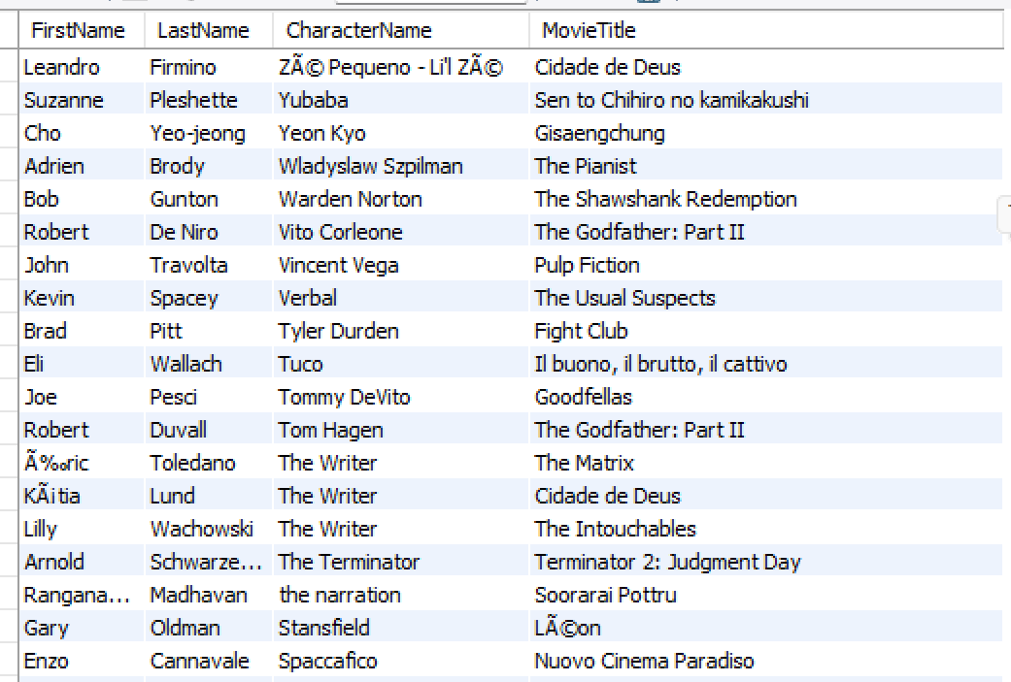

1. Blow is a view for the movies with different genres

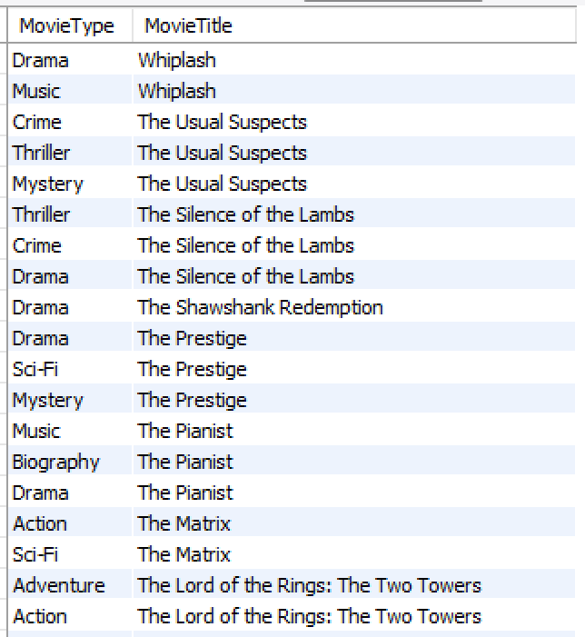

1. Here is a view of the companies and their corresponding average gross revenue for all the movies they produced, ordered by the average gross revenue descendingly.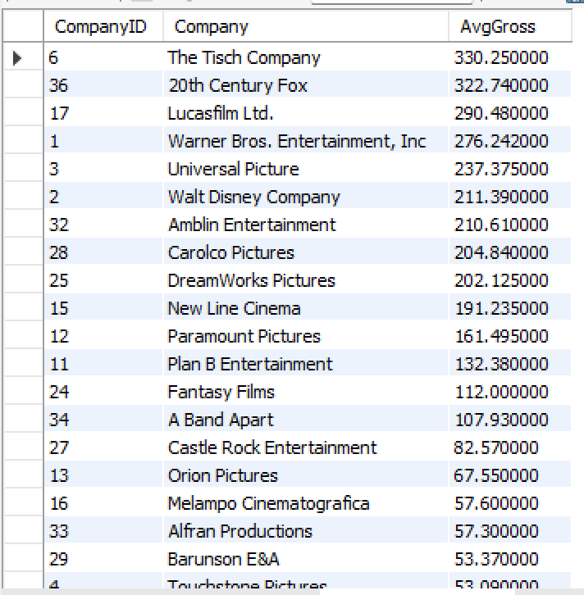
2. This is a view for us to find the average gross revenue for different movie types ordered by the genres’ name descendingly.

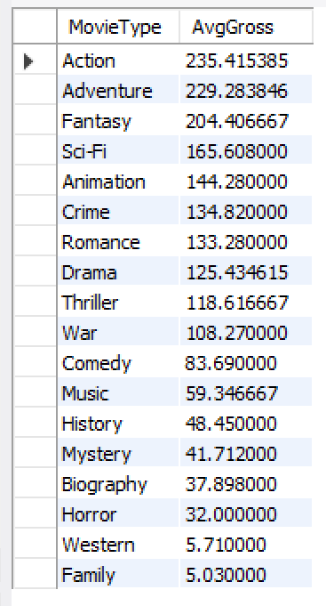

1. Below is a view for which company produced which movie and the corresponding genre of the movie

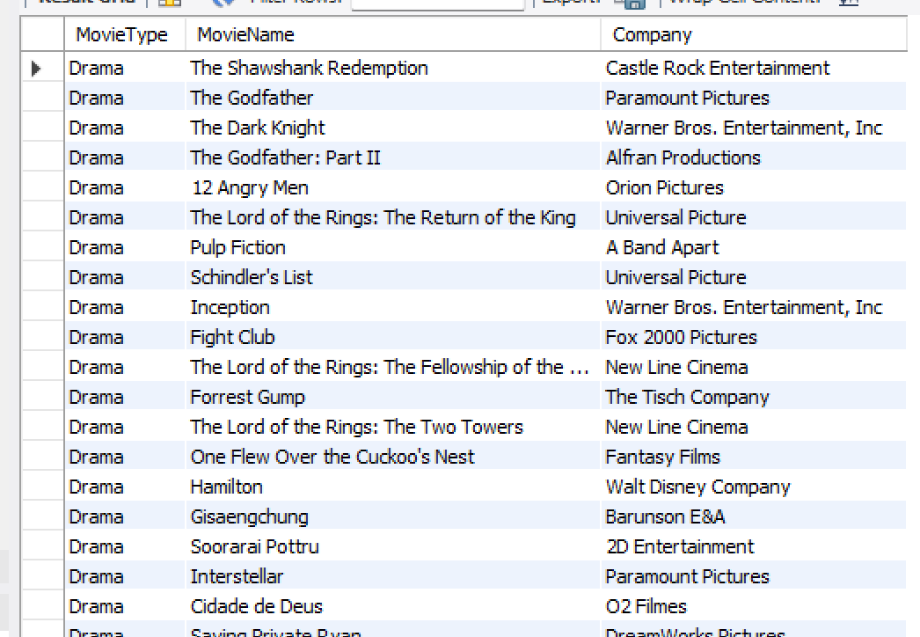

Here below is our PHP webpage link

https://orson.ischool.wisc.edu/~badger30/LIS464_FinalProject/index.php