World Orange and Tangerine Production (2017–2021)
Jesus Garcia
Computer Information Systems, Post University
CIS311: Technical Writing in CIS
Professor Unger
April 5, 2026

World Orange and Tangerine Production (2017–2021)

The following table and chart present data from the Food and Agriculture Organization of the United Nations (FAO) on world orange and tangerine production, measured in thousands of metric tons, for eight major producing countries from 2017 to 2021. As shown in Table 1, Brazil was by far the largest producer throughout the period, growing from 12,053 thousand metric tons in 2017 to 18,998 in 2021—a 57.6% increase that widened its lead over every other country. India was the second-fastest-growing producer, rising steadily from 8,776 to 10,806 thousand metric tons, suggesting long-term investment in citrus agriculture. The European Union and Egypt also recorded consistent, if more modest, gains each year. In contrast, the United States experienced the most dramatic decline of any country in the dataset, falling from 8,562 in 2017 to just 4,500 in 2021—a drop of nearly 47%—which may reflect the ongoing impact of citrus greening disease on Florida's orange industry. China's output was highly inconsistent, dropping sharply to 4,555 in 2018 before recovering and then declining again, indicating vulnerability to weather or market disruptions. As illustrated in Figure 1, which groups Egypt, Mexico, and Spain into an "Other" category for clarity, Brazil's dominance and the U.S. decline are the most visually striking trends. Taken together, the data suggest a meaningful global shift in citrus production: South American and South Asian producers are expanding capacity, while North American output is in sharp, sustained decline.

Table 1
World Orange and Tangerine Production by Country, 2017–2021 (Thousands of Metric Tons)
Country | 2017 | 2018 | 2019 | 2020 | 2021
Brazil | 12,053 | 13,165 | 15,482 | 16,982 | 18,998
China | 8,391 | 4,555 | 7,397 | 8,921 | 7,507
Egypt | 1,784 | 2,117 | 2,453 | 2,643 | 2,900
European Union | 4,563 | 4,871 | 4,989 | 5,551 | 6,603
India | 8,776 | 9,091 | 8,898 | 9,769 | 10,806
Mexico | 4,898 | 3,777 | 2,992 | 3,878 | 4,003
Spain | 3,325 | 2,671 | 2,906 | 3,287 | 3,422
United States | 8,562 | 7,453 | 9,321 | 6,349 | 4,500
Note. Countries listed in alphabetical order. Data reported in thousands of metric tons. Source: Food and Agriculture Organization of the United Nations. (2022). FAOSTAT database. https://www.fao.org/faostat

Figure 1
World Orange and Tangerine Production by Country, 2017–2021
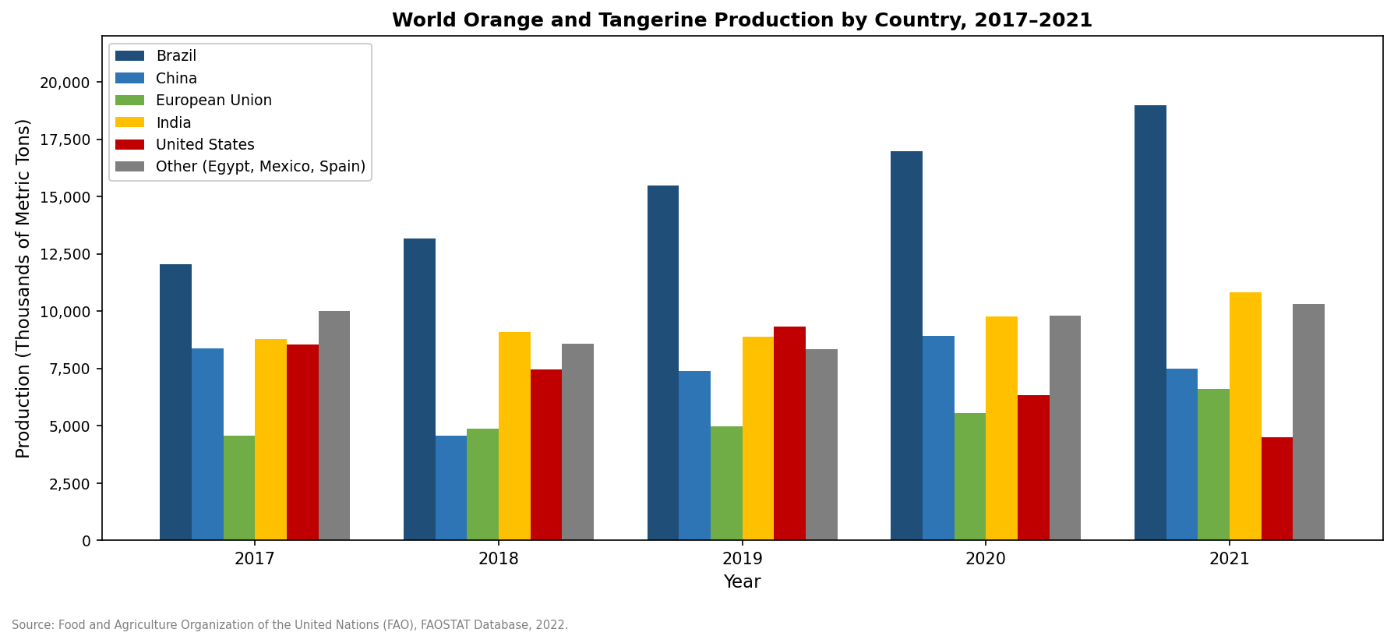
Note. Egypt, Mexico, and Spain are combined into "Other" to keep the chart within the six-bar limit per standard chart guidelines. Production values are in thousands of metric tons. Source: Food and Agriculture Organization of the United Nations. (2022). FAOSTAT database. https://www.fao.org/faostat

