CONSULTATIVE COMMITTEE FOR SPACE DATA SYSTEMS (CCSDS) WHITE PAPER ON THE USE OF BUNDLE PROTOCOL (BP) VERSION 7

Pitts, Robert L
Robert.l.pitts@nasa.gov

Contributors
Beau Blanding
Josh Deaton
Jonathan Jackson
Robert Neutze
David Zoller

Purpose: This white paper outlines what is necessary for the Version 7 (V7) Delay Tolerant Network (DTN) Consultative Committee for Space Data Systems (CCSDS) blue book and is based on IETF RFC BPBIS.v26 (Note: the original CCSDS standard as IRTF RFC 5050). The considerations in this white paper follow the current CCSDS Spec 734.2-B-1 (https://public.ccsds.org/Pubs/734x2b1.pdf) and are consistent with its intent and level of service. It identifies areas requiring updates and specification items that are essential to meet current minimums of capability. In addition, there will be new areas that are important based on operational and engineering experience over the last 5 or 6 years. Some of the items included may appear pedantic but they are included for completeness.
Finally, the term exploration, in this document and context, denotes the current growth in non-terrestrial international space exploration. As such, all references refer to international discussions and methods.
Description: The CCSDS Bundle Protocol (BP) was practically a specification for space applications that out of necessity intersects with the terrestrial internet. In some instances, usage of this protocol will also occur in a terrestrial fashion on large network implementations on the extra-terrestrial side of a space network. Following is an Adrian Hooke drawing that illustrates this vision.
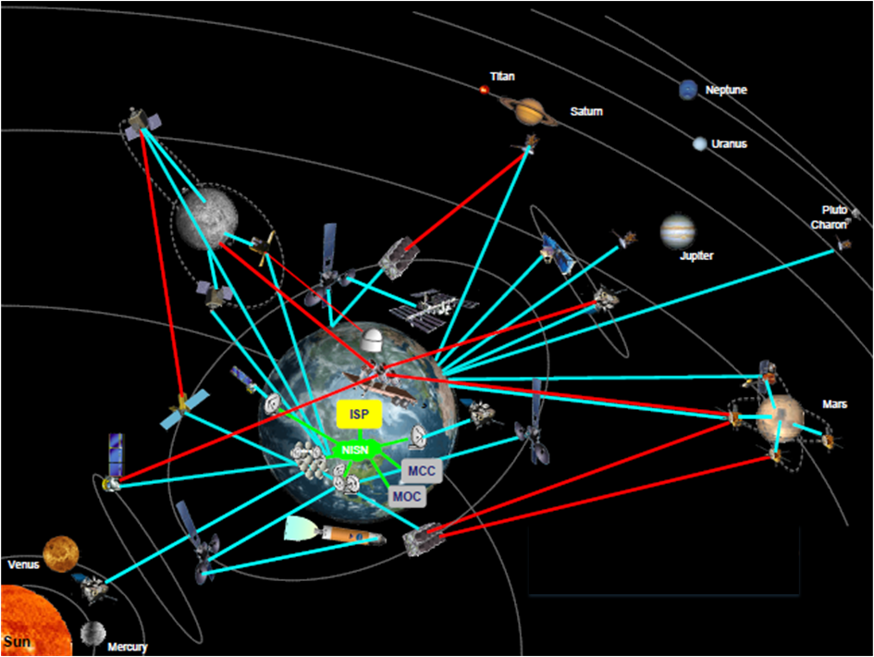
Figure 1: Space Internet Spanning Ground and Extraterrestrial Implementations
Additionally, there are scenarios such as last-hop that require conversion at the extraterrestrial end to a non-bundle model as well as end to end bundle traffic.
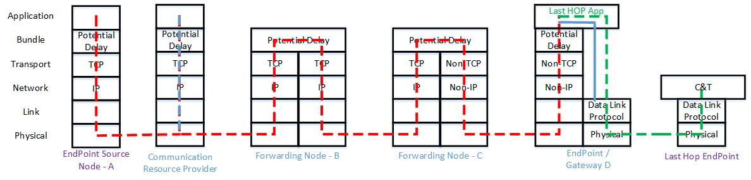
Figure 2: Last-Hop Implementation
In fact, for any device (payload or system) that needs to operate in a constrained communication environment, in all probability functions in an unconstrained environment as well. This is its local environment. Therefore, why are these devices required to be experts in both domains of communication? Would it not be advantageous to provide a service that allows extra-network access?
The International Space Station (ISS) has been exercising the bundle protocol between payloads on orbit and ground nodes for a number of years. Experience suggests payloads must be cognizant of traditional protocols onboard as well as DTN protocols. Therefore, we may have complicated ISS users’ and the mission control operations concept. The Version 7 update to bundle protocol will not address this specific issue, but will ensure maximum flexibility to allow remediation of issues associated with deployment of DTN extra-terrestrially.
Finally, in general the language and graphic representations needs adjusting to move the specification forward. These revisions will ensure there is no transference of concepts between V6 and V7 unless intended. For example, the old bundle node representation of Figure 3 shown below is from RFC 5050 and the CCSDS blue book.
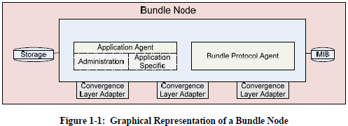
Figure 3: Graphical Representation of a Bundle Node (RFC 5050)
The new representation in Figure 4 is more mature, evolved, and consistent with the BPBIS RFC. This is typical and illustrates why items like this require modernization throughout.
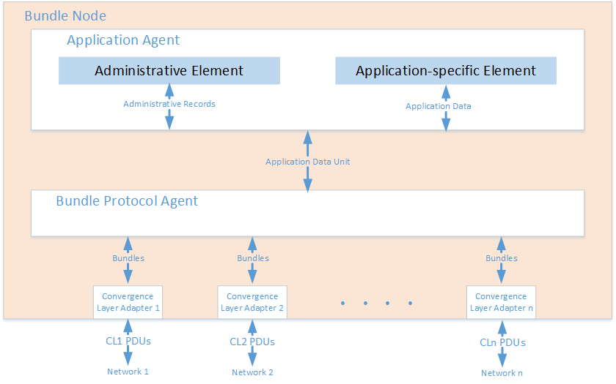
Figure 4: Graphical Representation of a Bundle Node (BPBIS RFC)
Following are the specification sections and associated areas of change. Appendices are not discussed since they are subject to the items in the main body of the specification.
Section 1: This section includes the purpose, scope, organization, definitions, and references. These need to be modernized for V7 with the appropriate items. Specifically:
  - Update to include new RFC and the addition of “ability to use available bandwidth for a wide variety of services and functions”
  - Modernize wording if required
  - General updates to reference the BPBIS RFC are required. Updates to the document sections should include removal of Aggregate Custody Signal (ACS) since it will be subsumed under the Bundle-in-Bundle Encapsulation (BIBE) RFC.
  - General updates to capture the latest RFC language and tone. Includes update to the Figure 1-1 and terminology updates to align them with BPBIS and BIBE language where applicable.
  - Update references.
Section 2: This section is the overview section that explains supported and unsupported features in the specification. The amount of detail is flexible as long as it discusses all the reasonable limitations and services. This should probably be a more detailed section since there are more RFCs and history to consider.
2.1 Generally needs an update based on the BPBIS RFC and defining terms such as routing, scheduling, etc. However, it should also specify that this specification is more compatible and scalable than RFC 5050. Since V6 will not be extended further, the expectation is that V7 will be widely be supported.
2.2 Details the infrastructure options and defines implementation boundaries. (Note: This section provides high-level guidelines and does not specify implementation details.)
2.3 Services to include are BIBE as well as BP services. BIBE is a major item to support V7 that was inherent in BP with RFC 5050 and several other draft RFCs to include “Custody Transfer Enhancement Block” and “Aggregate Custody Signals” by A. Jenkins S. Kuzminsky.
2.4 Add any additional capabilities and details to enable compatibility with the overall infrastructure.
Section 3: This is a very important section of the document. It describes the actual boundaries of CCSDS use. It requires an update for the new RFCs and any direction CCSDS wants to take.
3.1 Sets the stage and should be updated accordingly.
3.2 BPBIS, BIBE, CBHE
a. BIBE explicitly calls for support of encapsulation. In addition, custody transfer support to include ACS is included. Normal custody transfer under RFC 5050 is functionally a subset of ACS.
b. The original CBHE RFC is not required. The IPN scheme as outlined in the BPBIS (Section 4.1.5.1.2), should explicitly be identified as required, versus the DTN scheme.
3.3 ECOS may be required. Though it is not yet significantly used, it is anticipated as necessary in a multi-mission exploration environment.
a. ECOS original inclusion was due to the CCSDS working group deciding it was important to support more than three levels of priority.
b. In BPv6, ECOS was used to trigger Licklider Transmission Protocol (LTP) green versus red.
3.4 Emphasize Time and reinforce language.
a. Explore and define conditions with ground lunar and planetary bodies need to be explored/nailed down to include correlation/synchronization to UTC.
b. Define how the addition of the Bundle Age extension blocks that tracks accumulated time is used. Additionally, describe the basic unit of time.
3.5 Asynchronous Management Protocol (AMP) – Like BPSEC, this is beyond the scope of this specification. It is included here to highlight that management is a critical issue. As number of nodes requiring oversight and physical dispersal of nodes increases, management becomes exponentially important. See Section 4 below.
3.7 Supported CLAs;
a. More detail in the appendices.
b. LTP, Nack Oriented Reliable Multicast (NORM), User Datagram Protocol (UDP), Transmission Control Protocol (TCP) (what color)
c. Identify link utilization, IP Encapsulation (IPENCAP), Space Packet, and any other methods and implemented in relation to current specifications.
3.8 Describe the role of the Space Assigned Numbers Authority (SANA) and which of its registries are important?
Section 4: Service Description will require a careful detailed analysis of the BIBE and BPBIS RFCs.
- Specific block types and endpoints:
  - MultiCast
The ISS program or any of its sundry endeavors do not currently use Bundle Multicast. All bundle traffic is point to point. However, exploration has discussed in detail the need to send bundles to multiple diverse locations. Methods discussed are multiple sends and BP multicast.
- Multiple sends would include a BP node tasked to send a transfer twice. If going to the same network, this would be double the bandwidth use. An example of this would be a system sending data to Earth and requiring multiple endpoints such as an MCC and an engineering or science consumer. An alternate mechanism is to send the data to the MCC and let the MCC forward data through other methods to multiple consumers. This requires additional coordination and requires the consumers of the data to have multiple methods.
If going to different networks, such as Earth and a lunar node, the bandwidth is commensurate with dual networks so there is not double bandwidth consumed on a single network.
- For a BP multicast, single network communication would not require dual bandwidth. Therefore, sending bundles to Earth would require a Custodial-multicast-capable (CMC) node in a ground node to forward bundles to each end node.
If going to different networks, as previously stated with the Earth/lunar example, a single send is sufficient, reducing the source node resources slightly. However, there are no savings in network utilization.
- Bundle Protocol Security (BPSec)
BPSec is well beyond the scope for inclusion in the bundle specification. However, the security section of ANNEX G, should add that all non-compliant nodes act as a pass-through.
- Custody transfer – this was included in IRTF RFC 5050, however BPBIS does not directly support. Therefore, an additional IETF RFC is being generated called BIBE (https://datatracker.ietf.org/doc/draft-ietf-dtn-bibect ). Until that is complete, it is probably necessary to rewrite the ACS appendix D to accommodate.
- Compressed Bundle Header Encoding (CBHE) - RFC 6260 (https://www.rfc-editor.org/rfc/pdfrfc/rfc6260.txt.pdf ). As previously stated, it is subsumed by BPBIS section 4.1.5.1.2.
- ACS – specification as defined in Annex D of CCSDS BUNDLE PROTOCOL SPECIFICATION. To be deleted. (https://public.ccsds.org/Pubs/734x2b1.pdf) see BIBE in item 4c above.
- LTP - as defined by https://public.ccsds.org/Pubs/734x1b1.pdf . This was extended by RFC 7122 to support LTP using UDP/DCCP. Candidate for inclusion.
- Specific Convergence Layer Adapters (CLAs) –LTP, NORM over UDP, UDP, TCP (RFC 7242) as candidates.
Since the original deployment on the ISS with its limited set of convergence layers, there has been experience in the use of convergence layers on orbit and ground. The original deployment was with TCP, LTP over UDP for spacelink, UDP, and sTCP.
In the IETF, a number of RFCs expand this initial deploy as well as HOSC operational experience. As a result, the basic suite has been expanded with additional offerings. Following are a list of those that require consideration.
- Minimal TCP to replace sTCP – incorporates reduced overhead and increased security (optional). Experience with it has indicated that the use of Transport Layer Security (TLS) in the security option is an excessive performance hit.
- Delay-Tolerant Networking TCP Convergence Layer Protocol Version 4 to replace TCP – supports Bundle protocol V7.
- LTP over UDP/DCCP – RFC supporting congestion control of LTP over networks
- DTN over NORM – Efficient replacement for LTP over limited distances such as Earth to the Moon
- AMP – In the ISS environment, management has become a growing concern. As distance increase in exploration activities, AMP becomes a necessity. Somewhere in the specification, it should highlight the need and recommend a minimum set of Application Data Models (ADMs). The actual standard should be a standalone book.

Section 5: Services required includes on orbit and ground instances. However, our experiences should color this based on ISS. Items in this section should remain and another service requires consideration: Bundle replay.
Bundle replay is the capability to replay “lost” bundles. Ground systems often have queued data pending a replay. For DTN bundles, the data may expire. Bundle replay allows a user to recover this lost data and replay it into a bundle node. Originally developed as an engineering capability, it has been useful in recovering data that would otherwise be lost due to misadventure, failure, or incompetence.

Summary – This white paper has two goals:
- Identify BP V7 needs based on the V6 experience
- Describe minimum needs for a new blue book.
The BP V7 needs identified in this paper resulted from discussions within various DTN forums and ISS experience. Exploration activities, experience with DTN, and conduct of operations informed the minimum needs for a new blue book. In no way is this to limit DTN capabilities but only to establish a solid, ground floor baseline for adding new capabilities for long term deployment. Therefore, it will act as a platform for AMP, new CLAs, and unique implementations.

