**Pylint Results**

**The score of all python files currently in the Bird Watching App is above 9.0/10.0:**

**bird_map.py:**

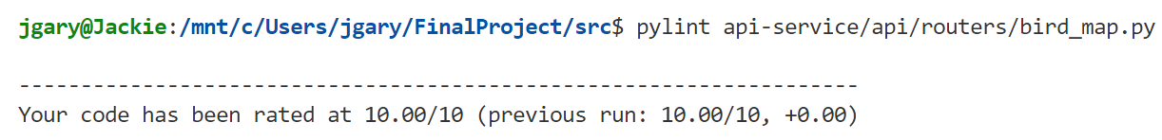

**bird_sound.py:**

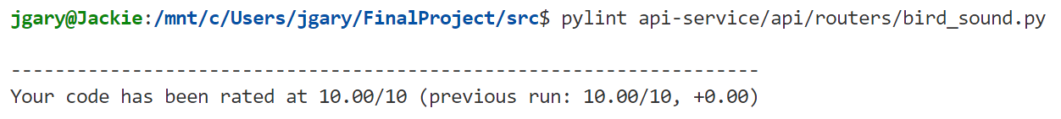

**service.py**

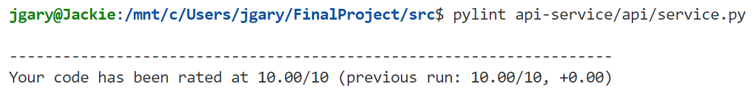

**llm_cnn_chat.py**

**agent_tools.py**

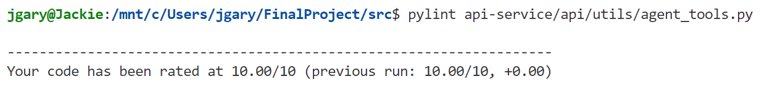

**chat_utils.py**

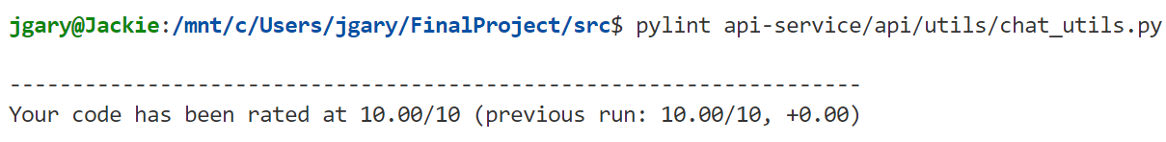

**llm_cnn_utils.py**

