CaptainFM — Design Document
A fast, keyboard-first file manager for Omarchy and Hyprland · Oct 20, 2026 · @Justin Garza

Overview
CaptainFM is a file manager for Omarchy on Hyprland: a Qt 6 QML interface over a Rust core. It opens any folder in under 50 ms, fuzzy-searches a whole drive within one frame, recolors live with the active Omarchy theme, and is driven entirely from the keyboard. It replaces Nautilus as the inode/directory handler. The feature set is inspired by File Pilot on Windows; the name, UI and code are original.
Goals
- Instant: first paint of a 100k-entry folder in under 100 ms; search results within one frame.
- At home on Omarchy: no window chrome, live theme sync, system monospace font, sane at half-screen tile width.
- Keyboard-first: modal vim-style keys, a leader key with hints, every action in a command palette and rebindable.
- Smooth: QML animations for panes, overlays and the zoom slider, without dropping frames.
- Lean: one binary under 15 MB on top of system Qt 6, no daemon.
Non-goals for 1.0
- X11, desktop-environment integration beyond freedesktop standards, cloud sync, tagging databases, an embedded terminal.
Users
- Omarchy and Hyprland users who want a GUI file manager that matches the rest of their setup.
- Developers and homelab admins working in large repos, media libraries and network shares.

Key decisions
Name: CaptainFM (captainfm, alias cfm). The -fm ending follows Linux file-manager tradition (pcmanfm, spacefm), so the name says what it is. Package, binary and Wayland app-id are captainfm. The AUR package also installs a cfm symlink, and anyone can set their own shell alias. Confirm captainfm and cfm are free on the AUR, crates.io and GitHub before publishing.
Toolkit: Qt 6 Qt Quick (QML) for the interface, Rust for everything else, joined in-process by cxx-qt. QML gives fluid animated UI, a theme that is just a set of bindable properties, and the ecosystem Hyprland users already script bars and widgets in. Rust keeps listing, indexing and file operations fast and safe. The Rust core exposes list models straight to QML, so a 100k-row folder never crosses a process boundary or gets serialized.
Option | Verdict | Reason
Qt 6 QML + Rust core via cxx-qt | Chosen | Fluid UI, property-based theming, in-process models for big folders, native DnD and clipboard
Quickshell front end + Rust backend over stdio | Rejected | Flea's approach. Quickshell is built for shells and widgets, and rows travel as JSON between processes
GTK4 + Rust, no libadwaita | Rejected | Mature and CSS-themeable, but static widgets and less animation headroom than QML
hyprtoolkit (C++) | Revisit later | Most Hyprland-native, still young (0.5.x)
iced (Rust) | Rejected | Weaker DnD, clipboard and accessibility today
Prior art: Flea. Flea is already a keyboard-first, MIT-licensed file manager for Omarchy, with a Quickshell QML front end over a Rust backend. It reads the live Omarchy palette and has a flea --default command that takes over inode/directory and Omarchy's file-manager shortcuts. CaptainFM borrows those integration ideas and differs in its build and focus:
 | Flea | CaptainFM (planned)
Front end | Quickshell (QML) | Standalone Qt Quick app (QML)
UI to core link | Rust child process, newline-delimited JSON | Rust in-process via cxx-qt list models
Runtime dependencies | Omarchy and Quickshell required | Qt 6 only; Omarchy integration optional
Focus | Fast keyboard-first browsing; no command palette | Command palette with inline rebinding, modal vim keys + leader, split panes, drive-wide index, batch rename, file-picker portal
Before committing, try Flea for a week. If it covers most of this, contributing to it may be the faster path.

Feature scope
The MVP is the nine features that make CaptainFM worth switching to on day one; the rest follow in 1.x.
Feature | What it does | Release
Instant listing | Async directory reads into a Rust list model, virtualized QML ListView, live inotify refresh | MVP
Tabs and panes | Numbered tabs, up to 4 panes, saved layouts | MVP
Modal keys + leader | vim motions, space leader with a hint popup, counts (5j) | MVP
Jump bar | Path autocomplete, recent folders, bookmarks, frecency ranking | MVP
Deep search | Whole-folder or whole-drive flattened view, fuzzy match, extension and date filters | MVP
Inspector | Side preview for text (syntax highlighted), images, PDFs, folders, archives | MVP
Command palette | Every action searchable; rebind hotkeys inline | MVP
Folder sizes | Recursive sizes computed in the background, sortable | MVP
Omarchy theme sync | Colors from the active theme, live reload on theme change | MVP
Batch rename | Template tokens, regex, case, live preview, undoable | 1.1
File picker portal | xdg-desktop-portal FileChooser backend; floating picker for other apps | 1.1
Remotes and devices | SMB, SFTP, MTP via GVfs; UDisks2 mount and eject | 1.1
Media preview | Video and audio scrubbing in the inspector via Qt Multimedia | 1.1
Tree and Miller columns | Alternate layouts | 1.2
Undo/redo | Journaled copy, move, rename, trash | 1.2
Plugins | QML panels and Lua actions | 2.0

UI design
CaptainFM looks like a terminal tool with a GUI: monospace type, no title bar, a mode badge, and a status line of key hints. Mockups below are original concept renders, tiled next to a terminal on Hyprland; in the app every color comes from the QML Theme singleton.

Main view
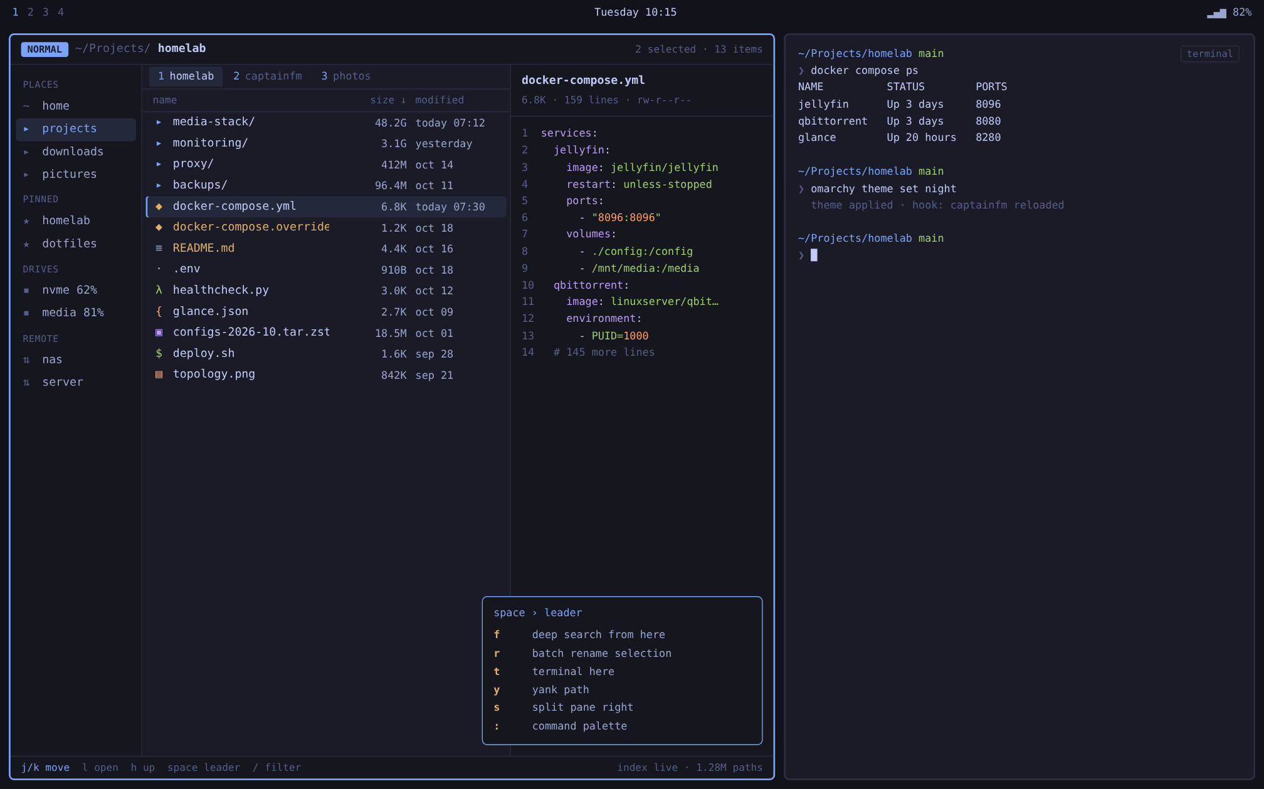
- Path line with a mode badge (NORMAL, SEARCH, VISUAL) replaces a title bar; numbered tabs switch with 1–9.
- The cursor row has an accent edge; selected files turn the warning color.
- space opens the leader hint popup, so new users learn the keymap without leaving the window.

Command palette
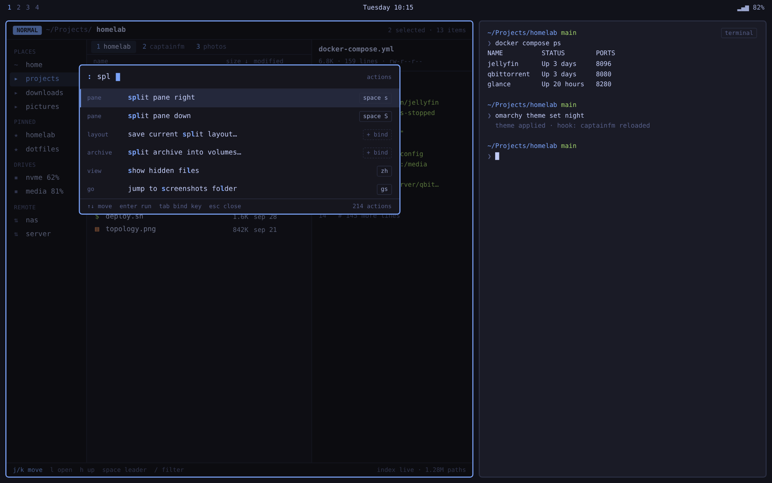
- : or Ctrl+Shift+P. Each result shows category, highlighted matches and its current binding.
- Tab on a result records a new binding; unbound actions show a dashed + bind badge.

Deep search
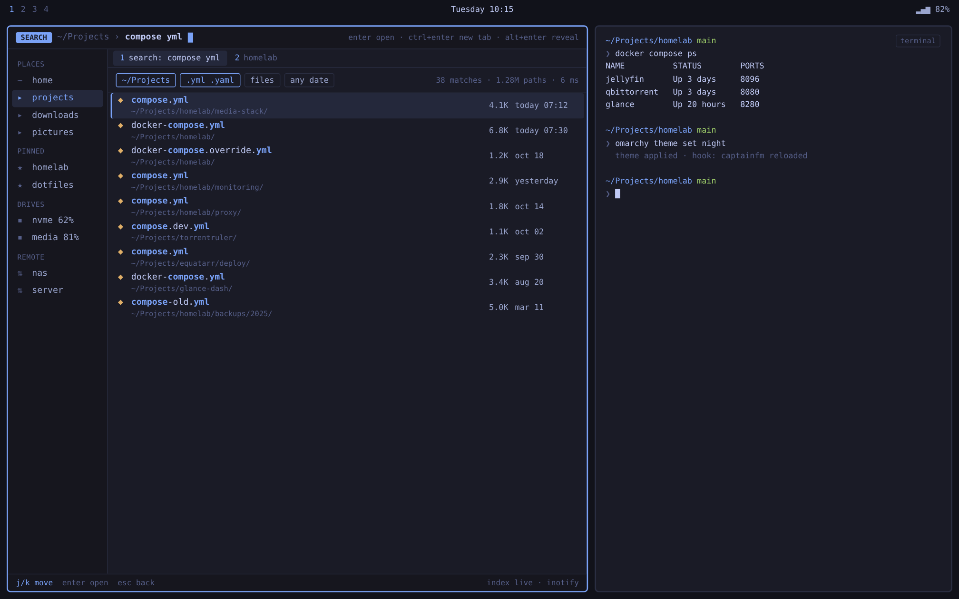
- space f searches everything under the current folder; results open as a tab.
- Filter chips for scope, extensions, files or folders, and date; the status line shows matches, index size and latency.

Batch rename
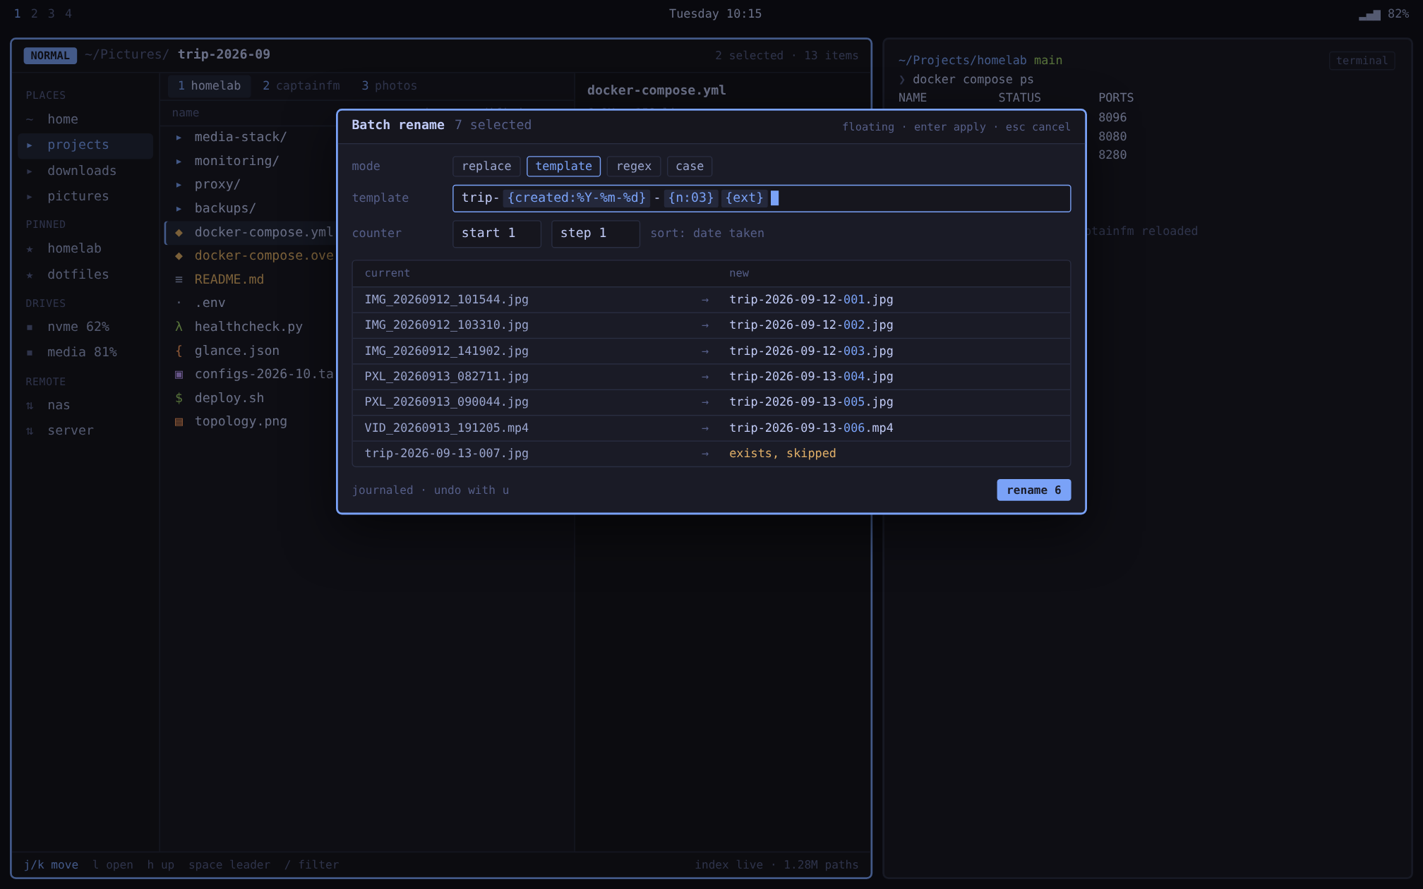
- space r opens a floating window (via a Hyprland window rule) with replace, template, regex and case modes.
- Live preview flags collisions and skips them; the whole rename is one journaled, undoable operation.

Theme switch
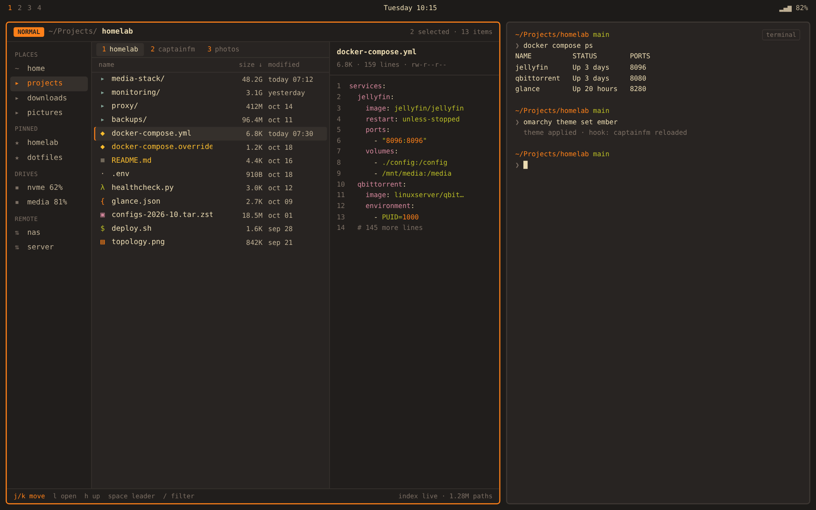
- After omarchy theme set, the hook updates the Theme singleton; accent, borders, syntax colors and the mode badge crossfade to the new theme without a restart.
Still to mock: settings, grid view, file-op progress, and the floating file picker.

Omarchy and Hyprland integration
CaptainFM plugs into Omarchy's own extension points (theme colors, templates, hooks, bindings) and ships one command to switch everything over.
Concern | Design
Theme colors | Rust reads the active theme's colors.toml and fills a Theme QML singleton (accent, background, foreground, palette roles). Every component binds to it; no hex values in QML except fallbacks.
Live reload | Install ~/.config/omarchy/hooks/theme-set that runs captainfm --reload-theme over a local socket. The singleton's properties change and QML recolors with an animated crossfade, no restart.
Theme overrides | Optional ~/.config/omarchy/themed/captainfm.toml.tpl so theme authors can set roles Omarchy's palette lacks (selection, diff colors).
Controls style | Own QML components on Qt Quick Controls Basic. No Fusion or Material look, no qt6ct dependency.
Window | Frameless, app-id captainfm via the desktop-file name. Main window tiles; picker and dialogs are separate floating windows.
Tile widths | Under 900 px hide the inspector; under 640 px collapse the sidebar to glyphs and drop the date column.
Font and icons | fontconfig monospace, so Omarchy's font switcher applies; Nerd Font glyphs when installed, icon theme otherwise.
Keys | In-app keys never use Super. Copy, cut and paste work as both modal y/d/p and Ctrl+C/X/V.
Become default | captainfm --default sets inode/directory, registers org.freedesktop.FileManager1, and points Omarchy's file-manager shortcuts (Super+Shift+F, Super+Alt+Shift+F) at uwsm app -- captainfm. captainfm --default off reverts.
File dialogs | 1.1: xdg-desktop-portal FileChooser backend; other apps' Open and Save dialogs become a floating CaptainFM picker.
Packaging | AUR first (captainfm-bin, captainfm-git); depends on qt6-declarative, optional qt6-multimedia, qt6-pdf (or qt6-webengine, check the Arch split).
Window rules shipped in the docs
windowrule = float, class:^(captainfm)$, title:^(Pick .*)$
windowrule = size 60% 70%, class:^(captainfm)$, title:^(Pick .*)$
windowrule = float, class:^(captainfm)$, title:^(Batch rename)$
The theming paths come from a third-party write-up of Omarchy's internals, and the shortcut keys from Flea's README. Verify both against the installed Omarchy version in M0. Windowrule syntax also shifts between Hyprland releases.

Architecture
CaptainFM is one process: a QML interface on Qt's GUI and render threads, a Rust core on a thread pool, and cxx-qt exposing Rust list models and signals straight to QML.
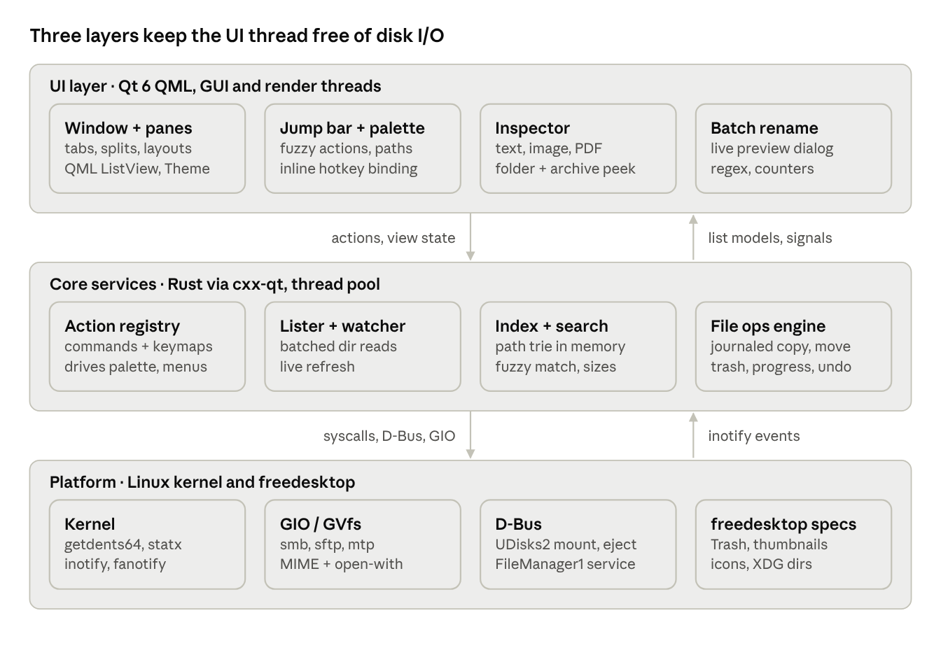
CaptainFM architecture · 3 layers, 12 components
QML never touches the disk. It calls Rust actions, binds to Rust models, and renders change signals as they arrive; heavy sorting and filtering stay in Rust.
Layer | Crates, modules and tools
UI | Qt 6 Qt Quick, Qt Quick Controls (Basic, custom components), Qt PDF, optional Qt Multimedia; qmlcachegen ahead-of-time QML compile
Bridge | cxx-qt, cxx-qt-lib (QObjects, QAbstractListModel, signals, QML element registration)
Async runtime | tokio (I/O), rayon (parallel stat, hashing)
Filesystem | rustix (getdents64, statx), raw inotify
Search | nucleo fuzzy matcher, custom compact path trie
Preview | syntect for syntax highlighting, sent to QML as styled spans
Desktop | zbus (UDisks2, FileManager1, portal), gio crate (GVfs remotes)
Theme and config | toml for colors.toml and settings; local-socket reload
File ops | In-house engine with an on-disk journal

Linux platform integration
Local paths go straight to the kernel from Rust for speed; everything users expect to just work goes through freedesktop standards.
Concern | Approach
Directory listing | getdents64 via rustix, batched statx on a thread pool; results appended to the QML model in chunks
Change detection | inotify per open folder; optional fanotify for whole-mount index updates
Drive index | Background walker builds a compact in-memory path trie, persisted to $XDG_CACHE_HOME/captainfm/index
Remotes and devices | GIO/GVfs from Rust (gio crate) for smb://, sftp://, mtp://; UDisks2 over D-Bus (zbus) for mount and eject
Trash | freedesktop Trash spec ($XDG_DATA_HOME/Trash, per-mount .Trash-$UID)
File types, open-with | shared-mime-info and .desktop files; launch through uwsm app -- when present
Thumbnails | Read the freedesktop thumbnail cache; generate missing ones with installed thumbnailers, visible rows first; served to QML through an image provider
Clipboard and DnD | Qt QMimeData with text/uri-list plus x-special/gnome-copied-files, so copy and paste interoperate with other file managers
Config and state | TOML in $XDG_CONFIG_HOME/captainfm (keymap, layouts); journal in $XDG_STATE_HOME/captainfm

Performance gates and keymap
Every target is a release gate, measured in CI on a fixed benchmark tree (1M files, ext4 and btrfs, NVMe).
Metric | Target
Cold start to first frame (QML cache warm) | < 200 ms
Open folder, 10k entries, first paint | < 30 ms
Open folder, 100k entries, first paint | < 100 ms
Fuzzy search keystroke to results, 1M paths | < 16 ms
Full index of 1M files, warm cache | < 4 s
Idle memory with 1M-path index | < 300 MB
Scroll and overlay animations | Locked to display refresh rate
QML files are compiled ahead of time with qmlcachegen so start-up never parses QML.
Default keymap (modal, all rebindable from the palette; a non-modal preset ships too)
Keys | Action
j / k, gg / G | Move down / up, top / bottom
h / l | Parent folder / open
v, V | Toggle select, select range
y / d / p (or Ctrl+C / Ctrl+X / Ctrl+V) | Copy / cut / paste
/ | Filter current folder
space | Leader with hint popup
space f | Deep search from here
space r | Batch rename selection
space t | Terminal here
space s / space S | Split pane right / down
: or Ctrl+Shift+P | Command palette
Ctrl+L | Jump bar
Tab | Inspector on/off
1–9 | Switch tab
zh | Toggle hidden files
u / Ctrl+R | Undo / redo file operation

Roadmap, risks and open questions
Five milestones take CaptainFM from a fast lister to a daily-driver 1.0 on Omarchy; each ends with the performance gates passing.
- M0 Spike — Rust core + cxx-qt bridge, getdents64 lister feeding a QML ListView, Theme singleton from colors.toml with live reload, benchmark harness in CI. Verify Omarchy paths and shortcuts. Try Flea side by side.
- M1 Navigator — modal keys and leader, tabs, panes, jump bar, sidebar, copy/move/trash with progress, inotify refresh.
- M2 Finder — background indexer, deep fuzzy search, filters, folder sizes.
- M3 Power tools — command palette with rebinding, inspector previews, captainfm --default, FileManager1 D-Bus, AUR packages.
- M4 1.0 — batch rename, file picker portal, GVfs remotes, media preview, docs.
Risk | Impact | Mitigation
cxx-qt bridge is a young, moving target | Build breaks on upgrades | Pin cxx-qt and Qt versions; keep the bridge thin (models and signals only)
Model updates for 100k rows stall the QML thread | Misses first-paint target | Append in chunks with beginInsertRows; sort and filter in Rust, not QML proxies
Overlap with Flea | Duplicated effort | Evaluate Flea in M0; contribute upstream if it covers the goals
Omarchy changes theme paths or shortcut names | Theme sync or --default breaks after an update | Keep paths in one config module; fall back to watching the theme dir; track Omarchy releases
Hyprland windowrule syntax changes | Floating picker misbehaves | Keep rules in docs, not code; test on each Hyprland release
Bulk file ops lose data on crash | Trust killer | Journaled ops, copy-then-rename, never delete before verify
Open questions
- Build on Flea or alongside it?
- License: MIT (matches Flea, easy to share code) or GPL-3.0?
- Build with Cargo only (cxx-qt-build) or CMake + Cargo for easier qmlcachegen and packaging?
Sources
- Flea: Omarchy file manager, Quickshell + Rust
- Omarchy theming system write-up
- Omarchy issue: file manager should not be Nautilus
- Omarchy keyboard shortcuts
- hyprtoolkit Debian package overview
- File Pilot (feature inspiration)

