**FINAL PROJECT PROPOSAL  
CMST 386 | Jacob Gaskill**

**CLIENT AND TOPIC**

The following proposal details a website I intend to create for myself, as an aspiring author. The site will be about the series of books I’m writing all based in one enduring world, and as such, the site will be about the world, and then have a page for each book series in it. This website serves as a site for my own home-based business. The client is technically me, and I am creating a requirements survey based on my own wants, needs, and thoughts.

**DEVELOPMENT PROCESS AND ENGAGEMENT**

In order to create a website that is easily accessible and locatable by the consumer base I want to reach, as well as a website that can be used by the broadest range of users based on skill and accessibility, I will most likely base my website off a few examples of existing popular ones, once I make sure they are using color theory and other principles properly. I will ensure that I include proper metatags, meta descriptions, link etiquette, and other proper SEO practices, to make sure my site gets grabbed up by the search engine crawlers and displayed to the end user. To that end, I will ensure to include tags and descriptions that tell the search engine bots that my books are fantasy fiction marketed towards adults. I intend to make the site look like old parchment, but with some interesting other colors to make it pop. Since I am the client and the developer, the consultation portion and the needs requirement survey become sort of integrated into my development process. My input as a client will drive how I as the developer lay out the site during wireframing and site mapping, and also how I choose fonts and color schemes.

**TESTING**

In order to ensure the delivery of a good product, I will test the website using at least three different browsers, including Mozilla Firefox, Google Chrome, Microsoft Edge (unfortunately), and Safari. Additionally, whether by using breakpoints or other means (I’ve been told that breakpoints are being phased out in favor of reactive designs), in order to ensure a usable layout for all screen sizes. I will still ensure to test the website delivery on at least three screen sizes, to include Desktop, Tablet, and Mobile standard sizes. In addition, I will ensure the website works when resizing the browser to ensure proper product delivery when using multiple window views on Desktop applications. Finally, to identify bugs, usability issues, and other problems to be corrected, I will send the URL to at least 10 people (to start) with an attached usability review checklist in order to ensure testers assess all aspects of the website.

**DESCRIPTION**

There are two primary purposes for this website: First, the website will serve as a way for new customers or fans of the fantasy book genre to find my work so they can keep apprised of new publications and increase the size of my fan base and also increase revenue. The website will contain a catalog of all in-process and completed (even though there are not any…yet) works and where to buy them, as well as background info in the form of a biography. Additionally, the site will cover the world my books are based in, and have sub-pages for each country or region. I will also add a category of dropdowns for the most famous characters in my books. Lastly, I intend to create a form page that is called “What do YOU want to read?”, where I basically take in user data on what they would be interested in reading. The page will have a search bar to give results of searches within the content of the pages.

The goals I would like to meet in the first year of the website launch:

• Generate public interest in upcoming book releases.

• Collect data on the subjects and ideas readers want to find in a book.  
• At least 100 users visit the site per week, and number of new users grows by at least 5% each week for the first year, leading to a 1200 new user/week and ~5000 new user/month milestone

The target audience for this website are readers of the fantasy genre of books. The website will need to appeal to PG-13 standard ages, and all genders, races, ethnicities, and economic statuses, while focusing on users with at least a high school education or equivalent, who live in primarily English-speaking countries (US, UK, AUS, NZ, & CAN). The expectation is that the majority of users will access this site through mobile or tablet devices, followed by desktops, so the site with be designed using a mobile-first strategy.

Because I am both client and developer, I am writing all the content, but the unique content I would expect the developer to provide would be a usable, unique, and fantastical UI design, while the client would need to source illustration images. All the website’s content will come from me, with the exception of the survey form, which I expect to populate using an outside list of subjects and ideas. The website will not need to be update frequently, as only when books are either completed or started will there be any new information to display.

**GROWTH & MAINTENANCE**

The intent is for this website to grow in traffic and revenue generation as time goes on, but this is obviously limited by the release and success of the books I release. Assuming a successful book launch, the website will likely need to include more services and functionality. Since I intend to use a basic banner subheading system for each page, there is plenty of room for additional services. One vital element of my development will be to use industry standard tags to make it so that anyone can take over the maintenance in the long term, so I can focus on writing the books! As far as scheduled maintenance, I expect it will need to be checked monthly to ensure there are no new problems, and checked weekly (or whenever something new is released or started) to make sure it is up to date.

**ORGANIZATION**

The diagram below details the layout of the website. Headings below the banner image provide the user a list of topics or selections. All pages are accessible from all other pages, making the usability simple for the broadest base of users. The navigation bar operates with point and click, and also via dropdown. If the user selects from the dropdown, they will be taken straight to the child page. If the user selects the parent link, it will take them to the parent page.

Below are the 5 main wireframes being considered for this project based on current requirements review, along with the overall site map plan.

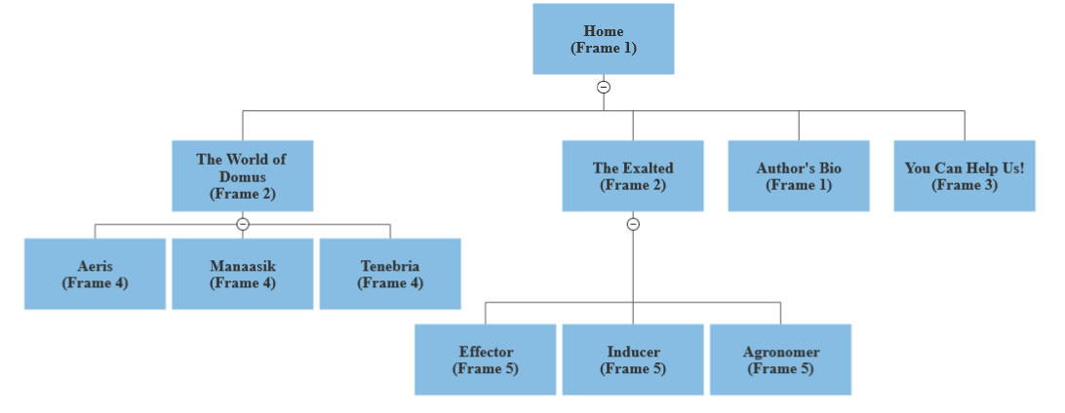

Site Map: All the pages on the site are listed above, and all sites will be accessible from all other sites.

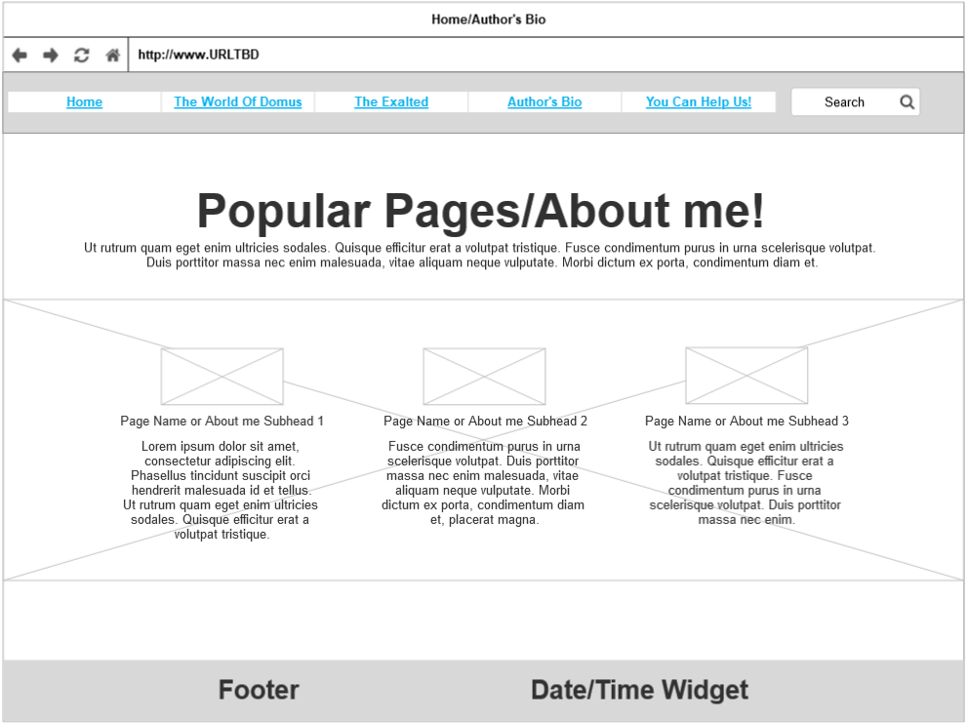

*Frame 2: The “home” page will always show the most visited pages with the first image found on that page as the image (I’ll have to figure out how to code that). Alternatively, this wireframe is used for the “Author’s Bio” page, and will feature of picture of the client and a brief biography with little subheading paragraphs with smaller images.*

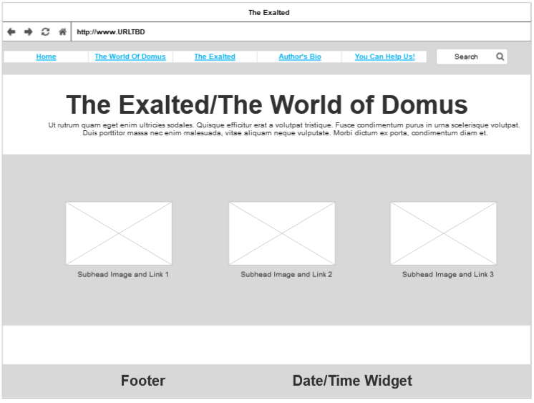

Frame 2: The parent “Exalted” and “World of Domus” pages both use this wireframe. In the former, each image will be a portrait art of a character that belongs to the respective type and each caption is the title in bold and a brief description. In the “World of Domus” page, each image will be a map of the respective country, a heading with the country’s name, and the text below a brief description of the country.

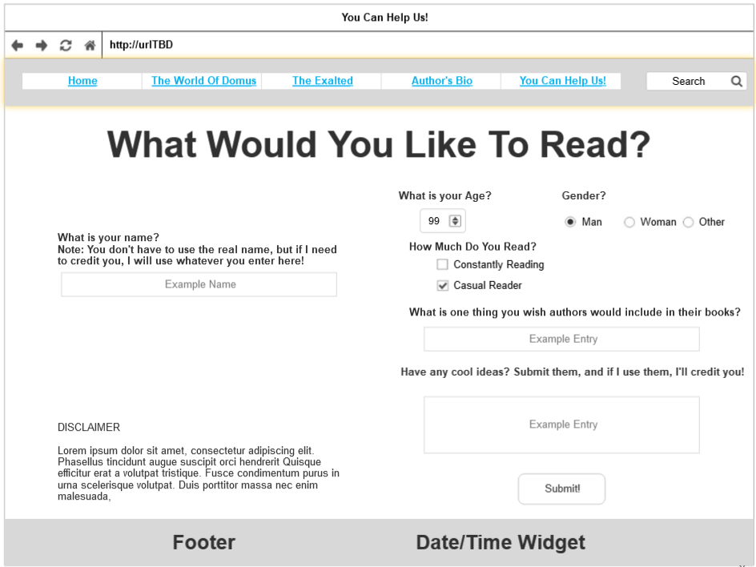

*Figure 3: The “You Can Help Us!” page is essentially a crowd-sourced survey page, where I can gather information from site visitors about what they want to see in a book, based on general demographic. The survey includes many questions using all the prompts asked for in the project 4 requirements.*

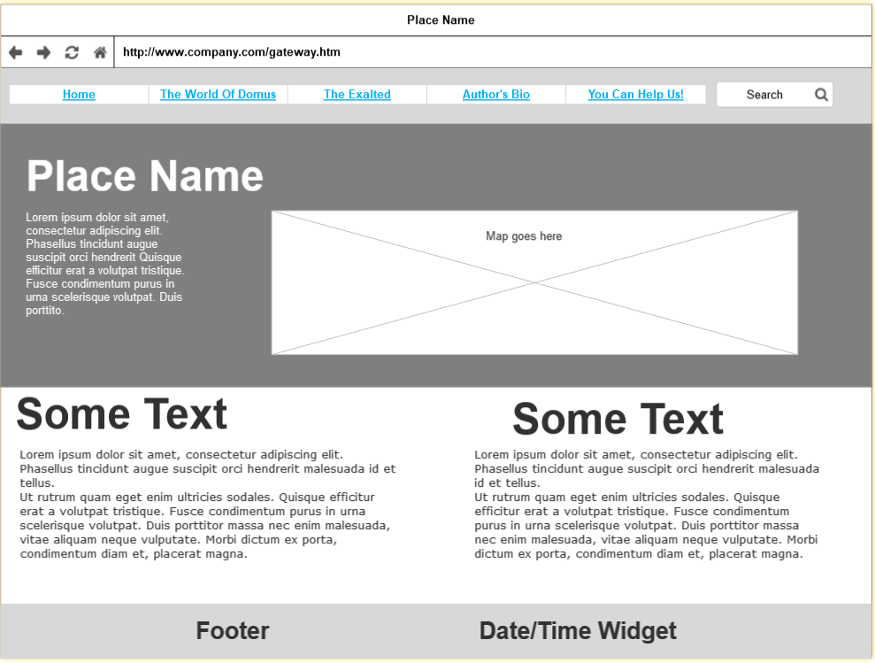

Figure 4: The “Place” page contains a larger version of the map, with subheadings that provide more information about the country. Information includes major cities, demographic info, and other persons and places of interest.

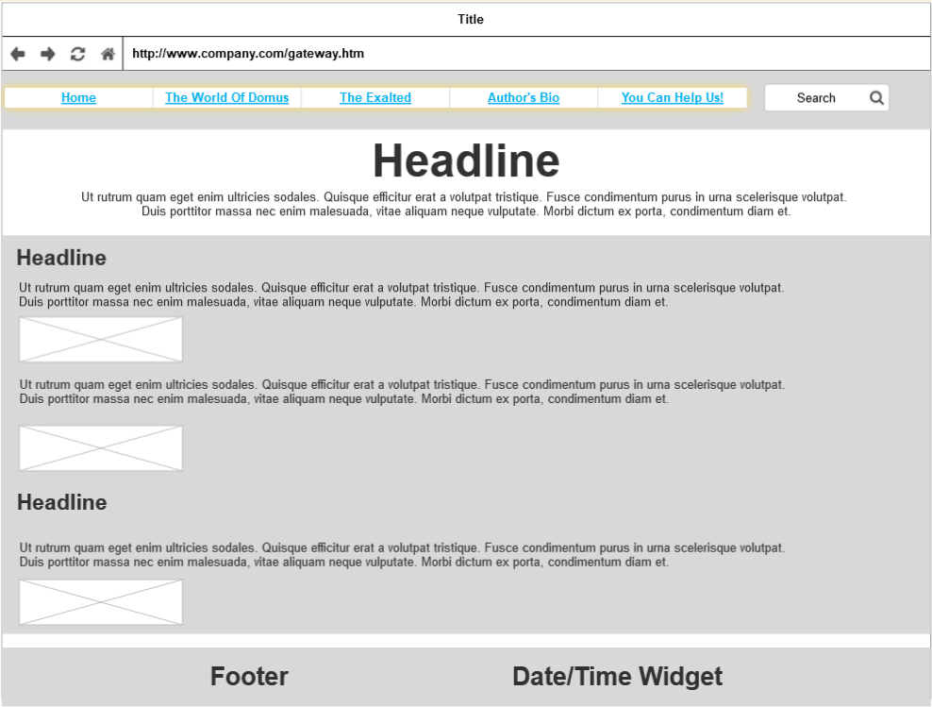

Frame 5: Finally, the “Exalted” child page will explain that particular type of Exalted hero, with subheading covering things like “Powers”, “Patron Deity”, and maybe “Famous Exalted” of that type. Images in or around the text should brighten and make the page more interesting. The wireframe does not capture that the user will scroll down and see more of the same format.

**SECURITY**

The site will not include any E-Commerce components, as of yet. There will also be no need for password protection, nor any need for user account creation. However, because this website will use user interaction in the form of the survey, security will be vital to the users and the client. To begin, I will need to choose a hosting service that provides SSL services and backups, as a baseline security requirement (BigCommerce Pty. Ltd., 2023). SSL, coupled with HTTPS authentication requirements will ensure customer data privacy, as well as provide a boost to SEO (BigCommerce Pty. Ltd., 2023).

**WEB HOSTING**

In order to get the client’s website from my local machine onto the web, we will need to pick a web host. Some of the key factors the client and I will need to consider when picking a web host are:

* Price (both initial and recurring)
* The amount of technical complexity the host can handle (such as size of files on the site and traffic)
* Usability (can the client add and change content as needed?)
* Support (can the client reach help when they need it?)
* Lead time (how long will it take to get the site launched and working?
* Cancellation (if worse comes to worst, can the client cancel their service and switch to a different one?) (Google LLC, n.d.)
* Reliability and performance (how long can the site be hosted before needing downtime, and how fast can the site be loaded?)
* Security (does the hosting service come with SSL certificates, or do they charge extra?)
* Backups (how often does the service back up sites, and how easy is it to recover lost data?)
* Does the site come with E-mail hosting?

The price of the website must be within the client’s means but also provide the desired functionality. The site must be able to contain dozens of images, but no large files like videos. The site must be easy to modify and add content to for the client. The client must be able to get support in case an error occurs or a problem arises that is beyond their ability to correct. The site must be able to be hosted to the web within 3 days of completion of the site source code. Cancellation fees must be reasonable, the company must provide an uptime guarantee, and must be launched no slower than 2 seconds (Baker, 2022). In my research 2 sites seem to come up that meet the client’s needs: DreamHost and WooCommerce. I will need to do more research to ensure that I’m not just getting overwhelmed by an ad campaign. The website will require using the HTML, CSS, JavaScript, and PHP languages, with HTML and CSS displaying and formatting the content, and JavaScript and PHP will allow use of more advanced features like user input and forms, date/time widget, and other features. Finally, I searched and found that theexaltedworld.com is available for a low price from godaddy.com.

**MARKETING**

In order to get the client’s page out to the largest audience possible, I intend to begin with an ad campaign for the merchandise. I can do this through google search and social media advertising. Using advertising in beginning can give an immediate boost to traffic, so that other, slower but more reliable methods can bolster traffic in the long term (Dearsley, 2021) The primary method to market the site, however, will be SEO, or Search Engine Optimization. SEO is a longer-term project that will bring more users to the client’s site from search engines like Google. By ensuring short and long tail keywords that most users would use to find products similar to the client’s are found within the website’s metadata and elsewhere (Dearsley, 2021). Now that I have experience using metatags like meta description, meta keywords, title tags, and how to optimize links so that the search engine bots can trawl my whole site efficiently, I can make sure SEO is as effective as possible at bringing in traffic from search engines.

**REFERENCES**

Baker, K. (2022, April 7). *11 website page load time statistics you need [+ how to increase conversion rate]*. HubSpot Blog | Marketing, Sales, Agency, and Customer Success Content. <https://blog.hubspot.com/marketing/page-load-time-conversion-rates>

BigCommerce Pty. Ltd. (2023). *Ecommerce security: Securing against cyber threats*. BigCommerce. <https://www.bigcommerce.com/articles/ecommerce/ecommerce-website-security/#best-practices-for-ecommerce-security>

Dearsley, B. (2021, April 7). *Startup marketing strategy: 18 ideas and tactics that actually work*. HubSpot Blog | Marketing, Sales, Agency, and Customer Success Content. <https://blog.hubspot.com/marketing/startup-marketing>

DreamHost. (2021, March 12). *How to choose the best web hosting for your site*. DreamHost Academy. <https://www.dreamhost.com/academy/how-to-choose-best-web-hosting/>

Google LLC. (n.d.). *How to choose a web host in 4 steps – Google domains*. Google Domains. <https://domains.google/learn/how-to-choose-a-web-host-in-4-steps/>

SmartDraw, LLC. (2023). Wireframe. <https://cloud.smartdraw.com/>