
Ministry of Health, NASCOP Unit
Kenya Anti-Retroviral medicines (ARVs) Stock Situation – January 2014 draft

Key Highlights:
A. Number of Patients on ART  As at end January 2014: ----------------663,709*  Adult patients ------------------------- 601,477  Pediatric patients--------------------- 62,232  *NB: Excludes private sector data.  B. Supporting agencies of above patients  C. Number of Patients on ART by pipeline: Adults, Children  D. Average scale-up rate (12 months rolling) for ART: 4,900 patients per month  KEMSA pipeline -------------------------------------- 2,876  - Adults = 2,478 Children = 398  Kenya Pharma pipeline----------------------------- 2024  - Adults = 1865 Children = 159 | Key regimens in use | No. of patients on ART  *2nd line, other codes listed as per new ARV LMIS tools
  - GoK | - GF | - USG
  Pipeline | KEMSA | Kenya Pharma | Line Total
  Adults | 264,667 | 336,810 | 601,232
  Paeds | 26,490 | 35,742 | 62,232
  TOTAL | 291,157 | 372,552 | 663,709
 | Adult | Patients numbers | % proportions
 | Option 1: d4T+3TC+NVP | 12,277 | 2.0%
 | Option 2: d4T+3TC+EFV | 2,156 | 0.4%
 | Option 3: AZT+3TC+NVP | 193,783 | 32.2%
 | Option 4: AZT+3TC+EFV | 50,997 | 8.5%
 | Option 5: TDF+3TC+NVP | 152,633 | 25.4%
 | Option 6: TDF+3TC+EFV | 157,441 | 26.2%
 | 2nd Line | 22,596 | 3.8%
 | Other regimens | 9,594 | 1.6%
 | Paediatric | Patients numbers | % proportions
 | Option 1: AZT+3TC+NVP | 22,944 | 36.9%
 | Option 2: AZT+3TC+EFV | 5,597 | 9.0%
 | Option 3: ABC+3TC+NVP | 18,975 | 30.5%
 | Option 4: ABC+3TC+EFV | 6,198 | 10.0%
 | Option 5: ABC+3TC+LPV/r | 3,707 | 6.0%
 | Option 6: AZT+3TC+LPV/r | 1,461 | 2.3%
 | 2nd Line | 2,546 | 4.1%
 | Other regimens | 804 | 1.3%

E: Stock Requests / Transfers & Key Receipts
Receipts under KEMSA: There were no receipts under KEMSA pipeline
Receipts under KP: 2,242 X 100s Fluconazole 200mg tablets; 20,000 X 100s Pyridoxine 50mg tablets
Transfers from KEMSA to KP: None
Transfers from KP to KEMSA: 75,000 x 30s packs of Tenofovir/Lamivudine/Efavirenz 300/300/600mg FDC tablets; 2000 X 90s Efavirenz 200mg
tablets; 5000 X 60s Zidovudine 300mg tablets; 15,000 x 30s packs of Tenofovir/Lamivudine 300/300mg FDC tablets; 160,000 X 60s NVP 200mg
tablets among others

3TC = Lamivudine; ABC = Abacavir; AZT = Zidovudine; ART = Antiretroviral Therapy; d4T = Stavudine; EFV = Efavirenz; FDC = Fixed Dose Combination; GF = Global Fund; GoK = Government of Kenya; KEMSA = Kenya Medical Supplies Agency; KP = Kenya Pharma; LMU = Logistics Management Unit; MSF = Médecins sans Frontières; NASCOP = National AIDS & STI Control program; NVP = Nevirapine; OI = Opportunistic infections; TDF = Tenofovir; USG =United States government .
National ARV Stock Status (Adult and Paediatric)
Figure 1: Adult ARV Stock status at KEMSA and Kenya Pharma as at end January 2014 (based on Patient months-of-stock [PMoS]) | Figure 2: Paediatric ARV Stock status at KEMSA and Kenya Pharma as at end January 2014 (based on Patient months-of-stock [PMoS])
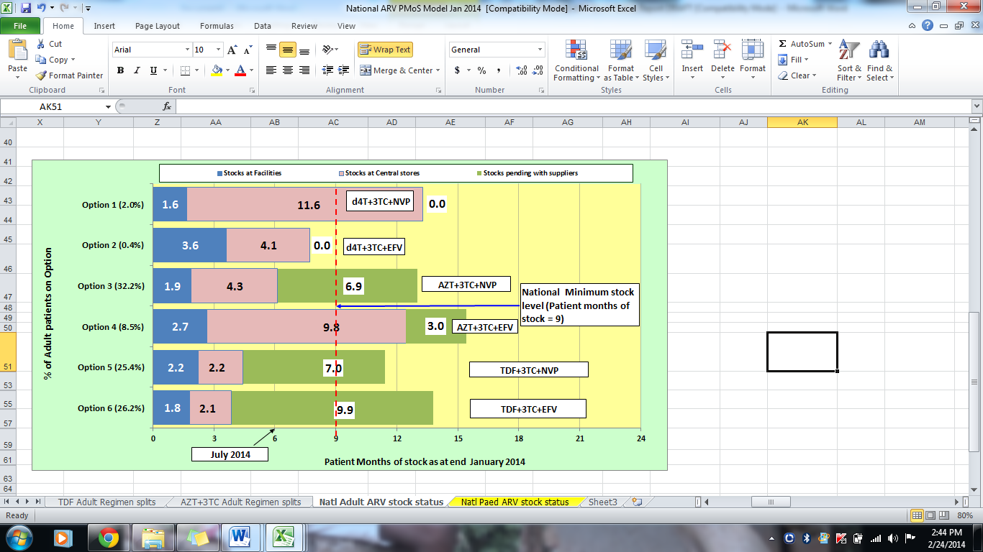  Data sources: NASCOP, KEMSA & LMU, Kenya Pharma, MSH/HCSM | 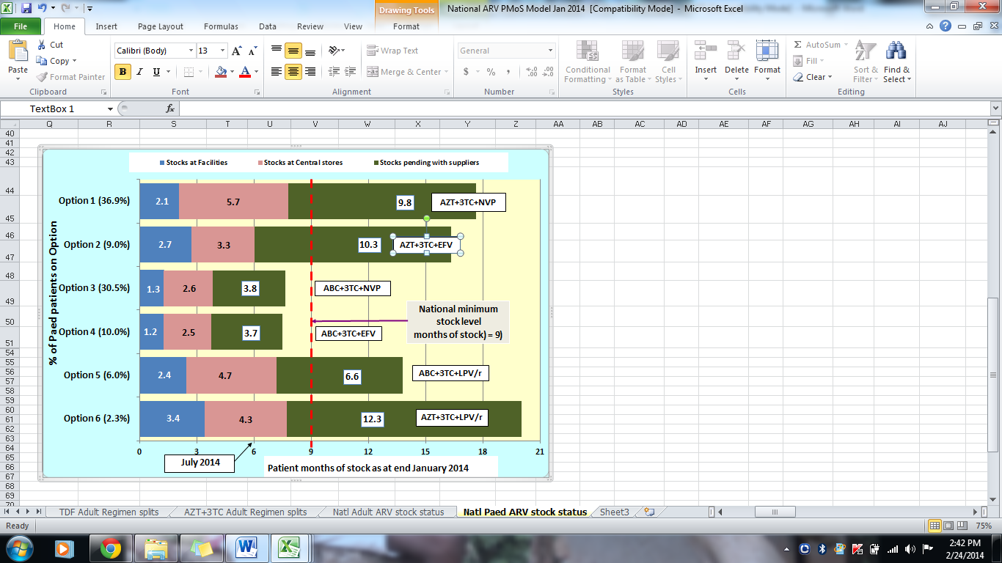  Data sources: NASCOP, Kenya Pharma, KEMSA & LMU, MSH/HCSM
NB: Patient Months-of-Stock refers to the equivalent number of months that the available quantities would maintain the current patient numbers on treatment.

National Adult ARV stock status

Adult ARV drugs are mainly procured through support from GoK, Global Fund (GF) and USG, and distributed through KEMSA and Kenya Pharma (KP) pipelines.
Comments:- Figure 1 above shows that:
- In country stocks for Options 2, 3, 5 and 6 are below the national recommended minimum stock level of 9 months.
Action: Fast track deliveries of pending stocks for options 3, 5 and 6 through KEMSA and KP.
- Adult patients on Stavudine-based Options 1 and 2 are down to about 2.4 % (14,433) with ongoing phase-out.
Actions: Continue to closely monitor the pipeline stocks and consumption. Follow up with facilities reporting highest numbers.

National Paediatric ARV stock status
Paediatric ARV drugs are currently procured through support from GF. Distribution is currently undertaken through both KEMSA and Kenya Pharma (KP).
Comments: - Figure 2 above shows that:
- In-country stocks for ALL Options are below the recommended national stock level of 9 months.
Action: Expedite deliveries under GF Year 2 procurement URGENTLY to restore in-country stock levels to a minimum of 9 months.
Action: Share existing central level stocks between Kenya Pharma and KEMSA pipelines to mitigate stock outs in the respective pipelines.
- Combined facility and central level stocks for Options 3 and 4 are CRITICALLY low, being below stock level of 6 months.
Action: Initiate new procurements for options 3 and 4 under GF Year 3 procurement URGENTLY to restore national stock levels to a maximum of 12 months.

National reporting rate and Timeliness of reporting for the ARV Program (KP and KEMSA pipelines)
Figure 3: Reporting rates for ARV Ordering points for KP and KEMSA pipelines - January 2014 (n = 310)
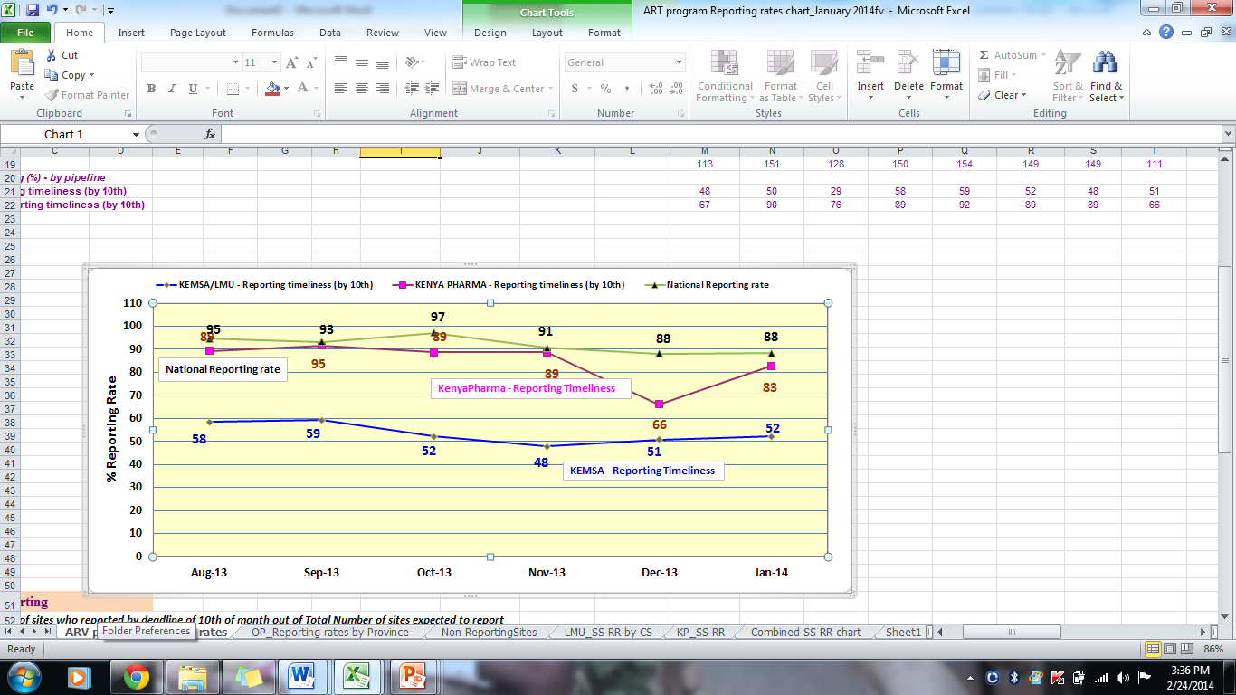
Data sources: NASCOP, KEMSA, Kenya Pharma, MSH/HCSM

Figure 3 above shows the following:
- The average combined national reporting rate across the 310 ordering points for January 2014 was 88%, with a reporting rate of 80% for the KEMSA pipeline sites and 96% for the Kenya Pharma pipeline sites respectively.
- In the Kenya Pharma pipeline, 83% of the health facilities reported in time i.e. by the 10th of the month (n = 168)
- In the KEMSA pipeline, 52% of the health facilities reported in time i.e. by the 10th of the month (n = 142)

This document is produced by the HIV Commodity Security Committee of NASCOP in collaboration with partners.

