
Ministry of Health, NASCOP Unit
Kenya Anti-Retroviral medicines (ARVs) Stock Situation – October 2013 draft

Key Highlights:
A. Number of Patients on ART  As at end October 2013: ----------------649,085*  Adult patients ------------------------- 589,893  Pediatric patients--------------------- 59,192  *NB: Excludes private sector data.  B. Supporting agencies of above patients  C. Number of Patients on ART by pipeline: Adults, Children  D. Average scale-up rate (12 months rolling) for ART: 4368 patients per month  KEMSA pipeline -------------------------------------- 2721  - Adults = 2383 Children = 338  Kenya Pharma pipeline----------------------------- 1647  - Adults = 1537 Children = 110 | Key regimens in use | No. of patients on ART  *2nd line, other codes listed as per new ARV LMIS tools
  - GoK | - GF | - USG
  Pipeline | KEMSA | Kenya Pharma | Line Total
  Adults | 261,729 | 328,164 | 589,893
  Paeds | 24,468 | 34,724 | 59,192
  TOTAL | 286,197 | 362,888 | 649,085
 | Adult | Patients numbers | % proportions
 | Option 1: d4T+3TC+NVP | 22,124 | 3.8%
 | Option 2: d4T+3TC+EFV | 4,423 | 0.7%
 | Option 3: AZT+3TC+NVP | 189,071 | 32.1%
 | Option 4: AZT+3TC+EFV | 49,844 | 8.4%
 | Option 5: TDF+3TC+NVP | 150,342 | 25.5%
 | Option 6: TDF+3TC+EFV | 146,207 | 24.8%
 | 2nd Line | 21,190 | 3.6%
 | Other regimens | 6,692 | 1.1%
 | Paediatric | Patients numbers | % proportions
 | Option 1: AZT+3TC+NVP | 21,414 | 36.2%
 | Option 2: AZT+3TC+EFV | 5,391 | 9.1%
 | Option 3: ABC+3TC+NVP | 18,251 | 30.8%
 | Option 4: ABC+3TC+EFV | 5,807 | 9.8%
 | Option 5: ABC+3TC+LPV/r | 3,461 | 5.8%
 | Option 6: AZT+3TC+LPV/r | 1,415 | 2.4%
 | 2nd Line | 2,394 | 4.0%
 | Other regimens | 1,059 | 1.8%

E: Stock Requests / Transfers & Key Receipts
Receipts under KEMSA: 10,000 X 5 X 60ml Lopinavir/ritonavir liquid
Receipts under KP: 168,500 X 30s packs of Tenofovir/Lamivudine/Efavirenz 300/300/600mg FDC tablets; 149,553 X 60s Abacavir/Lamivudine 60/30mg FDC tablets; 100,000 X 60s Zidovudine/Lamivudine/Nevirapine 300/150/200mg FDC tablets
Transfers from KEMSA to KP: 3000 X 5 X 60ml Lopinavir/ritonavir liquid and 500 X 28 Diflucan 200mg tablets.
Transfers from KP to KEMSA: 75,000 X 30s packs of Tenofovir/Lamivudine/Efavirenz 300/300/600mg FDC tablets; 50,000 X 60s Abacavir/Lamivudine 60/30mg FDC tablets; 39,000 X 120s Lopinavir/ritonavir 200/50mg tablets

3TC = Lamivudine; ABC = Abacavir; AZT = Zidovudine; ART = Antiretroviral Therapy; d4T = Stavudine; EFV = Efavirenz; FDC = Fixed Dose Combination; GF = Global Fund; GoK = Government of Kenya; KEMSA = Kenya Medical Supplies Agency; KP = Kenya Pharma; LMU = Logistics Management Unit; MSF = Médecins sans Frontières; NASCOP = National AIDS & STI Control program; NVP = Nevirapine; OI = Opportunistic infections; TDF = Tenofovir; USG =United States government .
National ARV Stock Status (Adult and Paediatric)
Figure 1: Adult ARV Stock status at KEMSA and Kenya Pharma as at end October2013 (based on Patient months-of-stock [PMoS]) | Figure 2: Paediatric ARV Stock status at KEMSA and Kenya Pharma as at end October2013 (based on Patient months-of-stock [PMoS])
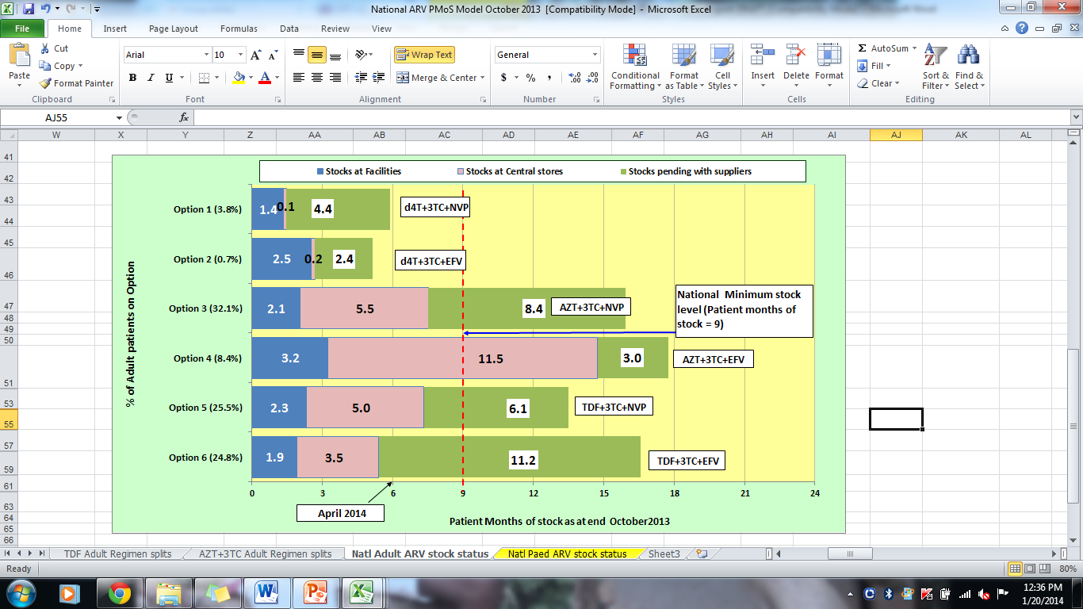  Data sources: NASCOP, KEMSA & LMU, Kenya Pharma, MSH/HCSM | 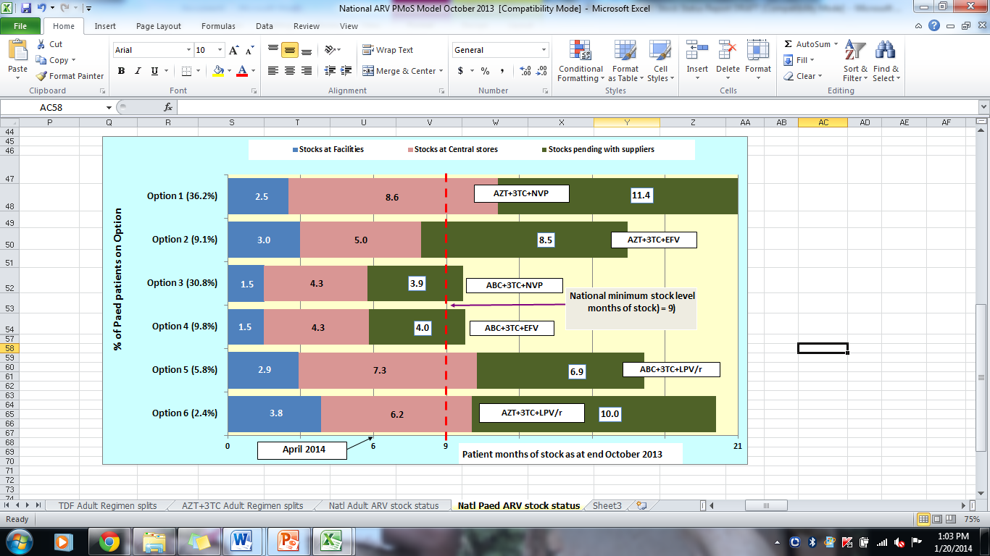  Data sources: NASCOP, Kenya Pharma, KEMSA & LMU, MSH/HCSM
NB: Patient Months-of-Stock refers to the equivalent number of months that the available quantities would maintain the current patient numbers on treatment.

National Adult ARV stock status

Adult ARV drugs are mainly procured through support from GoK, Global Fund (GF) and USG, and distributed through KEMSA and Kenya Pharma (KP) pipelines.
Comments:- Figure 1 above shows that:
- In country stocks for Options 1, 2, 3, 5 and 6 are below the national recommended minimum stock level of 9 months.
Action: Fast track deliveries of pending stocks for options 1, 2, 3, 5 and 6 through KEMSA and KP
- Adult patients on Stavudine-based Options 1 and 2 are down to about 4.5 % (26,547) with ongoing phase-out.
Actions: Continue to closely monitor the pipeline stocks and consumption. However, given that there are no new planned procurements for options 1 and 2, communication on complete phase out of options 1 and 2 is urgent.

National Paediatric ARV stock status
Paediatric ARV drugs are currently procured through support from GF. Distribution is currently undertaken through both KEMSA and Kenya Pharma (KP).
Comments: - Figure 2 above shows that:
- In-country stocks for Options 2, 3 and 4 are below the recommended national stock level of 9 months and CRITICALLY low for options 3 and 4.
Action: Expedite delivery of Options 2, 3 and 4 under GF URGENTLY to restore in country stock levels to a minimum of 9 months.
Action: Share existing central level stocks between Kenya Pharma and KEMSA pipelines to mitigate stock outs in the respective pipelines.
- Combined central level and stocks pending with suppliers for Options 3 and 4 are at the national recommended minimum stock level of 9 months.
Action: Initiate new procurements for options 3 and 4 URGENLTY to restore national stock levels to a maximum of 12 months.

National reporting rate and Timeliness of reporting for the ARV Program (KP and KEMSA pipelines)
Figure 3: Reporting rates for ARV Ordering points for KP and KEMSA pipelines - October2013 (n = 310)
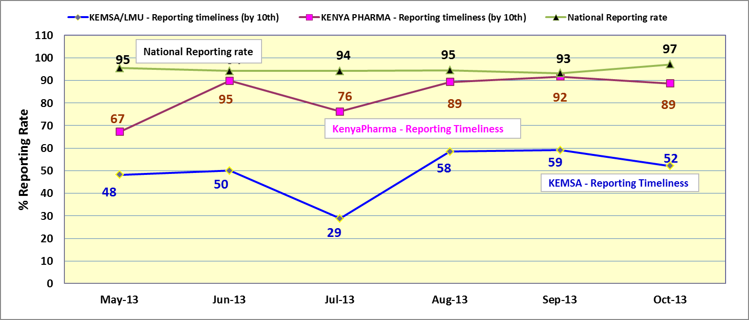
Data sources: NASCOP, KEMSA, Kenya Pharma, MSH/HCSM

Figure 3 above shows the following:

- That the average combined national reporting rate across the 310 ordering points for October2013 was 97%, with a reporting rate of 96% for the KEMSA pipeline sites and 98% for the Kenya Pharma pipeline sites respectively.
- That in the Kenya Pharma pipeline, 89% of the health facilities reported in time i.e. by the 10th of the month (n=168)
- That in the KEMSA pipeline, 52% of the health facilities reported in time i.e. by the 10th of the month (n=142)

This document is produced by the HIV Commodity Security Committee of NASCOP in collaboration with partners.

