
Ministry of Health, NASCOP Unit
Kenya Anti-Retroviral medicines (ARVs) Stock Situation – September 2013*draft

Key Highlights:
A. Number of Patients on ART  As at end August 2013: ----------------638,005*  Adult patients ------------------------- 580,493  Pediatric patients--------------------- 57,512  *NB: Excludes private sector data.  B. Supporting agencies of above patients  C. Number of Patients on ART by pipeline: Adults, Children  D. Average scale-up rate (12 months rolling) for ART: patients per month  KEMSA pipeline -------------------------------------- 3,625  - Adults = 3,724 Children = -99  Kenya Pharma pipeline----------------------------- 555  - Adults = 506 Children = 49 | Key regimens in use | No. of patients on ART  *2nd line, other codes listed as per new ARV LMIS tools
  - GoK | - GF | - USG
  Pipeline | KEMSA | Kenya Pharma | Line Total
  Adults | 257,916 | 322,577 | 580,493
  Paeds | 23,943 | 33,569 | 57,512
  TOTAL | 281,859 | 356,146 | 638,005
 | Adult | Patients numbers | % proportions
 | Option 1: d4T+3TC+NVP | 26,966 | 4.6%
 | Option 2: d4T+3TC+EFV | 4,898 | 0.8%
 | Option 3: AZT+3TC+NVP | 187,264 | 32.3%
 | Option 4: AZT+3TC+EFV | 49,345 | 8.5%
 | Option 5: TDF+3TC+NVP | 145,167 | 25.0%
 | Option 6: TDF+3TC+EFV | 140,039 | 24.1%
 | 2nd Line & Other regimens | 26,814 | 4.6%
 | Paediatric | Patients numbers | % proportions
 | Option 1: AZT+3TC+NVP | 21,099 | 36.7%
 | Option 2: AZT+3TC+EFV | 5,184 | 9.0%
 | Option 3: ABC+3TC+NVP | 18,114 | 31.5%
 | Option 4: ABC+3TC+EFV | 5,727 | 10.0%
 | Option 5: ABC+3TC+LPV/r | 2,799 | 4.9%
 | Option 6: AZT+3TC+LPV/r | 1,329 | 2.3%
 | 2nd Line & Other regimens | 3,260 | 5.7%

E: Stock Requests / Transfers & Key Receipts
Receipts under KEMSA: 122,320, packs of TDF300/3TC300, 123,000 packs of AZT300/3TC150 under G.o.K tenders
Receipts under KP: 109,000 X 30s packs of Tenofovir/Lamivudine/Efavirenz 300/300/600mg FDC tablets; 34,960 X 30s packs of Tenofovir/Lamivudine 300/300mg FDC tablets; 26,279 X 120s packs of Lopinavir/Ritonavir 200/50mg FDC tablets
Transfers from KEMSA to KP: There were no transfers from KEMSA to Kenya Pharma Project in September 2013.
Transfers from KP to KEMSA: 150,000 packs of Nevirapine 200mg tablets, and other OI medicines.

3TC = Lamivudine; ABC = Abacavir; AZT = Zidovudine; ART = Antiretroviral Therapy; d4T = Stavudine; EFV = Efavirenz; FDC = Fixed Dose Combination; GF = Global Fund; GoK = Government of Kenya; KEMSA = Kenya Medical Supplies Agency; KP = Kenya Pharma; LMU = Logistics Management Unit; MSF = Médecins sans Frontières; NASCOP = National AIDS & STI Control program; NVP = Nevirapine; OI = Opportunistic infections; TDF = Tenofovir; USG =United States government .
National ARV Stock Status (Adult and Paediatric)
Figure 1: Adult ARV Stock status at KEMSA and Kenya Pharma as at end September 2013 (based on Patient months-of-stock [PMoS]) | Figure 2: Paediatric ARV Stock status at KEMSA and Kenya Pharma as at end September 2013 (based on Patient months-of-stock [PMoS])
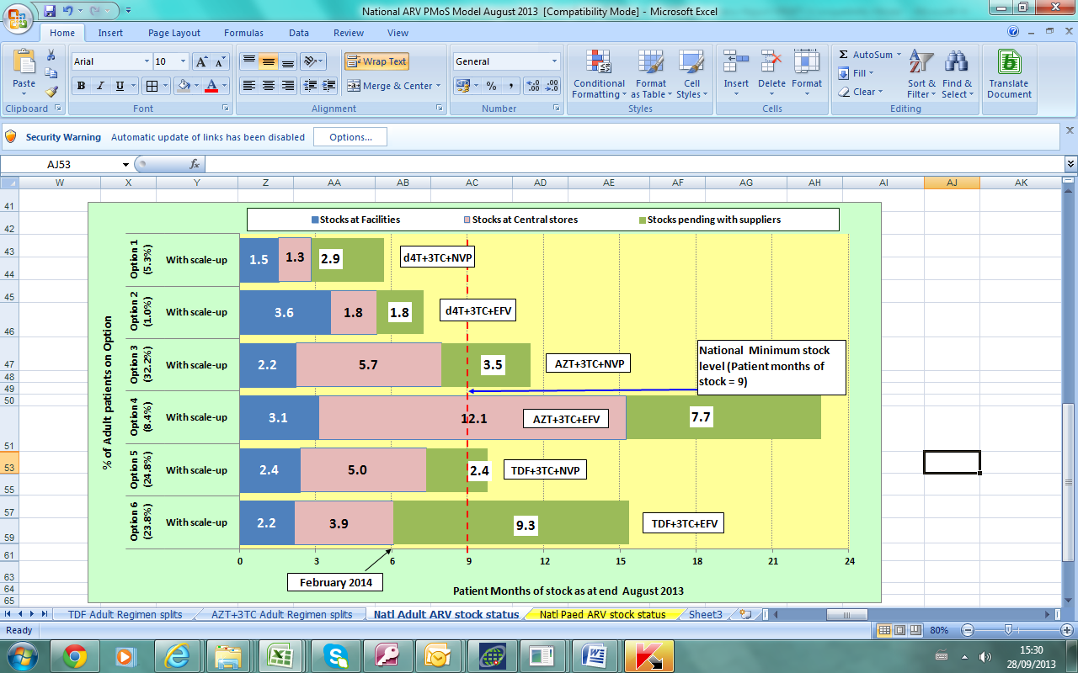  Data sources: NASCOP, KEMSA & LMU, Kenya Pharma, MSH/HCSM | 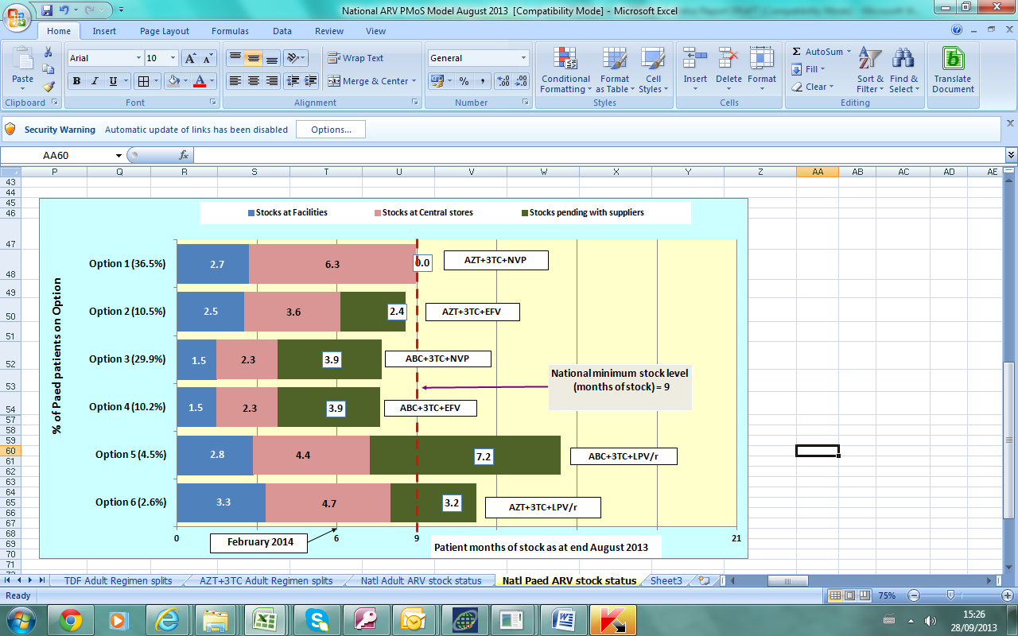  Data sources: NASCOP, Kenya Pharma, KEMSA & LMU, MSH/HCSM
NB: Patient Months-of-Stock refers to the equivalent number of months that the available quantities would maintain the current patient numbers on treatment.

National Adult ARV stock status

Adult ARV drugs are mainly procured through support from GoK, Global Fund (GF) and USG, and distributed through KEMSA and Kenya Pharma (KP) pipelines.
Comments:- Figure 1 above shows that:
- In country stocks for Options 1, 2, 3, 5 and 6 are below the national recommended minimum stock level of 9 months.
Action: Fast track deliveries of pending stocks for options 1, 2, 3, 5 and 6 through KEMSA and KP
- Adult patients on Stavudine-based Options 1 and 2 are down to about 6.2% (35,942) with ongoing phase-out. The pipeline stock levels of Options 1 and 2 is at least 6 MOS with no further planned procurements.
Actions: Continue to closely monitor the pipeline stocks and consumption. Call down stocks of TDF-based and AZT-based regimen commodities in line with the observed transition trend.

National Paediatric ARV stock status
Paediatric ARV drugs are currently procured through support from GF. Distribution is currently undertaken through both KEMSA and Kenya Pharma (KP).
Comments: - Figure 2 above shows that:
- In-country stocks for ALL Options are below the recommended national stock level of 9 months.
- Both central level and stocks pending with suppliers stocks for Options 2, 3 and 4 are below the national recommended minimum stock level of 9 months.
- There are no stocks pending with suppliers for Option 1.
Action: Expedite planned procurement of ALL Options under GF especially to achieve and maintain the desired 13.5 months. Expedite delivery of stocks pending with suppliers for Options 2, 3, 4, 5 and 6.
Action: Share existing central level stocks between Kenya Pharma and KEMSA pipelines.

Reporting rates for the ARV Program (KP and KEMSA pipelines)
Figure 3: Reporting rates for ARV Ordering points for KP and KEMSA pipelines - September 2013 (n = 310) | Figure 4: Timeliness of reporting (Percentage of ARV Ordering points reporting by deadline) – September 2013
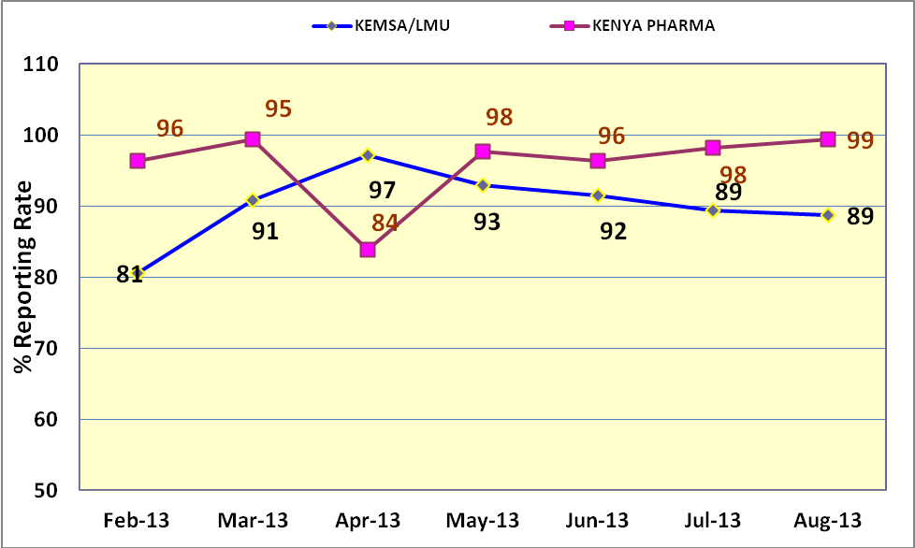  Data sources: NASCOP, KEMSA & LMU, Kenya Pharma, MSH/HCSM | 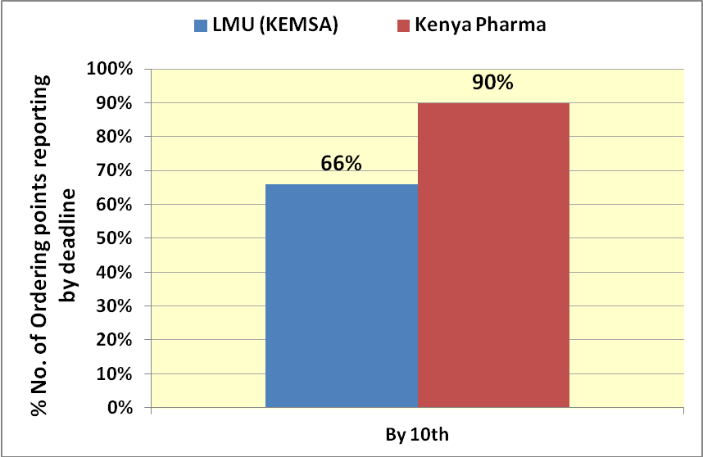  Data sources: NASCOP, Kenya Pharma, KEMSA & LMU, MSH/HCSM

Figure 3 above shows that the average combined reporting rate across the 310 ordering points for August 2013 was 94%, with a reporting rate of 89% for the LMU/KEMSA pipeline sites and 99% for the Kenya Pharma pipeline sites respectively.

Figure 4 above shows that the timeliness of reporting increased for KEMSA pipeline compared to the previous month where 66% of sites in the LMU/KEMSA pipeline and 90% of the facilities in Kenya Pharma pipeline reported on time giving an average timely reporting rate of 80%, an increase from 55% last month.

This document is produced by the HIV Commodity Security Committee of NASCOP in collaboration with partners.

