PUNE INSTITUTE OF COMPUTER TECHNOLOGY

Department of Computer Engineering

DBMSL (310247)

K-1 Batch Roll no-31109

Name -Jayesh Gopal Bangad

**B1 ASSIGNMENT**

Problem Statement:

Study of Open Source NOSQL Database: MongoDB

(Installation, Basic CRUD operations, Execution)

Installation of MongoDB:

Download MongoDB executable .msi file. Select the latest version for Windows, the Windows Server 2008 R2 is the version if you are on Windows 7, 8 or 10.

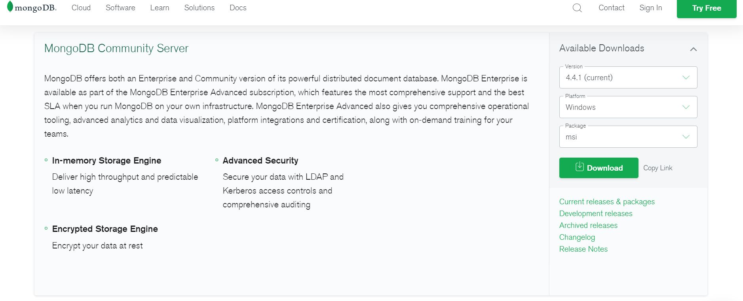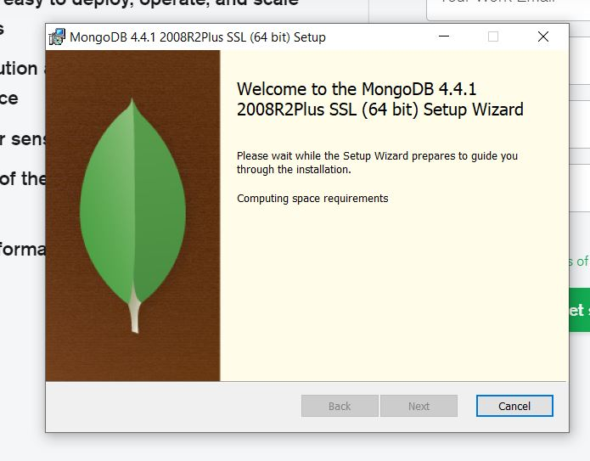

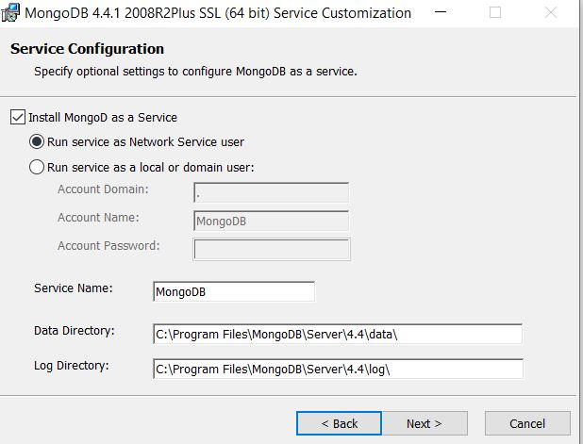

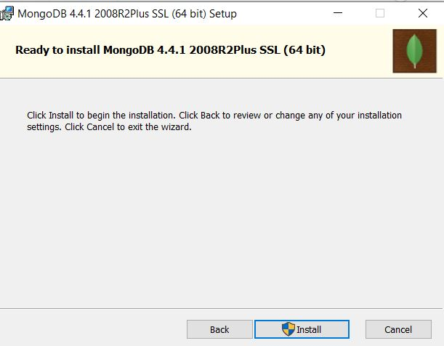

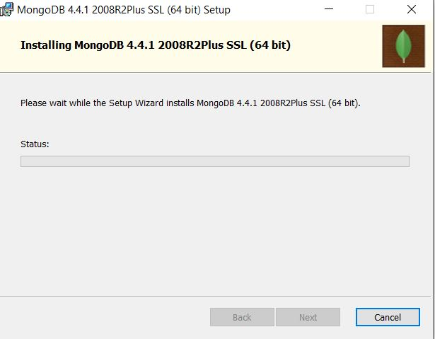

Execute the command mongod.exe --dbpath "DATA_DIRECTORY_PATH" to configure the data path and start the MongoDB server. Please replace the *DATA_DIRECTORY_PATH* with the path of data directory present inside MongoDB installed folder. On running this command, the below log will be displayed which says that the MongoDB configuration is successful and the server is up and running fine.

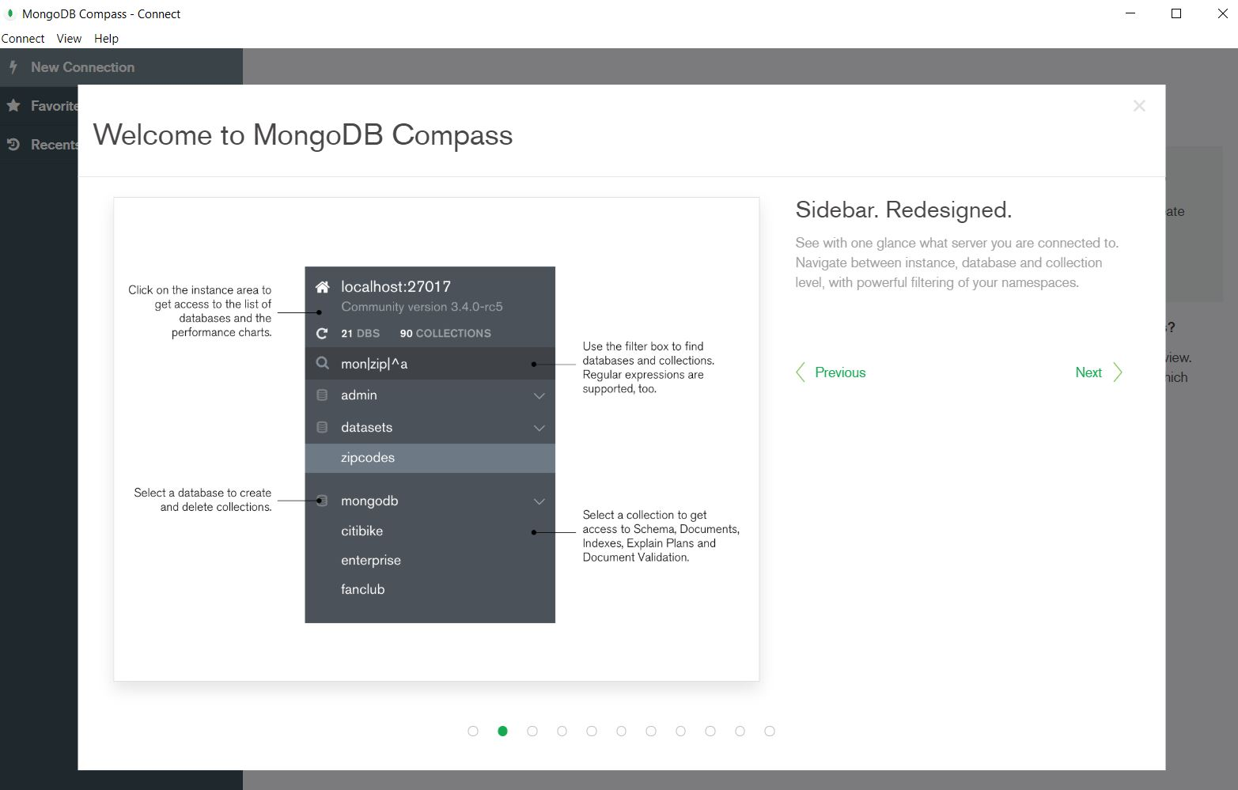

With this, we have successfully installed the MongoDB on the windows environment and we are good to start off with the MongoDB.

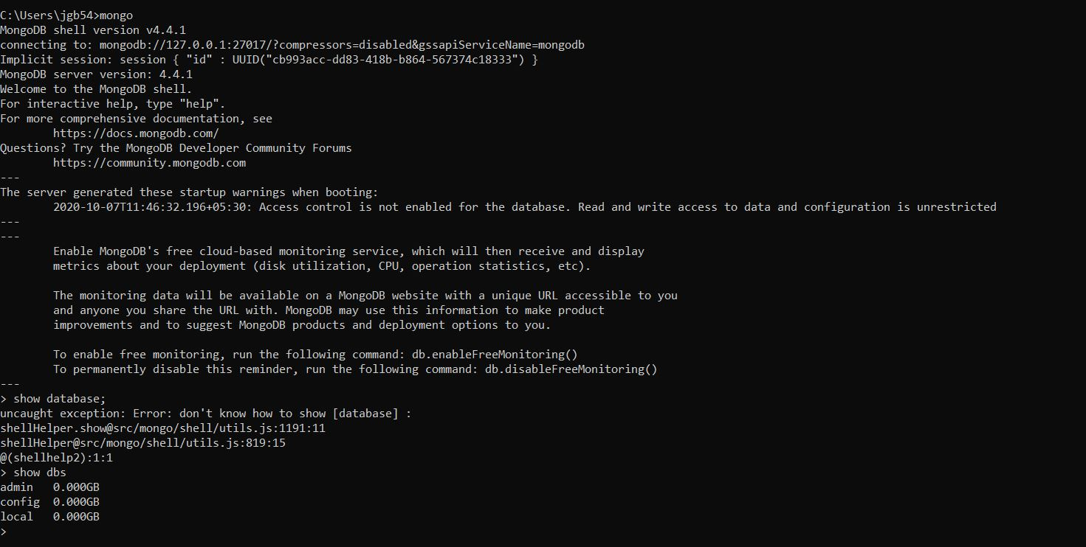

CRED Operation:

Create Database:

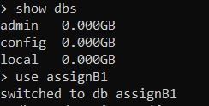

Drop Database:

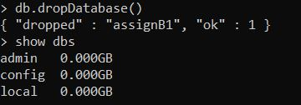

Create Collection:

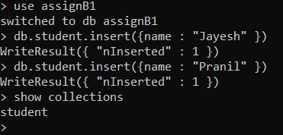

Drop Collection:

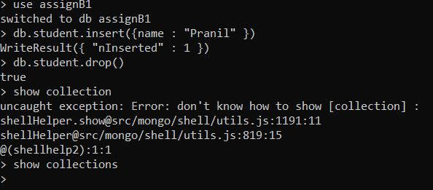

Insert in Collection:

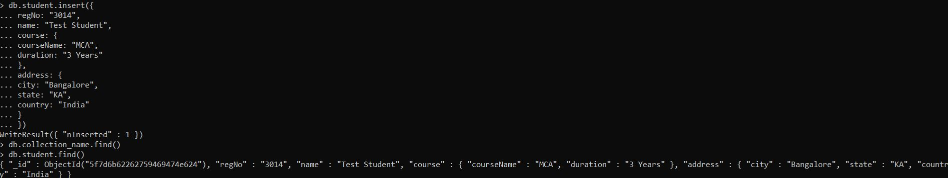

Update in Collection:

