PUNE INSTITUTE OF COMPUTER TECHNOLOGY

Department of Computer Engineering

DBMSL (310247)

K-1 Batch Roll no-31109 Roll no-31110

Name Jayesh Gopal Bangad Name-Pranil Bhalerao

**Mini Project Report**

**Title :** E-Market for HandiCrafts

**Introduction :**

E Marketplace (Like Amazon, flipkart) wherein tribals can promote, market and sell tribal produce such as handicrafts, arts, paintings, minor forest products etc. on line with provision of delivery and e-payment and promotional discounts.

**Abstract :**

This project is aimed at developing an Online Shopping for customer. The system is an online application that can be accessed throughout the organization and outside as well with proper login provided.The project has been planned to be having the view of distributed architecture, with centralized storage of the database. The application for the storage of the data has been planned. Using the constructs of MongoDB and all the user interfaces have been designed using the JAVA. The database connectivity is planned using the “Database” methodology. The standards of security and data protective mechanism have been given a big choice for proper usage. The application takes care of different modules and their associated reports, which are produced as per the applicable strategies and standards that are put forwarded by the administrative staff.

**Motivation :**

According to Wikipedia the GDP of Andaman and nicobar (which is tribal area) in 2018-19 was lowest compared to other states in India  
It was ranked 33rd   
So ,to boost the economy we are planning create this webapp.  
Another motivation was vocal for local.

**Objective :**

To ensure a wider reach to genuine art lovers, millennial fashionistas and ethnic folk, TRIBES India is making its presence felt through our web app.

To create a web application so that tribal people can promote their products.

To boost indian economy.

**Technology-Stack :**

Front-End :

ReactJS

BackEnd :

NodeJS

MongoDB

**DataFlow Diagram :**

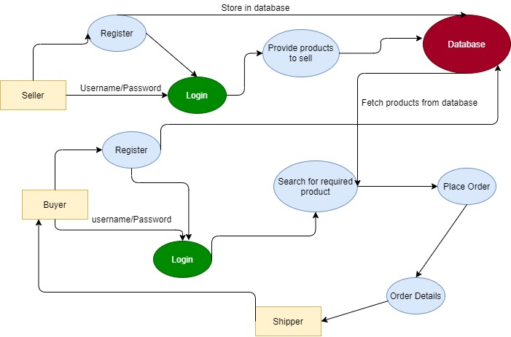

**Source Code:**

**https://github.com/pranil22/e_market_MERN**

**Implementation :**

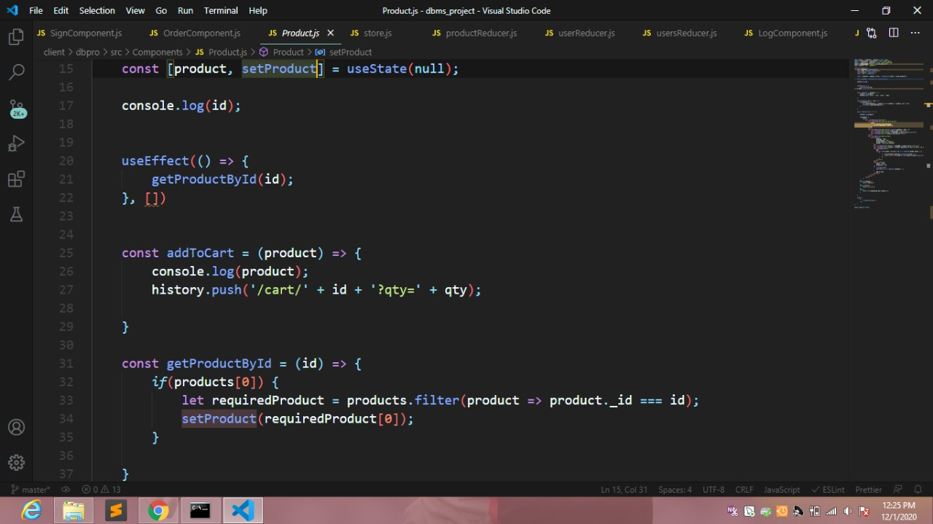

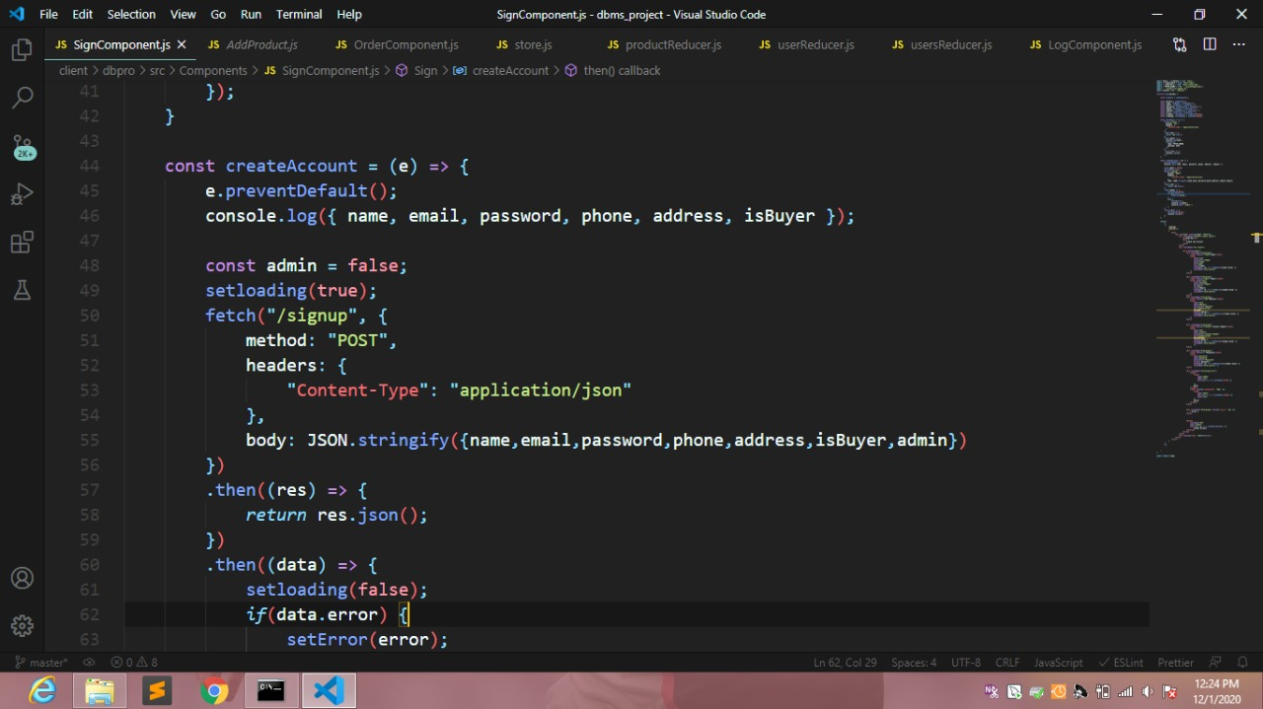

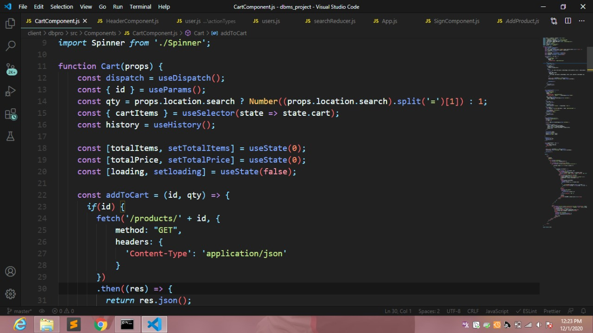

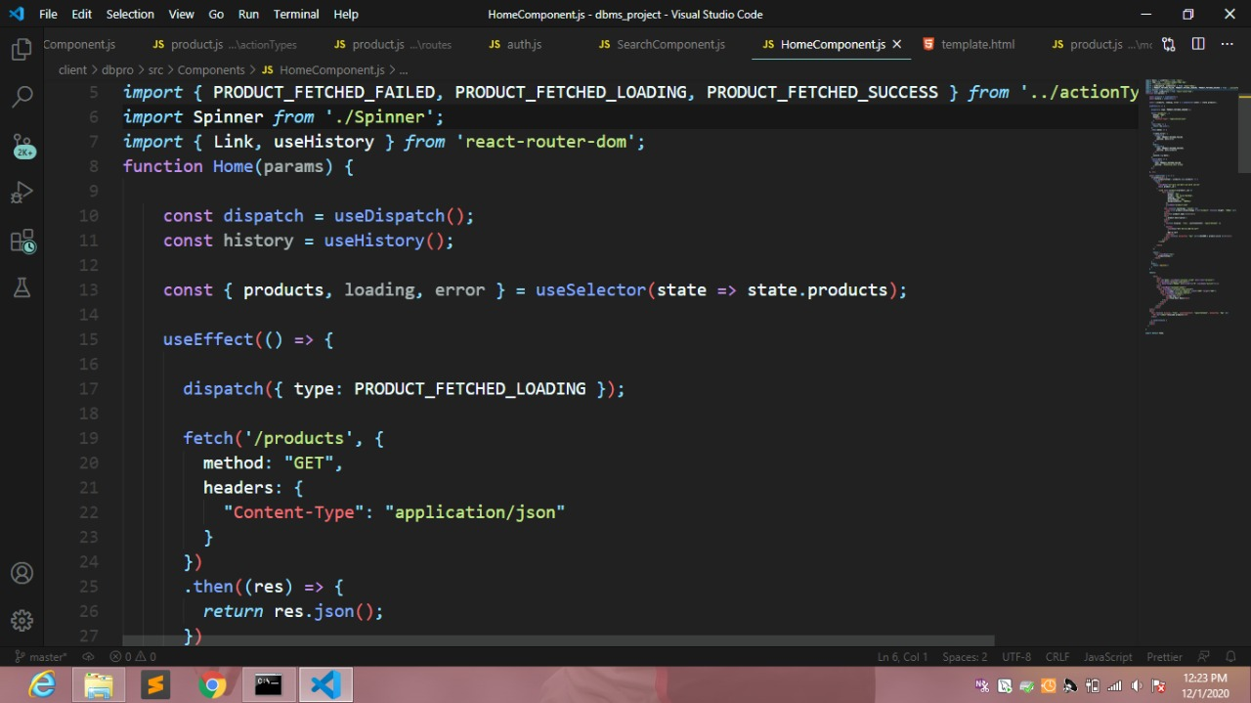

**Output Screen :**

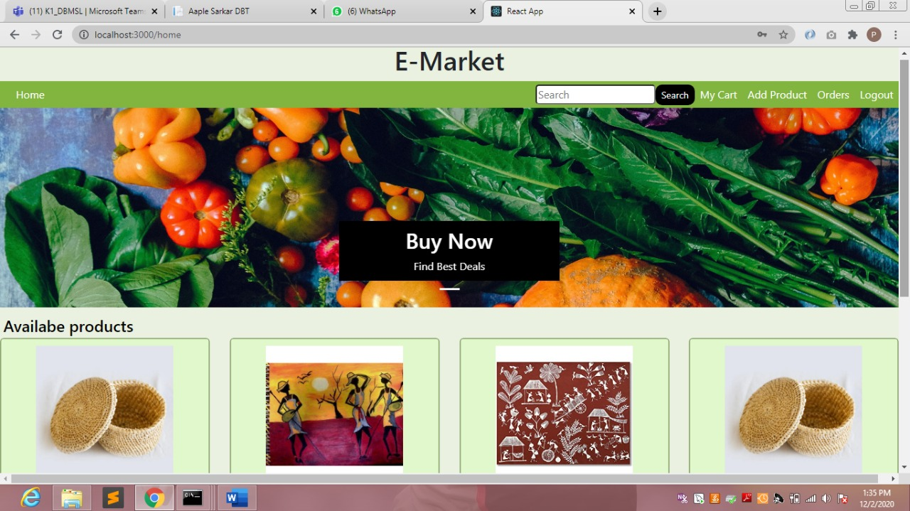

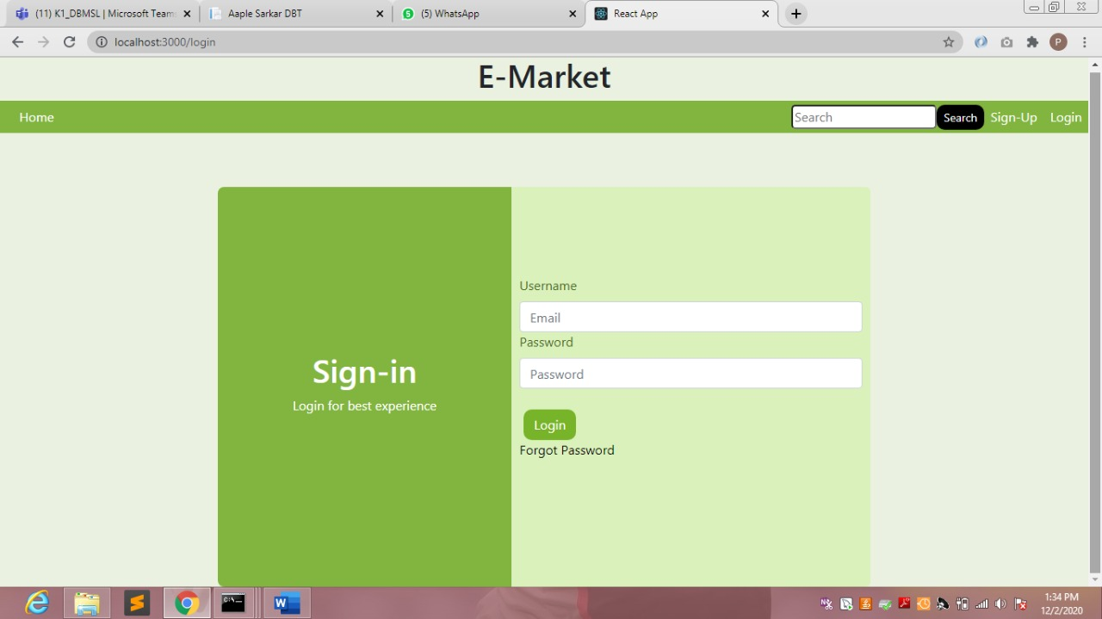

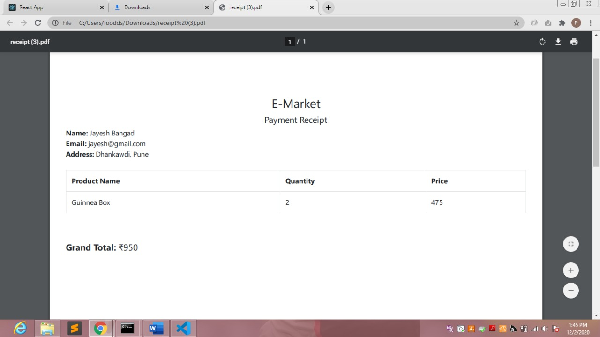

**Scope for the Future Development :**  
The system can be designed for further enhancement .This could also be developed according to the growing needs of the customer.

**Conclusion :**

This project developed, incorporated all the activities involved in the browsing centre.

It provides all necessary information to the management as well as the customer with the use of this system; the user can simply sit in front of the system and monitor all the activities without any physical movement of the file. Management can service the customers request best in time.

The system provides quickly and valuable information. These modules have been integrated for effective use of the management for future forecasting and for the current need.