PUNE INSTITUTE OF COMPUTER TECHNOLOGY

Department of Computer Engineering

DBMSL (310247)

K-1 Batch Roll no-31109

Name -Jayesh Gopal Bangad

**Mock Test 1**

Problem Statement :

SQL queries using SQL DML statements: Insert, Select, Update, Delete with operators, functions, and set operator.

Consider two relations.

Emp( empId,empName,empSal,empDeptId)

Dept(deptId int, deptName varchar(10))

1 .Create database ASS_B1

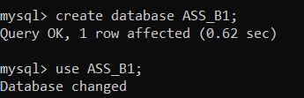

2 Create table Emp and Dept

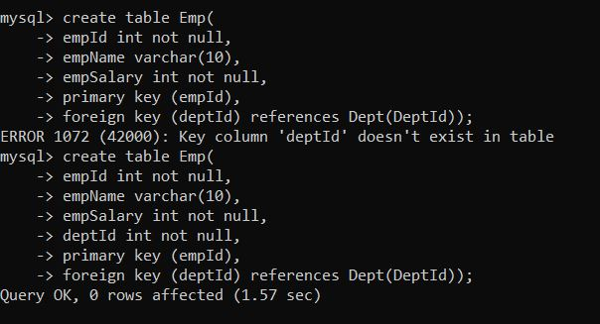

3 Set appropriate primary key and Foreign key.

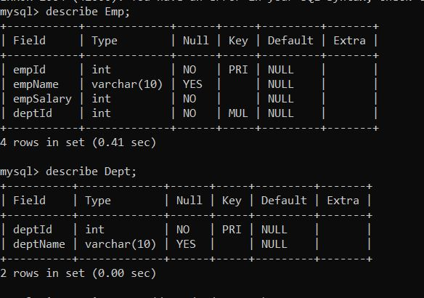

4. Insert few Record.

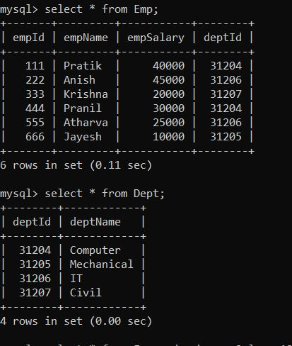

5.Display information of those  emp whose salary is greater than 20000.

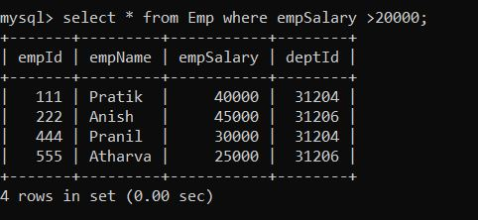

6.List the employee details in the ascending order of their basic salary

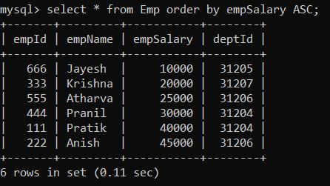

7.List employees belonging to department 30, 40, or 10

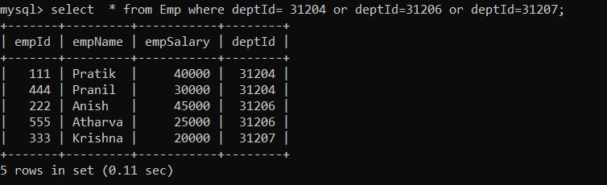

8.List the employee details whose salary is between 10000 to 30000.

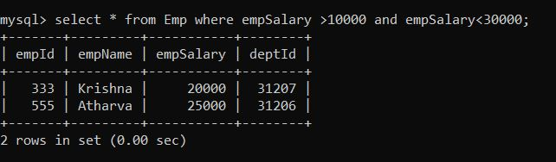

9.List the employee details whose name starts with A and salary is greater than 20000.

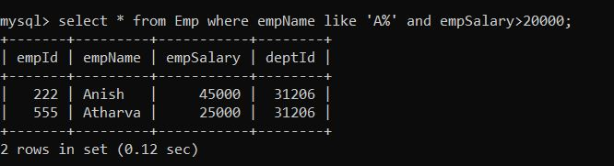

10.List the names of emp whose are working in 'Computer' department.

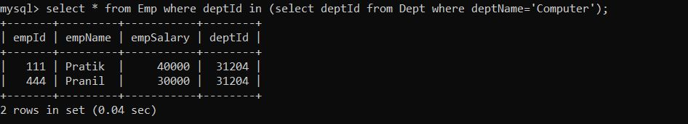

11.Change deptName from 'Computer' to 'Computer Engineering'.

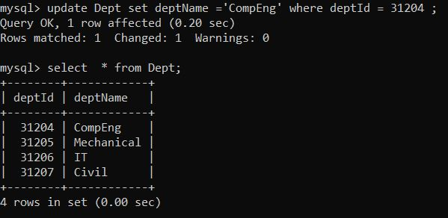

12.List the total salary, maximum and minimum salary and average salary of the  employees, for

department 30.

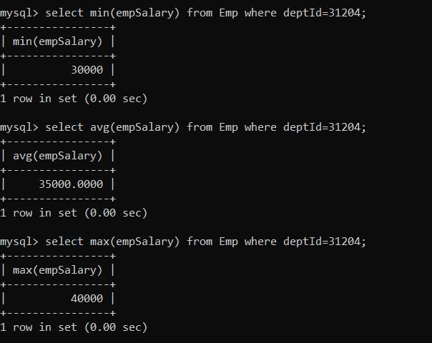

13.List average sal of each deptID.

