PUNE INSTITUTE OF COMPUTER TECHNOLOGY
Department of Computer Engineering
DBMS
K-1 Batch Roll no-31109 Name -Jayesh Gopal Bangad
B1 ASSIGNMENT

Being a NoSQL tool means that it does not use the usual rows and columns that you so much associate with the relational database management. It is an architecture that is built on collections and documents. The basic unit of data in this database consists of a set of key–value pairs.It allows documents to have different fields and structures. This database uses a document storage format called BSON which is a binary style of JSON documents.The data model that MongoDB follows is a highly elastic one that lets you combine and store data of multivariate types without having to compromise on the powerful indexing options, data access, and validation rules.

Architecture of MongoDB NoSQL Database
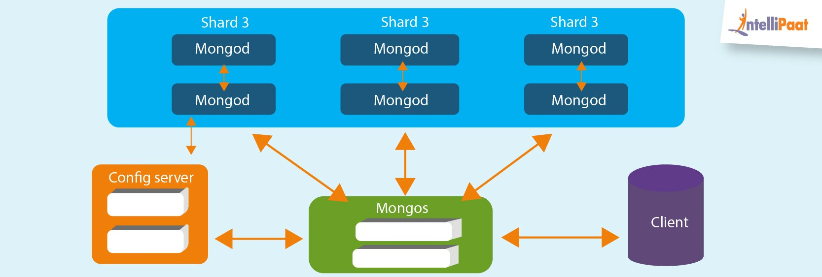
Database: In simple words, it can be called the physical container for data. Each of the databases has its own set of files on the file system with multiple databases existing on a single MongoDB server.
Collection: A group of database documents can be called a collection. The RDBMS equivalent to a collection is a table. The entire collection exists within a single database. There are no schemas when it comes to collections. Inside the collection, various documents can have varied fields, but mostly the documents within a collection are meant for the same purpose or for serving the same end goal.
Document: A set of key–value pairs can be designated as a document. Documents are associated with dynamic schemas. The benefit of having dynamic schemas is that a document in a single collection does not have to possess the same structure or fields. Also, the common fields in a collection’s document can have varied types of data.

Important Features of MongoDB
- Queries: It supports ad-hoc queries and document-based queries.
- Index Support: Any field in the document can be indexed.
- Replication: It supports Master–Slave replication. MongoDB uses native application to maintain multiple copies of data. Preventing database downtime is one of the replica set’s features as it has self-healing shard.

- Multiple Servers: The database can run over multiple servers. Data is duplicated to foolproof the system in the case of hardware failure.
- Auto-sharding: This process distributes data across multiple physical partitions called shards. Due to sharding, MongoDB has an automatic load balancing feature.
- MapReduce: It supports MapReduce and flexible aggregation tools.
- Failure Handling: In MongoDB, it’s easy to cope with cases of failures. Huge numbers of replicas give out increased protection and data availability against database downtime like rack failures, multiple machine failures, and data center failures, or even network partitions.
- GridFS: Without complicating your stack, any sizes of files can be stored. GridFS feature divides files into smaller parts and stores them as separate documents.
- Schema-less Database: It is a schema-less database written in C++.
- Document-oriented Storage: It uses BSON format which is a JSON-like format.
- Procedures: MongoDB JavaScript works well as the database uses the language instead of procedures.

