PUNE INSTITUTE OF COMPUTER TECHNOLOGY
Department of Computer Engineering
DBMSL (310247)
K-1 Batch Roll no-31109
Name -Jayesh Gopal Bangad
B2 ASSIGNMENT

Problem Statement:
Design and Develop MongoDB Queries using CRUD operations. (Use CRUD operations, SAVE method, logical operators)

1. Insert :

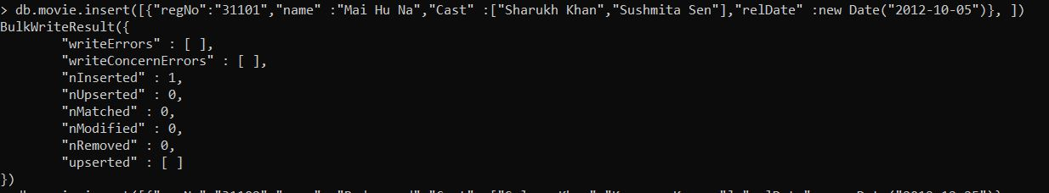
2. Insertmany() :
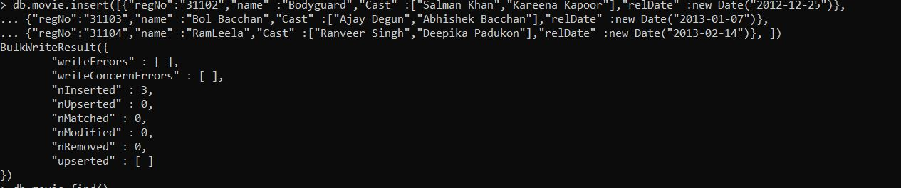
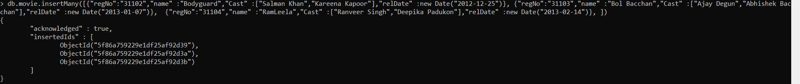
3.find() :
4.update() :
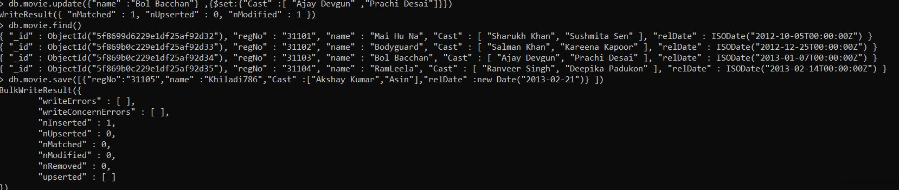

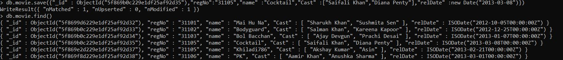
5.Save() :

6.upsert :
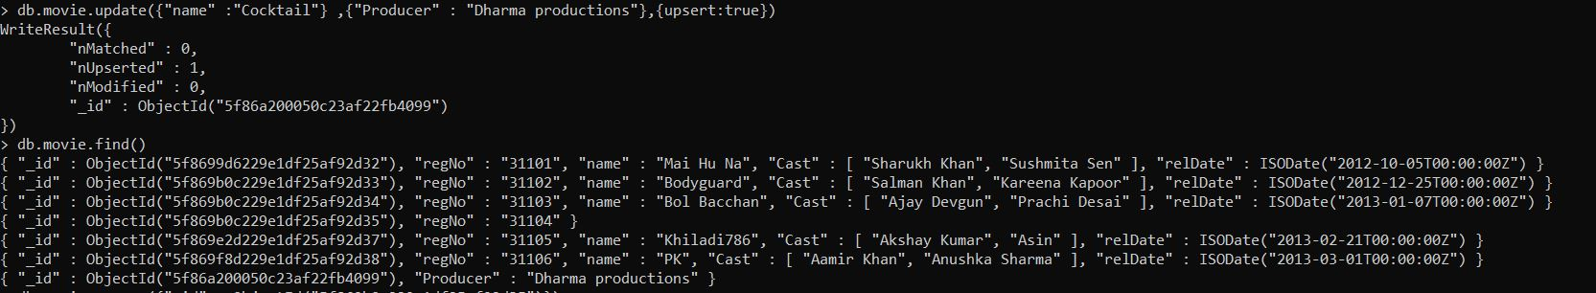
7. remove() :
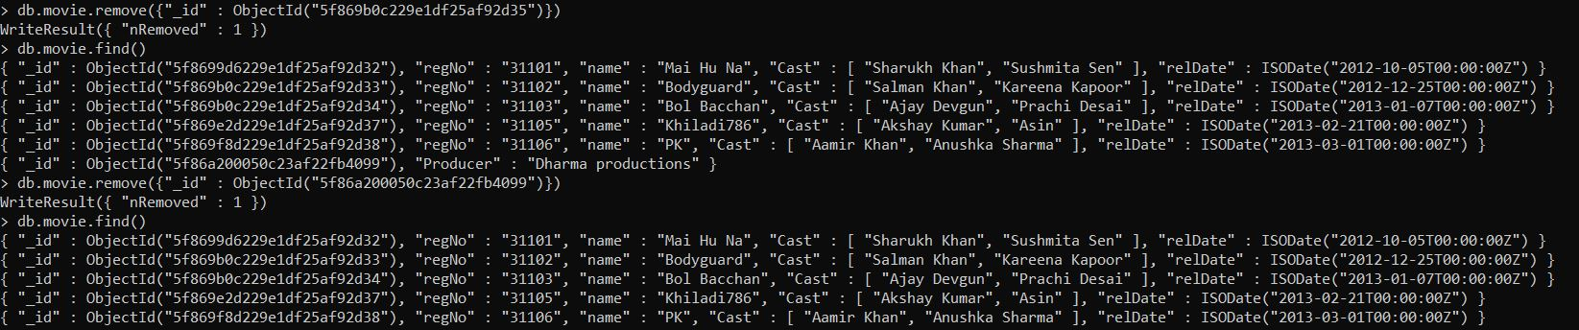
8.deleteMany():

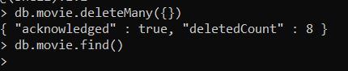

9.find().pretty() :

