PUNE INSTITUTE OF COMPUTER TECHNOLOGY
Department of Computer Engineering
DBMSL (310247)
K-1 Batch Roll no-31109
Name -Jayesh Gopal Bangad
Mock Test 2

Problem Statement:
Assignment B2 :Design and Develop MongoDB Queries using CRUD operations. (Use CRUD operations, SAVE method, logical operators)

Insert Method in MongoDB :

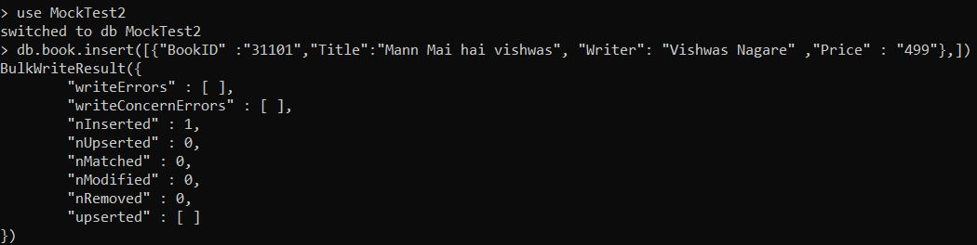

InsertOne Method in MongoDB :

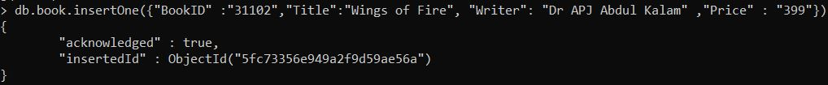

InsertMany Method in MongoDB :

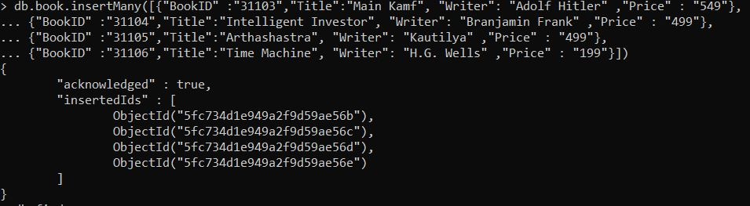

Find Method In MongoDB:
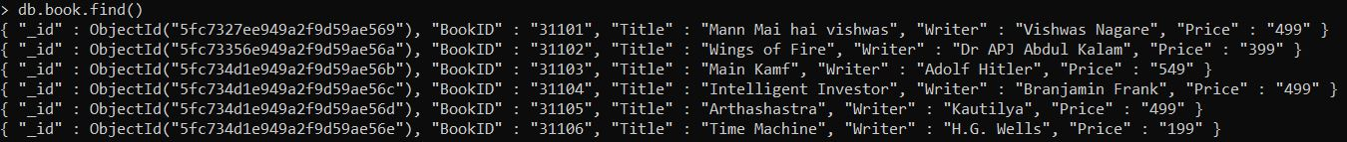

Update Method in MongoDB:

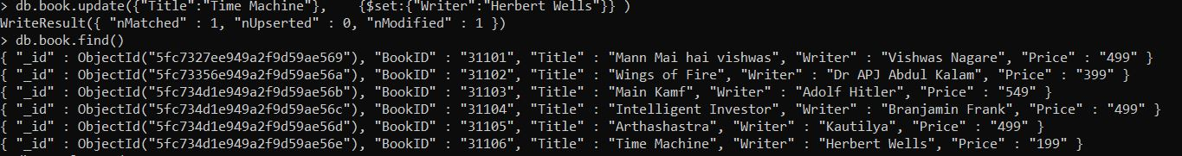
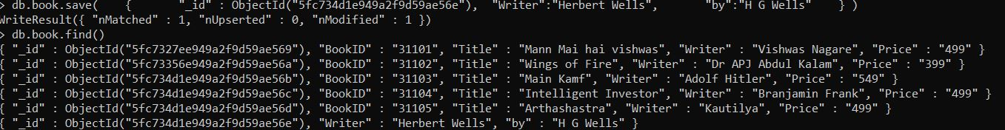
Save Method in MongoDB :

Remove in MongoDB :

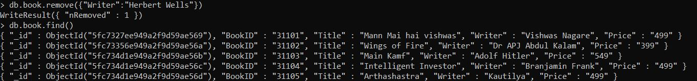
Find Method In MongoDB :

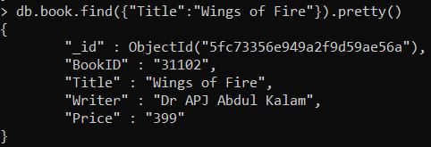

Less Than In MongoDB :

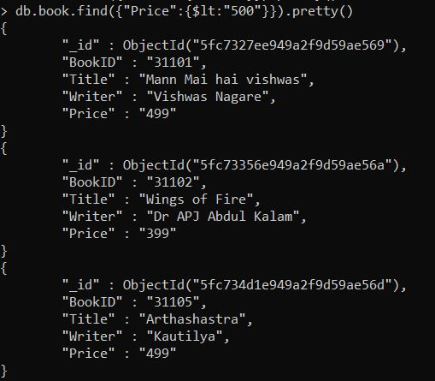

Greater Than In MongoDB :

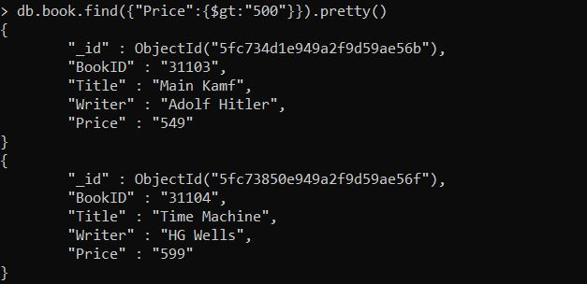

AND in MongoDB :
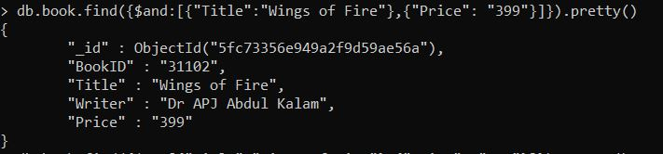

OR in MongoDB :

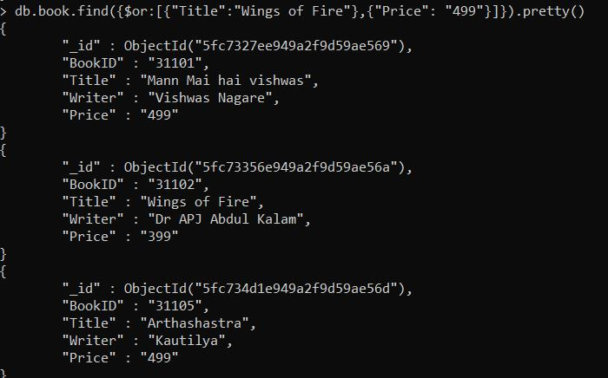

NOT in MongoDB :

db.Collection_name.find().pretty() :
