ANALYSTLAB AFRICA | Experience Lab Internship Programme
FinTrust Digital Bank
Week 4 Final Report: Business Intelligence and Dashboard Solution
Track: Data Analytics Author: Yawa Jacqueline GBEDEVI Project: FinTrust Financial Intelligence & Digital Banking Support Solution
FinTrust is a fictional organisation and all data is synthetic. Risk_Review_Flag is an educational label. It is not a fraud determination, and nothing in this report should be read as fraud detection or as advice for a real bank.

Summary
This is the final version of my Data Analytics work. Over four weeks I moved from a plan (Week 1), to a cleaned dataset and first findings (Week 2), to a deeper analysis and a first full dashboard (Week 3). This week was about testing everything again and being able to prove the numbers.
Three things stand out. First, every number on the dashboard was recomputed independently in Python and matched (21 of 21 checks). Second, six findings were re-tested with a method different from the one that produced them, and all six hold, although two needed a more careful wording. Third, the data has some strong limits that I could only see after looking harder, for example every hour of the day has exactly 500 transactions, and ATM transactions are recorded with a mobile phone as the device nine times out of ten. These limits are documented so nobody over-reads the results.
What | Result
Data quality tests | 12 of 12 pass (notebook, Part A)
Dashboard values checked against an independent calculation | 21 of 21 match
Final SQL queries | 10 queries (JOIN, GROUP BY, CASE, CTE, subquery, window functions); results match Python and the dashboard
Final business insights | 6, each with Finding, Evidence, Business Meaning, Recommended Action
Validated findings | 6 re-tested with a second method; 0 rejected, 2 reworded, 1 new data limitation found
Reproducibility | Notebook run twice, identical results; relative paths; requirements file; README

1. Part A: Final data and analysis review

1.1 Review checklist
What had to be confirmed | How it was checked | Result
Data quality issues have been addressed | 12 automated tests in the notebook: row counts, unique IDs, customer links, amounts above zero, date range, allowed categories, count of Not Provided values | 12 of 12 pass
Calculations are accurate | 21 values shown on the dashboard recomputed independently in Python (Appendix A) | 21 of 21 match
SQL queries produce the expected results | Final script run again in DuckDB, then compared with the notebook and the dashboard | All 10 queries match
Python analysis is reproducible | Notebook run from top to bottom twice, fixed random seed, relative file paths, requirements.txt | Identical results
KPIs are clearly defined | KPI documentation in section 3.2 (definition, value, page) | 14 KPIs defined
Findings are supported by evidence | Each finding re-tested with a second method (section 5) | All 6 hold

1.2 Corrections and improvements made
I compared the Week 3 draft of the dashboard and the Week 3 documents with the data and with each other. These are the differences I found and what changed.
# | What was found | Correction in the final version
1 | The dashboard showed the average transaction value only. My own Recommendation 1 says the median must sit next to it (average is 4.5 times the median). | Median card added to the Home page, and a median column added to the segment table.
2 | The table "Preferred versus actual channel" was titled "% of each row" but its columns added up to 100%, so it answered a different question and hid the finding. | Table rebuilt with row percentages. It now matches SQL query F8 exactly.
3 | The segment comparison table hid the SME row and the median column. | Table resized, all four segments and both measures are visible.
4 | Filters had different names on different pages (Customer_Segment, C_Segment, Cust_Segment, Transaction_Type, Tx_Type). | Same names on every page (C_Segment, Tx_Type).
5 | International flag rates were shown without the number of international transactions, although they are few (480). | Card "International Tx = 480" added to the Risk Review page.
6 | A card about high-value share of value (62.47%) sat on the Risk Review page, but it describes amounts, not risk. | Card removed from that page. The figure is kept in SQL query F6 and in Insight 1.
7 | A comment in the Week 3 SQL says international transactions are flagged "1.6 to 2.4 times" more often. The exact ratios are 1.52 to 2.41 (for example 48.15 / 31.62 = 1.52). | Final SQL says 1.5 to 2.4, as the findings document and the notebook already did.
8 | KPI document says Transfers and Deposits are 40.7% of transactions. 4,877 / 12,000 = 40.6% (the 40.7% came from adding two rounded shares). | Final figure is 40.6%.
9 | The Week 3 notebook read a file called FinTrust_Data.xlsx with sheet names that are not in the project folder, so a reviewer could not run it. | Notebook now reads the project data from the data folder with relative paths, with a requirements file and a README.
10 | Two data quality observations were never reported (device versus channel, location versus home city). | Documented in section 7.

2. Part B: Final SQL analysis
The final script is sql/FinTrust_Week4_Final_SQL.sql. It keeps the ten queries that matter most for decisions, cleaned and commented. It was written for DuckDB and can be run in DBeaver or with sql/run_sql.py.
Query | Business question | Techniques | What it reveals
F1 | Do the loaded tables match the dashboard control values? | Aggregations, MEDIAN, JOIN | 12,000 transactions, 1,500 customers, 560.48M NGN, 90.47% success, 19.60% flagged
F2 | Do the four segments behave differently? | JOIN, subquery, GROUP BY | Almost identical on volume, value, success and flag rate
F3 | Where do failures happen? | GROUP BY, window function | Mobile App holds 47.0% of failures with 42.5% of traffic
F4 | Do international status and amount add up in the flag? | CTE, CASE | Each adds to the other. Highest rate is international above 118k (48.15%)
F5 | Which transaction types concentrate flags? | Window functions, lift | Transfer (1.45x) and Cash Withdrawal (1.29x) hold 58% of all flags
F6 | How much value do the very large transactions carry? | CTE, CASE, window total | 12.3% of transactions carry 62.5% of the value
F7 | Is value concentrated in a few customers? | CTE, NTILE, cumulative window | Top 20% of customers hold 43.57% of value
F8 | Do customers use the channel they declare? | JOIN, row percentages with window | No. About 42% use the Mobile App whatever they declare
F9 | Are Dormant accounts really inactive? | CTE, JOIN, conditional aggregation | 98 of 107 Dormant customers transacted in the last 30 days
F10 | Is there a trend over the quarter? | CTE, moving-average window | 133 or 134 transactions every day, no trend

2.1 The three queries I would present first
F4, risk review by international status and amount band. This is the query that explains the flag best, because it shows two effects at once without one hiding the other.
Amount band | Domestic | International | International transactions
Under 10k | 16.92% | 34.12% | 255
10k to 50k | 16.87% | 40.65% | 123
50k to 118k | 18.23% | 29.17% | 48
Above 118k | 31.62% | 48.15% | 54
International transactions are flagged 1.5 to 2.4 times more often in every band. The amount only matters above about 118k. The international groups are small, so I read the direction and not the exact percentages.
F3, channel reliability. It separates two ideas that are easy to mix up, the failure rate and the number of failures.
Channel | Transactions | Failed | Failure rate | Failed value (NGN) | Share of all failures
Mobile App | 5,102 | 296 | 5.80% | 13,086,618 | 47.0%
POS | 2,393 | 125 | 5.22% | 3,919,784 | 19.8%
Web | 1,869 | 88 | 4.71% | 4,610,964 | 14.0%
ATM | 1,747 | 73 | 4.18% | 1,729,471 | 11.6%
USSD | 889 | 48 | 5.40% | 1,478,914 | 7.6%
The Mobile App has the most failures simply because it carries the most traffic. Its rate is higher, but not by a margin that the data can prove (section 5).
F6, weight of high-value transactions. 1,474 transactions above 117,923 NGN (12.3% of the count) carry 350.1M of the 560.5M NGN total (62.5%). This one result explains why the average is 4.5 times the median, and why reporting the average alone would mislead.

3. Part C: Final Power BI dashboard

3.1 Structure
The dashboard has four pages with a side menu, the same four slicers on every page (Month, C_Segment, Channel, Tx_Type), and one extra slicer where it makes sense (Account_Status on Customers, Tx_Status on Transactions).
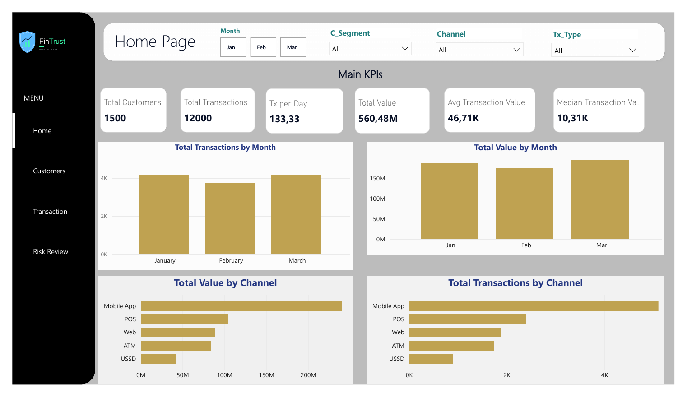
Figure 1. Home page: main KPIs, monthly trend and channel weight.
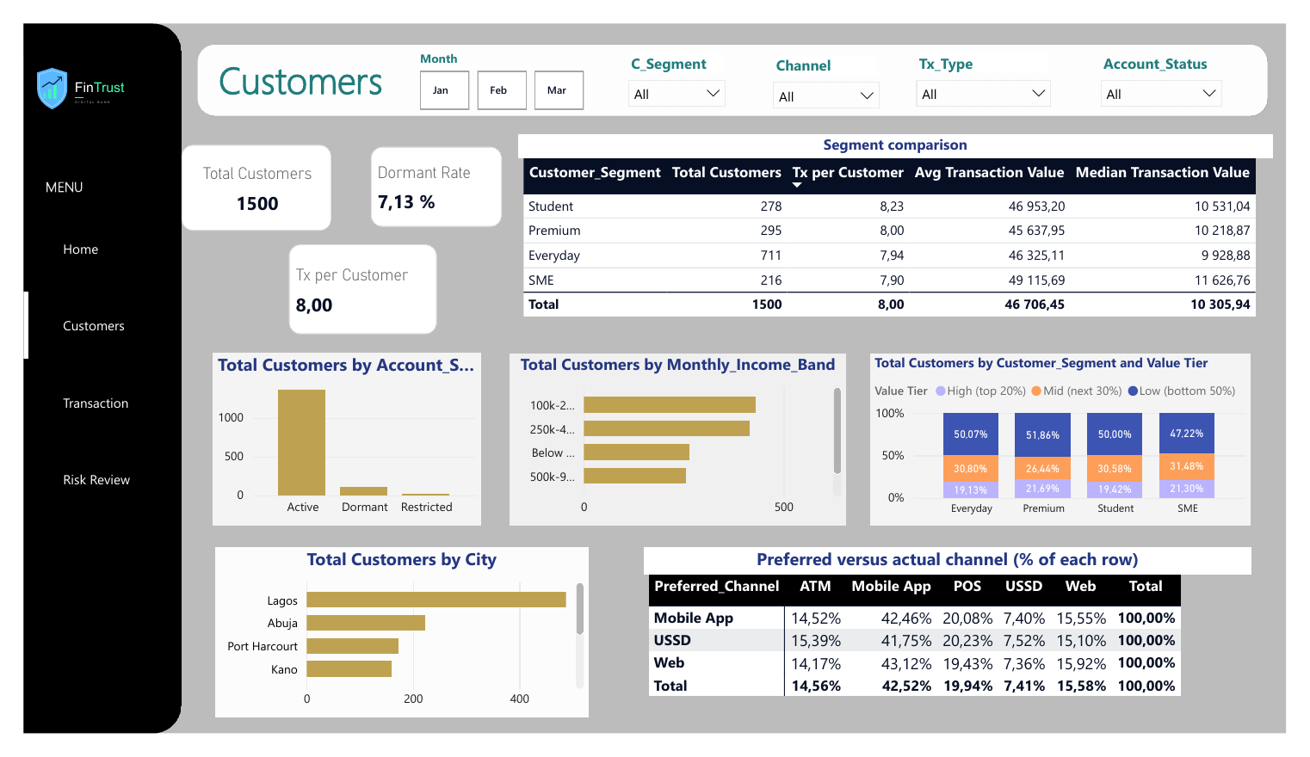
Figure 2. Customers page: segments, status, income, city, and preferred versus actual channel.
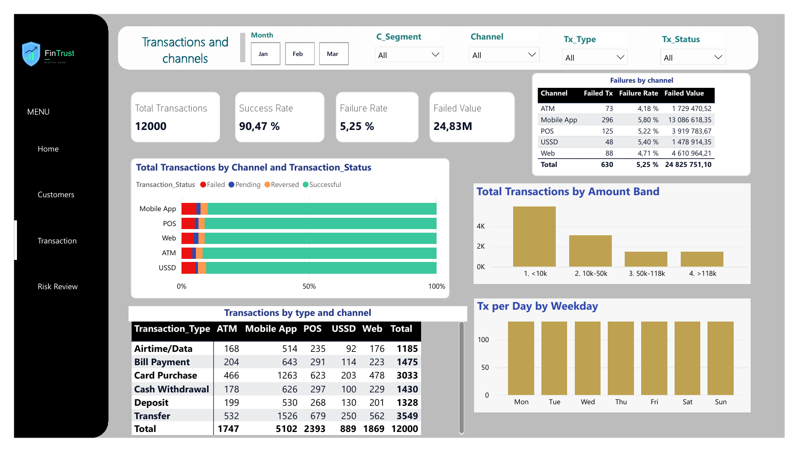
Figure 3. Transactions and channels page: success, failure, status mix, amount bands, type by channel.
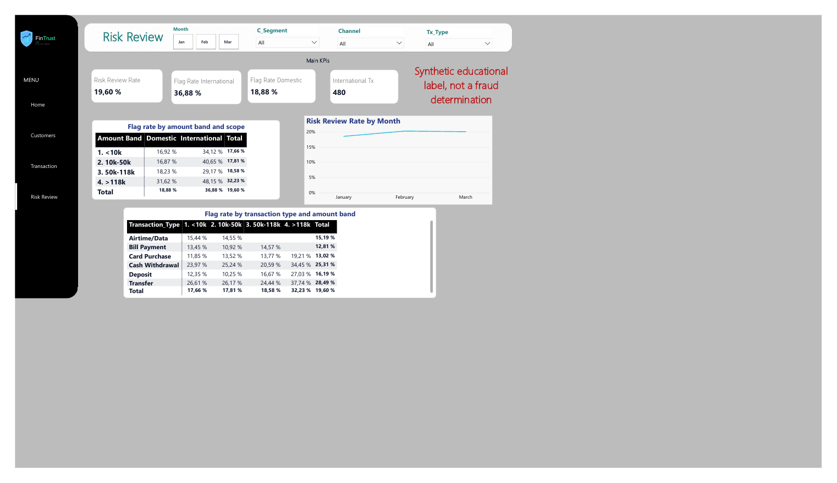
Figure 4. Risk Review page, with the reminder that the flag is synthetic.

3.2 KPI documentation
KPI | How it is calculated | Value | Page
Total Customers | Distinct Customer_ID in the customer table | 1,500 | Home, Customers
Total Transactions | Number of rows in the transaction table | 12,000 | Home, Transactions
Tx per Day | Total transactions divided by days with activity (90) | 133.33 | Home
Total Value | Sum of Amount_NGN | 560.48M NGN | Home
Avg Transaction Value | Total value divided by total transactions | 46,706 NGN | Home, Customers
Median Transaction Value | Middle value of Amount_NGN. Always read next to the average | 10,306 NGN | Home, Customers
Dormant Rate | Dormant customers divided by all customers. A status label, not a measure of inactivity | 7.13% | Customers
Tx per Customer | Transactions divided by customers | 8.00 | Customers
Success Rate | Successful transactions divided by all transactions | 90.47% | Transactions
Failure Rate | Failed transactions divided by all. Reversed (2.72%) and Pending (1.57%) are not counted as failed | 5.25% | Transactions
Failed Value | Sum of Amount_NGN where status is Failed | 24,825,751 NGN | Transactions
Risk Review Rate | Flagged transactions divided by all. Synthetic label | 19.60% | Risk Review
Flag Rate International / Domestic | Flagged divided by all, inside each group | 36.88% / 18.88% | Risk Review
International Tx | Number of transactions with International_Transaction = Yes | 480 | Risk Review

3.3 Dashboard review
Review point | Assessment
KPI accuracy | All 21 checked values match an independent calculation (Appendix A). The decimal-comma import error that multiplied amounts by about 90 in an earlier file does not occur: total value is 560.48M NGN.
Visual clarity | One colour family (gold for values, navy for titles), a title on every visual, and the same layout logic on the four pages.
Filters and slicers | Four common slicers with identical names on every page, plus Account_Status and Tx_Status where relevant.
Labels and titles | Every visual is titled. The Risk Review page carries a red reminder that the label is synthetic and not a fraud determination.
Consistency | Rates are always shown as percentages with two decimals, amounts as K or M on cards and in full in tables.
User experience | The side menu shows the current page. The story follows the order Home, Customers, Transactions, Risk Review, which is also the order of the presentation.
Use of the median | Median card on the Home page and median column in the segment table, so the average is never shown alone.

4. Part D: Final business insights
Each insight follows the order Finding, Evidence, Business Meaning, Recommended Action. All figures are from the 12,000 cleaned transactions and 1,500 customers (January to March 2026).

Insight 1. A typical transaction is much smaller than the average suggests
Finding Transaction amounts are very uneven. A small group of large transactions pulls the average far above what most customers do.
Evidence Average 46,706 NGN, median 10,306 NGN (ratio 4.5). 1,474 transactions above 117,923 NGN are 12.3% of the count and 62.5% of the value.
Business meaning A manager reading only the average would think a typical transaction is around 47,000 NGN, when half of all transactions are below about 10,000 NGN. Limits, pricing and fees designed on the average would fit very few customers. The total value also moves a lot with a handful of operations.
Recommended action Show the median next to the average in every report (done on the dashboard), add the amount-band view, and follow high-value transactions as their own group.

Insight 2. The Mobile App is where failures are most numerous, not proven to be where they are most likely
Finding The Mobile App has the largest number of failed transactions and the largest failed value, but its failure rate is not clearly higher than other channels.
Evidence 296 failed transactions and 13.09M NGN of failed value (47.0% of both, with 42.5% of traffic). Failure rate 5.80% against 4.18% to 5.40% elsewhere. Chi-square across five channels p = 0.081. Each channel against the rest, corrected for five comparisons, gives p = 0.11 for the Mobile App.
Business meaning An incident on the Mobile App touches the most customers, so it deserves attention. But the data does not show that the app is technically weaker, and a large investment justified only by the rate gap could be premature.
Recommended action Analyse the causes of Mobile App failures (error type, transaction type, device). Add a monthly failure-rate indicator by channel with an alert level, and decide on investment when more months of data show whether the gap stays.

Insight 3. The risk-review flag follows three clear factors
Finding Flagged transactions concentrate on international transactions, on Transfers and Cash Withdrawals, and on amounts above about 118k. Segment and channel add little.
Evidence Logistic regression with all factors together gives odds ratios of 2.7 (international), 2.5 (Transfer), 2.2 (Cash Withdrawal) and 1.8 (high amount). Segment effects are all close to 1 (p above 0.4). Highest observed rate 48.15% (international above 118k). Cross-validated ROC-AUC 0.64.
Business meaning The flag is partly explainable, which is useful for deciding where a review team should look first. An AUC of 0.64 also tells us that these factors only explain part of it, which is normal for a synthetic label. The flag must never be presented as proof of fraud.
Recommended action Define review criteria around the three factors, rank the review queue by their combination, and measure how many reviewed cases are confirmed. In this project this stays a description of a synthetic label.
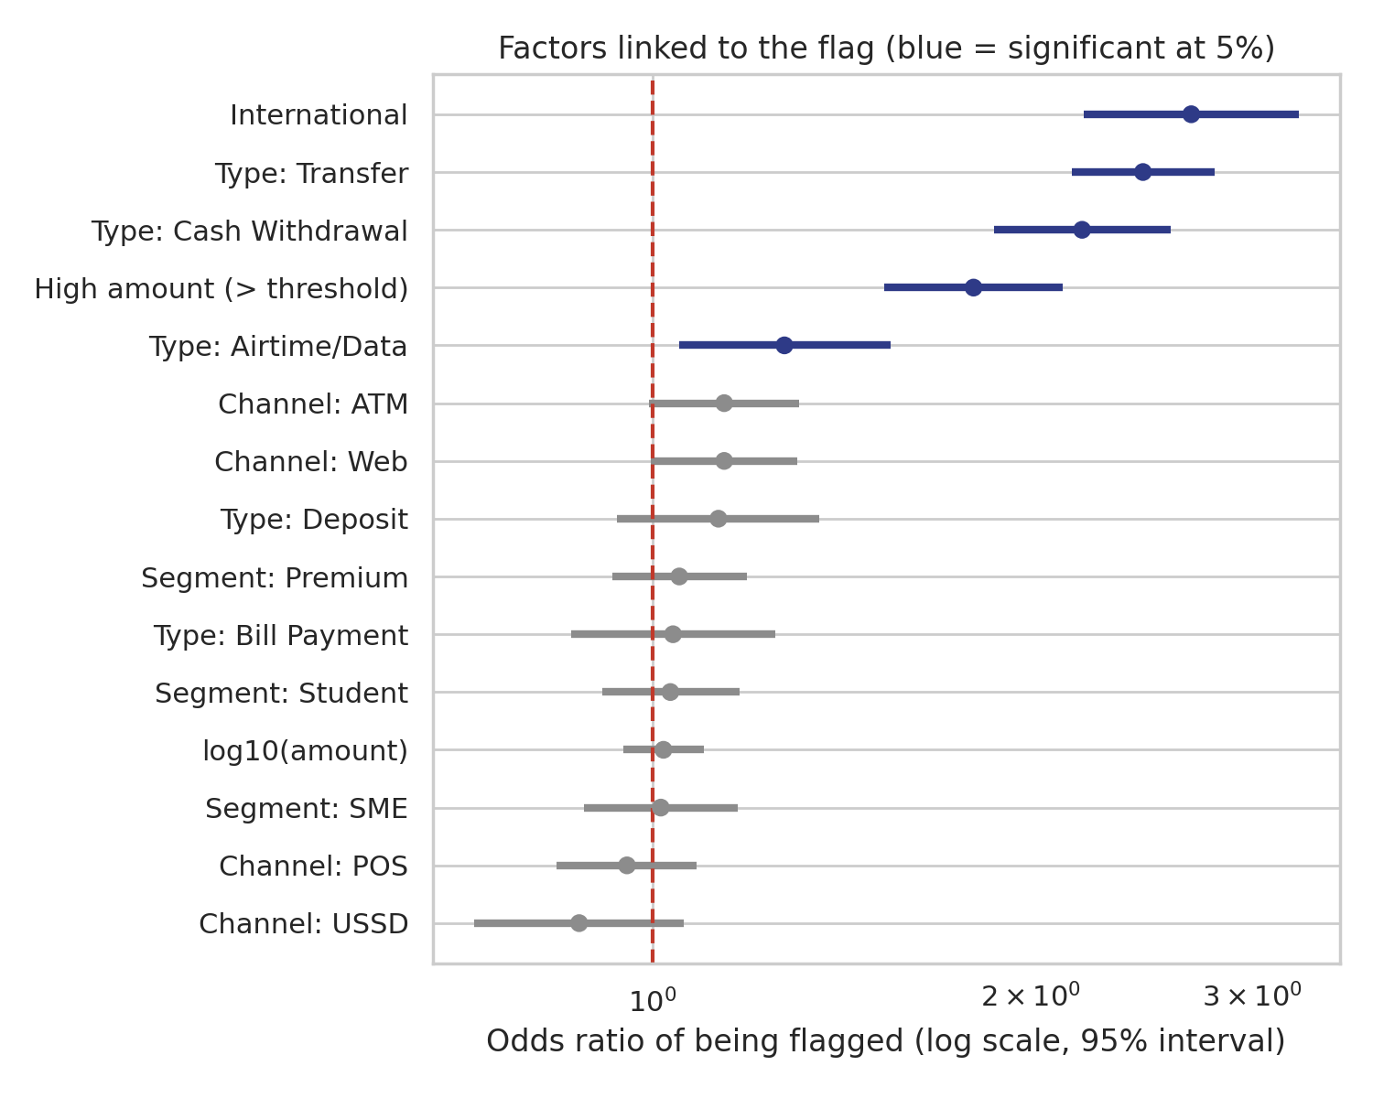
Figure 5. Odds ratios of the flag, all factors tested together (blue means significant at 5%).

Insight 4. The four segments behave almost the same, so the Premium label does not identify high-value customers
Finding Segments do not differ in how much or how often customers transact. Value is more concentrated by individual customer than by segment.
Evidence About 8 transactions per customer in every segment (7.90 to 8.23). Medians 9,929 to 11,627 NGN with overlapping confidence intervals, Kruskal-Wallis p = 0.20. The top 20% of customers by value hold 43.6% of total value (Gini 0.40), and every segment contains a similar mix of high and low customers.
Business meaning Retention or loyalty offers built on the Premium label may not reach the customers who actually generate value.
Recommended action Review how the Premium segment is defined, and test a value-based list (for example the top 20% of customers by transaction value) for retention actions.
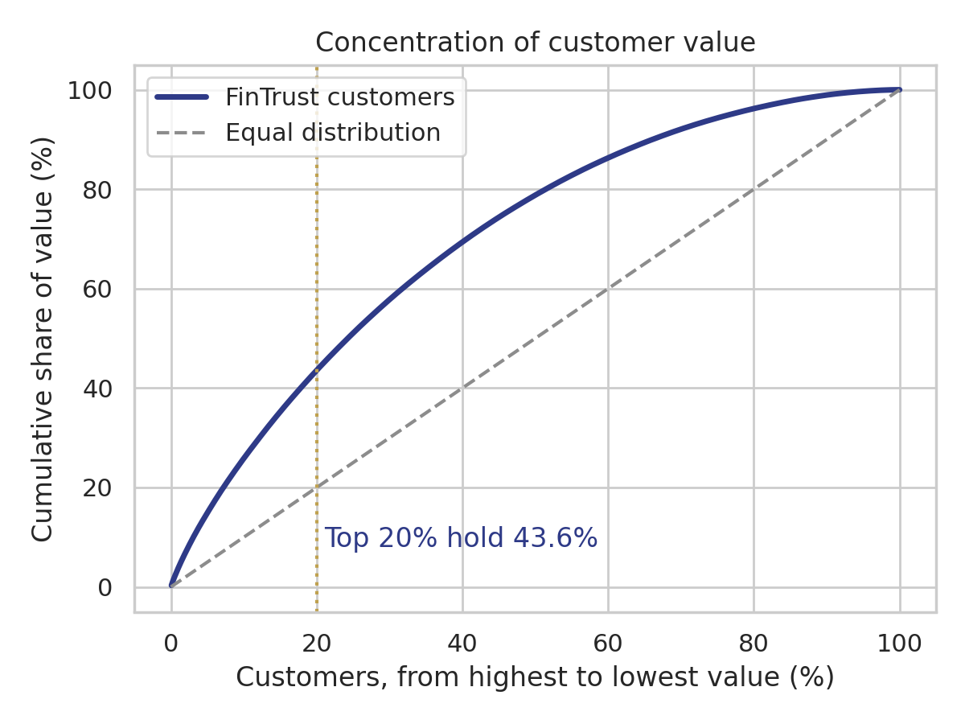
Figure 6. Concentration of customer value.

Insight 5. Account status and preferred channel do not describe customer behaviour
Finding The fields Account_Status and Preferred_Channel cannot be used alone to measure inactivity or to target channel campaigns.
Evidence 98 of 107 Dormant customers made a transaction in the last 30 days of the data (91.6%, against 93.7% for Active). Dormant and Restricted customers make as many transactions as Active ones (8.09 and 8.62 against 7.98). Whatever channel a customer declares, about 42% of their transactions are on the Mobile App (chi-square p = 0.95, Cramer's V = 0.01).
Business meaning A Dormant rate of 7.13% would wrongly suggest 107 inactive customers. Campaigns based on the declared channel would target people who do not use it.
Recommended action Check how Account_Status is defined and updated, add an inactivity indicator based on the date of the last transaction, and profile customers on observed channel use.
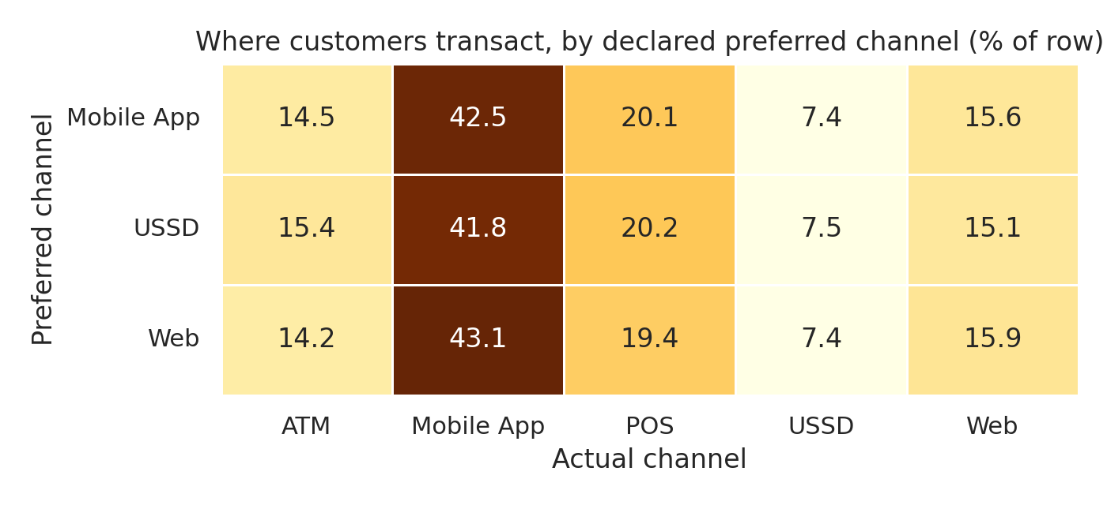
Figure 7. Where customers transact, by declared preferred channel.

Insight 6. Transfers and Card Purchases are over half of all activity, in every channel
Finding Two transaction types make up most of the volume, and the same two lead in all five channels.
Evidence Transfer 29.6% and Card Purchase 25.3% of transactions (54.9% together). They rank first and second in all five channels. Transfers also carry 42.4% of the total value and have the highest flag rate (28.49%).
Business meaning A fault or slowdown on these two flows touches most customers whichever channel they use, and Transfers are also where review effort would be concentrated.
Recommended action Make these two flows the first targets for testing and monitoring, and track their success rate separately.

5. Part E: Final validation
Each finding was tested again with a method different from the one that produced it. The code is in notebooks/FinTrust_Week4_Final_Analysis.ipynb and the numbers are saved in docs/validation_results.json.
Finding | Validation method | Result | Conclusion
1. The four segments behave alike (Premium is not lowest) | Bootstrap 95% interval of each median and of the Premium minus others gap; Kruskal-Wallis test | Intervals overlap for all segments. Premium minus others gap = -93 NGN, interval -1,336 to +1,119. p = 0.20 | Confirmed. No segment can be called higher or lower
2. Mobile App: most failures in number, higher rate not proven | Wilson 95% intervals; each channel against the rest with a correction for 5 comparisons | Mobile App 5.80% (5.19 to 6.48). Raw p = 0.022, corrected p = 0.11. Five-channel test p = 0.081 | Confirmed as nuanced. Volume argument holds, reliability gap not proven
3. Value is concentrated in a few transactions and, less strongly, a few customers | Independent pandas recalculation of the SQL deciles; Gini coefficient; Lorenz curve | Top 20% of customers = 43.57% of value, top 30% = 57.81%, Gini 0.40. 12.3% of transactions = 62.5% of value | Confirmed. Skew is stronger at transaction level than at customer level
4. The flag follows international status, high amount, Transfer and Cash Withdrawal | Logistic regression with all factors together; 5-fold cross-validated ROC-AUC | Odds ratios 2.7, 1.8, 2.5, 2.2. Segment close to 1. Amount adds nothing once the 118k threshold is in the model. AUC 0.64 | Confirmed and sharpened. The effect is a step above the threshold, and only part of the flag is explained
5. Preferred channel and account status do not match behaviour | Chi-square test and Cramer's V; share of Dormant customers active in the last 30 days | p = 0.95, V = 0.01. 91.6% of Dormant customers active in the last 30 days | Confirmed. These fields should not be used alone
6. Activity is flat, no trend or peak hour can be read | Chi-square test of hours against a uniform pattern; transactions per day and per month | Exactly 500 transactions in every hour (p = 1.00); 133 or 134 per day; 133.3 per day in each month | Confirmed. It is a property of the synthetic data, not a business result

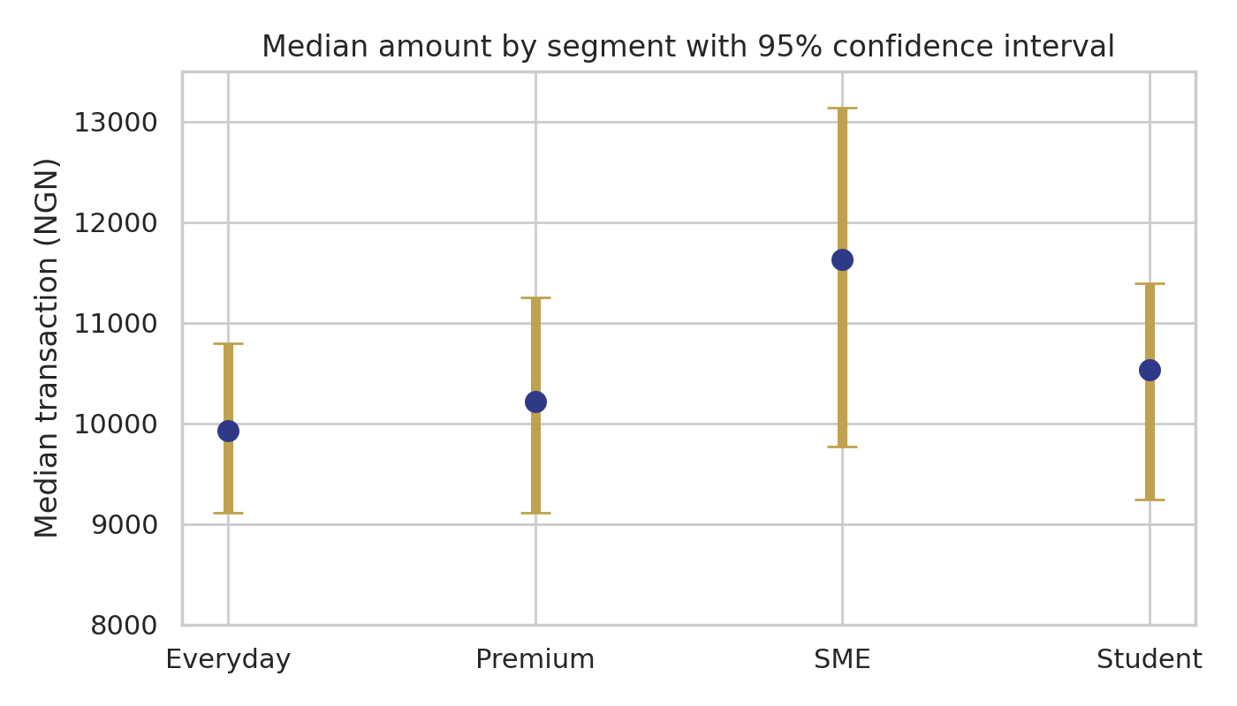
Figure 8. Median transaction amount by segment with 95% confidence interval.
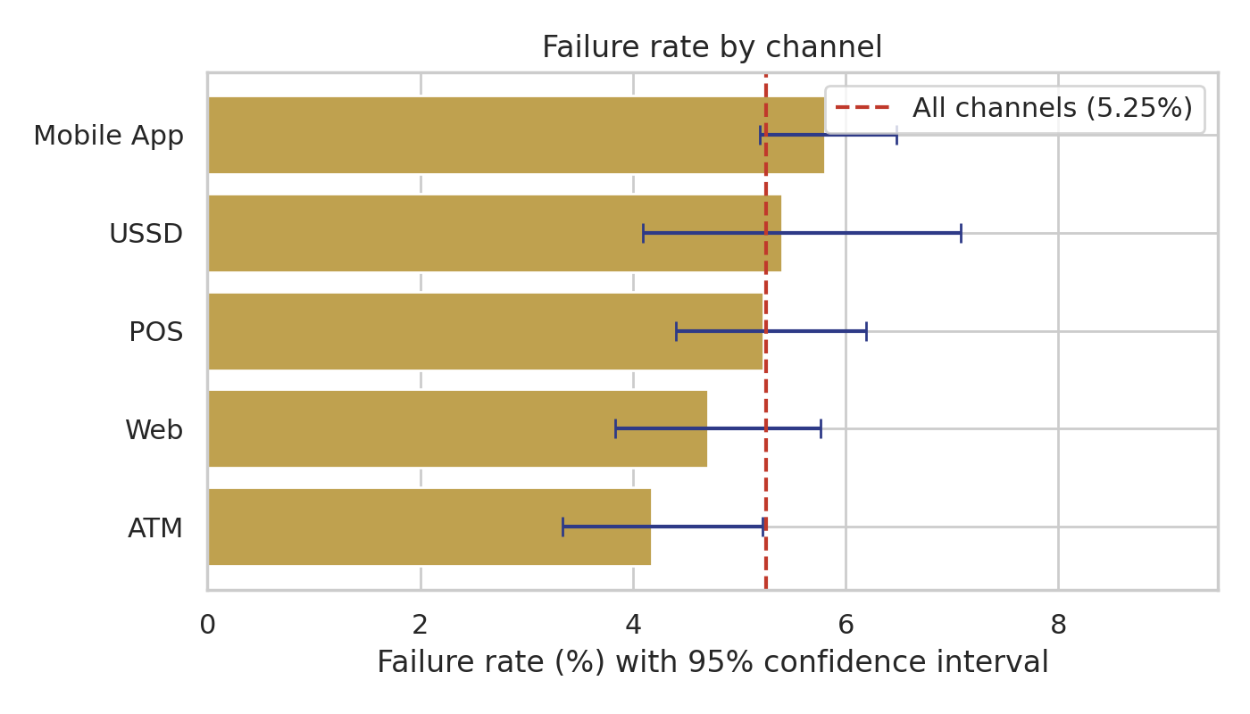
Figure 9. Failure rate by channel with 95% confidence interval.

5.1 What changed after validation
- Finding 1 (Week 3): the Week 2 claim that Premium has the lowest value was dropped. Week 4 confirms the revision with intervals.
- Finding 2 (Week 3): reworded from "least reliable channel" to "most failures in number". Week 4 adds the correction for several comparisons, which moves the Mobile App result from p = 0.022 to p = 0.11.
- Role of channel in the flag (new wording this week): Week 3 said channel makes little difference. A simple test finds a small but detectable difference (Web 21.4% and ATM 21.2% against USSD 17.3%, p = 0.019). Once transaction type and amount are controlled for, ATM and Web are borderline (p = 0.062 and 0.055) and the other channels are not significant. The accurate wording is "small and borderline", not "none".
- Transfer and Deposit share of transactions: 40.7% corrected to 40.6%.

6. Testing, refinement and re-test
The programme asks for the sequence Final Output, Test, Finding, Refinement, Re-test, Final Result. These are the five cycles of the final week, plus the cycles already documented in Week 3.
Cycle | Final output tested | Test | Finding | Refinement | Re-test and result
1 | Dashboard (Week 3 draft) | Review of each page against my own KPI plan, recommendations and SQL results | Median missing, preferred-channel table read the wrong way, segment table cut, inconsistent filter names, no count behind international rates, a non-risk card on the Risk page | Six changes listed in section 1.2 (items 1 to 6) | 21 dashboard values recomputed, 21 of 21 match. Validated
2 | Data after cleaning | 12 automated data quality tests | All pass. Two new data observations (device versus channel, location versus city) found while profiling | Documented in section 7, with a note on what they limit | Tests run again, 12 of 12 pass. Validated
3 | Findings 1 to 6 | Second method for each finding (section 5) | All hold. Channel effect on the flag needed a more careful wording. Mobile App result changes after correcting for multiple tests | Wording changed in Insights 2 and 3 and in the validation table | Numbers reproduced by SQL, Python and dashboard. Validated
4 | Documentation and SQL comments | Cross-check of every number quoted in Weeks 2 and 3 against the data | 1.6 versus 1.5 ratio, 40.7% versus 40.6%, notebook file name not in the project | Corrected (section 1.2, items 7 to 9) | SQL re-run, all quoted numbers consistent. Validated
5 | Python notebook | Full run twice from the top, fixed seed | Identical results on the second run | None needed | Identical totals, median, success rate and flag rate. Validated

Cycles of Weeks 2 and 3 that still apply, in short. The 5 empty rows found in the cleaned Excel sheet were removed (12,005 rows became 12,000). The Week 2 February dip turned out to be the 28-day month. Findings 1 and 2 were revised after tests did not support them.

7. Data quality documentation
Issue | Size | Decision | Effect checked
Missing Device_Type or Location | 188 transactions (96 and 96, 4 in both) | Replaced with "Not Provided", rows kept | Flag rate p = 0.12, success rate p = 0.52, no significant difference. Group should be read as its own category
Outliers by the IQR rule (above 117,922.86 NGN) | 1,474 transactions (12.3%) | Kept and flagged as a separate band, not deleted | They carry 62.5% of value and are flagged more often, so deleting them would hide the real picture
Device_Type does not match Channel (new) | 89.9% of ATM transactions are recorded with a device other than ATM Terminal; channel and device are independent (p = 0.146) | Device_Type is not used in any conclusion | Documented. Real systems would check this rule
Location is not linked to the customer's city (new) | Equal in only 12.7% of transactions | Location is not used for a travel or fraud-style reading | Documented
Empty rows in the cleaned Excel sheet (Week 2 file) | 5 rows without Transaction_ID | Removed. The original project file has exactly 12,000 rows | Load test: 12,000 rows and 12,000 unique IDs
Decimal comma and date format when exporting to CSV | Amounts multiplied by about 90 in one export | Final CSV files are exported with a dot and ISO dates | Total value 560.48M NGN matches in SQL, Python and Power BI
Account_Status and Preferred_Channel do not match behaviour | 107 Dormant, 26 Restricted customers | Shown with a caveat, not used as inactivity | Section 5, finding 5
Very regular synthetic pattern | 500 transactions in each hour, 133 or 134 per day | No time-of-day, growth or seasonality conclusions | Section 5, finding 6
Data Dictionary covers customers only | Transaction fields not described | Field meanings used in this project are listed in the KPI documentation | Documented

8. Integration with the wider FinTrust solution
The agreed flow is Customer and Transaction Data, Analytics Findings and KPIs, Predictive Risk Intelligence, ML Workflow or Service, Knowledge-Based GenAI Support, Integrated FinTrust Solution. My track sits in the second step. Below is what my work makes available. I only count something as integrated when there is evidence that another track used it.
My output | Who could use it | What it contains | Status
Cleaned dataset and data quality rules | Data Science, ML Engineering | Cleaned CSV files, the 12 data tests (allowed categories, amounts above zero, date range, unique IDs) | Available in the repository
Flag drivers and the 117,923 NGN threshold | Data Science | International status, Transfer, Cash Withdrawal and amount above threshold are the useful factors. Segment and channel add little. Amount adds nothing beyond the threshold. Cross-validated AUC of a simple model is 0.64 | Available as a comparison point for the DS feature work
KPI definitions and validated figures | Generative AI, Project Management | Definitions in section 3.2 and the validated numbers | Available. The assistant must still answer from the approved Knowledge Base only
Final dashboard | Project Management (final presentation) | Four pages, 14 KPIs | Available

Outputs received from other tracks (output received, how it was used, what changed, evidence of use):

9. Assumptions, limitations and responsible use
- FinTrust is fictional and all data is synthetic. Results describe this dataset and would need to be rebuilt on real data.
- Risk_Review_Flag is an educational label. It is not a fraud determination, and the dashboard and this report say so.
- The solution is not a production banking system and gives no personal financial, investment or legal advice.
- Three months of data cannot show growth or seasonality. The perfectly regular daily and hourly pattern rules out any peak-hour reading.
- International transactions are few (480), so international percentages are directions, not precise values. Restricted accounts are only 26 customers.
- Statistical tests were applied to a few planned comparisons. Comparisons chosen after looking at the data (such as the Mobile App against the rest) are corrected for several tests and are not used as proof.
- Device_Type and Location are not reliable in this data (section 7) and are not used for conclusions.
- Customer value is measured by the sum of transaction amounts only. It is not profit or lifetime value.

10. Decisions and lessons learned

10.1 Main decisions of Week 4
Decision | Reason | Impact
Show the median with the average everywhere | Average is 4.5 times the median | Dashboard and report no longer suggest a 47,000 NGN typical transaction
Describe Mobile App failures by volume, not as a weaker channel | Rate gap not significant after correction | Recommendation is to investigate and monitor
Rebuild the preferred-versus-actual table with row percentages | It must answer "where do customers who prefer X transact?" | Visual now supports Insight 5
Keep Device_Type and Location out of the conclusions | Both are unrelated to channel and home city in this data | Fewer wrong stories
Keep the analysis simple (SQL, pandas, one regression) | The track is Data Analytics, and the work must be easy to explain | Clear presentation. Predictive modelling stays with the Data Science track

10.2 Lessons learned
What worked well. Recomputing every dashboard number in a second tool caught real problems that looked fine on screen (a mislabelled table, a hidden SME row). Writing the findings in the order Finding, Evidence, Meaning, Action stopped me from showing charts without a point. Being willing to revise two Week 2 findings made the final story more credible.
What was hard. Keeping the same figures in SQL, Python, Power BI and three Word documents. Small rounding differences (40.7% against 40.6%) show how easily numbers drift. The synthetic data was also too regular for several analyses I had planned, so I had to say clearly what it cannot show.
What I would do differently. Build one reconciliation table on day one and re-run it after every change. Check data relationships (device and channel, location and city) during cleaning, not at the end. Start the dashboard review earlier, because layout fixes in Power BI take longer than the analysis itself.

11. Deliverables and submission checklist
Deliverable | File or location | Status
Final Power BI dashboard | FinTrust_Week3_Dashboard. | Done, export to attach
Final SQL scripts | FinTrust_Week4_Final_SQL.sql | Done and tested
Final Python notebook | notebooks/FinTrust_Week4_Final_Analysis.ipynb | Done and tested
KPI documentation | Section 3.2 of this report | Done
Final business insights and recommendations | Sections 4 and 5 of this report | Done
Validation evidence | Section 5, Appendix A | Done
Data quality documentation | Section 7 of this report | Done
Final project documentation | This report and README.md | Done
Individual video (5 to 10 minutes) |  | To record
GitHub repository updated (week4 folder) |  | To push
LinkedIn post and X post

Appendix A. Dashboard reconciliation (21 checks)
Dashboard visual | Dashboard | Notebook | Result
Home: Total Customers | 1,500 | 1,500 | PASS
Home: Total Transactions | 12,000 | 12,000 | PASS
Home: Tx per Day | 133.33 | 133.33 | PASS
Home: Total Value (M NGN) | 560.48 | 560.48 | PASS
Home: Avg Transaction Value (K NGN) | 46.71 | 46.71 | PASS
Home: Median Transaction Value (K NGN) | 10.31 | 10.31 | PASS
Customers: Dormant Rate (%) | 7.13 | 7.13 | PASS
Customers: Tx per Customer | 8 | 8 | PASS
Customers: Premium median (NGN) | 10,218.87 | 10,218.87 | PASS
Transaction: Success Rate (%) | 90.47 | 90.47 | PASS
Transaction: Failure Rate (%) | 5.25 | 5.25 | PASS
Transaction: Failed Value (M NGN) | 24.83 | 24.83 | PASS
Transaction: Mobile App failed tx | 296 | 296 | PASS
Transaction: Mobile App failed value (NGN) | 13,086,618.35 | 13,086,618.35 | PASS
Transaction: Mobile App transactions | 5,102 | 5,102 | PASS
Risk: Risk Review Rate (%) | 19.60 | 19.60 | PASS
Risk: Flag Rate International (%) | 36.88 | 36.88 | PASS
Risk: Flag Rate Domestic (%) | 18.88 | 18.88 | PASS
Risk: International Tx | 480 | 480 | PASS
Risk: Flag rate >118k international (%) | 48.15 | 48.15 | PASS
Customers: Preferred=USSD, actual Mobile App (%) | 41.75 | 41.75 | PASS

